План-конспект уроку з англійської мови за професійним спрямуванням.
Схематичний план уроку
 | Початок уроку. Організаційний момент. | 2 хв
 | Повідомлення теми та мети уроку. Перевірка домашнього завдання. | 5 хв
3. | Мовна зарядка. Введення в іншомовне середовище. | 2 хв
4. | Словникова робота. | 4 хв
5. | Виконання лексичних вправ | 5 хв
6. | Читання | 7 хв
7. | Аудіювання | 7 хв
8. | Говоріння | 4 хв
9. | Граматика | 7 хв
10. | Пояснення домашнього завдання. Підсумки уроку. | 2 хв

Клас: 11 клас, ІІ курс
Тема уроку: Hand tools for cutting and turning.
Мета:
Навчальна:
- Активізувати лексичний матеріал по темі “Hand tools for cutting and turning”;
- Використовувати нові слова з даної теми; ставити питання та відповідати на них;
- Формування комунікативної компетентності учнів у процесі творчих вправ;
- Формування соціокультурної компетентності;
- Практикування вміння читання, аудіювання, говоріння та письма;
- Поглиблення знань учнів з назв інструментів та їх застосування.
Розвиваюча:
- Розвивати увагу;
- Розвивати пам'ять;
- Розвиток уміння послідовно передавати свою думку іноземною мовою;
- Розвиток уміння пошуку інформації, класифікації та аналізу.
Виховна:
- Сприяти вихованню культури спілкування у здобувачів освіти;
- Формування поведінкових компетенцій: ефективно співпрацювати під час парної та групової роботи;
- Активізація творчих і ділових якостей учнів;
- Прищеплювати позитивне ставлення до англійської мови.
Тип уроку: комбінований
Вид уроку: навчально-практичне заняття з використанням інтерактивних технологій.
Обладнання: Постер, вправи на ресурсі Liveworksheets, аудіозапис, комп’ютер, картки для самостійної та групової роботи.
Очікувані результати:
Здобувач освіти повинен знати:
- лексику з теми;
- правила будови англійського речення,
- правила читання та перекладу тексту.
Учень повинен уміти:
- давати відповіді на питання здобувачів освіти та викладача, підтримувати бесіду;
- презентувати усно свої думки та твердження;
- отримувати нові знання та застосовувати їх у практичній діяльності;
- сприймати на слух інформацію англійською мовою;
- використовувати ІКТ під час виконання завдань.
Міжпредметні зв’язки: предмет «Слюсарна справа».
ХІД УРОКУ
I. | підготовка до сприйняття іншомовного мовлення
Greeting | 1. Привітання, організація здобувачів освіти  Т: Good day students!Are you in good mood?  I hope everybody is fine. So, let’s start our lesson.
Theme of the lesson  Aim  Checking homework | 2. Повідомлення теми та мети уроку. Перевірка домашнього завдання.  T: The theme of today's lesson is “Hand tools for cutting and turning” and our aim is to get to remember the names of hand tools, talk about what this tools are used for. We will read the story, you’ll translate it to me and do the task. Also, we’ll have listening grammar and speaking.  T: But firstly lets check the homework for today. What is the homework for today?  P: We should write a letter to a friend and tell him\her what hand tools we have at home and what for are we use them.
 | T: Your letters are gorgeous! I see that you’ve learnt the vocabulary about hand tools. So, let’s start our new topic!
Warming up | 3. Уведення в іншомовну атмосферу.  T: Now, I ask you to make as many words as yoy can from the word “screwdriver” (examples)  - screw – саморіз 6. wreck – трощити 11. deer – олень, олені  - wide – широкий 7. risk – ризик 12. side – сторона, бік  - driver – водій 8. diver – дайвер 13. ever – коли-небудь  - wire – дріт 9. rice – рис 14. wise – мудрий  - river – річка 10. weed – бур’ян 15. drive – водити
II. | ОСНОВНА ЧАСТИНА УРОКУ
Presentation  and Practice | T: What tool can be used to cut pipes? What are some different types of wrenches? Let’s see the poster and do the task.  https://drive.google.com/file/d/13F4_UfCkL6b8HStK-7PXp6SYtDr49_aO/view?usp=sharing  In this exercise you will find pictures to help you study the basic mechanics’ tools and improve your language level.  T: Now, let’s check how do you remember new words.  - Виконуємо вправу 1.  https://www.liveworksheets.com/worksheets/en/English_as_a_Second_Language_(ESL)/Vocabulary/Grasser_Hand_Tools_rf3485272px  - Виконуємо вправу 2.  Exercise 2. Fill in the blanks with the correct words and phrases from the word bank.  pipe wrench, Allen wrench, ratchet wrench, combination wrench,  ball pein hammer  - See which ________________ fits the hexagonal recess in this bolt.  - Tom used the open end of the ____________________.  - The plumber used an adjustable ___________________.  - Sue shaped the metal fitting with a ___________________.  - Where are the sockets for this__________________?
Reading | - Pre-reading  1. What tool should be used to cut wood?  a) wire cutter b) hand saw c) hacksaw d) ball pein hammer  2. Which tool CANNOT work on different sizes of bolts?  a) Allen key b) pipe wrench  c) combination wrench c) ratchet wrench and socket set  - Reading  Once upon a time in the bustling town of Toolsville, there lived a young tinkerer named Timmy. Timmy's dream was to become the finest handyman in the land. One day, he received a mysterious package with all sorts of tools inside, including a ratchet wrench and a combination wrench.  Curious about the sender, Timmy embarked on a journey to find the gift's origin. Along the way, he encountered a mischievous elf named Elwin, who had stolen a pipe wrench from the local blacksmith. Determined to stop Elwin's thievery, Timmy used his Allen wrench to disarm the elf and retrieve the stolen tool.  As Timmy continued his quest, he stumbled upon a village under attack by pesky critters. Swiftly, he grabbed his nut driver and tightened all the loose screws, saving the day. Grateful for his heroism, the villagers gifted him a ball paint hammer, which they said possessed magical properties.  With his new tool in hand, Timmy felt invincible and decided to confront a treacherous beast lurking in the nearby forest. Armed with a wire cutter, he skillfully dismantled the traps set by the creature, gaining its respect in the process.  Feeling more confident than ever, Timmy took on a construction project in Toolsville using a hack saw to cut through the wood with precision. He also utilized a variety of sockets to ensure the fittings were secure.  Word of Timmy's remarkable skills spread like wildfire, and soon he found himself in high demand across the kingdom. With his trusty toolset, he repaired wagons, fixed roofs, and mended broken fences.  One day, the king's palace suffered a terrible leak, and Timmy was summoned to repair it. Armed with his pipe wrench and an unwavering determination, he fixed the issue, earning the king's admiration and a royal commendation.  As time went on, Timmy's legend grew, and he became known as the "Master of Tools." People from far and wide sought his expertise, and he traveled the world, helping those in need with his unmatched skills.  However, amidst all the fame and glory, Timmy remained humble and kind, always ready to assist anyone, regardless of their station in life. He continued to carry his toolset with him, never knowing when he might be called upon to save the day.  And so, the young tinkerer's journey as the "Master of Tools" continued, leaving a trail of fixed problems and grateful hearts wherever he went, proving that with the right tools and a good heart, one can accomplish anything.  - Post-reading  - What were the two types of wrenches that Timmy received in the mysterious package?  - Who did Timmy encounter on his journey, and what tool did he use to retrieve the stolen pipe wrench?  - How did Timmy use his nut driver to help the villagers?  - What magical tool did the grateful villagers gift Timmy?  - Which tool did Timmy use to dismantle traps set by the treacherous beast in the forest?  - How did Timmy utilize the hack saw during his construction project in Toolsville?  - What type of tool did Timmy use to ensure secure fittings in his construction work?  - What problem did Timmy fix in the king's palace, and which tool did he use to fix it?  - What did Timmy become known as in the kingdom due to his remarkable skills?  - Why was Timmy always ready to help others, regardless of their station in life?
Listening | a) Pre- listening  - Do you have many tools at home?  - Are they new or old?  - Are they expensive today?  b) Listening  https://drive.google.com/file/d/1MtnH4TZB6MF04RSXzVN029EkGz2GiI8N/view?usp=sharing  Listen to a conversation between a sales associate and a customer. Complete the conversation with the words from the box.  Anything else; hacksaws; hand saws; Do you mean; pipe wrenches; place an order  Employee: - Grasser Hand Tools, how can I help you?  Customer: - Hi, this is Tom from Russet Hardware. I’d like to 1) ______ _____ ________.  Employee: - Hi, Tom. What can I put you down for?  Customer: - Well, I need five 2) _________ _________, a case of Allen wrench sets, and a box of adjustable hook spanner wrenches.  Employee: - Okay. 3) _______ ________?  Customer: - Yes. I need three more of the small 4) __________ ________ with replaceable blades.  Employee: - 5) ________ ________ __________ the hand saws, or the hacksaws?  Customer: - Oh, 6) ____________.  c) Post-listening  Mark the following statements as True (T) or False (F).  - ____ The man calls to get help choosing tools.  - ____ The man orders several pipe wrenches.  - ____ The man needs hand saws and hacksaws.
Speaking | 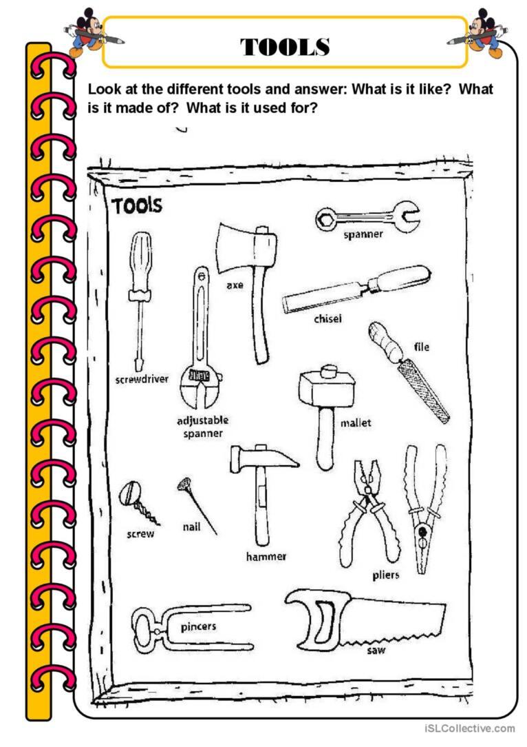
Writing | T: Now I suggest you to repeat the construction of Wh-questions inPresent Simplle.  Exrecise: Put the words in the correct place and write down the sentence.  1. The column recommends that homeowners buy a tape measure. (What)  2. The ratchet wrench comes with a socket set and two socket extensions. (What)  3. The air compressor has worn piston rings. (What rings)  4. A bench grinder features an LED light to help a mechanic see better. (Why)  5. Wood screws are the best for solid wood surfaces. (What screws)  6. Wood screws are the best for solid wood surfaces. (What surfaces)  7. The piston rings need to be changed before using them again. (When)  8. The drill press has motor speed options. (What)  9. The drill press has motor speed options. (What options)  10. The woman needs a machine to sharpen hand tools. (Who)  KEY:  - What does the column recommend?  - What comes with a socket set and two socket extensions?  - What rings has the air compressor worn?  - Why does a bench grinder feature an LED light?  - What screws are the best for solid wood surfaces?  - What surfaces are wood screws the best for?  - When do the piston rings need to be changed?  - What has motor speed options?  - What options does the drill press have?  - Who needs a machine to sharpen hand tools?
III. | ЗАКЛЮЧНА ЧАСТИНА УРОКУ
Homework | Write a letter to your friend and tell him\her what hand tools you would like to buy and what for.
Summarizing | Підведення підсумків уроку.  Т: Our lesson soon will come to its end, lets summarize what we learn today.  What do we learn today? What do we remember today? What activities do you like more?  Do not you change the mind and want to work on your profession?

СПИСОК ВИКОРИСТАНИХ ДЖЕРЕЛ:
- Jim D. Dearholt Career Paths «MECHANICS» @Express Publishing, 2012. [Електронний ресурс] – Режим доступу: http://www.expresspublishing.co.uk
- Career Paths «TEACHER’S BOOK» Jim D. Dearholt @Express Publishing, 2012 [Електронний ресурс] – Режим доступу: http://www.expresspublishing.co.uk

