
ГІМНАЗІЯ №32 «УСПІХ»
Печерського району
міста Києва
КРОС-КУЛЬТУРНИЙ ПРОЄКТ



Київ — 2023
Мета проєкту:
- вчити комплексно застосовувати набуті знання, уміння і навички відповідно до поставлених завдань;
- формувати ключові (інформаційно-комунікаційну, самоосвітню, соціальну, комунікативну, загальнокультурну) та предметні (мовну, мовленнєву, читацьку) компетентності;
- вчити працювати з різними інформаційними джерелами, довідниками та словниками різних типів;
- збагатити словниковий запас учнів;
- активізувати пізнавальну діяльність учнів;
- розвивати уміння спілкуватися іноземними мовами;
- розвивати уяву, творчі здібності, естетичний смак;
- розширювати світогляд здобувачів освіти.
Очікувані результати:
  - використовують мову для власної творчості;
- мають відповідний запас слів у межах свого вікового періоду, свідомо вживають їх у мовленні;
- знають та свідомо вживають у мовленні відомі граматичні форми;
- самостійно читають і розуміють тексти різних типів (у тому числі автентичні);
- працюють з різноманітними інформаційними джерелами;
- самостійно знаходять необхідну інформацію, сприймають, аналізують, систематизують її;
- виокремлюють головне, інтерпретують інформацію в текстах;
- використовують інформацію в текстах для збагачення власного досвіду;
- створюють власні висловлювання відповідного типу (пишуть короткі тексти на задану тему, зв’язуючи низку окремих елементів у лінійну послідовність);
- висловлюють власну думку, оцінні судження;
- усвідомлюють особливості життєвого досвіду народів, мови яких вивчають;
- розуміють важливість оволодіння іноземними мовами;
- розуміють потребу в удосконаленні власної мовленнєвої культури;
- творчо підходять до виконання завдань, продукують свої власні думки;
- надають інформацію (презентують проєкт) іноземною мовою;
- самостійно організовують та планують свою позаурочну діяльність;
- самостійно контролюють проміжні й кінцеві результати роботи;
- доброчесно використовують чужі ідеї;
- комунікують в ході роботи з однолітками і дорослими.
Дидактична характеристика проєкту:
Тип проєкту:
- За освітньою галуззю: міжпредметний (англійська мова, іспанська мова)
- За тривалістю: короткотривалий (1 тиждень)
- За видами діяльності: творчий, інформаційний
- За кількістю учасників: індивідуальний
ЕТАПИ РОБОТИ
Перший – організаційно-підготовчий. На цьому етапі вчитель разом з учнями визначає тему; формулює мету і завдання, окреслює очікувані результати; планує роботу, допомагає скласти опорну таблицю та збирати інформацію.
PHOTO

Name of the festival
When does it take place?
Where does it take place?
What is the aim of the festival?
What do you know about the history of the festival?
What do people do before the celebration?
What do people do during the celebration?
Do you recommend the festival?

Другий етап – основний. Цей етап передбачає самостійну роботу учнів з різними інформаційними джерелами та створення власного висловлення відповідного типу з подальшою презентацією. Під час презентації учні розповідають про події та свята, які їх зацікавили; висловлюють свої власні думки, оцінні судження та рекомендації.
Третій етап – заключний. Проєкт завершується аналізом проведеної роботи, у ході якого встановлюється, чи досягнуті мета та очікувані результати. Здійснюється самооцінка, обговорення особистих досягнень учнів. На цьому етапі також проходить виставка дитячих робіт.

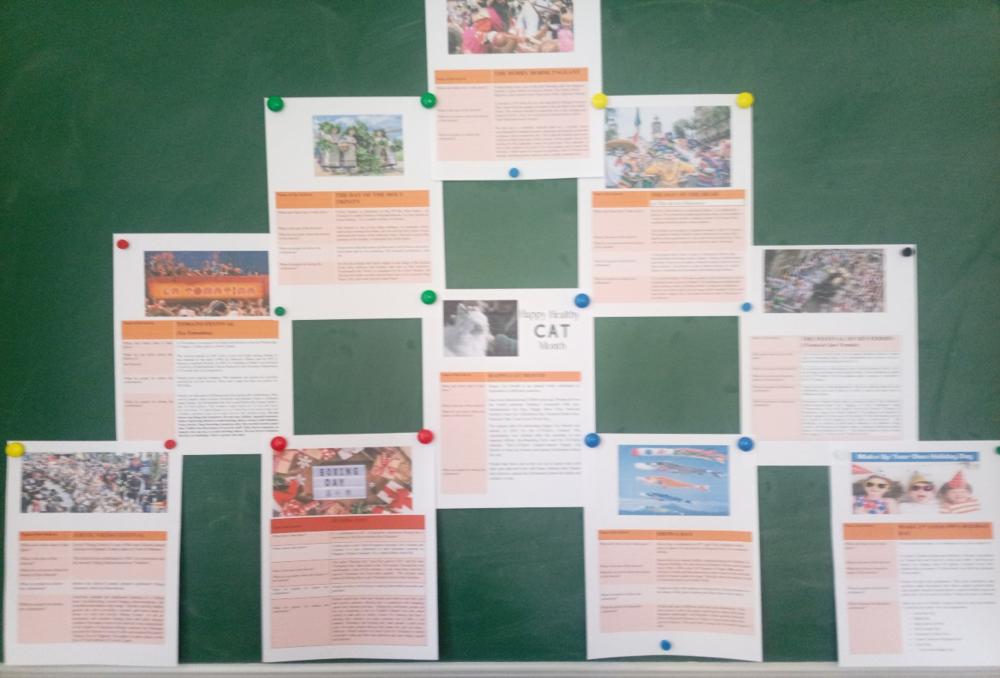

ОРІЄНТОВНА ТАБЛИЦЯ ДЛЯ САМОАНАЛІЗУ

Цей проєкт був… | Цікавим/корисним…*
Під час роботи над проєктом я … | Збагатив свій лексичний запас/ розширив свій світогляд/ дізнався багато нового про свята та цікаві події в різних країнах світу/ навчився працювати з автентичними текстами/ навчився складати власні висловлення відповідного типу…*
Під час роботи над проєктом найлегшим для мене було… | Працювати з інформаційними джерелами/аналізувати та інтерпретувати тексти/створити власне висловлювання/організувати свою позаурочну діяльність/презентувати проєкт/сформулювати власну думку…*
Під час роботи над проєктом найважчим для мене було… | Працювати з інформаційними джерелами/аналізувати та інтерпретувати тексти/створити власне висловлювання/організувати свою позаурочну діяльність/презентувати проєкт/сформулювати власну думку…*
Під час роботи над наступним проєктом я хотів би… | Дізнатися про …/ дослідити питання…/ розглянути проблему…**
* учні зазначають, що саме було корисним у цьому проєкті та чого вони досягли відповідно до мети проєкту та очікуваних результатів, визначених на початку роботи

**спираючись на очікування учнів щодо роботи над наступними проєктами можна виявити цікаві для учнів теми, чітко спланувати роботу та визначити бажані кінцеві результати; такий підхід допоможе значно підвищити ефективність проєктної діяльності.

Для оцінювання презентації можна взяти за основу чек-лист, рекомендований Міністерством освіти і науки України.
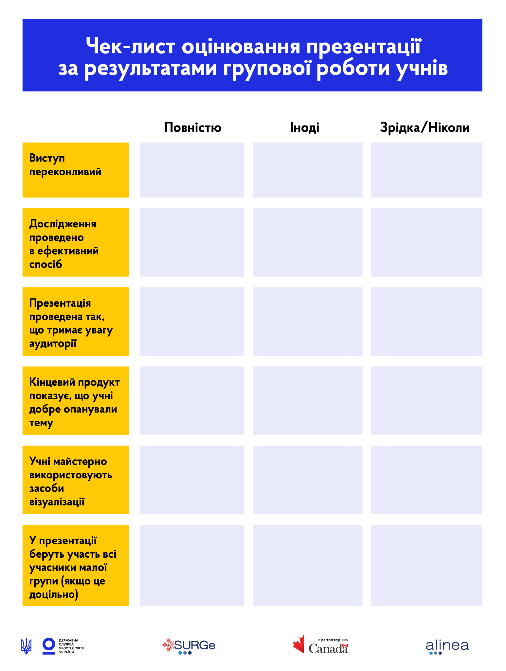





Name of the festival | BOXING DAY
When does it take place? | It is celebrated on 26th of December. Sometimes Boxing Day is described as “the first weekday after Christmas”.
Where does it take place? | It takes place in the United Kingdom Australia, New Zealand, and Canada. It is also celebrated in such European countries as Hungary, Poland, Germany. It is a bank holiday in the UK.
What is the aim of the festival?  What do you know about the history of the festival? | The name “Boxing Day” was first used in 1833. and the term “Christmas box” dates back to the 17th century. Boxing Day was traditionally a day off for servants - a day when they received a special Christmas box from their masters. The servants went home on Boxing Day to give Christmas boxes to their families.
What do people do before the celebration? | People are busy with buying or making handcrafted postcards and presents.
What do people do during the celebration? | People spent time with their friends and relatives and they give and receive presents. Boxing day is connected with shopping, sports and unusual activities. During the celebration people can try out swimming in the icy English Channel, fun runs, horse racing or take part in charity events. Fox hunting has been a Boxing Day tradition for many centuries but in 2004 it was banned. Nowadays the Boxing Day hunt parade is held every year. For many people Boxing Day means the only one thing – leftovers. People prepare too much food for Christmas to satisfy everyone’s tums and they turn leftovers into tasty dishes, snacks and desserts.

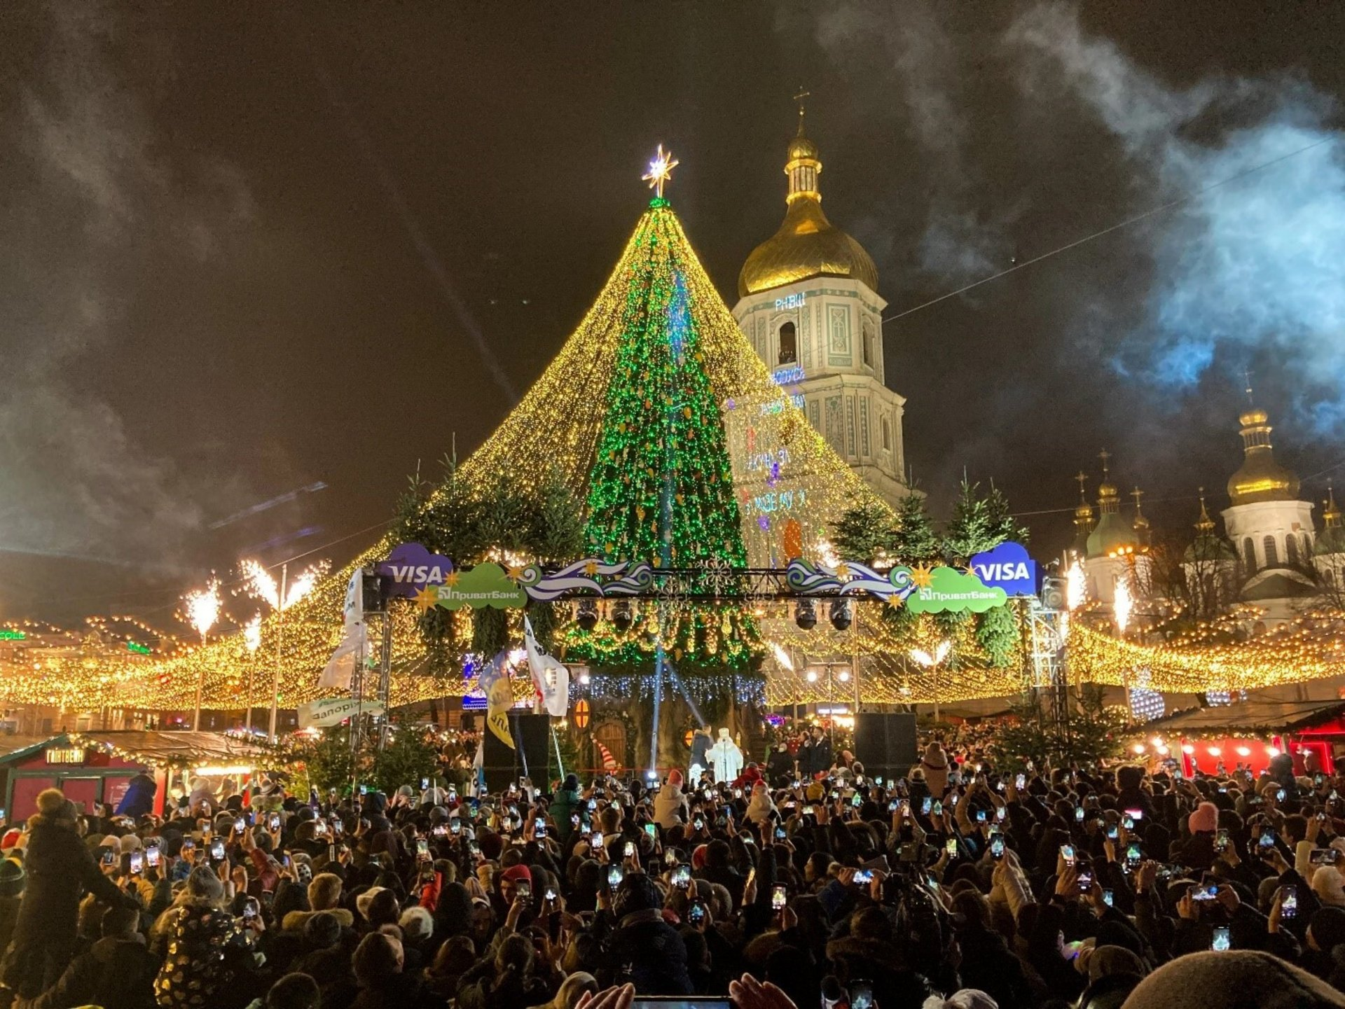
Name of the festival | CHRISTMAS
When and where does it take place? | Ukrainian people celebrate Christmas on 7th January (according to the Julian calendar). At the same time some Ukrainians celebrate Christmas on 25th December (according to the Gregorian calendar). It is the official state holiday since 2017.
What is the aim of the festival?  What do you know about the history of the festival? | This holiday is connected with the date of Jesus’s birth. Christmas began to be widely celebrated in the 9th century. The first Christmas tree appeared in Strasbourg in 1605. In the 18th century people started giving gifts to family members.
What do people do before the celebration? | Traditionally, Christmas in Ukraine starts on January 6 (Christmas Eve) with the so-called Sviata Vecheria. The festivities start with the appearance of the first star. The table should be served with 12 dishes to symbolize the twelve apostles. The main dish is Kutya (boiled wheat mixed with poppy seeds and honey). The main house decoration is the didukh (a sheaf of wheat stalks). Children prepare vertep performanses. The main attribute of the vertep is the Christmas star. It is a symbol of joy and it brings the news of the birth.
What do people do during the celebran? | The morning of 7th January starts with the greeting "Christ is born!" and the response "Glorify Him!". On this day people go to church and visit their relatives. Boys and girls sing Christmas songs - Koliadky (the name comes from the word ‘calendar’). «Carol of the bells» is the most popular Christmas song in the world. It was composed by Mykola Leontovych at the beginning of the 20th century and based on the ancient Ukrainian folk songs.

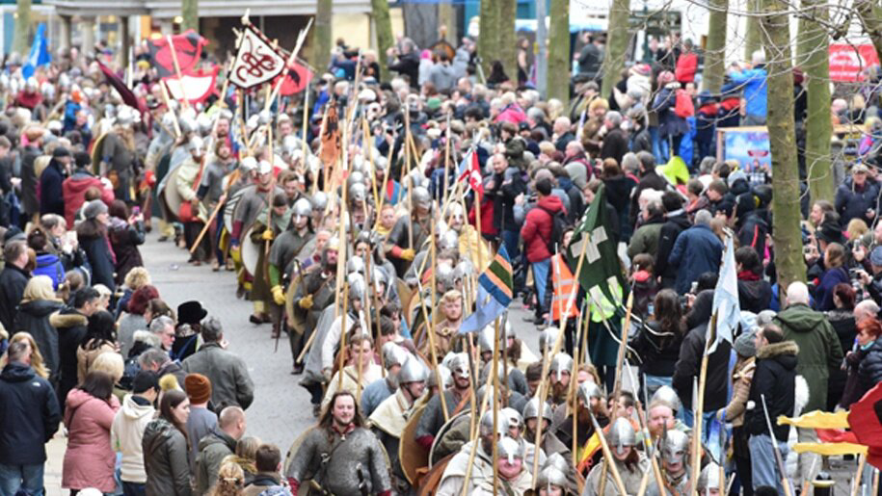
Name of the festival | JORVIK VIKING FESTIVAL
When and where does it take place? | Jorvik Viking Festival is one of the most famous annual festivals in England. It takes place in York in February.
What is the aim of the festival?  What do you know about the history of the festival? | This festival was established in 1985. It is connected with the ancient Viking festival known as "Jolablot".
What do people do before the celebration? | Before the festival people prepare traditional Viking costumes, food and decorations.
What do people do during the celebration? | Activities include the traditional burning of a Viking boat, axe-throwing, sword forging demonstrations, old Scandinavian dances and songs. Tourists can buy leather goods, fur, silver jewellery, swords, and horns made of bones or visit the Jorvik Viking Centre to see an enormous old wooden fishing boat and other strange exhibits.The main event of the festival is the reenactment of the Battle of Stamford Bridge between the Normans ans and the Saxons. It was in 1066 and marked the end of Viking Era in England. Nowadays it takes place in the Eye of York infront of Yorvik Castle.

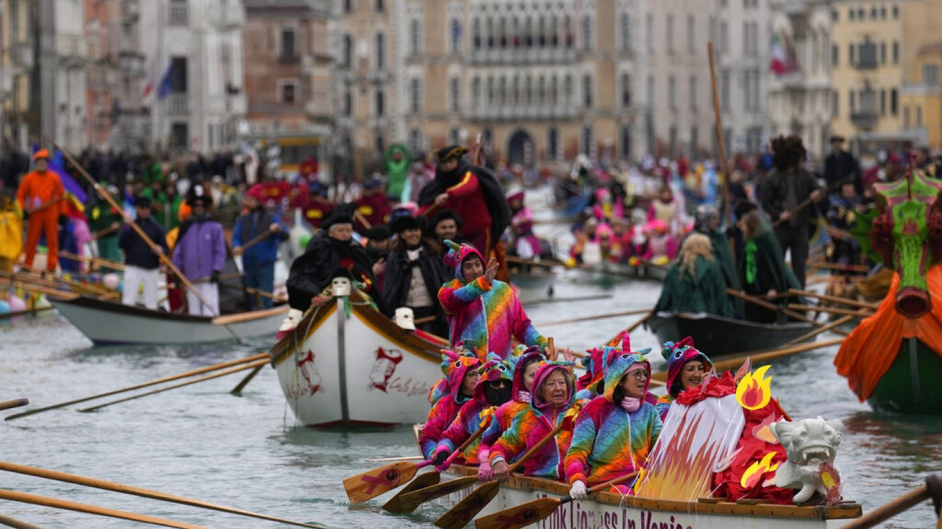
Name of the festival | THE VENICE CARNIVAL  (Carnevale di Venezia)
When and where does it take place? | The Venice Carnival in an annual two week pre-Lent festival held in Venice, Italy.It always finishes on Shrove Tuesday
What is the aim of the festival?  What do you know about the history of the festival? | The Venice Carnival is one of the oldest carnivals in the world, It started in 1162. The people of Venice gathered in Saint Mark’s Square (San Marco) to dance and celebrate their victory over the enemy. It became extremely popular during the 18th century. When Napoleon invaded Venice, the Carnival was banned. In 1979 Italian government decided to promote the Venetian culture and history.
What do people during the celebration? | The carnival is famous all over the world for its elaborate costumes and masks. The Colombina is a half-length mask that covers eyes and nose. It is usually decorated with coloured stones and feathers. The mask is named after a female comedy character. The Plague Doctor mask is famous for its long beak and wide staring eyes. It was invented by French doctor Charles de Lorme in the 17th century. The Volto mask is plain white and covers the face. It is often worn with black cloaks. During the celebrations some people are dressed as famous Italian characters: Harlequin, Pierrot, Pantalone and others. Traditionally, the ancient ritual "Volo della Colombina" opens the carnival and paper dove is launched from the bell tower in St. Mark's Square. The final weekend of the carnival is said to be the best time to attend. The local people and tourist walk around the city, watch street performances and comedy shows, admire the gorgeous costumes and magnificent masks. They can take part in fascinating historical re-enactments, masquerade balls or numerous parades.

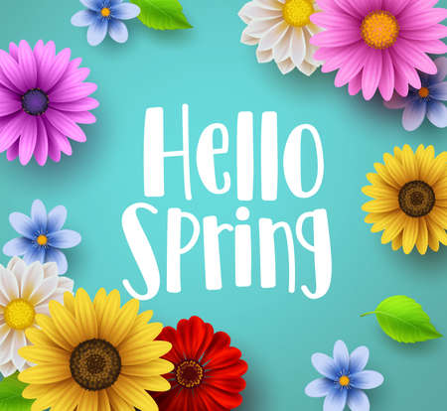



Name of the festival | MAKE UP YOUR OWN HOLIDAY DAY
When and where does it take place? | It’s an unofficial holiday. It is celebrated every year on March 26.
What is the aim of the festival?  What do you know about the history of the festival? | It’s a day to create a holiday and celebrate it. The idea was offered by Thomas Roy and Ruth Roy in the early 2000s. The Roys are famous for creating about 80 holidays (Answer Your Cat’s Question Day on January 22, More Herbs, Less Salt Day onAugust 29 and others).
What do people do before the celebration? | People are busy with preparations. They post information, plan activities, make decorations and videos, prepare special dishes. Some people organize themed parties, compose holiday songs and make clips. All you need is an idea of what you want to celebrate.
What do people do during the celebration? | Make up your own holiday! Create it, share the news and celebrate it when the day comes. Use your imagination!  - Good Hair Day  - Purple Day  - Sleep Like a Cat Day  - Pink Pancake Day  - Christmas In March Day  - Create a Musical Instrument Day  - Picnic Day  - …Your Own Holiday Day

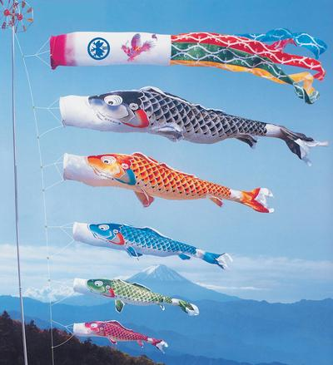

Name of the festival | SHOWA DAY
When and where does it take place? | Showa Day is celebrated on 29th April. The celebration takes place in Japan. It is also known as Showa-No-Hi. It is a national holiday.
What is the aim of the festival?  What do you know about the history of the festival? | Showa Day is an annual holiday commemorating the birthday of Emperor Hirohito. He was known as Emperor Showa and reigned from 1926 to 1989 as the 124th Emperor of Japan. Sho means shining or bright and wa means peace and is used to describe the period of history under his reign. This day starts the famous week of festivities known as Golden Week.
What do people do before the celebration? | People are busy with making or buying kites, flying streamers in the shape of fish, paper lanterns and place them in the streets.
What do people do during the celebration? | People take part in different festivities and celebrations. They have picnics, walk in the parks admiring the sakura blossoms. Japanese traditionally visit Hirohito’s tomb and the National Showa Memorial Museum in Tokyo to learn more about this period of history. The main dish is unagi, the favourite Emperor’s dish.


Name of the festival | MOTHER’S DAY
When and where does it take place? | In Ukraine it falls on the second Sunday of May. It has been celebrated every year since 1999. It is not a public holiday in our country.
What do you know about the history of the festival? | Ancient Greeks celebrated Mother’s Day to honor Rhea, the Mother of the Gods. In the USA it was established by Anna Jervis in May in 1907. Nowadays it is celebrated in 50 countries. In some countries people has given it a religious meaning.
What do people do before the celebration? | Children are busy with making handcrafted postcards and presents.
What do people do during the celebration? | There are many ways to celebrate Mother’s Day. People buy cards, flowers, chocolates, jewelry and other gifts for their mothers. Some restaurants offer special Mother’s Day breakfasts or dinners.



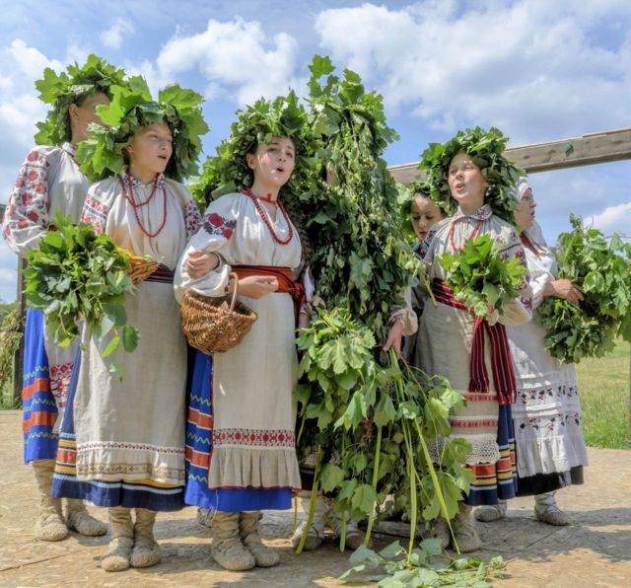

Name of the festival | THE DAY OF THE HOLY TRINITY
When and where does it take place? | Trinity Sunday is celebrated on the 50th day after Easter . In Ukraine it is called Triitsia or Piatydesiatnytsia. It is also known as Green Sunday. It is a public holiday in Ukraine.
What is the aim of the festival?  What do you know about the history of the festival? | This festival is one of the oldest holidays. It symbolize God’s nature and combines the Father, the Son and the Holy Spirit. It also represents the victory of the truth and virtue. The dove is one of the symbols of the holiday. It represents the Holly Spirit.
What do people do before the celebration? | Housewives clean the house and decorate it with flowers and herbs. Each plant has its own meaning. The bouquets symbolize a new life.
What do people do during the celebration? | On this day people take birch, maple or oak twigs to the church, invite their relatives and friends, take part in folk festivities. Traditionally the Trinity is considered to be a girls’ holiday. On this day they make wreaths and put them into a river to predict their future. They also bake special round bread.

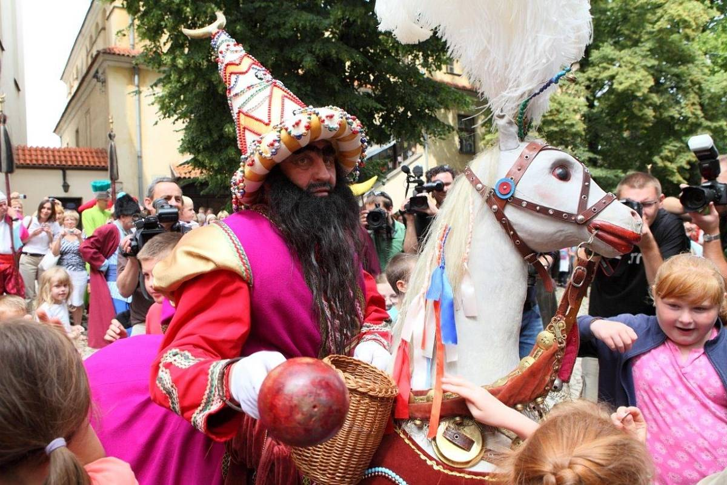

Name of the festival | THE HOBBY HORSE PAGEANT
When and where does it take place? | It takes place every year on the first Thursday after the religious holiday Corpus Christi in Cracow, Poland. The Hobby Horse Pageant is also known as the Tatar rider or the Lajkonik Festival.
What is the aim of the festival?  What do you know about the history of the festival? | It started in 1287 when the city was attacked by Mongol warriors. They came from the steppes of central Asia and they were called Tatars. The warriors decided to attack the city in the morning and stopped to have a rest. The local people attacked them, killed Tatar Khan and saved Cracow.
What do people do during the celebration? | On this day, a colorfully dressed rider on a wooden horse accompanied by standard-bearers, musicians and people in national costumes, travel around the city. The Lajkonik touches spectators with his golden mace and collects money. Some people want to be touched by the Lajkonik’s mace for good luck. The Lajkonik is one of the symbols of Cracow. It is very popular and its name has become a trade name for numerous products sold in Poland and abroad, including hotels, snacks, seats in public transport ect.

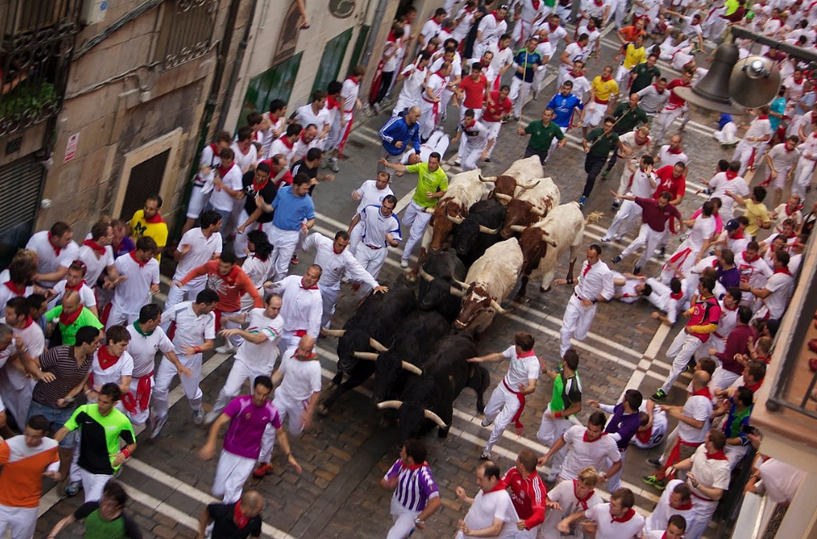

Name of the festival | THE FESTIVAL OF SEN FERMIN  (Fiesta de San Fermín)
When and where does it take place? | The Festival of Sen Fermin is an annual multiday holiday. It takes place in Pamplona, Spain. The celebrations start at noon on July 6 and continue until midnight on July 14.
What is the aim of the festival?  What do you know about the history of the festival? | It is also known as Sanfermines and is held in honour of the city’s first bishop and patron saint Saint Fermin. The celebrations started in the 16th century. The first parade called comparsa was held in the 19th century.
What do people do before the celebration? | People are busy with preparations. They are looking forward to the celebrations and save money to rent a room and take part in different activities.
What do people do during the celebration? | Pamplona’s modern fiesta starts at noon on July 6 with fireworks called chupinazo and the singing of the traditional song “Pamploneses, Viva San Fermín, Gora San Fermín” (“People of Pamplona, Long Live Saint Fermín”). All people are dressed in whirte because it’s the code of the festival. The best-known part of the festival is the running of the bulls, or the encierro. The bullfight, or corrida, is held every afternoon. In addition to this events, the Procession of Saint Fermín, a religious celebration, takes place in the morning on July 7. The festival ends on July 14 with the singing of “Pobre de Mi” (“Old Poor Me”).

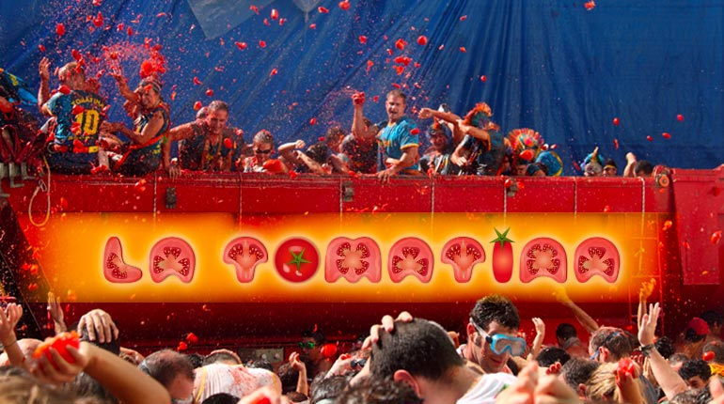
Name of the festival | TOMATO FESTIVAL  (La Tomatina)
When and where does it take place? | La Tomatina is an annual food fight festival held on the last Wednesday of August. It takes place in Buñol, Spain.
What do you know about the history of  the festival? | The festival started in 1945 with a local food fight among friends. It was banned in the early 1950s by Francisco Franco but in 1957 it became a national holiday. In 2002 La Tomatina of Buñol was declared a Festivity of International Tourist Interest by the Secretary Department of Tourism due to its popularity.
What do people do before the celebration? | People grow special tomatoes The tomatoes are grown in Castellón exclusively for the festival. They aren’t tasty but they are perfect for throwing.
What do people do during the celebration? | People can take part in different activities during the celebrations. They can try paella, watch tomato fireworks and parades, listen to different music bands. On Wednesday the first event before the tomato battle is the “el Palo Jabón”. The tomato fight starts at 11 am and lasts for one hour. To participate in La Tomatina you must wear old clothes, protect your eyes and follow the instructions. Do not throw anything but tomatoes. Do not tear clothes. Squash tomatoes before throwing them to avoid hurting others. Keep a safe distance from trucks. Stop throwing tomatoes after the second starter pistol shot. Follow the directions of security staff. Only throw tomatoes at targets you can see, to avoid hurting others. Do not throw tomatoes directly at buildings. Have a great, fun time!

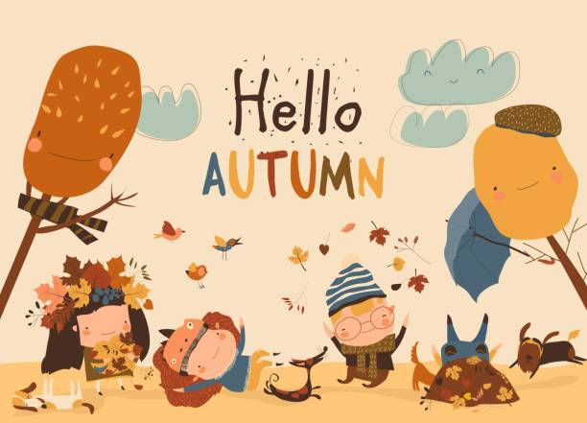



Name of the festival | HAPPY CAT MONTH
When and where does it take place? | Happy Cat Month is an annual event celebrated in September in different countries.
What is the aim of the festival?  What do you know about the history of the festival? | Cats were domesticated 10000 years ago. People all over the world celebrate holidays connected with cats. International Cat Day, Happy Mew Year, National Answer Your Cat’s Questions Day, National Kitten Day, National Take Your Cat to Work Day…  The unique idea of celebrating Happy Cat Month was started in 2015 by the CATalyst Council. The organization was formed after the meeting of two separate efforts, Re-Branding Felix and the CATalyst Summit. The CATalyst Council started Happy Cat Month to help cat owners and spread information about the cats.
What do people do during the celebration? | People take their cats to the vet, try to spend time with their pets and have fun with them, educate their friends and relatives, spread the information about the health and welfare of cats..
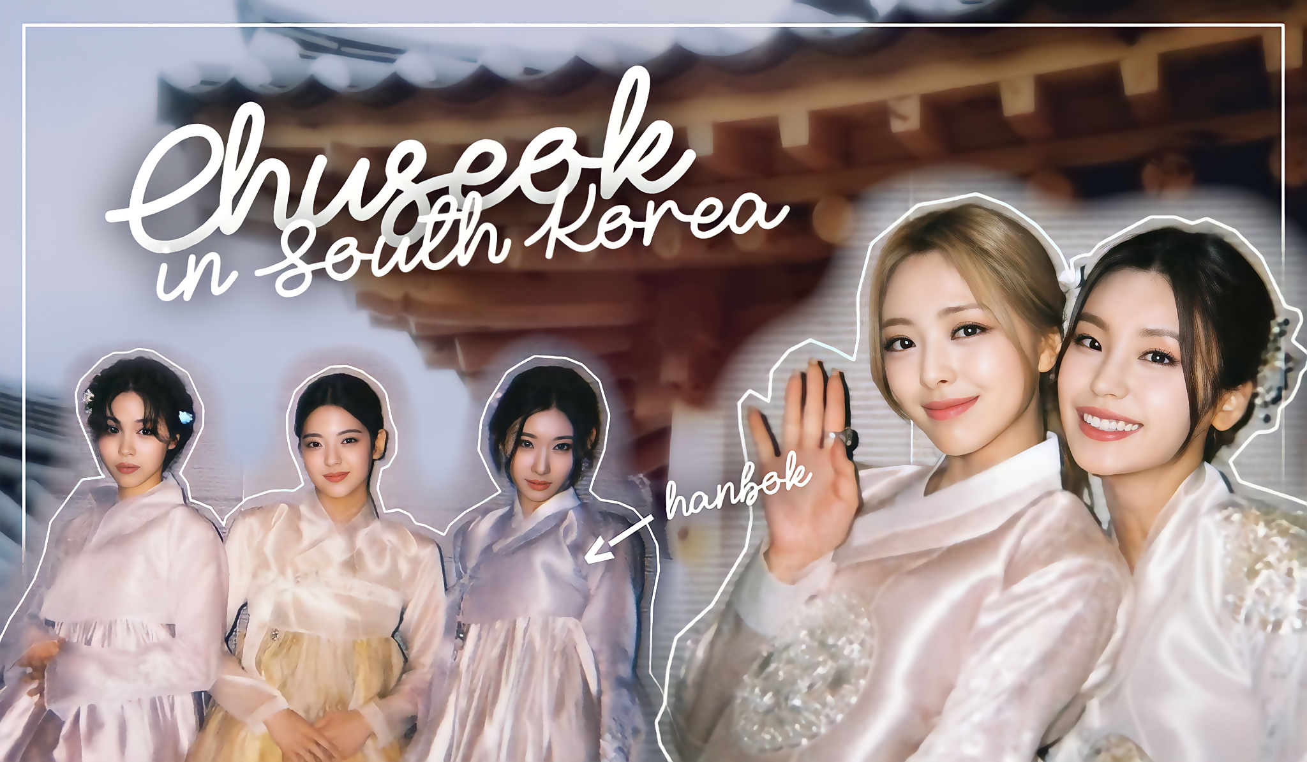
Name of the festival | CHUSEOK
When and where does it take place? | Chuseok (Korean: 추석; "autumn evening") is also known as Hangawi (Hangul: 한가위; "the great middle of autumn")/ Sometimes it is called Korean Thanksgiving Day. It is a major mid-autumn harvest festival. It lasts three day holiday. In South Korea it is celebrated according to the lunar calendar on the 15th day of the 8th month on the full moon. It is usually celebrated in September or in October. Like many other harvest festivals around the world, it is connected with the autumn equinox.
What is the aim of the festival?  What do you know about the history of the festival? | Chuseok originates from Gabae, which started during the reign of Silla the third king (57 BC - 935 AD). According to legend Silla started a month-long weaving contest between two teams. The team who had woven the most cloth won, and they were treated by the losing team with food, drinks, and other gifts. Nowadays people honour their ancestors on these days.
What do people do before the celebration? | People are busy with buying presents and preparing traditional dishes. They prepare “new crop” rice and half-moon cakes called songpyeon. This dishes will be brought to the memorial tombs and offered their ancestors. Spam is the most popular gift sets.
What do people do during the celebration? | For Korean people Chuseok means family, gifts, fun and too much food. Koreans visit their hometowns, spend time with their families, meet with their relatives. During Chuseok, all family members dress in hanbok - the national traditional costume. In the morning they hold a ceremony to remember their ancestors. After the ceremony, they eat traditional dishes, talk and play games, dance folk dances such as talchum (mask dance) or ganggangsullae (Korean circle dance) and take part in ssireum (traditional Korean wrestling). Many events are held in the National Museum of Korea and the National Folk Museum of Korea.

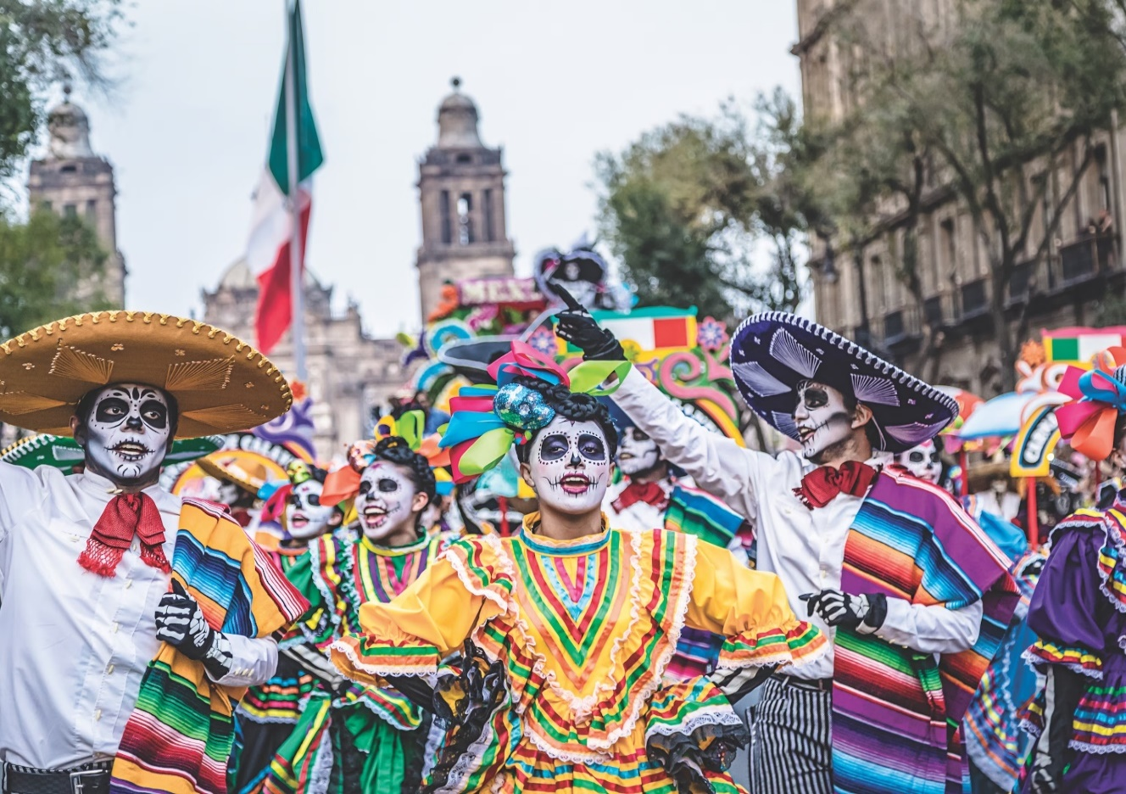
Name of the festival | THE DAY OF THE DEAD  (el Día de los Muertos)
When and where does it take place? | The Day of the Dead is a multi-day holiday. It is celebrated in Mexico. The celebration traditionally takes place on November 1-2 and is connected with the Catholic holiday of All Souls' Day combined with the ancient Aztec customs.
What is the aim of the festival?  What do you know about the history of the festival? | The holiday was brought by Spanish invaders in the 16th century. The people of Mexico believe that on this day the souls of the dead have the opportunity to visit those who are still alive. They visit cemeteries to communicate with the souls of the dead.
What do people do before the celebration? | Local people build altars in honor of deceased relatives and decorate them with sugar skulls, photos, verbena, favorite drinks and foods. They set up candles to help the spirits find the way to their relatives. The altars are often created at home or in public places. Cemeteries are decorated with ribbons and flowers.
What do people do during the celebration? | It is a joyful holiday. The main symbols of the festival are calacas (skeletons) and calaveras (skulls). The skeletons are playing the guitar, taking a bath or making tortillas. During the celebration people wear skull masks and eat sugar skulls (candies). They wish each other a happy Day of the dead with the words “Feliz dia de los Muertos”.

