Test 5
Health and Body Care
1.
2. Read and choose True or False
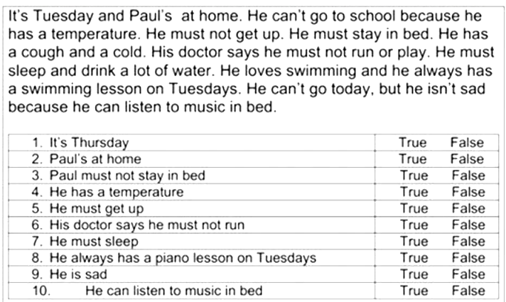

3. Read and match./ Прочитай і підбери.
  - A headache…… a. I don`t walk.
  - A stomach ache …... b. I go to sleep.
  - A sore throat……. c. I go to the dentist. .
  - A toothache……. d. I don`t drink or eat.
5) A cold…… e. I drink warm tea with honey.
6) A broken leg….. f. I stay in bed.

4.Write Yes / No. / Напиши так / ні.
1.You should eat healthy food………
2. You should do morning exercises………
3. You should eat a lot of sweets………
4. You should eat fruit and vegetables…….
5. You should brush your teeth once a day…….
6. You should do sport……..

