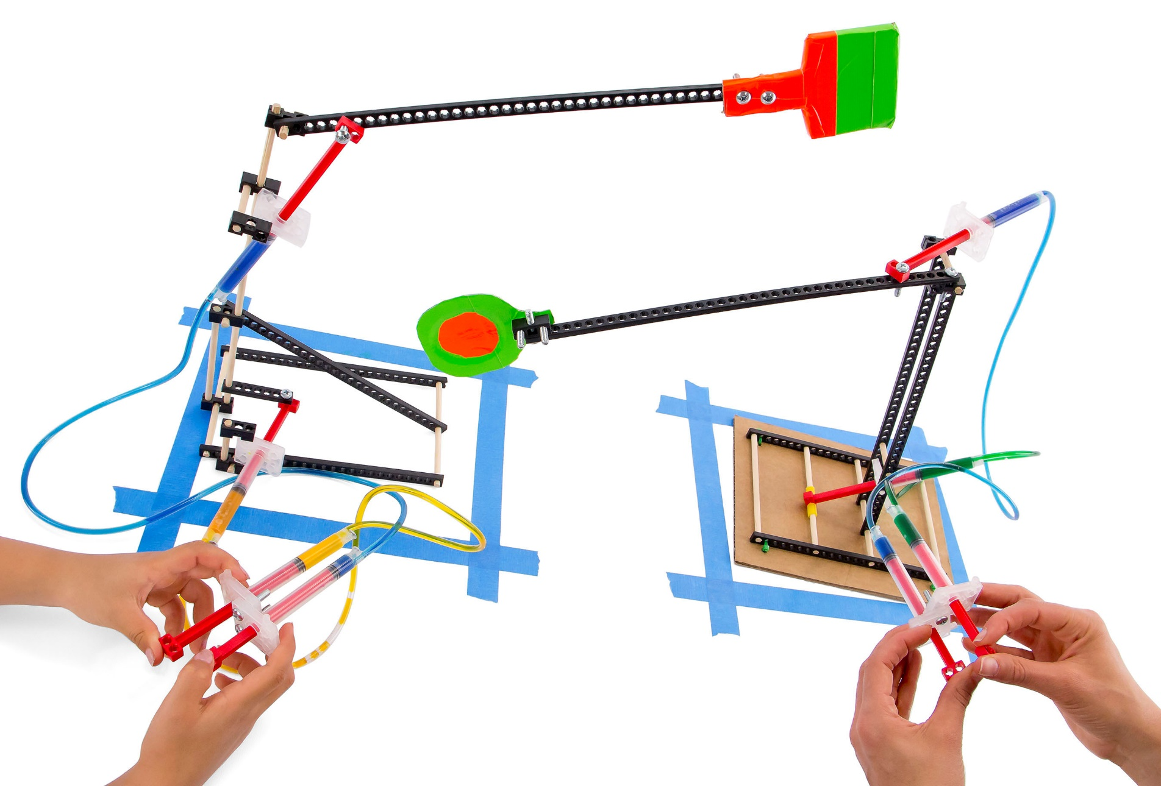

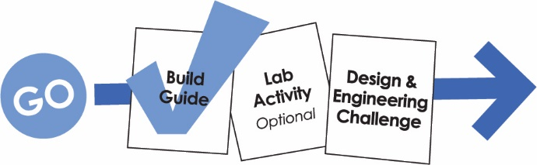

Download classroom documents at teachergeek.com/learn
For use with TeacherGeek Judo-Bot Activity Pack,
or Maker Cart available at teachergeek.com.

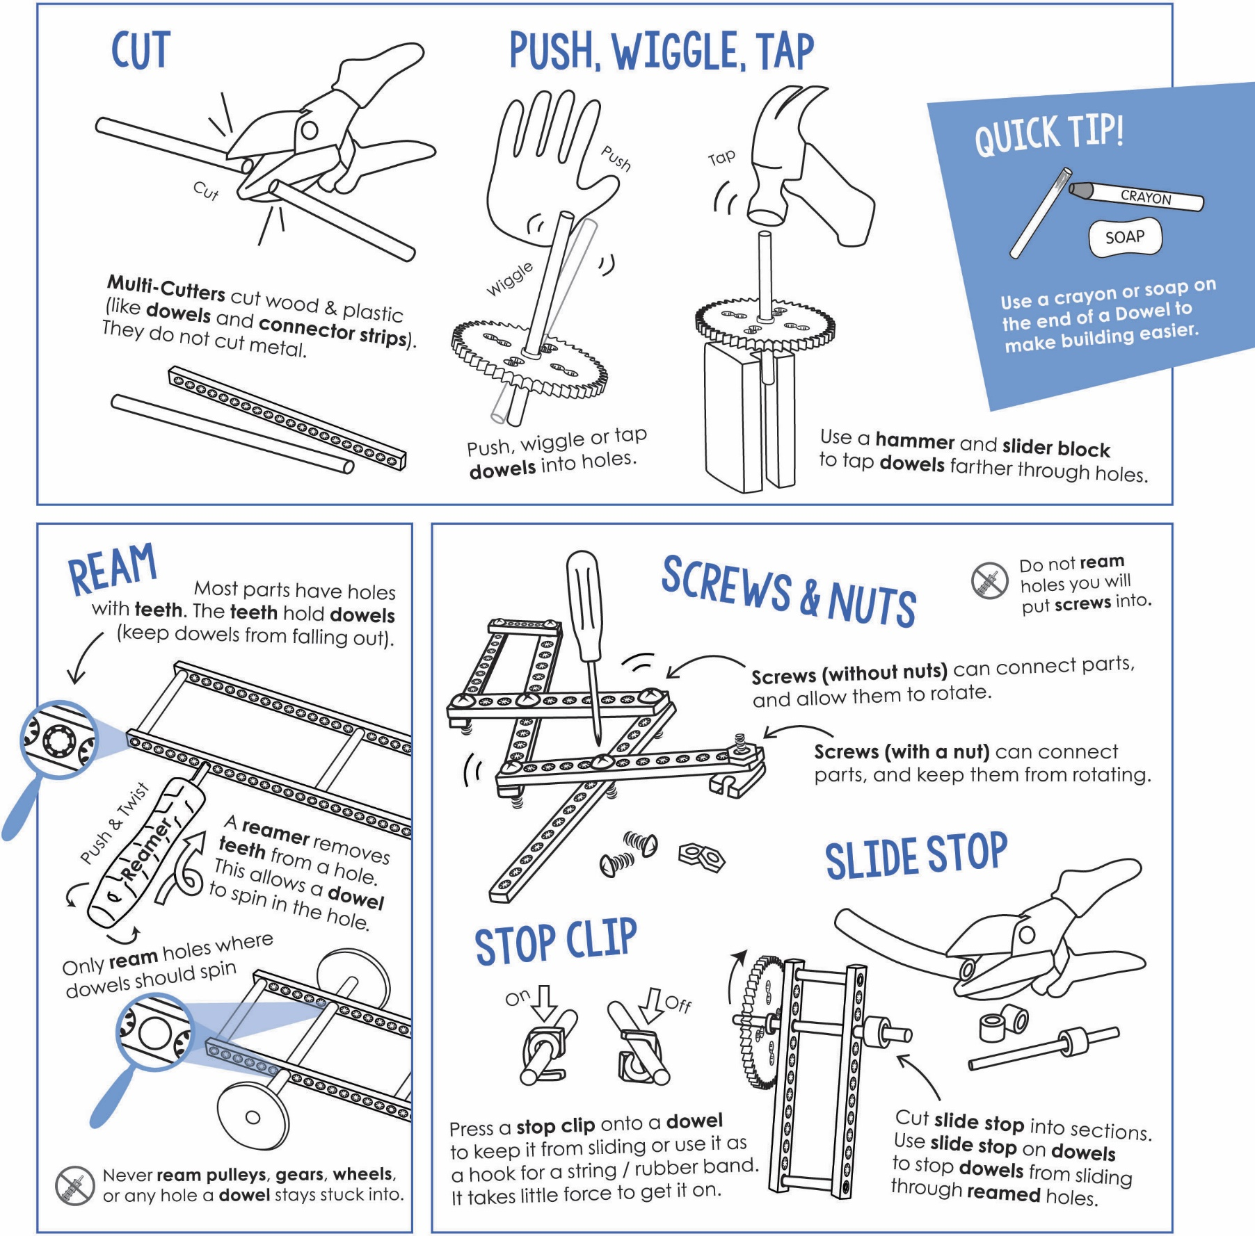


Below is the list of “ingredients” you’ll need for one Judo-Bot.
Available as single: SKU 1824-72 or 10 pack: SKU 1824-62. Both include extra parts for your own innovative creations!
 |  |  |  | 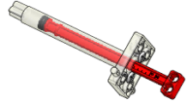
6 - Connector Strips | 6 - Dowels  300mm (12″) | 1 - Slide Stop  76mm (3″) | 8 - Blocks | 4 - 4.5mL Cylinders
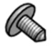 |  |  | 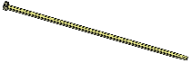 | If using the Maker Cart  vinyl tubing roll, cut  two sections, 2 ft. in  length each.
4 - Cylinder Screws | 6 - 25mm Screws  #10 25mm (1″) | 6 - Nuts  #10 | 4 - Zip Ties | 2 - 2 ft. Vinyl Tubing



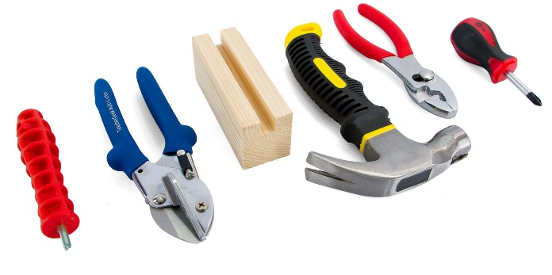
This isn’t a kit. You’re going to really build (cut, ream, screw) your Judo-Bot.
Here are tools you’ll need to get started:
- Reamer
- Multi-Cutter
Or get the complete
TeacherGeek / Maker Tool Set
Single SKU 1823-24
Class Set SKU 1823-85
- Tapping Block
- Hammer
- Pliers
- Screwdriver

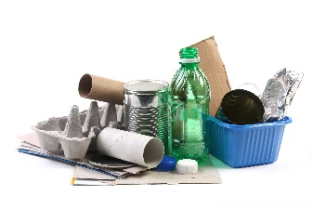
Tape | Recycling Materials  What else could you  use for a Judo-Bot base? | Crayon  Rub on dowels to make sliding them easier into holes of components.

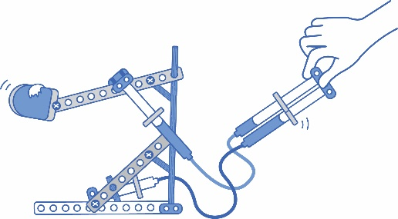
Are you ready to R-U-M-B-L-E?!
In this guide, you will build an example Judo-Bot.
Design a bot-for-battle using levers and fluid power.

Tap the dowels from Step 1 into
a connector strip, four holes in from each end of the strip.

Cut two 4 cm (1.5″) and
one 15 cm (6”) dowels.

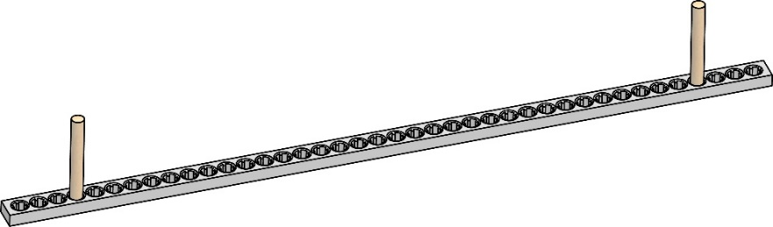
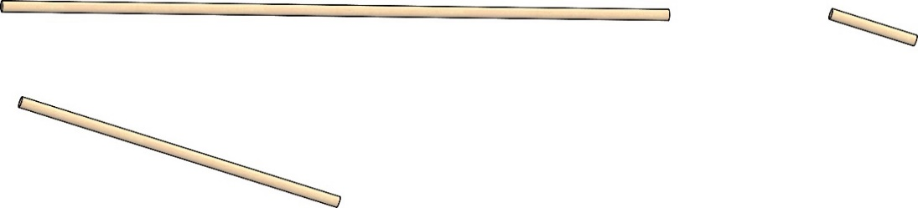
Cut!

4 cm

4 cm

15 cm

Tap!

Connector Strip


Four Holes

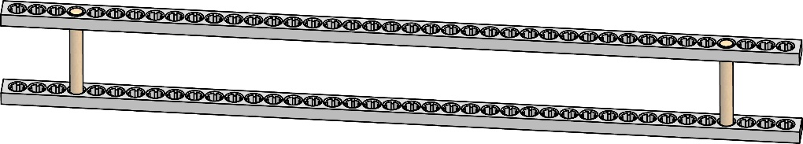
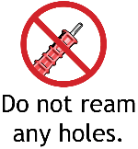
Push or tap a connector strip
onto the dowels from Step 2.
This will be your upright.

Tap!

Upright

Four Holes

Insert the 15 cm (6”) dowel from Step 1
into the reamed holes from Step 4.
Let 5 cm (2”) hang off both sides.

Ream the top two holes
at one end of your upright.

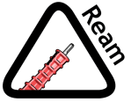
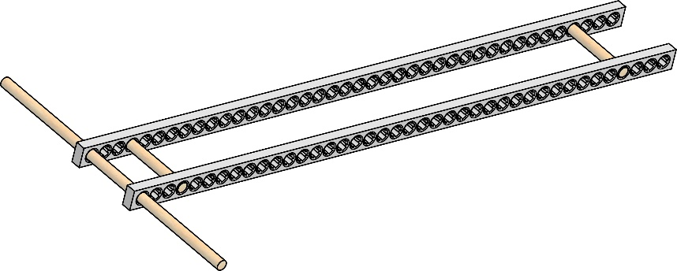
Reamed Holes

Reamed
Holes

Congratulations!
Your upright is finished.

►
5 cm

Tap the dowels from Step 6 into the first hole on each end of a connector strip.

Cut two 15 cm (6″) dowels.

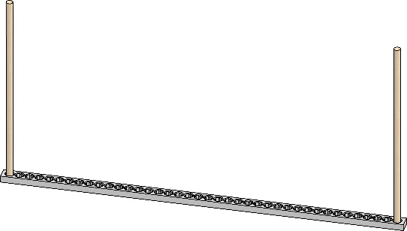
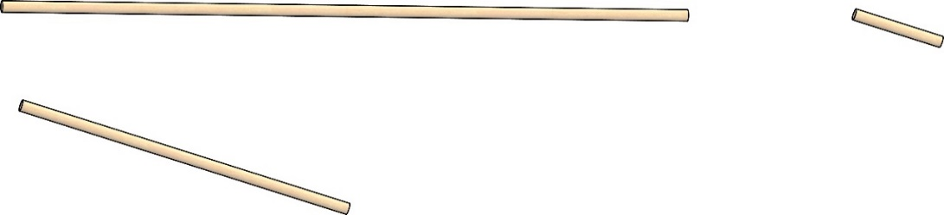
Tap!

Cut!

15 cm

15 cm

Connector Strip

Place the upright from Step 5 in the base. Stretch the base to align the dowel with the 16th hole of the strips.

Push or tap a connector strip
onto the dowels from Step 7.
This is your Bot’s base.

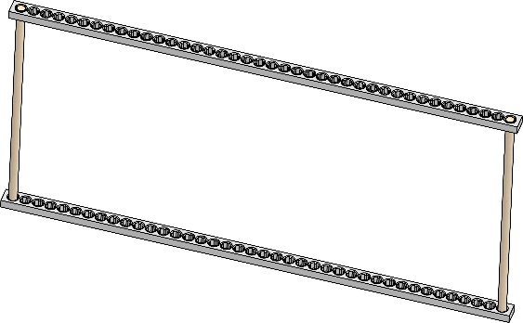
Tap!

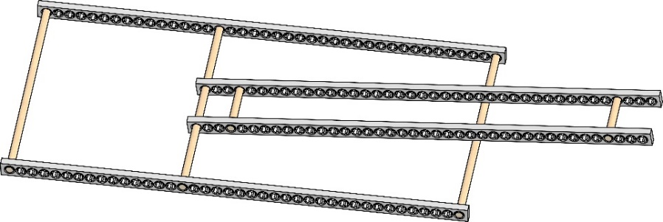
Stretch!

Upright

Base

Base

16 holes

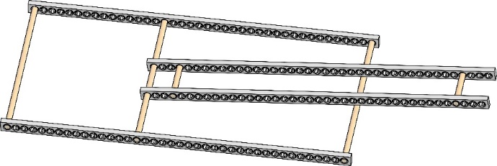
Upright

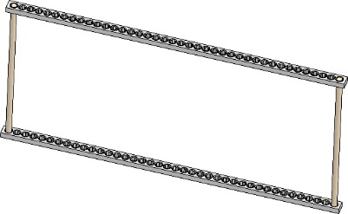
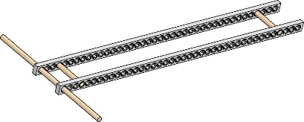
+

=

Base

Frame

Congratulations!
Your frame is finished.

►


Piston

Barrel

Piston

2 ft. Section of Tubing

4.5mL Cylinder

Hydraulic systems use fluid to transmit power.
Using cylinders and tubing, you will create
a hydraulic “control” system to
move your Judo-Bot.

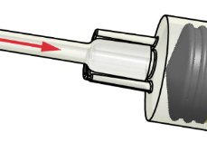
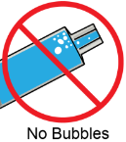
Attach a 2 ft. tubing section to
one filled cylinder from Step 10.

Fill two 4.5 ml cylinders with water.
Submerge the cylinder barrel in water. Pull the piston out to fill
the barrel completely with fluid.
Fill
Connection
Close-Up

Tip: to work properly,
no air bubbles should be
in the cylinders or tubes.

No Bubbles!

Pull!

Piston

Attach the water-filled tubing from Step 12 to the second
cylinder from Step 11.

Fill the tubing from Step 11 with water.
Pull the piston back, then push in to fill the tubing with fluid. The barrel will be empty.

Barrel

Cylinder
from Step 2

Water-Filled Tubing

No Bubbles!

Tip: Use a cup or
glass to catch fluid.

Repeat Steps 10-14 to create another hydraulic system.
These will power your Judo-Bot.

Keep the tubing attached with a cylinder screw. Insert the screw into the hole aside each cylinder’s tip.

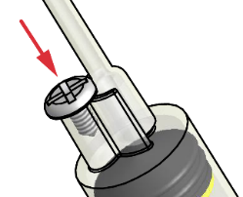
Cylinder Screw

Hydraulic System

Hydraulic System


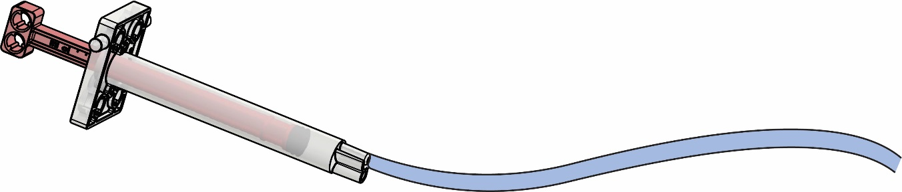
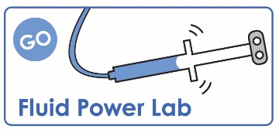
Piston

Ream one of the holes on one cylinder’s
piston from a hydraulic system from Step 15.

Documents at teachergeek.com/learn
If you are going
to do the optional
Fluid Power Lab,
now’s the time!

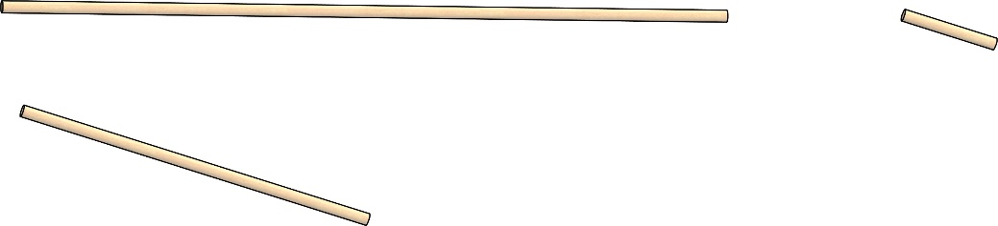
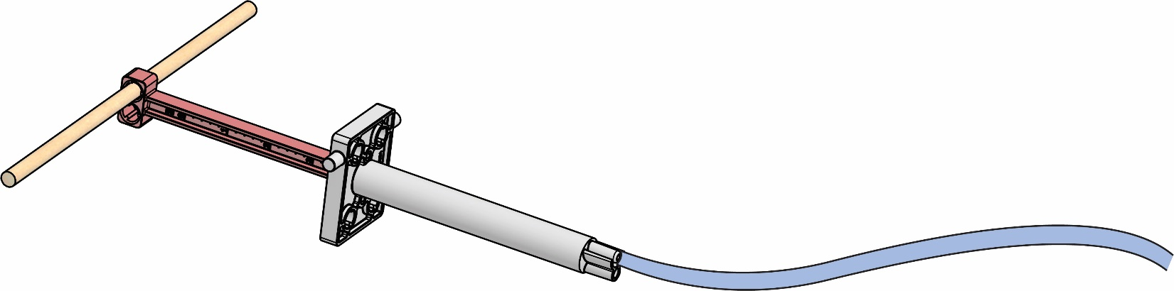
15 cm

Cut a 15 cm (6”) dowel.

Insert the dowel from Step 17 into
the reamed hole from Step 16.

Reamed Hole

Piston

Cut!

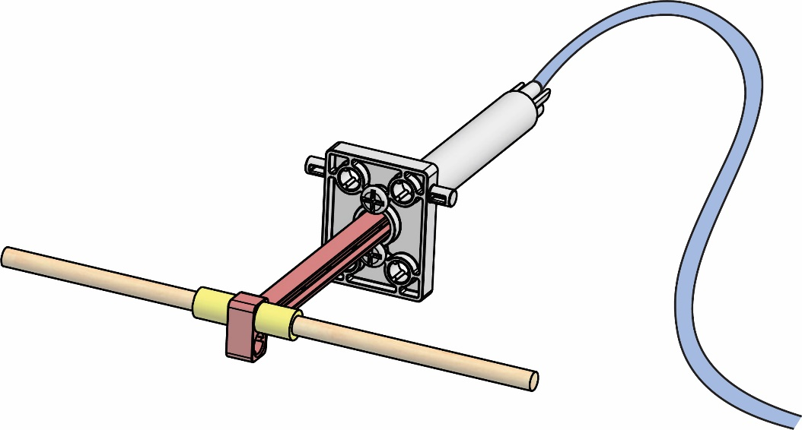
Center the piston on the dowel.
Slide a 4 mm (0.15″) piece of slide stop on each side of the piston to keep it in place.

Cylinder Pegs

Slide Stop

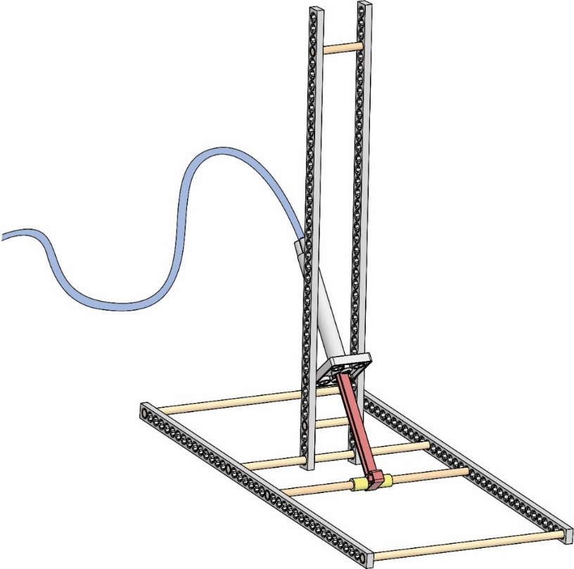
Upright

Place the cylinder from Step 19 into
the frame from Step 9. Stretch the frame
to align the dowel 8 holes from the upright.

Insert the cylinder pegs
between the upright’s
connector strips.

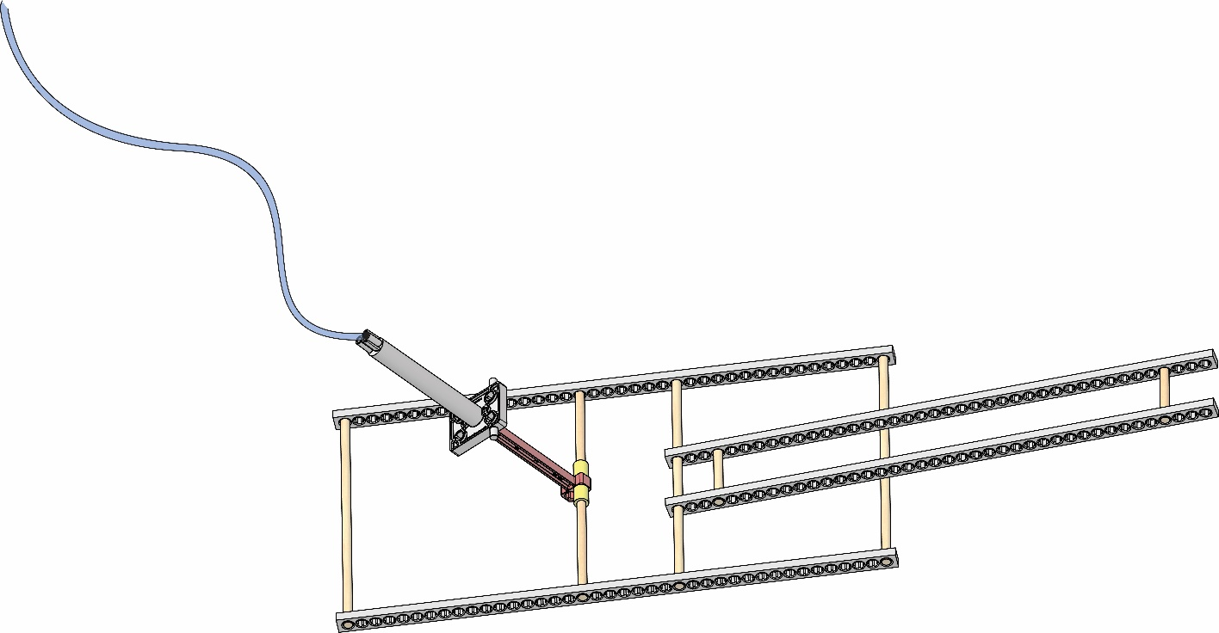
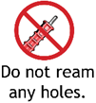
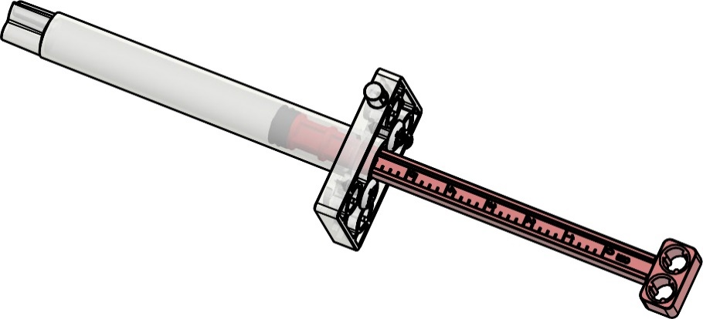
Cylinder
Pegs

Stretch!

Upright

Piston

Base

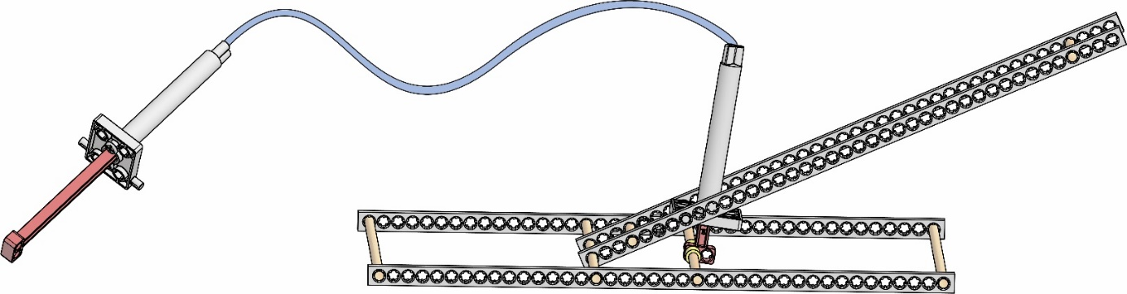

Congratulations!
The first half of your Judo-Bot is finished.

►

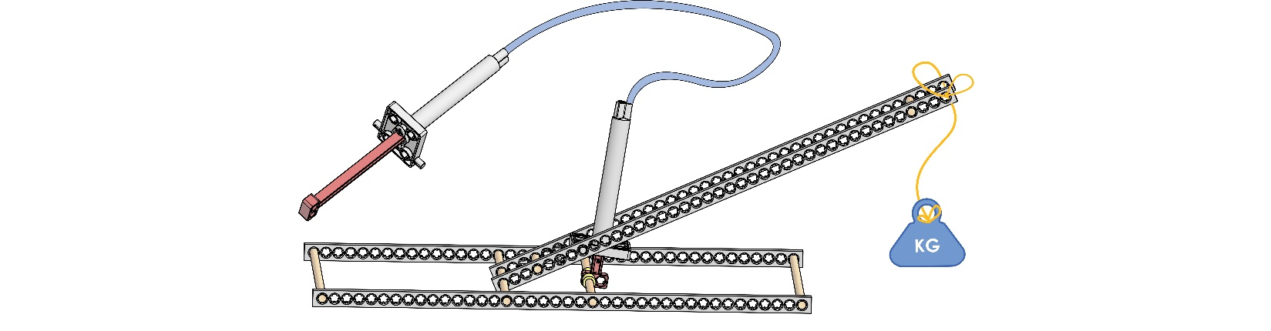
Try clay!
Force _{in}

Distance _{in}

Force _{out}

Distance _{out}

{

}

Mechanical Advantage: trading distance for force

Fulcrum
(Pivot Point)

Test how it moves – use the
hydraulic system to move the
upright up and down. Attach
a weight to the upright’s end
(piece of clay, cup of pennies).
Change the fulcrum of your
upright’s cylinder – what height
makes the weight easier to lift?


\
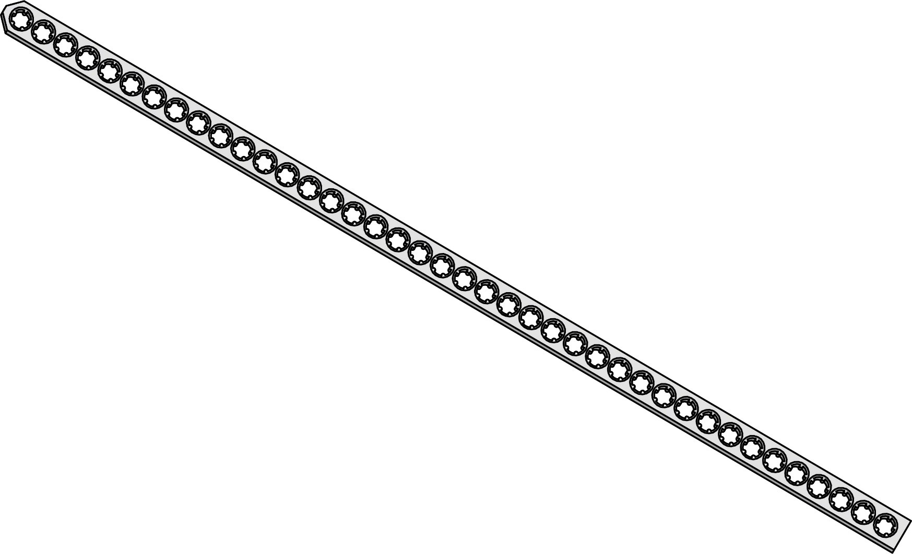
Attach two blocks to the top
holes of the upright from Step 21.
Tighten with two nuts and screws through the block’s center hole.

Cut the corners off one
end of a connector strip.

Tighten!

Cut!

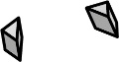
Cut Corners

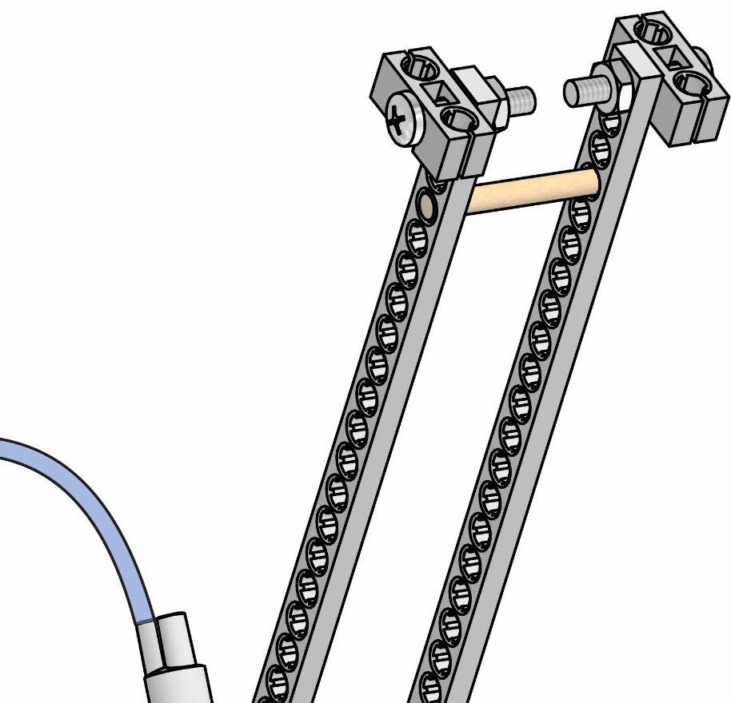
Nut

Block

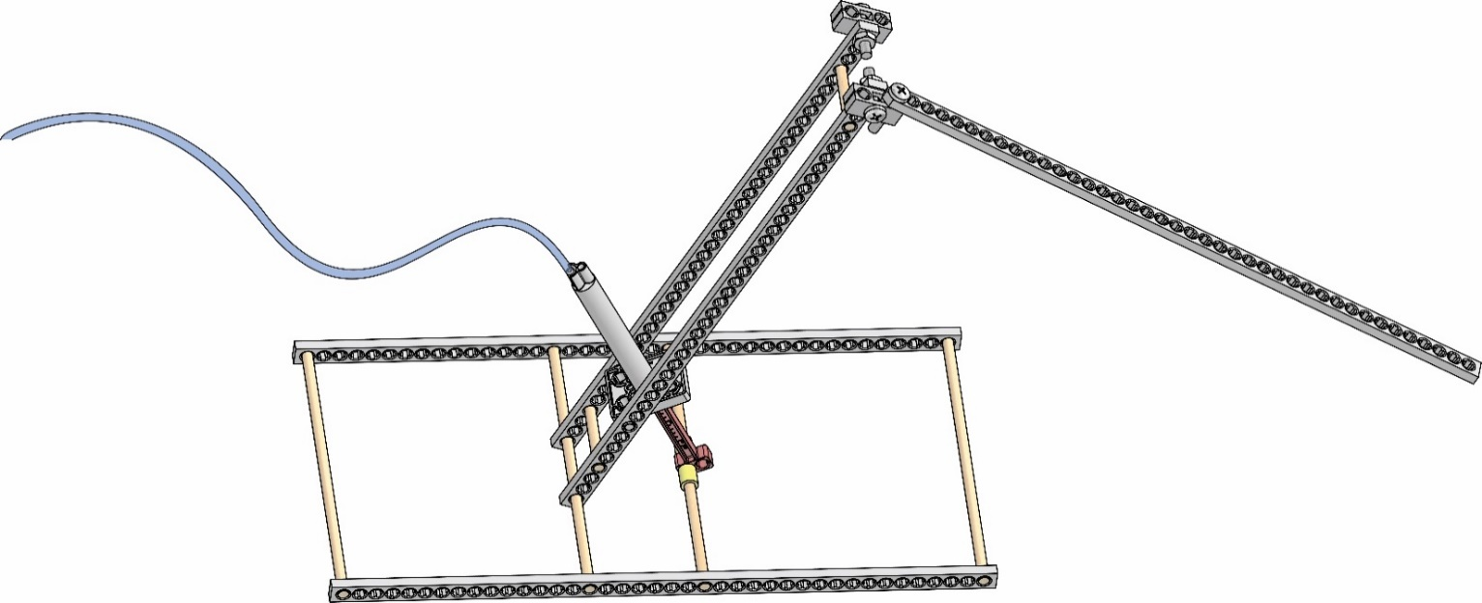
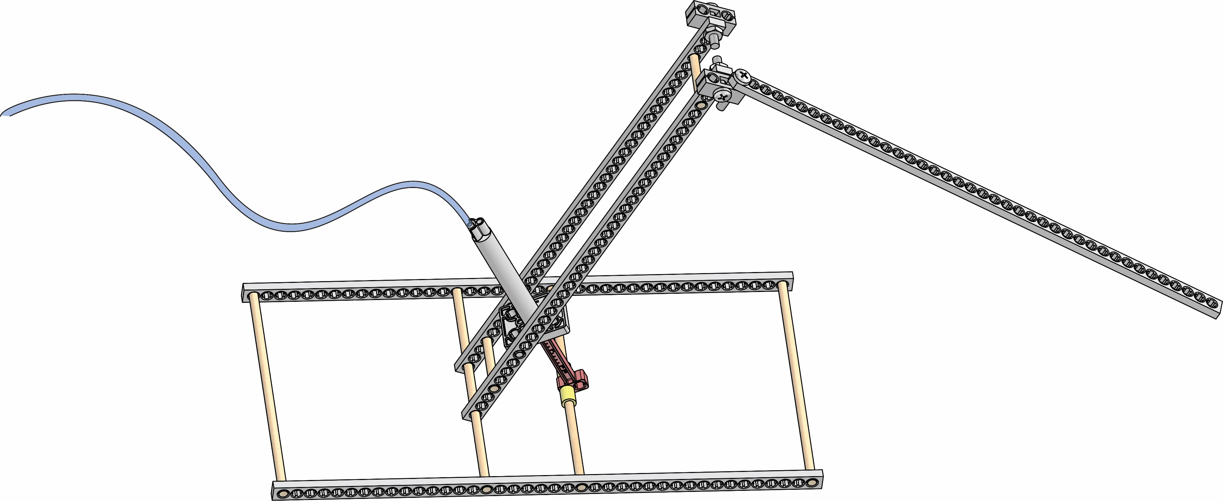
Lever Arm

Screw

Tip: No nut is necessary
for the lever arm’s screw.
It stays loose to rotate.

Screw

Block

Attach the connector strip from Step 23 to an upright’s block
from Step 22 with a screw.
This is your lever arm.

Attach a cylinder from the second
hydraulic system from Step 15 to the upright. Insert the cylinder peg to the block as shown.

Attach the piston to the lever arm with a screw.

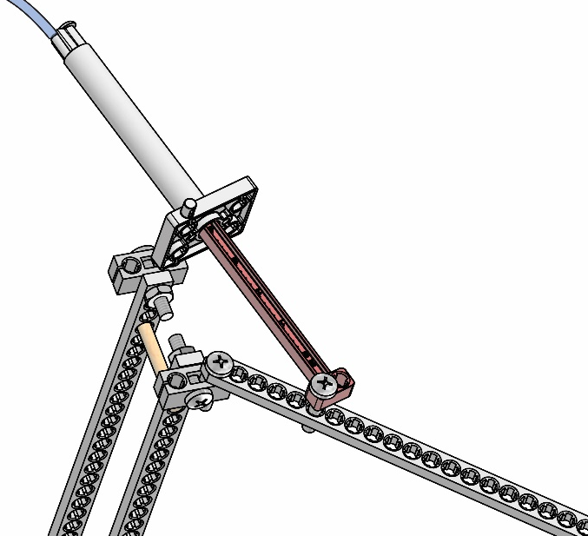
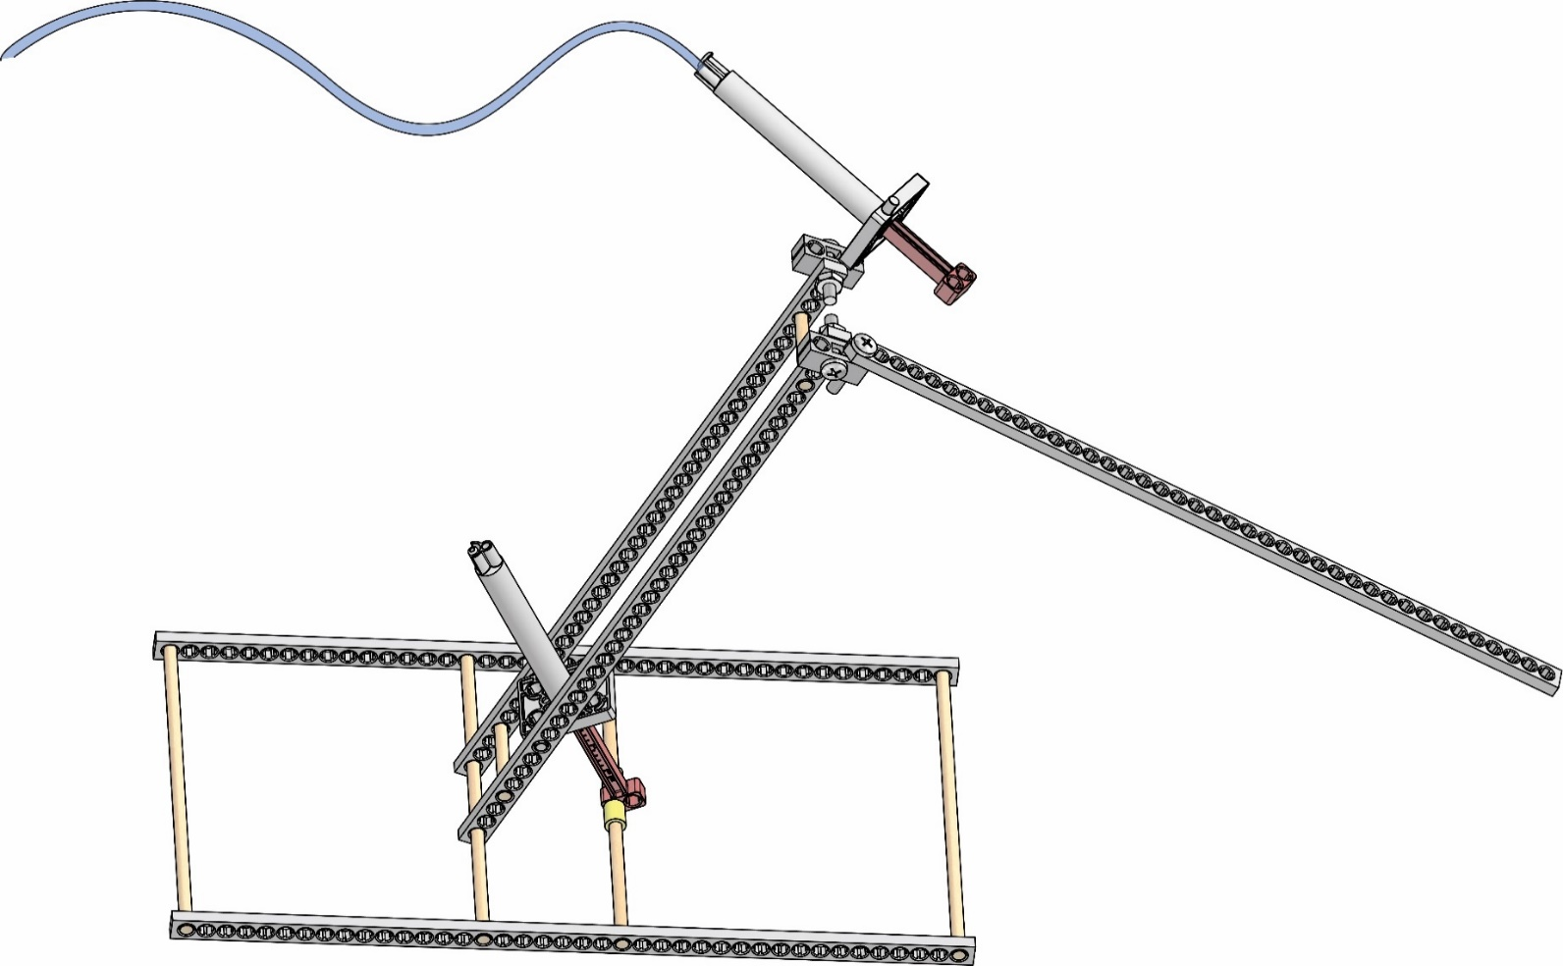
Cylinder
Peg

Screw

Piston

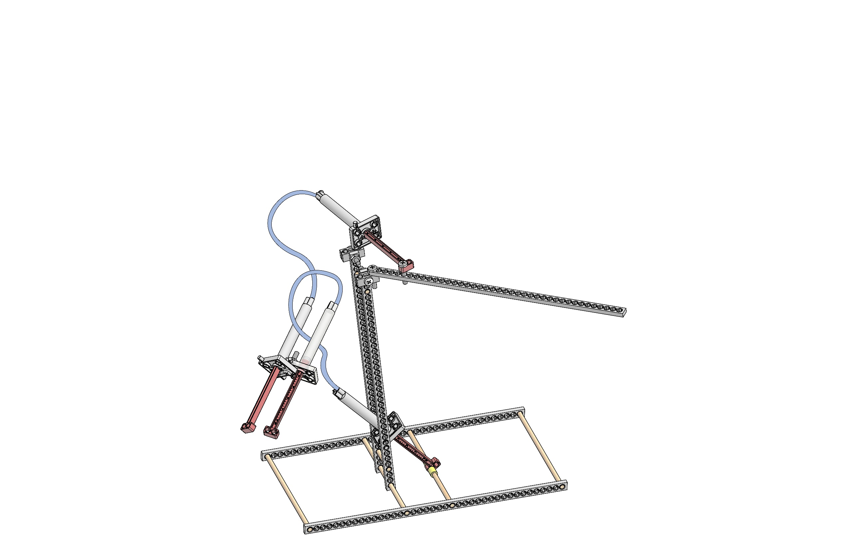
Attach the two hydraulic systems together to form a control panel.
Use a nut and screw as shown.

Tip: Cable ties keep cylinders
in place if the peg slips out.

Control Panel

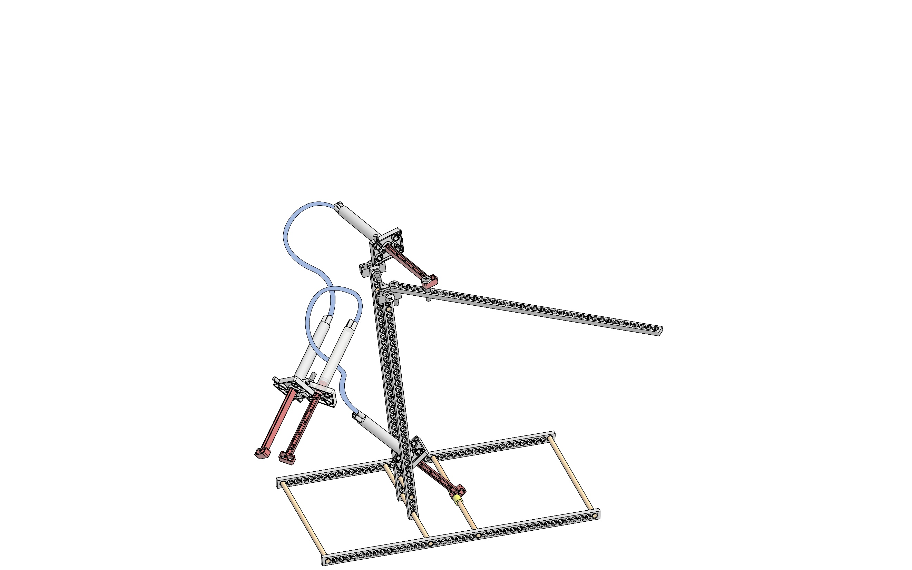

Control Panel

Screw


Nut

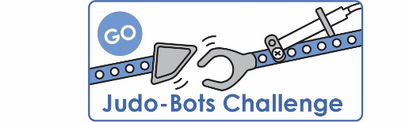
If you are going
to do the optional
Judo-Bot Challenge,
now’s the time!
Documents at teachergeek.com/learn
Congratulations!
You have built an example Judo-Bot.
However, you can make it better!

►

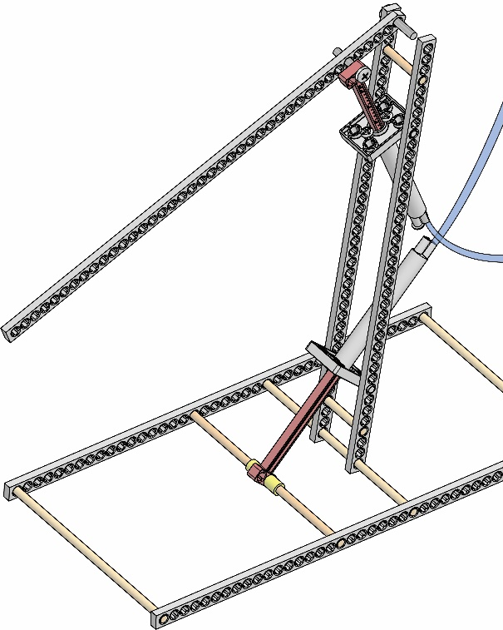

This build guide is for an example Judo-Bot frame.
In the Engineering Challenges, you can design and
re-design your build and add end effectors for battle.
Create the ultimate bot to compete in tournaments!
Will you win? Find out more: teachergeek.com/learn

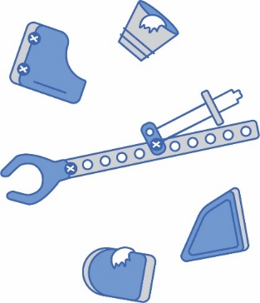
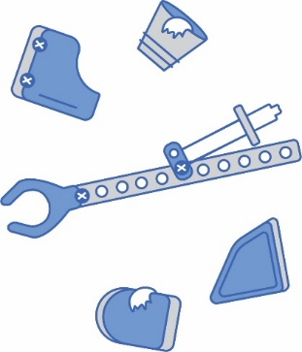
Alternative
Judo-Bot Design

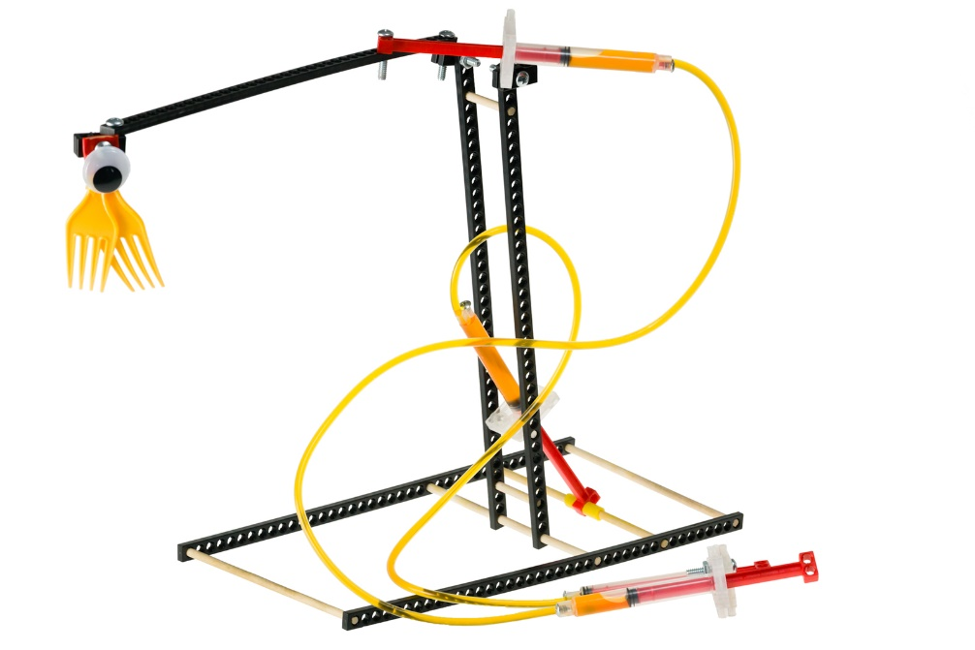
Use found and recycled materials
to craft unique end effectors
(detachable ends of robot or
lever arms) for your Judo-Bot.



Design, Create, Innovate
Your example Judo-Bot doesn’t have to look this way.
Reposition the lever arm-cylinder from Step 26 to fit in the upright or place the cylinder (fulcrum) closer or further up the arm. The possibilities are endless!

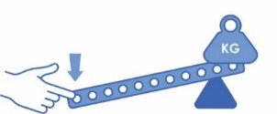
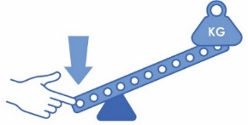
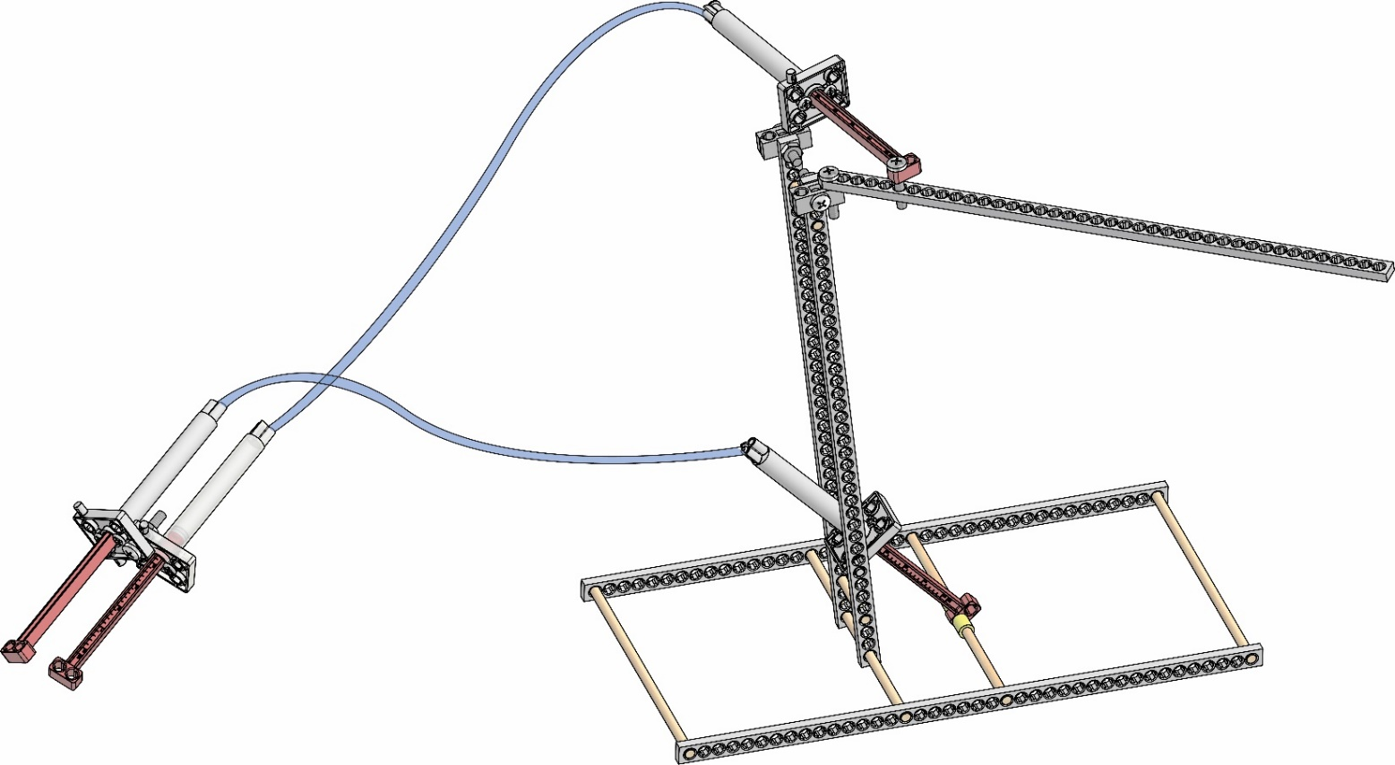
Applying force a short distance from the fulcrum means more effort to lift the load a shorter distance.
Applying force a long distance
from the fulcrum allows just a
little effort to lift a large load.
The cylinder acts as
the fulcrum (pivot point).
Lever Arm
Cylinder

Levers trade distance for force.
A connector strip
is a type of lever.

Upright

