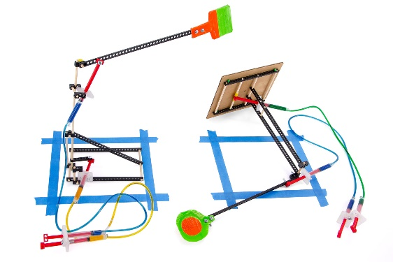
Time Limit: Two-minutes

The Challenge: Engineer your Judo-Bot to knock over an opponent or push them out of the arena.

Push!

Difficulty: Easy-Medium

Challenge Supplies
- Two (or more) assembled Judo-Bots
- Extra TeacherGeek components
- Arena materials (tape, chalk)
- Recycled or found materials
- TeacherGeek tools
- Timer
- Ruler

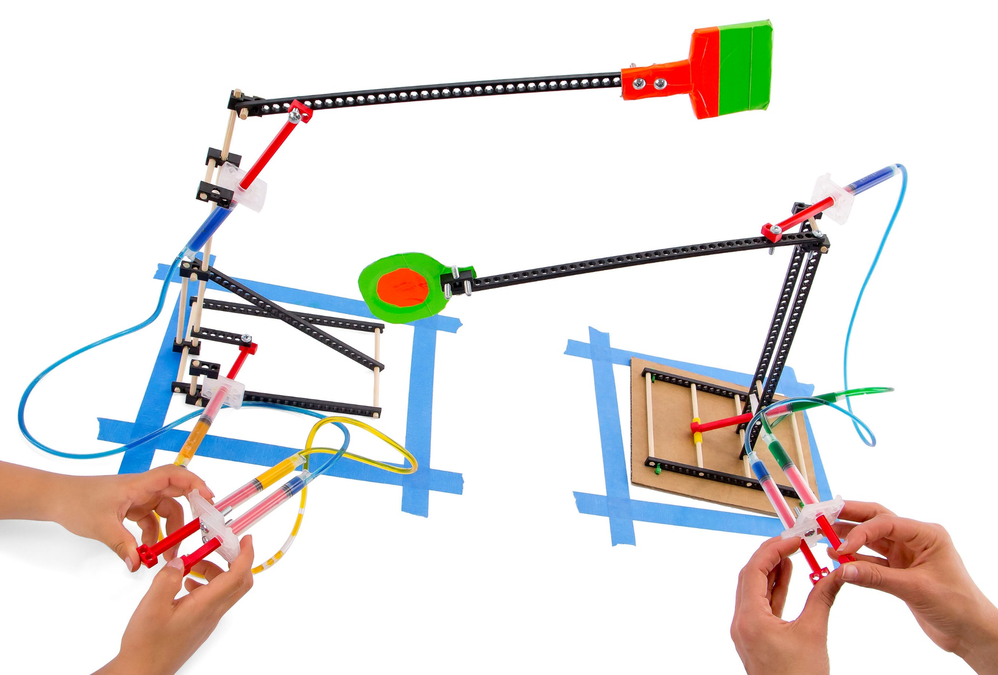


End Effector

Tip: Build a base
to stabilize your
Judo-Bot.

These are example Judo-Bots.
You can make them so much better. Engineer your bot for combat with different bases
and end effectors.

Clay


18 cm (7”)

35 cm (14”)

18 cm (7”)

Arena

Place Judo-Bot Here

Place Judo-Bot Here

Judo-Bots need an arena
for combat. It consists of
two rectangles marked on
a flat surface. Use tape or
chalk to outline, as shown.


Use hydraulic power to battle your Judo-Bots.

B.

K.O! Knocking an opponent over is an immediate win!

Start with the bot’s lever arms not touching, nor extending over the opponent’s arena edge.

Place your Judo-Bot inside the arena,
(no portion of the base should be outside the rectangle).

No Touching!

A.

B.

Battle for Two Minutes!

C.

Knocked-Over!

C.

If the opponent’s base is outside the arena by
the end of two-minutes, they lose on default.

D.

E.

Both bots in-bounds and upright by the end of two-minutes? It’s a draw!

Note: If both bots are “out-of-bounds”
after two-minutes, measure with a ruler
to determine which is further from the arena’s edge. Shortest distance wins!

D.

Out-of-Bounds

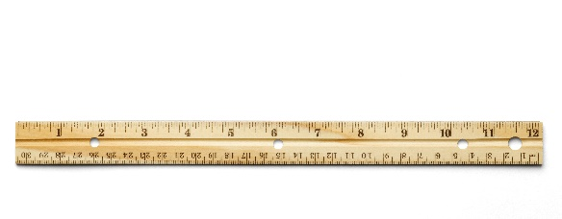


Fail to follow these constraints?
Disqualification!

(rules and limits for your design)
- Only hydraulic power may be used to move and control the Judo-Bot.
  - Hydraulic lines may not be pushed or pulled to move the bot – just pistons.
- The base may not be anchored (taped, screwed, bolted) to the arena surface.
- The weight of the Judo-Bot and components may not exceed 250 grams.
- Additional materials should be brought in for Judo-Bot designs, if they are:
  - TeacherGeek Components
  - Found & Recycling Bin Materials
  - Teacher Approved
  - Non-Hazardous (no sharp edges, harmful chemicals, etc.)
- You will have _____________________ to complete your design challenge.



Fill in how much
time you have
The time from building and
re-designing your Judo-Bot
to the start of the competition.



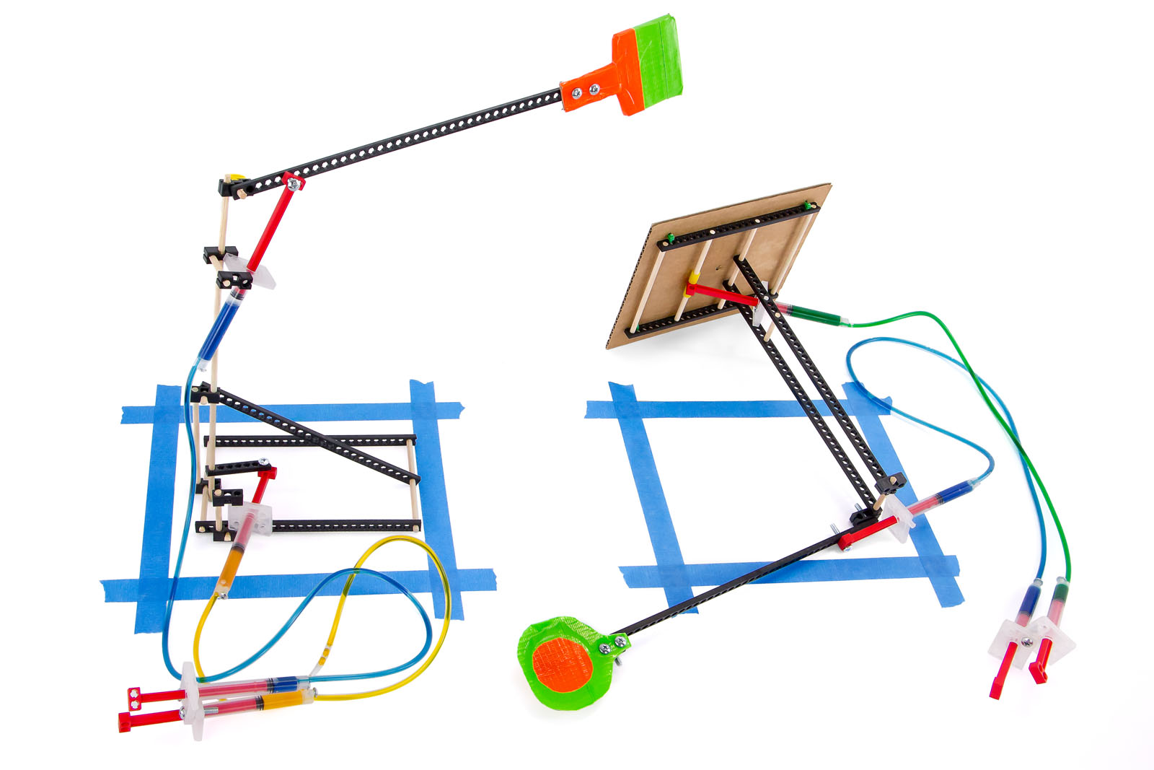
Base

Twist
Ties

Base

How Will You Stabilize Your Judo-Bot?
The example Judo-Bot base is light and easy to tip-over.
Its footprint (dimensions) should not exceed 18 cm x 35 cm.
You can design your base to be any size – but consider:

Big bases provide
more support, yet
are closer to the
arena edge.

Small bases are
less stable, but further from the arena edge.

T-T-Tip!

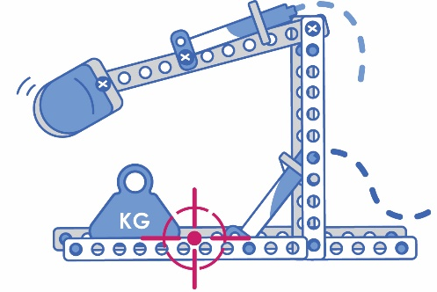
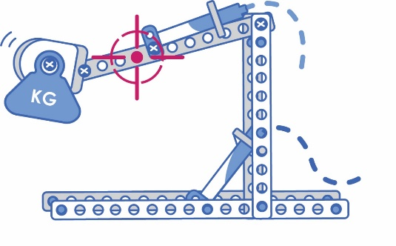
Lowering the center of gravity
by placing more weight on the
base makes bots more stable.

High Center of Gravity

Raising the center of gravity
with heavier end effectors
makes the bot unstable.
A top-heavy arm is great
for whacking opponents!

Center of Gravity
The center of gravity is the point
where your bot is equally balanced.
The maximum weight of your Judo-Bot
should not exceed 250 grams (0.5 lbs).
Where will you place your weight?
Will you use heavy or light materials
for your base and end effector?

Low Center of Gravity


Fulcrum
(Pivot Point)

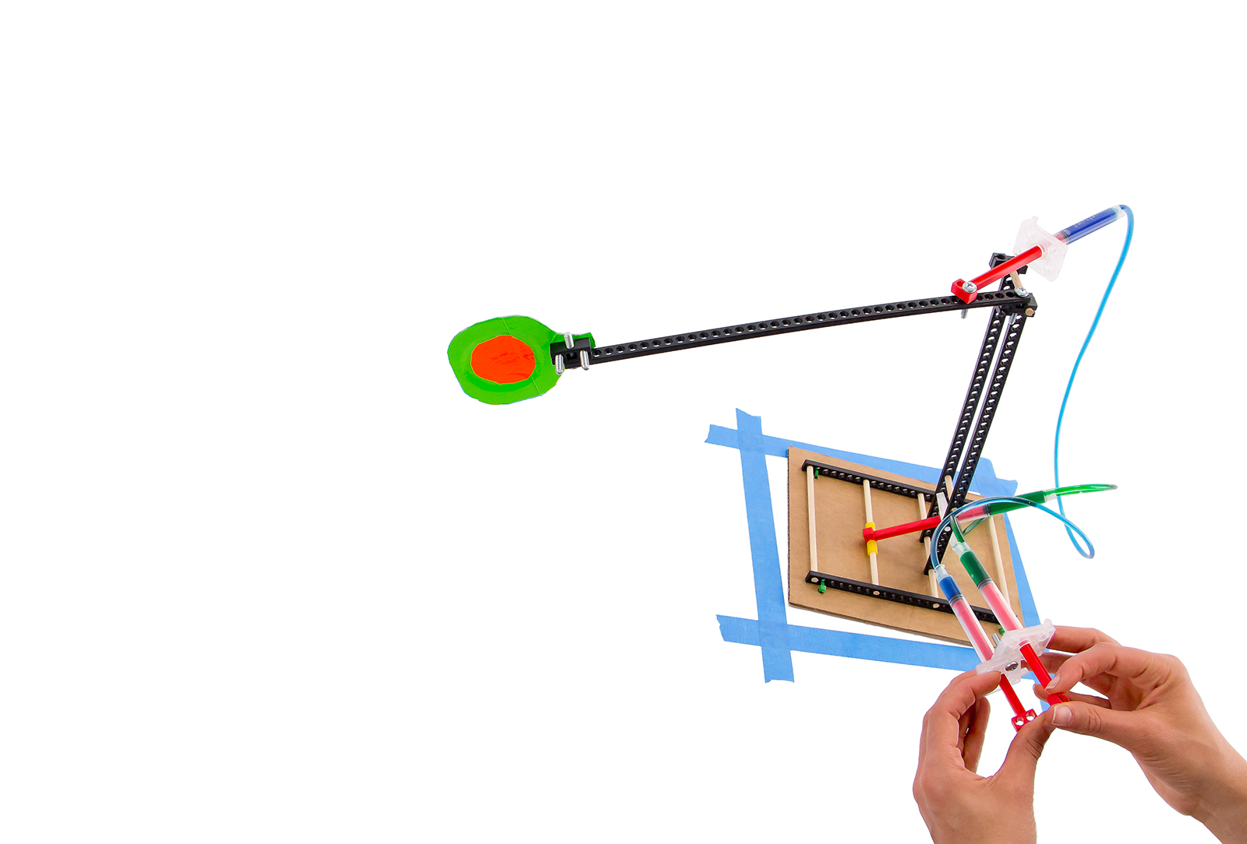
Trading Force for Distance
Your Judo-Bot uses more than hydraulic power to move – levers allow you to trade force for distance in battle.

Distance
(Lever Arm)

Mechanical
Advantage

Output Force
Input Force

=

End
Effector

Output Force
(Motion of the Arm)

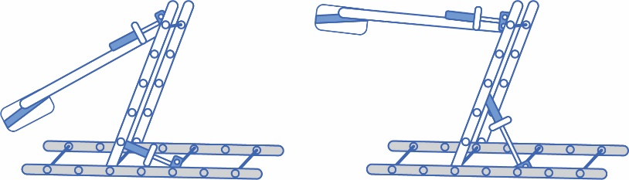
Reposition the base’s cylinder as low on
the upright as possible.
Is the effort it takes to move the upright easy or difficult?

Try It Out!

Reposition the base’s cylinder as high on
the upright as possible.
Is the effort it takes to move the upright easy or difficult?

Input Force
(Control Panel)

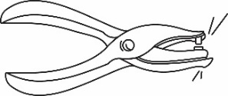
Use blocks, screws, tape
and hole punchers to
attach your end effectors.

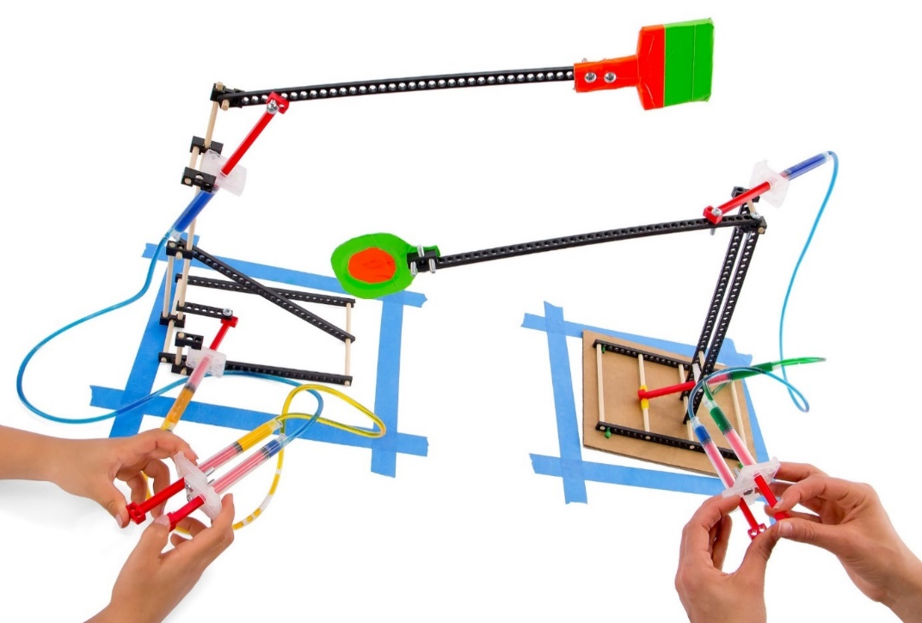
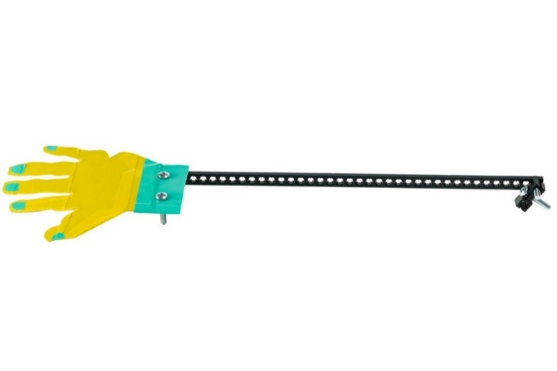
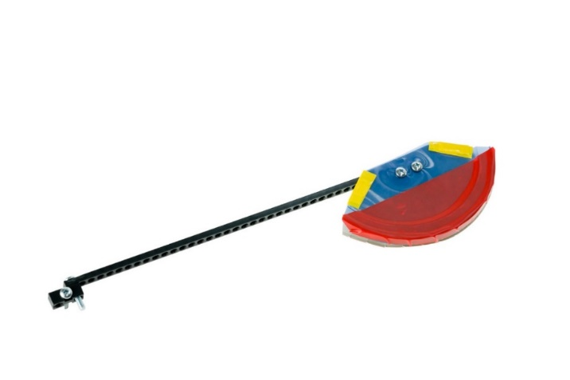
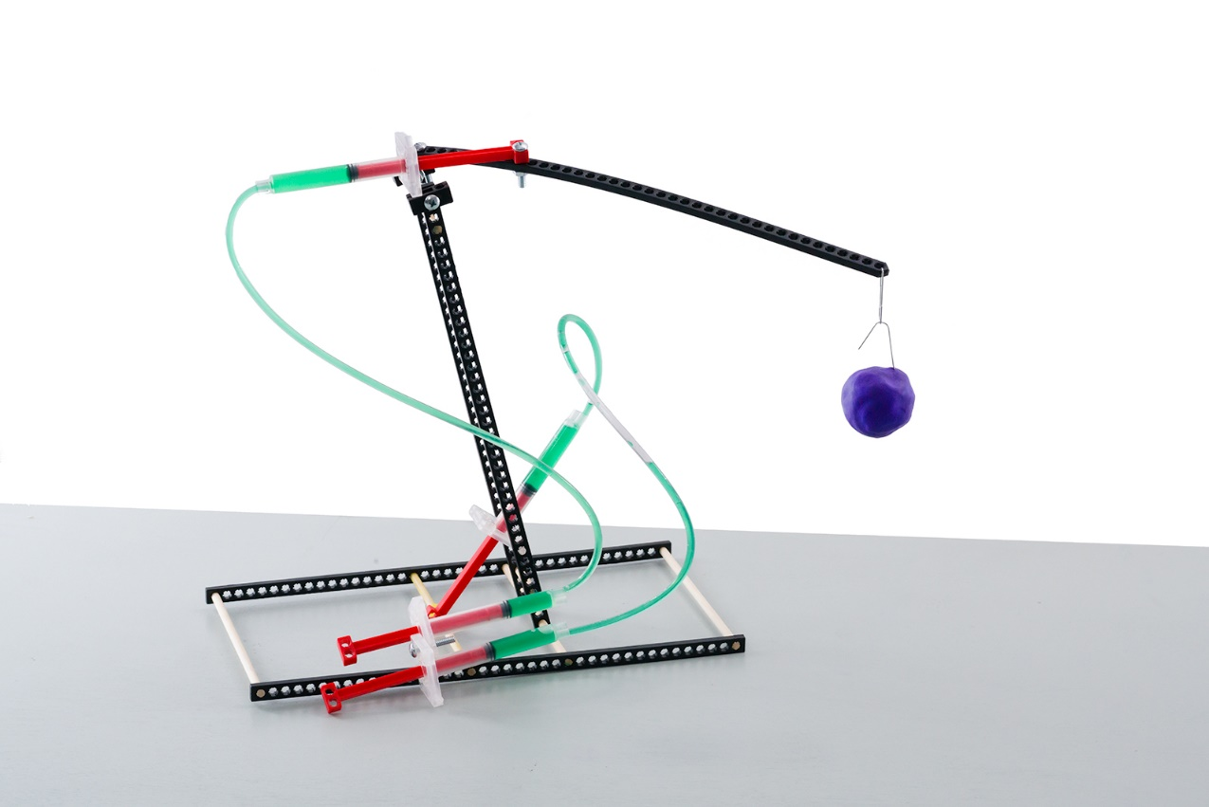
Push!

Tip!

Whomp!

Teachers initial here when students are finished:

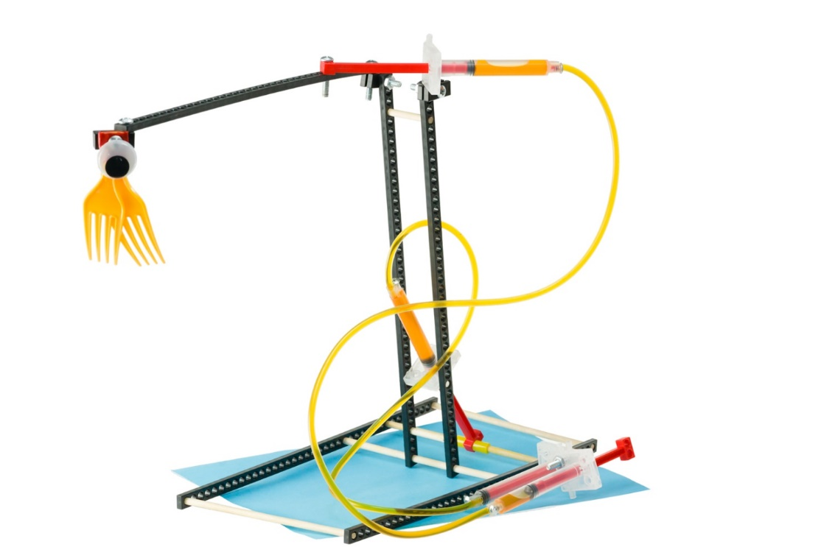

Base

Hydraulic
System

Lever Arm

End
Effector

An end effector is the device or
tool at the end of your lever arm.
Its design changes how your
Judo-Bot can battle – slapping,
pushing, gripping, and swinging.
Use found or recycling bin materials.

Try Styrofoam,
old cardboard,
paper, plastic,
TeacherGeek
components


Tally your design’s wins + losses in the chart below. Record notes for the engineering process.

Judo-Bot Tally Sheet: Points Scored
Group Names | Win! | Lose! | What happened?  [e.g. How did you win or lose? What parts of your design changed? How would you redesign your Judo-Bot for future competition?]
The Engineering Design Process:

You will be using the Engineering Design Process. What does that mean?
Your design is never finished! It can always be improved. Fill out a new Engineering Notebook page each time you design/redesign your Judo-Bot.


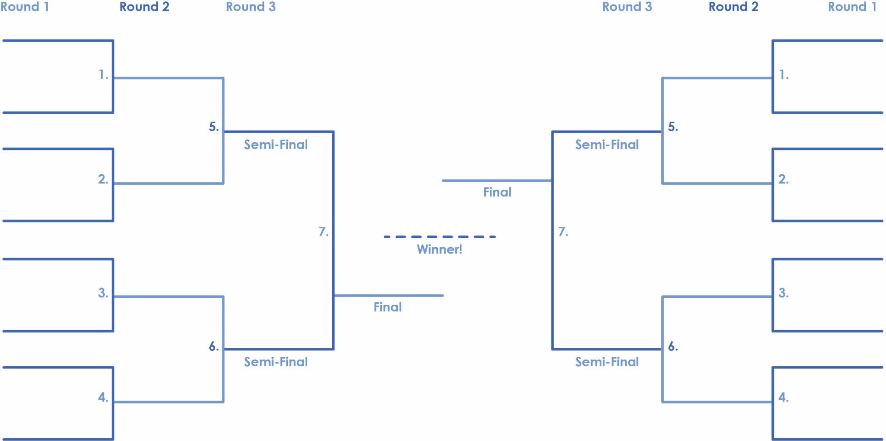
TeacherGeek
Intercontinental
Championship Belt.

Use an elimination tournament bracket for class competition.
This bracket can fit sixteen
Judo-Bot teams or designs.

