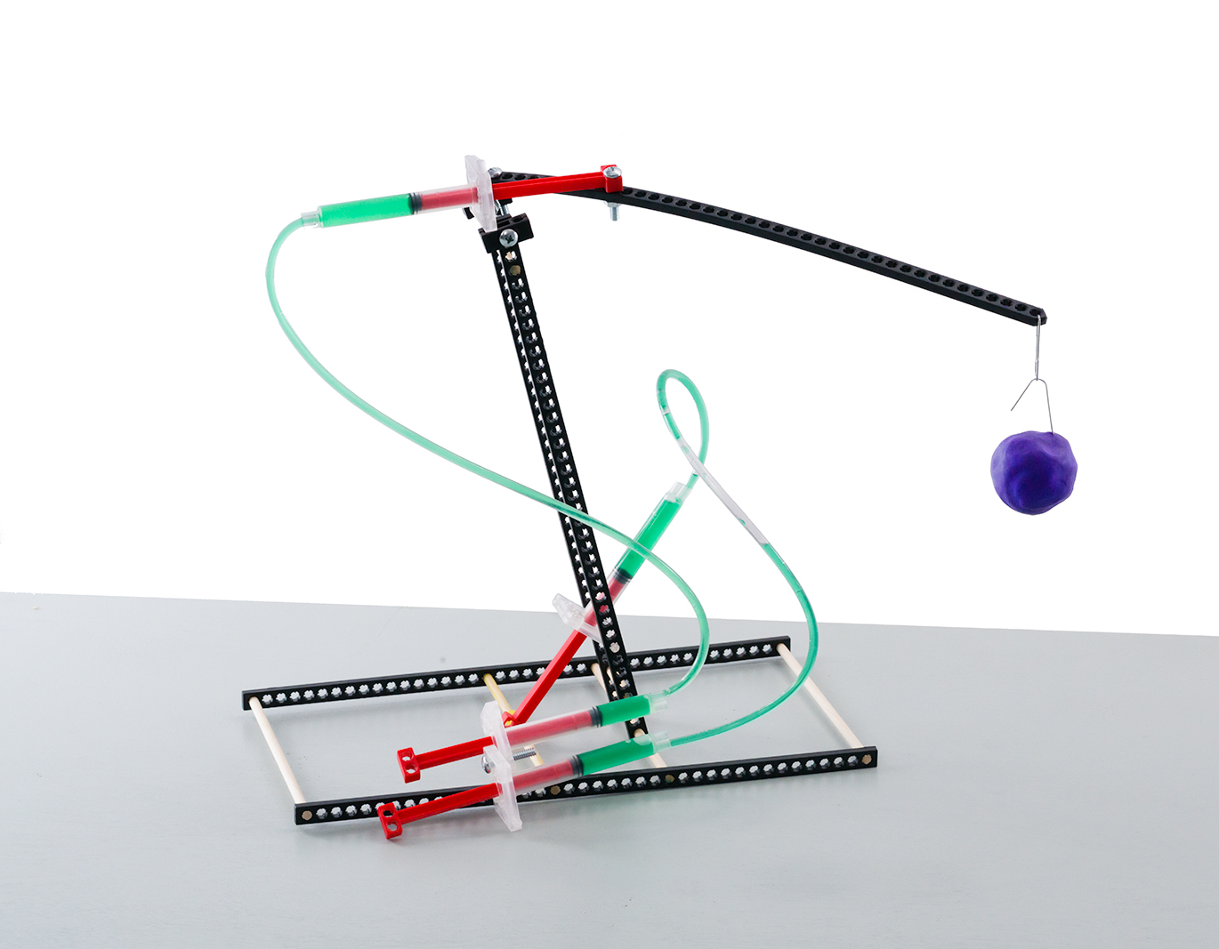
Challenge Supplies
Judo-Bot, paper clips,
100-500 grams of clay, ruler

The Challenge: Redesign your Judo-Bot to
lift the most weight, as high as possible, without the frame tipping over.

Time Limit: Two-minutes

Difficulty: Hard


Lift weight 30 cm (1ft) from surface.

The clay must be placed
30 cm from the base to start.

Base

Bend two paper clips to lift & hold the clay.
One for the lever arm, the other as a handle for the clay (weight).

Optional: Make the challenge more difficult
by requiring the bot’s base stay in one place.

This is an example Judo-Bot design. You can make it so much better. Redesign it so the lever arm can
lift as much weight as possible.

Clay

Constraints: (rules and limits for your design)
- Only hydraulic power may be used to move and control the Judo-Bot.
  - Hydraulic lines may not be pushed or pulled to move the bot – just pistons.
- The base may not be anchored (taped, screwed, bolted) to the challenge surface.
- The End Effector must be one paper clip, bent however you choose.
- Additional materials should be brought in for Judo-Bot designs, if they are:
  - TeacherGeek Components
  - Found & Recycling Bin Materials
  - Teacher Approved
  - Non-Hazardous (no sharp edges, harmful chemicals, etc.)
- You will have _____________________ to complete the design challenge.

Fill in how much
time you have
The time from building and
re-designing your Judo-Bot
to the start of the competition.

 | Weight Lifted  (Grams) | Height Lifted  (Cm)
Design #1
Design #2
Design #3
Design #4
Design #5
Design #6
Design #7
Independent Variable:
Height Lifted by Lever Arm

Dependent Variable:
Weight of Clay in Grams

