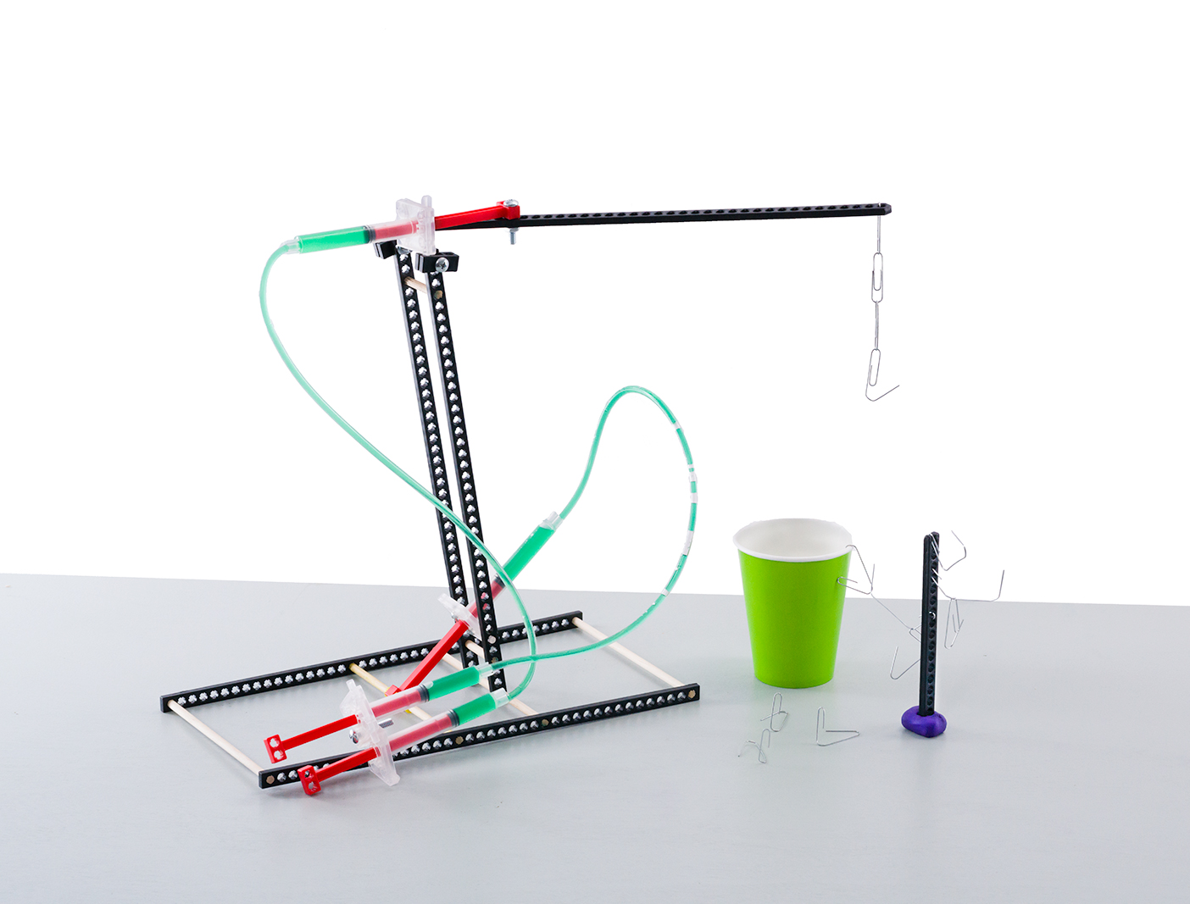
Challenge Supplies
Judo-Bot, 25-50 paper clips,
cup or container for sorting, ruler

The Challenge: Redesign your Judo-Bot
to pick up and sort as many paper clips
as possible in two minutes’ time.

Time Limit: Two-minutes

Difficulty: Easy-Medium


Attach bent paper clips
to your lever arm to act
as end effectors to grab and sort the other clips.

Pick up paper clips 30 cm (1ft) from surface.

Paperclip
Tree

Tip: Use a “tree” structure to hold paper clips –
a connector strip and clay allows the clips to be grabbed at different heights.

Use any cup or container

This is an example Judo-Bot.
You can make it so much better. Redesign it to pick up and sort
as many paper clips as possible.

Clay

Constraints: (rules and limits for your design)
- Only hydraulic power may be used to move and control the Judo-Bot.
  - Hydraulic lines may not be pushed or pulled to move the bot – just pistons.
- The base may not be anchored (taped, screwed, bolted) to the challenge surface.
- The end effector should include a paper clip in some way.
- Additional materials should be brought in for Judo-Bot designs, if they are:
  - TeacherGeek Components
  - Found & Recycling Bin Materials
  - Teacher Approved
  - Non-Hazardous (no sharp edges, harmful chemicals, etc.)
- You will have _____________________ to complete the challenge.

Fill in how much
time you have
The time from building and
re-designing your Judo-Bot
to the start of the competition.

Amount of Paper Clips Picked Up and Sorted, in Two Minutes

Group Name | Design #1 | Design #2 | Design #3 | Design #4 | Design #5 | Design #6

