University of Strathclyde, Bahrain
Classrooms & Lecture Theatres
Extron AV Control Panel
Quick User Guide

1. Overview of the Touch Panel
The control panel operates two independent displays — a Left Display and a Right Display. Down each side of the screen is a column of source buttons; the column on the left controls the Left Display, and the column on the right controls the Right Display.
Tapping a source button opens a pop-up window in the centre of the screen with instructions for that specific source. A room name and date/time are shown at the top of the panel, and the room audio volume slider and mute icon sit below the pop-up area.
- Left Display sources: PC, Laptop, Laptop USB-C, Document Camera, BYOD Wireless, Display Off.
- Right Display sources: the same six options, controlling the right-hand screen instead.

2. Selecting a Source
To show something on a display:
- Look at the coloured column for the display you want to control (blue = Left Display, red = Right Display).
- Tap the button for the source you want to use (e.g. PC, Laptop, Document Camera).
- A pop-up will appear in the centre of the panel with connection instructions for that source.
- Tap Close in the top-right of the pop-up once you're connected, to return to the main screen.

3. Source Guides

3.1 PC
Use the lectern PC to present from a University-managed computer.
- Use the keyboard and mouse provided on the lectern.
- Log in with your University of Strathclyde credentials.
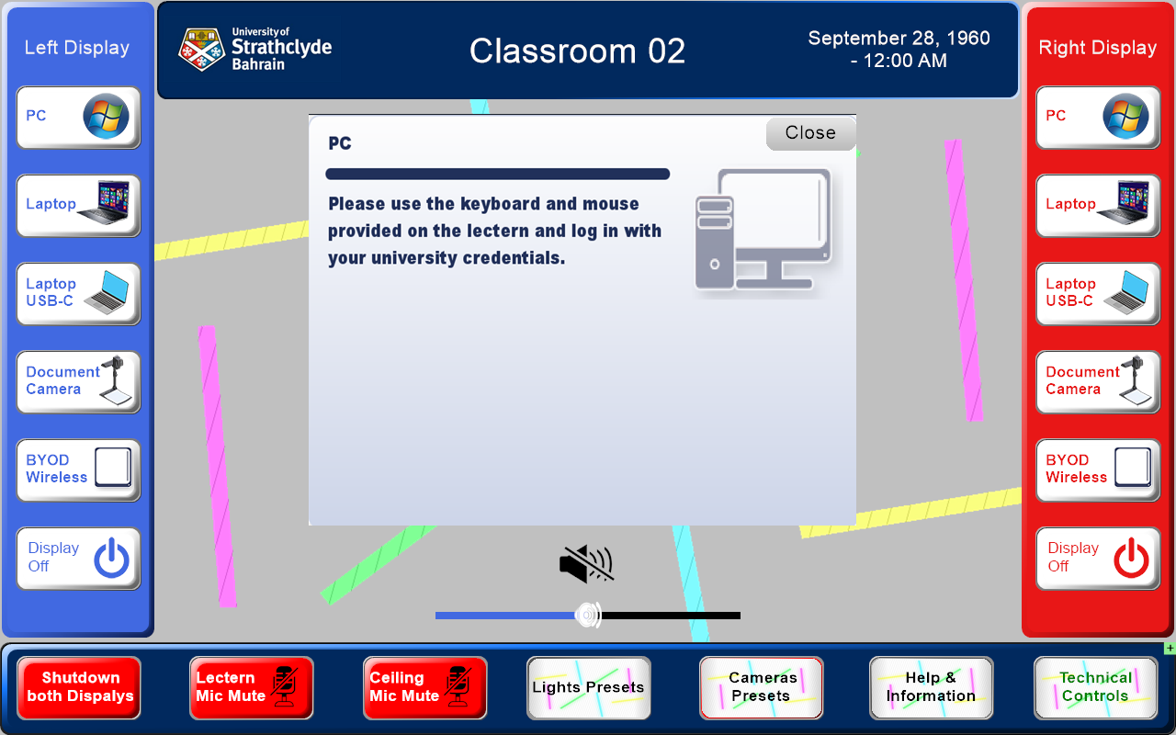
PC source pop-up

3.2 Laptop (HDMI)
Use this option to connect a laptop using the HDMI cable supplied at the lectern.
- Connect your laptop to the appropriate HDMI cable.
- You may need to set your laptop to duplicate its display to both the laptop screen and the room screen.
- Use the hotkey combination below for your laptop brand to toggle this display mode as described on the screen.
- With Windows 11, the easiest way to toggle between screen modes is pressing the Windows key + K, which will allow you to toggle between extend or duplicate display.

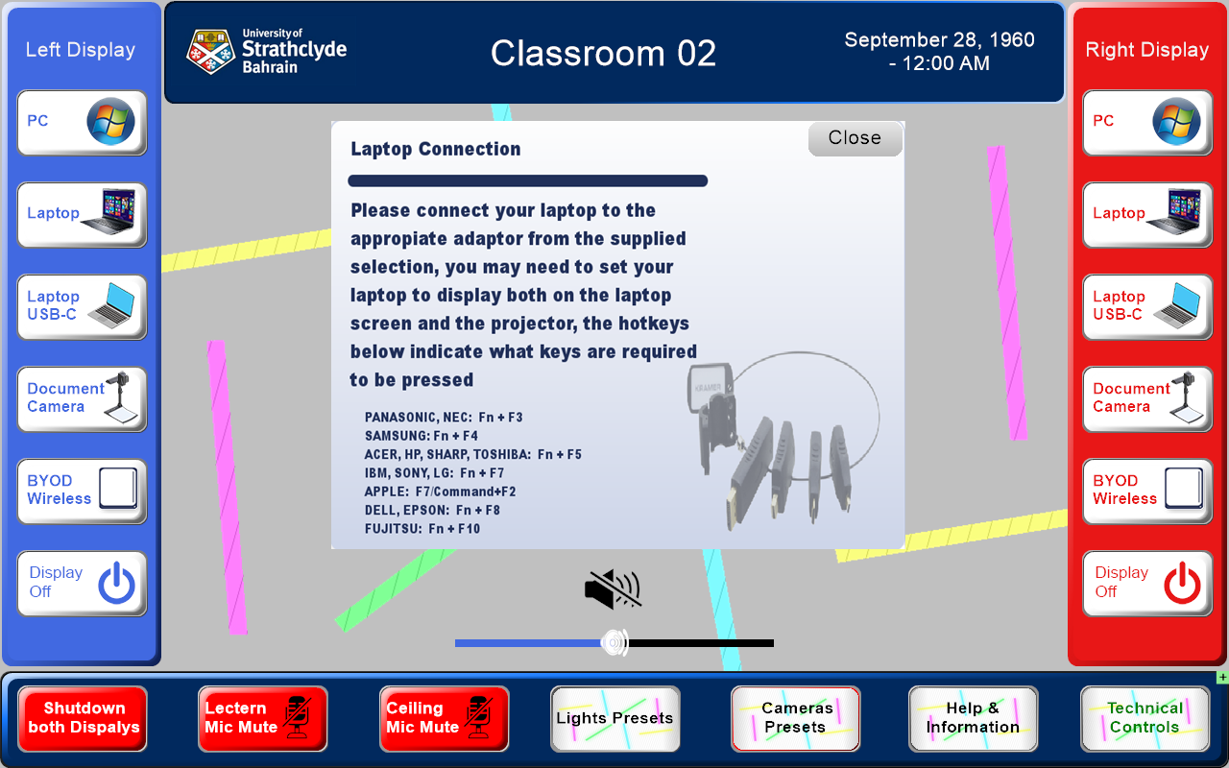
Laptop connection pop-up

3.3 Laptop USB-C
Use this option if your laptop supports video over USB-C.
- Connect your laptop using the supplied USB-C cable.
- You may need to set your laptop to duplicate its display to both the laptop screen and the room screen, using the same hotkeys listed in section 3.2.
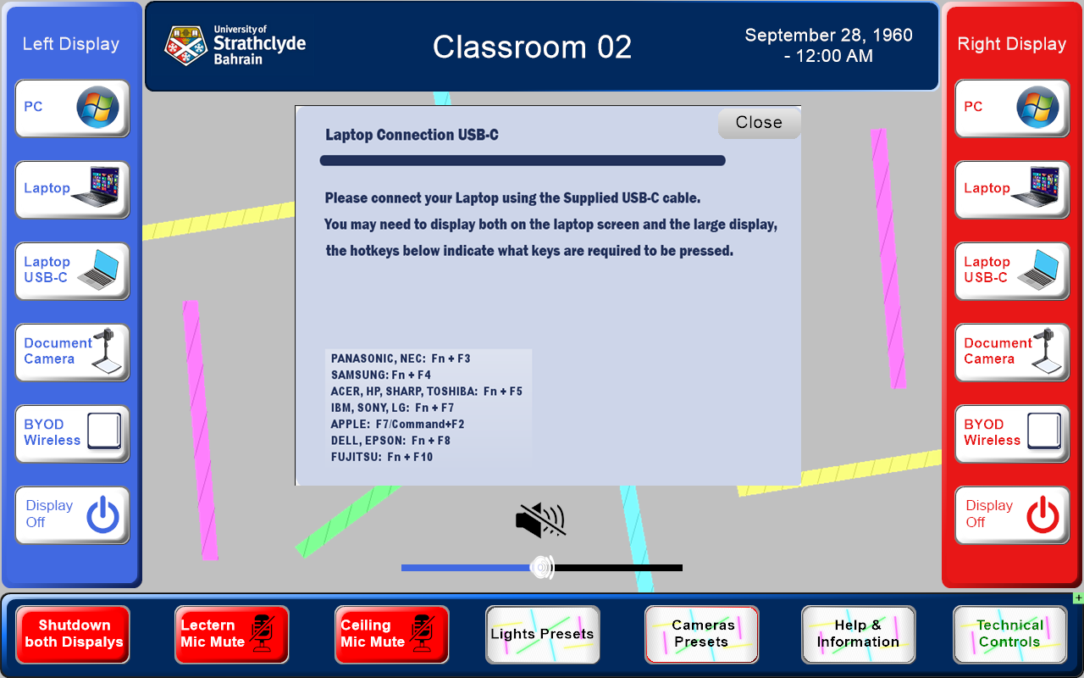
Laptop USB-C connection pop-up

3.4 Document Camera
Use the document camera to display physical documents or objects.
- Place your document or object on the base of the camera, underneath the camera head.
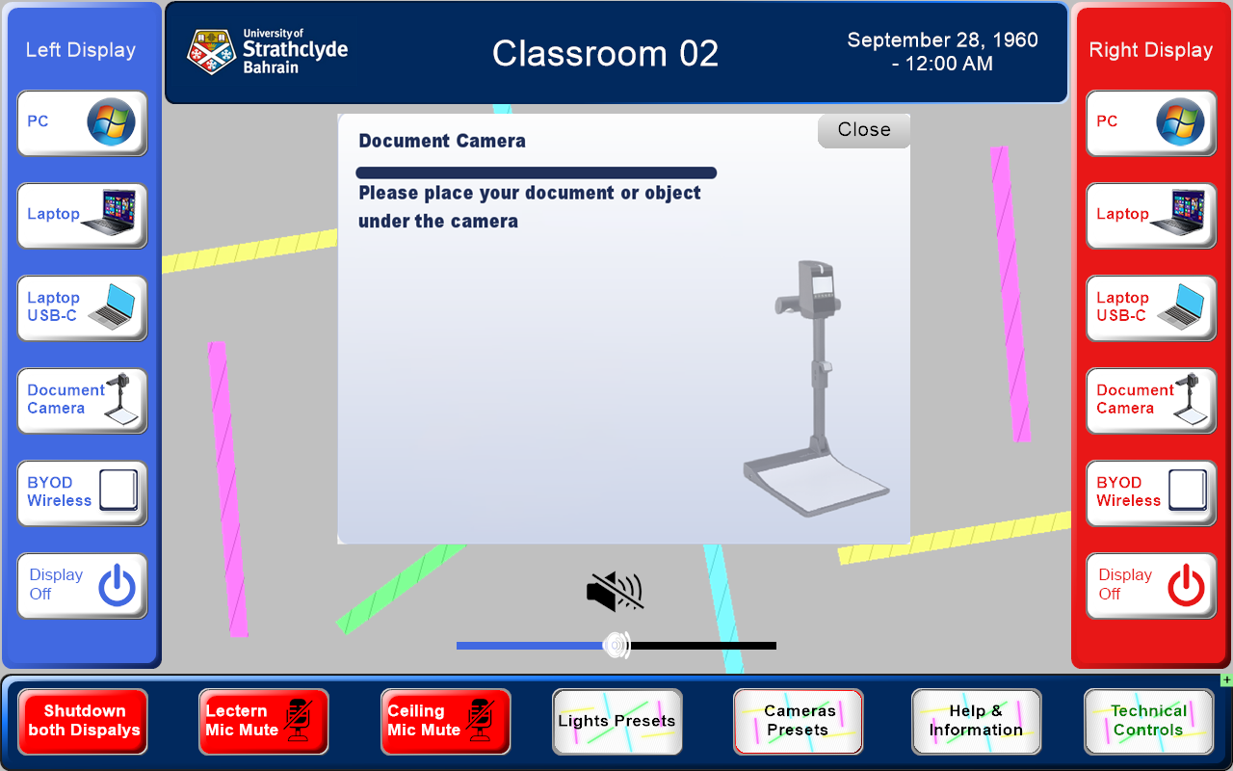
Document Camera pop-up

3.5 BYOD Wireless
Cast a device's screen to the room displays without cables.
- Launch the Mersive Solstace BYOD software on your device and select the room you are in.
- When prompted on the app enter the 4 digit pin code that’s displayed the large presentation screen.
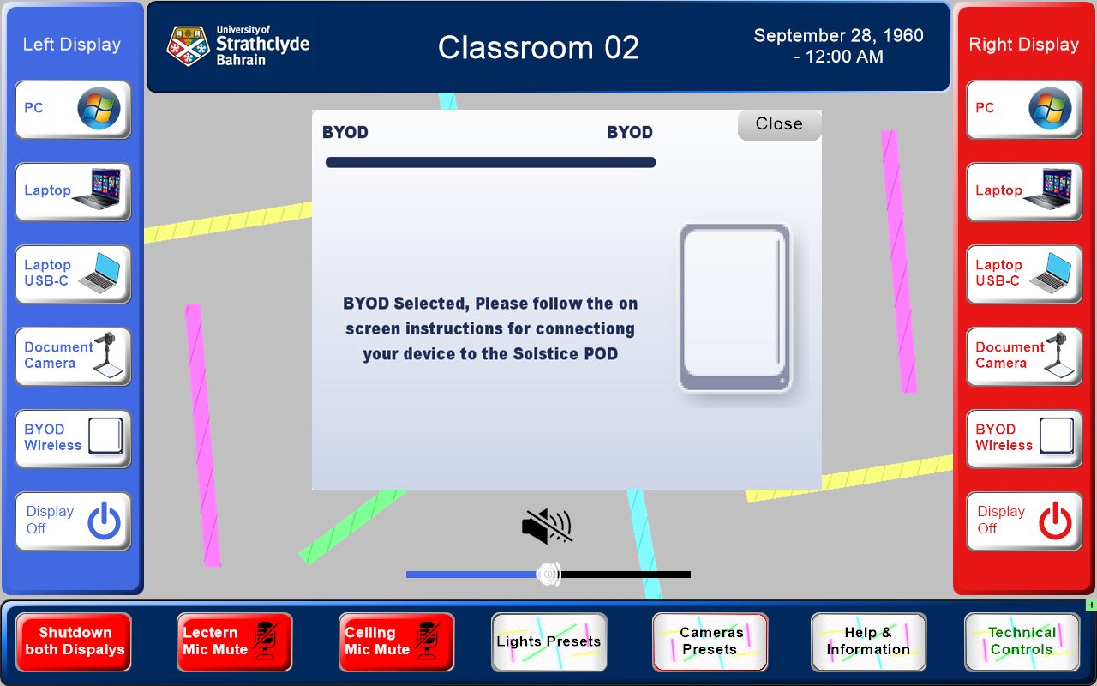
BYOD Wireless pop-up

4. Sound
A volume slider and speaker/mute icon are shown beneath the pop-up area on the main screen. Tap the speaker icon to mute or unmute the room, and drag the slider to adjust the overall volume.


5. Microphones
Two microphone mute buttons are available along the bottom toolbar of the main screen: Lectern Mic Mute and Ceiling Mic Mute. Tap a button to mute or unmute that microphone.
A separate Microphones Input Gain screen (opened via Technical Controls, see section 7.3) shows individual gain sliders and mute icons for the Gooseneck (lectern) and Ceiling microphones.
Microphones mute buttons

6. Cameras and Lighting

6.1 Camera Presets
Tap Cameras Presets on the bottom toolbar to open the camera preset screen.
- Students — Partial: frames a partial view of the student seating area.
- Students — Full Class: frames the whole student/class area.
- Professor — Narrow: switches the presenter camera to a narrow (zoomed-in) framing, e.g. for a single presenter.
- Professor — Wide: switches the presenter camera to a wide framing, e.g. for a full-room view.
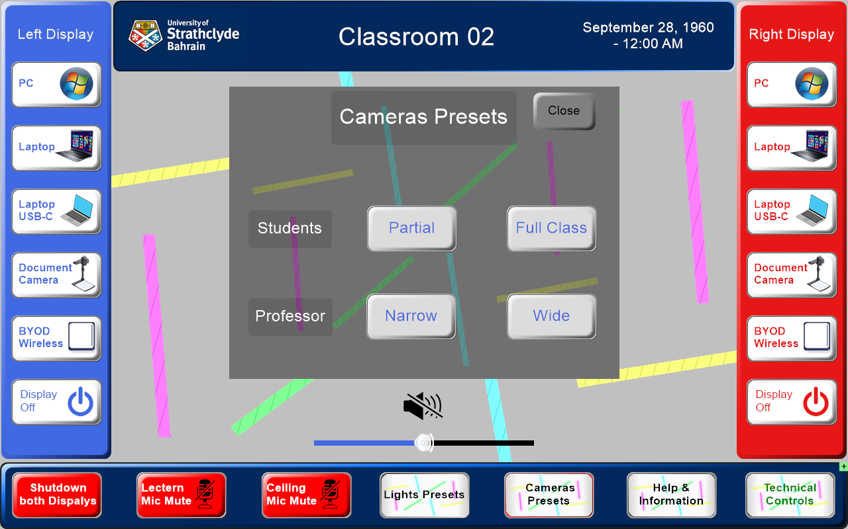
Camera Presets pop-up

6.3 Lighting
Tap Lights Presets on the bottom toolbar to control the room lighting:
- First Row ON / OFF — controls the lights closest to the screen (useful to dim for presentations).
- Lighting ON / OFF — controls the main room lighting.
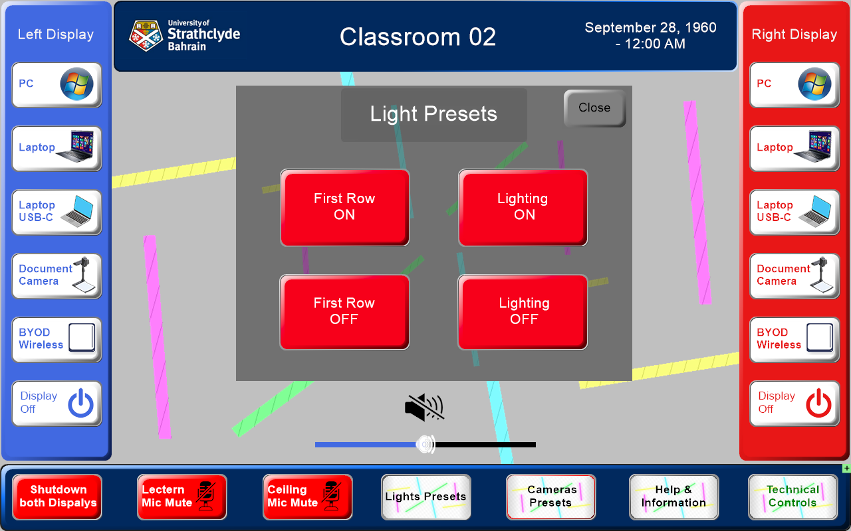
Light Presets pop-up

7. Technical Controls / Advance Control

7.1 Password/ Advance control
Tap Technical Controls on the bottom toolbar to access advanced settings, including Cameras (full pan/tilt/zoom/preset control) and Audio. These controls are protected by a 4-digit passcode (the AV Helpdesk can give you the passcode).
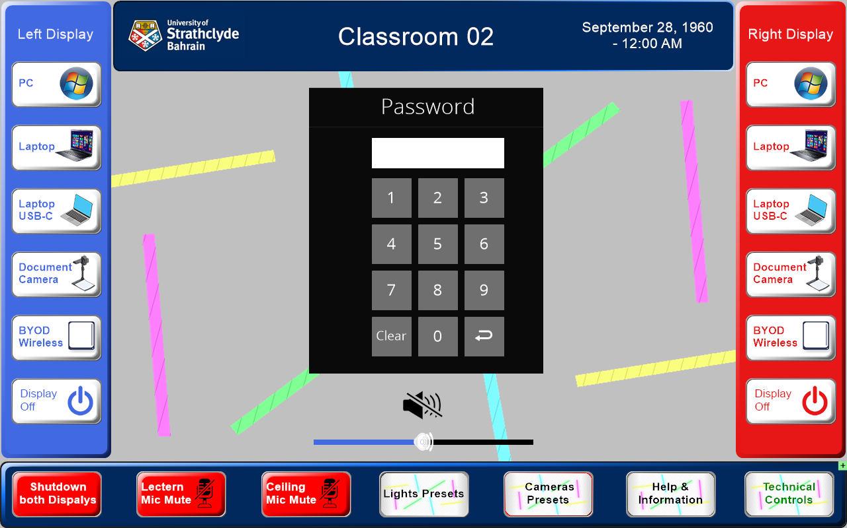
Password Control screen

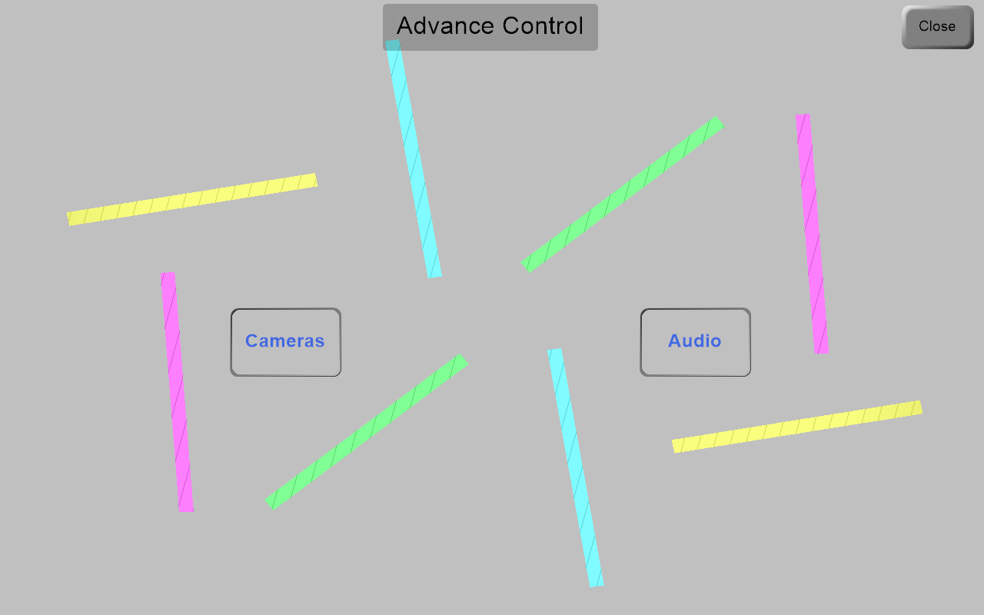
Advance Control screen

7.2 Full Camera Control
Full manual camera control (available via Technical Controls, see section 7) provides:
- Power — turn the camera On or Off.
- Pan/Tilt — arrow buttons to move the camera up, down, left, or right, and a home button to re-centre it.
- Zoom — + and – buttons to zoom in and out.
- Presets Recall — buttons 1–3 to jump to a saved camera position.
- Presets Save — buttons 1–3 to save the current camera position to that preset slot. These presets can also be recalled from the Camera Presets page (see section 6.1): on the Students camera, preset 1 is Partial and preset 2 is Full Class; on the Professor camera, preset 1 is Narrow and preset 2 is Wide.
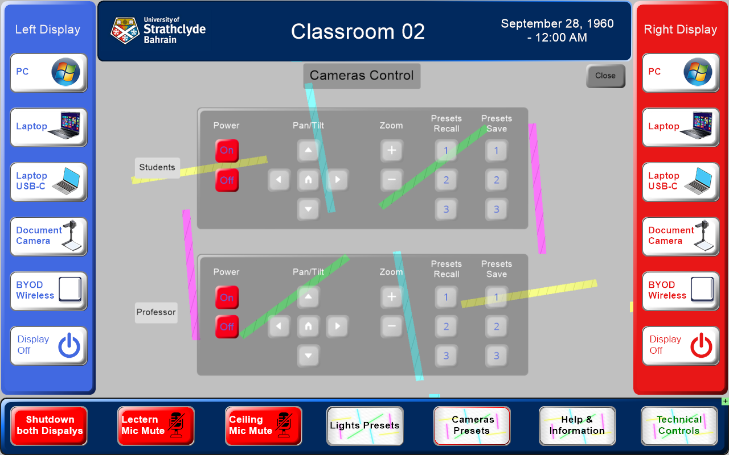
Camera Control pop-up

7.3 Audio
Tap the audio button and it will allow you to adjust microphone levels in the space.
A volume slider and speaker/mute icon are available for each microphone. Tap the speaker icon to mute or unmute the microphone in the room, and drag the slider to adjust the overall volume.

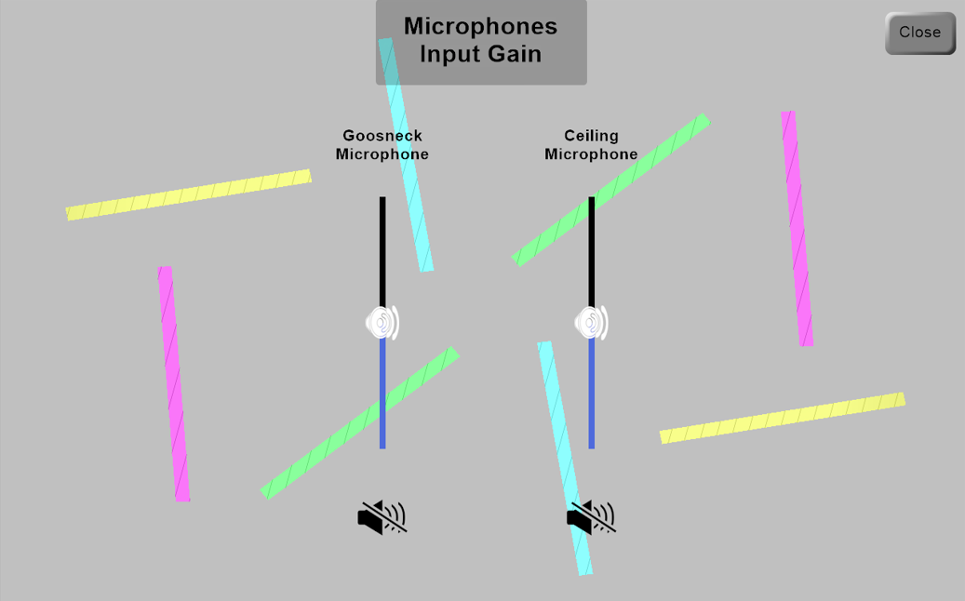
Microphone Input Gain pop-up
Tap Close to exit this area and return to the main panel.

8. Bottom Toolbar Reference
- Shutdown Both Displays — turns off both screens and ends the session.
- Lectern Mic Mute — mutes/unmutes the lectern gooseneck microphone.
- Ceiling Mic Mute — mutes/unmutes the Ceiling microphone.
- Lighting Presets — selects relevant teaching lighting scenes.
- Cameras Presets — quick Students (Partial/Full Class) and Professor (Narrow/Wide) camera framing.
- Help & Information — contact/help information for the room.
- Technical Controls — advanced camera and audio settings.

9. Joining 2 classrooms
There is the ability to join 2 classrooms together to create one larger space. This is achieves by pressing the university logo on the top LHS. Audio and video is duplicated in both rooms. There is also a hand-held microphone available in each of the primary rooms; volume control for this is in the Technical Controls page. This is only available in the following rooms:
- CR1 joins with CR2, and you present from CR1.
- CR5 joins with CR2, and you present from CR5.
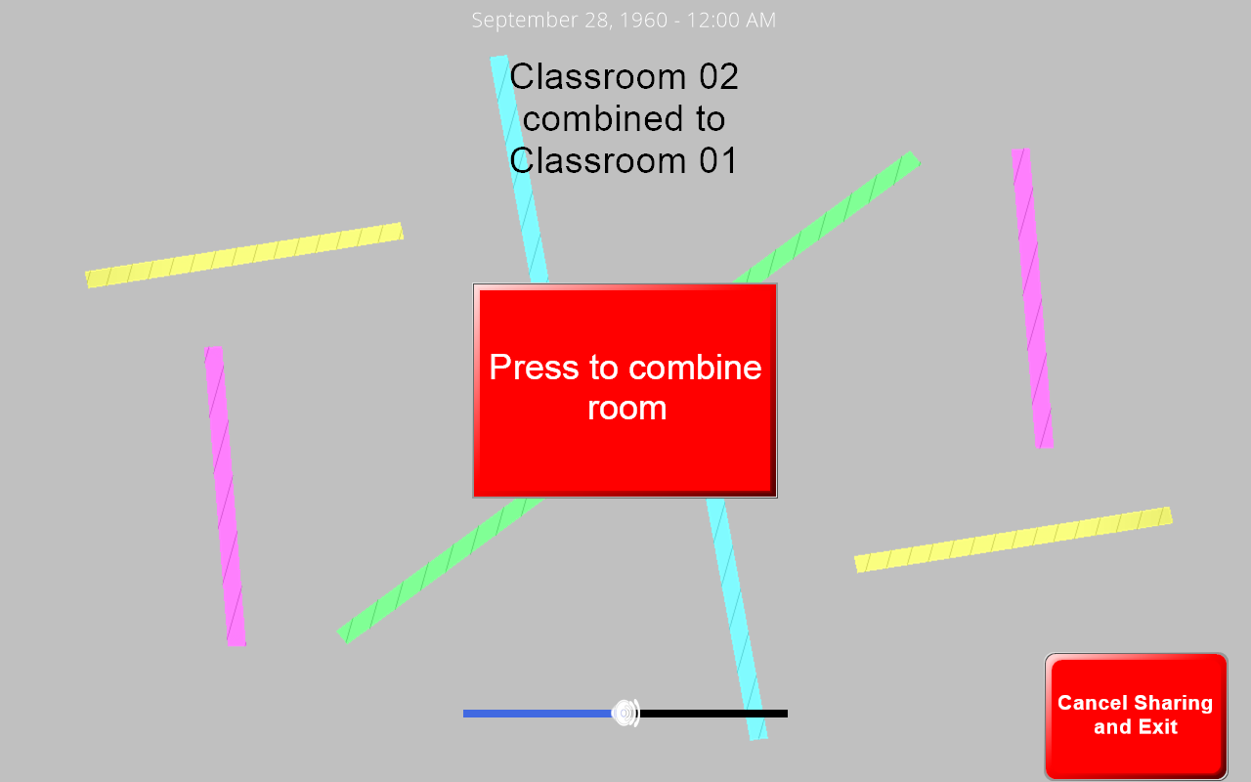
Room Combine pop-up

10. Ending Your Session
- Disconnect any laptop cables and remove USB-C/adaptor connections.
- You can either shut down individual screens by tapping the appropriate Display off button
- Or Tap Shutdown Both Displays on the bottom toolbar to turn off both the screens.
- If you used the document camera, return it to its folded, stored position.

11. Need Help?
If you experience a fault or need assistance during a session, tap Help & Information on the bottom toolbar, or contact University of Strathclyde IT/AV Support on +44 141 548 5999, or complete the "report a fault" form online at: https://www.strath.ac.uk/studywithus/ourcampus/whatsoncampus/it/hiringservice/technologyissuereporting/

