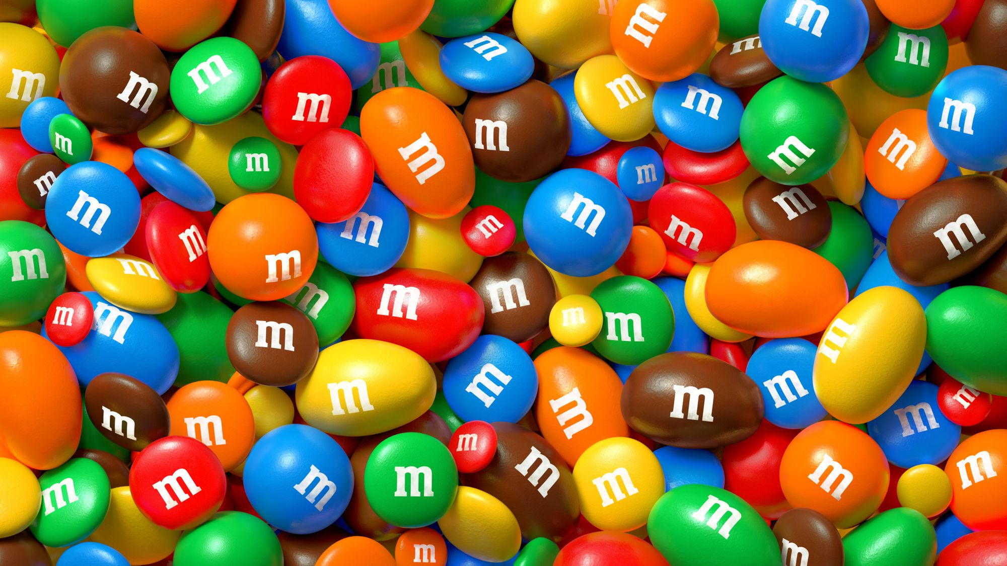
 | entrance | column | landmarks | a government | sculpture
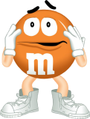 | origin | sight | royal | to  locate | to inspire
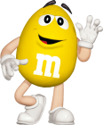 | to  fix | to destroy | wobbly | law | fountain
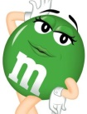 | Cairo | Egypt | Mexico | Egyptian | Scotland
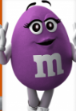 | along | towards | behind | over | away from
 | bridge | skyscraper | bell | tower | cathedral

 | entrance | column | landmarks | a government | sculpture
 | origin | sight | royal | to  locate | to inspire
 | to  fix | to destroy | wobbly | law | fountain
 | Cairo | Egypt | Mexico | Egyptian | Scotland
 | along | towards | behind | over | away from
 | bridge | skyscraper | bell | tower | cathedral

 | activity | creative | physical | both | fan
 | ballet | choir | violin | piano | guitar
 | hobby | gardening | cycling | drawing | skating
 | to collect | stamps | watches | stones | coins
 | be keen on | be good at | be fond of | be interested in | enjoy
 | attraction | maze | theme park | roundabout | adventure

 | activity | creative | physical | both | fan
 | ballet | choir | violin | piano | guitar
 | hobby | gardening | cycling | drawing | skating
 | to collect | stamps | watches | stones | coins
 | be keen on | be good at | be fond of | be interested in | enjoy
 | attraction | maze | theme park | roundabout | adventure
 | dad | cat | rat | fat | and
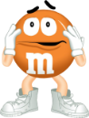 | mum | run | fun | up | jump
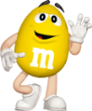 | pig | his | six | big | it
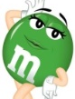 | pen | vet | red | ten | pet
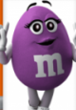 | dog | fox | frog | doll | hop
 | Tom | Liz | Ben | Sam | Ann

 | dad | cat | rat | fat | and
 | mum | run | fun | up | jump
 | pig | his | six | big | it
 | pen | vet | red | ten | pet
 | dog | fox | frog | doll | hop
 | Tom | Liz | Ben | Sam | Ann

 | capital | country | state | centre | Motherland
 | traffic | traffic lights | crossroads | main | square
 | modern | native | famous | independent | hero
 | chestnut | oak | leaf | leaves | grain
 | town | city | street | region | place

 | capital | country | state | centre | Motherland
 | traffic | traffic lights | crossroads | main | square
 | modern | native | famous | independent | hero
 | chestnut | oak | leaf | leaves | grain
 | town | city | street | region | place

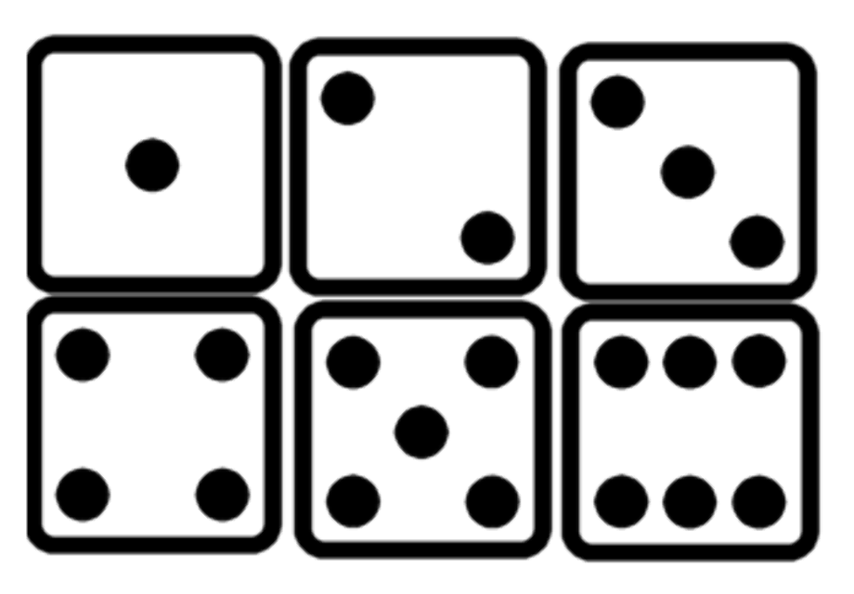
I | Name | Cat | Six | Five | Run
He | Cake | Jam | His | Kite | Swim
She | Take | Dad | Sit | Ride | Walk
It | Snake | Sam | Pig | Nice | Sing
We | Game | Rat | It | Like | Play
You | Jane | Fat | Did | Nine | Jump
They | Kate | Flat | Is | Bike | Paint

I | Name | Cat | Six | Five | Run
He | Cake | Jam | His | Kite | Swim
She | Take | Dad | Sit | Ride | Walk
It | Snake | Sam | Pig | Nice | Sing
We | Game | Rat | It | Like | Play
You | Jane | Fat | Did | Nine | Jump
They | Kate | Flat | Is | Bike | Paint

 | article | leaflet | world | famous | Union Jack
 | discover | display | spend | situated | include
 | trip | journey | choice | travel | tour
 | country | language | national | German | Japan
 | desert | dessert | sea | Pacific | ocean

 | article | leaflet | world | famous | Union Jack
 | discover | display | spend | situated | include
 | trip | journey | choice | travel | tour
 | country | language | national | German | Japan
 | desert | dessert | sea | Pacific | ocean

