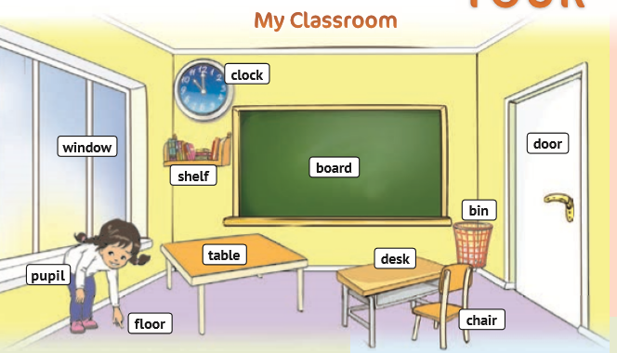

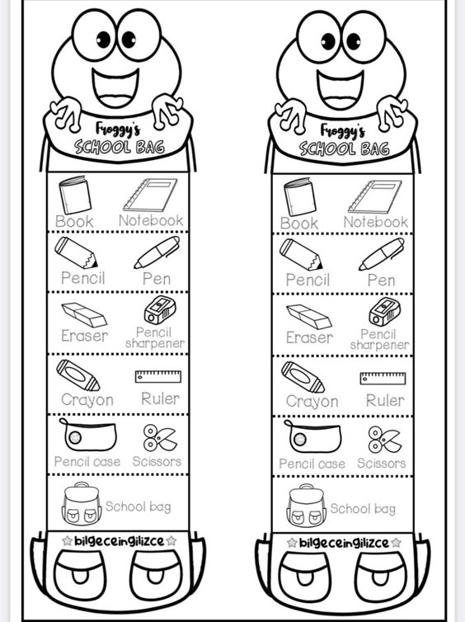
Scissors
Pencil case
Ruler
Crayon
Sharpener
Rubber
Pen
Pencil
Exercise-book
Book
School bag
School bag
Scissors
Pencil case
Ruler
Crayon
Sharpener
Rubber
Pen
Pencil
Book
Exercise-book
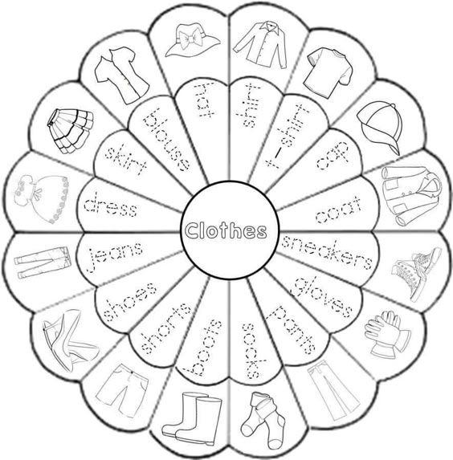

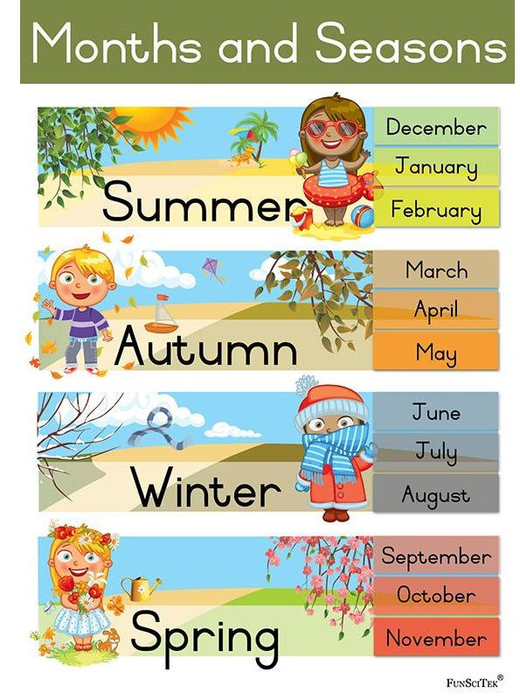

1 | one | +teen | eleven | 11
2 | two | +teen | twelve | 12
3 | three | +teen | thirteen | 13
4 | four | +teen | fourteen | 14
5 | five | +teen | fifteen | 15
6 | six | +teen | sixteen | 16
7 | seven | +teen | seventeen | 17
8 | eight | +teen | eighteen | 18
9 | nine | +teen | nineteen | 19
10 | ten | +teen | twenty | 20

1 | one | +teen | eleven | 11
2 | two | +teen | twelve | 12
3 | three | +teen | thirteen | 13
4 | four | +teen | fourteen | 14
5 | five | +teen | fifteen | 15
6 | six | +teen | sixteen | 16
7 | seven | +teen | seventeen | 17
8 | eight | +teen | eighteen | 18
9 | nine | +teen | nineteen | 19
10 | ten | +teen | twenty | 20

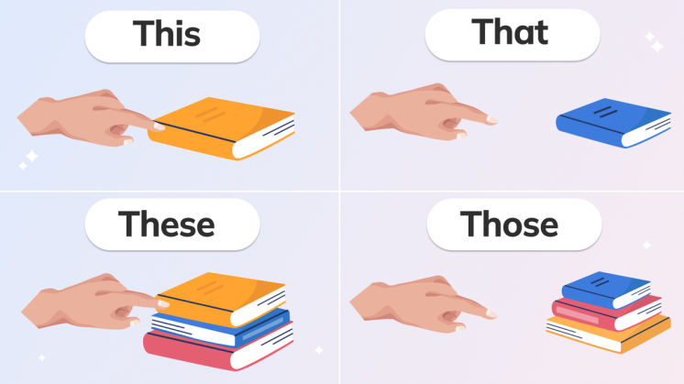

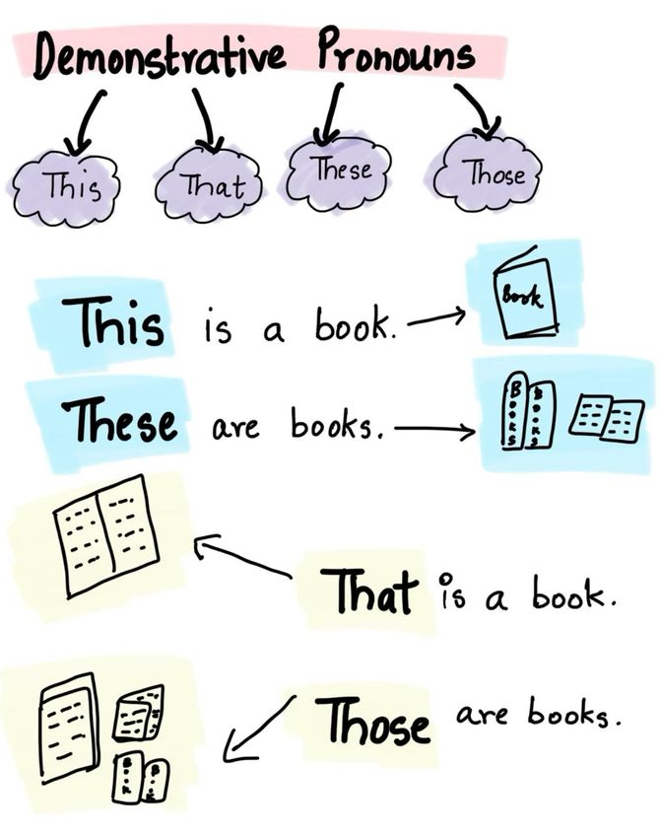

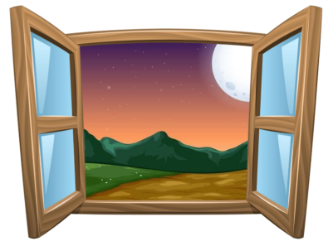
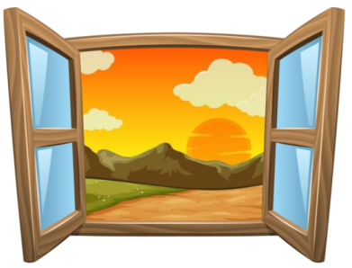
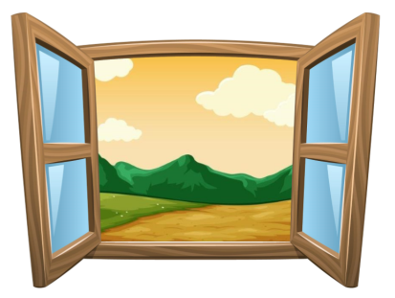
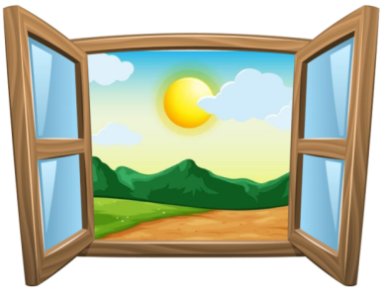

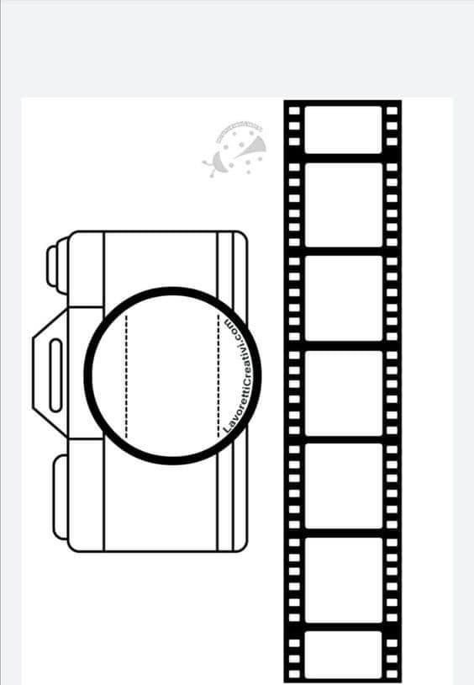

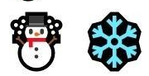
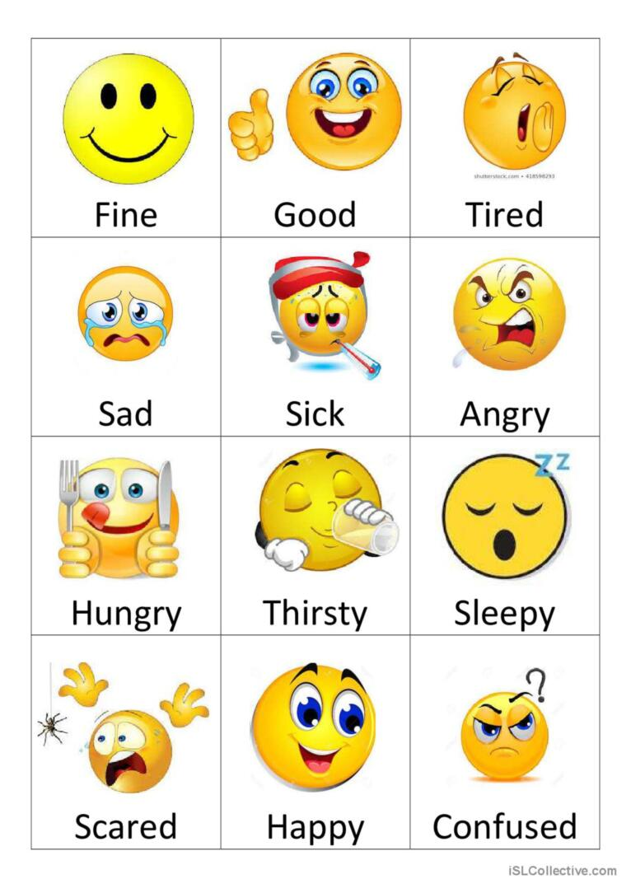

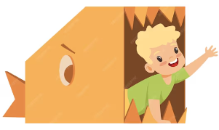
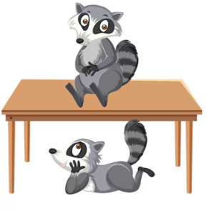
in
in
on
on
on
under
under
under
in

under
under

