f
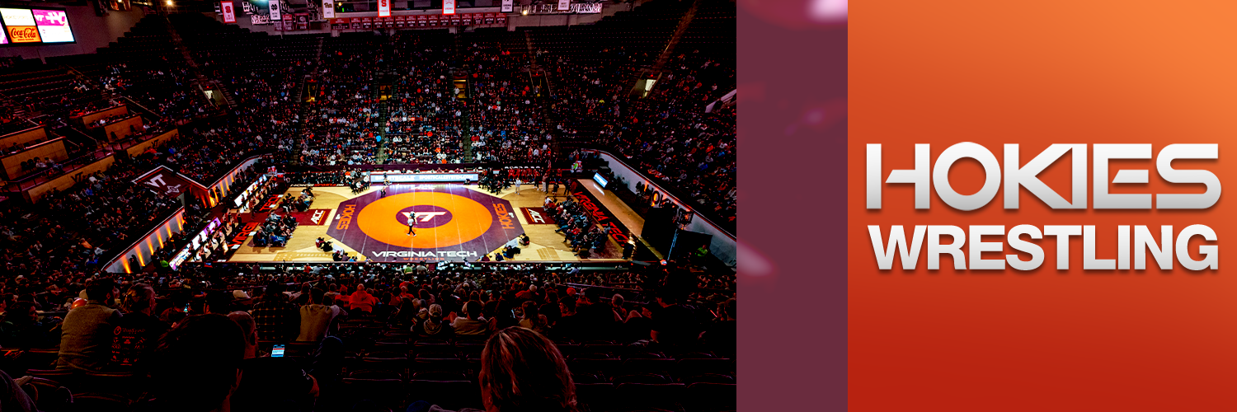

10 Top-11 NCAA Finishes / 14 CONFERENCE TITLES / 51 ALL-AMERICANS / 94 ACC CHAMPIONS / 1 NCAA CHAMPION
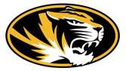
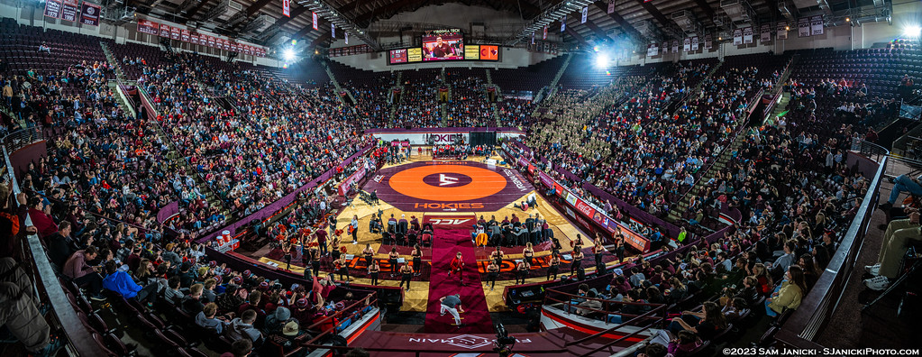
2023-2024
RECORD
ACC
NON-CONFERENCE HOME
AWAY
NEUTRAL

No. 11 VIRGINIA TECH HOKIES VS

No. 3 MISSOURI TIGERS

3-1, 0-0 ACC 4-0, 3-0 BIG 12
3-1
0-0
2-1
1-0
0-0

Head coach: Tony Robie
Record at Virginia Tech: 67-19 (7th season) Series Record vs. Missouri: 3-4
Head coach: Brian Smith Record at Missouri: 324-108-3 (25th season)
Series Record vs. Virginia Tech: 4-3

MATCH 5 | VIRGINIA TECH vs Missouri | Jan. 2, 2024 | 6:30 PM EST | Columbia, MO | Hearnes Center
@MizzouWrestling
QUICK COMPARISON
3-1 | Record | 4-0
5 | All-Americans | 5
3 | Conference Champions | 2
11 | NCAA Qualifiers | 10
1 | NCAA Champion | 1
3 | World Medalists/Team Members | 4

@HokiesWrestling

All times Eastern
* - ACC Match

////////////////////////////////////////////////////////////////////////////////////////////////////////////////////////////////////////////////////////////////////////////////////////////////
Day | Date | Opponent | TV | Time/Result
Sat.. | Nov. 4 | Southeast Open | FLO | 9:30AM
Fri. | Nov. 10 | #7 Ohio State | ACCNX | L, 12-24
Sun. | Nov. 12 | American University | ACCNX | W, 39-4
Fri. | Nov. 17 | at #14 Rutgers | B1G+ | W, 24-19
Sun. | Nov. 19 | at Keystone Classic | FLO | --
Sun. | Dec. 1 | at Cliff Keen LV | FLO | --
Sun. | Dec. 2 | at Cliff Keen LV | FLO | --
Sun. | Dec. 17 | #19 Stanford | ACCNX | W, 29-7
Sun. | Jan. 2 | at #3 Missouri | FLO | 6:30PM
Thu. | Jan. 7 | at #5 Cornell | TBD | 1PM
Sun. | Jan. 12 | Appalachian State | ACCNX | 7PM
Fri. | Jan. 26 | North Carolina * | ACCN | 7PM
Fri. | Feb. 2 | at Virginia * | ACCNX | 7PM
Fri. | Feb. 9 | Duke * | ACCN | 7PM
Sat. | Feb. 10 | George Mason | ACCNX | 4PM
Fri. | Feb. 16 | at Pittsburgh * | ACCN | 7PM
Fri. | Feb. 23 | at NC State * | ACCN | 7PM
Sun. | Mar. 10 | ACC Championships | ACCN | ALL DAY
Thu. | Mar. 21 | NCAA Championships | ESPN+ | ALL DAY
Fri. | Mar. 22 | NCAA Championships | ESPN+ | ALL DAY
Sat. | Mar. 23 | NCAA Championships | ESPN | ALL DAY

KEY STORYLINES

- The Hokies return all five of their All-Americans from a season ago including 2019 national champion and 3x All-American Mekhi Lewis and 2x All-American Bryce Andonian for their final year of eligibility.

- As a team Tech entered the season as No. 2, No. 3, and No. 5 according to Intermat, Flowrestling, and NWCA, respectively.

- Joining Lewis and Andonian to lead the Hokies are two-time All-American Sam Latona, Eddie Ventresca, and Caleb Henson. Tech also returns a total of 11 NCAA Qualifiers.

- Lewis looks to become the first 4x NCAA All-American in program history as he chases his second national title in his final year of eligibility.

- The Hokies finished ninth at the 2023 NCAA Championships, marking their 10th straight top-11 finish and the highest placing ACC team.

- Tech extended their streak of finishing with three or more All-Americans for the 10th straight season. The Hokies are one of only four programs to continue the streak – Penn State, Iowa, and Cornell.

- The Hokies boast the reigning ACC Freshman of the Year in Caleb Henson after claiming an ACC title and All-American honors as a true freshman.

- Head coach Tony Robie enters his seventh season at the helm after being elevated to head coach in 2017 after 15 years as an assistant in Blacksburg. Robie is the reigning 2023 ACC Coach of the Year – his fourth honor in seven seasons

HISTORY
Matches contested: 7
Virginia Tech record: 3-4
Home: 2-1
Away: 1-3
First meeting: L, 6-33, ‘04-05
Last meeting: W, 17-15, ‘22-23

QUICK FACTS
THE BASICS
University Name: Virginia Tech
Location: Blacksburg, Va.
Founded: 1872
Enrollment: 37,000
President: Dr. Timothy Sands
Director of Athletics: Whit Babcock Nickname: Hokies
Mascot: HokieBird
Colors: Chicago Maroon & Burnt Orange
Affiliation: NCAA Division I
Conference: Atlantic Coast

HOME VENUE
Cassell Coliseum
Capacity: 2,028

TEAM INFORMATION
2022-23 Record: 10-
Home / Away:
Conference Record: 4-1
Conference Regular Season: 1st
Conference Tournament Finish: 2nd
Postseason: 9th;
Five All-Americans

MEDIA INFORMATION
MEDIA ACCESS/CREDENTIALS
Outlets interested in obtaining media access to cover Virginia Tech wrestling home matches must apply for credentials through Ethan Aguigui (media contact) via email at aguigui@vt.edu.

All credentials for Virginia Tech home matches during the 2023 season will be issued on a single-match basis.

INTERVIEW POLICY
Matchdays: Virginia Tech head coach Tony Robie and requested student-athletes will be available to the media after the match.

Non-Matchdays: All coach and student-athlete interview requests need to be arranged through the Virginia Tech Strategic Communications Office - contact Ethan Aguigui by email at aguigui@vt.edu. Student-athletes and coaches should not be contacted directly under any circumstances.

WT. | 2023-2024  Name | Cl. |  | VIRGINIA TECH  Hometown | High School (College)
157 | Bryce Andonian | Sr. |  | Kirtland, OH | St. Edward’s
141 | Chris Bacchioni | Fr. |  | Wayne, NJ | Bergen Catholic
133 | Jack Bastarrika | Fr. |  | Flanders, NJ | Mount Olive
165 | Connor Brady | r-Jr. |  | Powell, OH | Liberty
174 | James Brown | r-So. |  | Clarks Summit, PA | Abington Heights
285 | Hunter Catka | r-Jr. |  | Brookhaven, PA | Sun Valley
141 | Donovan Chavis | Fr. |  | Green Township, NJ | Saint Peter’s Prep
141 | Mac Church | Fr. |  | Waynesburg, PA | Waynesburg Central
174 | Kolton Clark | r-Sr. |  | Scottsboro, AL | Scottsboro
149 | Tom Crook | So. |  | Tampa, FL | Tampa Jesuit
165 | Ty Finn | r-So. |  | Simsbury, CT | Simsbury
184 | Sam Fisher | r-Jr. |  | Warrenton, VA | Fauquier
125 | Cooper Flynn | r-So. |  | Seymour, TN | McDonough School (MD)
133 | Logan Frazier | Fr. |  | Crown Point, IN | Crown Point
MD | Brandon Green | Sr. |  | Swedesboro, NJ | Paulsboro
133 | Caden Hagler | r-So. |  | Charlottesville, NC | Providence Day
149 | Caleb Henson | So. |  | Cartersville, GA | Woodland
157 | Rafael Hipolito | Fr. |  | Manaus, Brazil | Independence (VA)
184 | Dakota (Cody) Howard | Sr. |  | Cleveland, OH | St. Edward’s
133 | Sam Latona | r-Jr. |  | Alabaster, AL | Thompson
174 | Mekhi Lewis | Sr. |  | Somerset, NJ | Bound Brook
141 | Hunter Mason | Fr. |  | Greeneville, TN | Greeneville
157 | Kylan Montgomery | Jr. |  | Mascoutah, IL | Mascoutah
285 | Jimmy Mullen | Fr. |  | Kearney, NJ | St. Joe’s Regional
149 | Luke Robie | Fr. |  | Christiansburg, VA | Christiansburg
197 | Sonny Sasso | Fr. |  | Nazareth, PA | Nazareth
197 | Andy Smith | r-Jr. |  | Christiansburg, VA | Christiansburg
157 | Jackson Spires | r-So. |  | Erie, PA | General McLane
197 | Thomas Stewart, Jr. | r-Fr. |  | Triangle, VA | Blair Academy
157 | Clayton Ulrey | r-Jr. |  | Grantville, PA | Lower Dauphin
125 | Eddie Ventresca | r-So. |  | Roxbury, NJ | Pope John XXIII
149 | Preston Walls | r-So. |  | Orlando, FL | Lake Highland Prep

/////////////////////////////////////////////////////////////////////////////////////////////////////////////////////////////////////////////////////////////////////////

PRONUNCIATION GUIDE
Bryce Andonian | An-DOH-ni-an
Chris Bacchioni | Bah-SHE-oh-ni
Donovan Chavis | Shave-is
Rafael Hipolito | Hip-oh-LEE-toh
Sam Latona | La-toh-na
Luke Robie | ROH-bee
Clayton Ulrey | Uhl-ray
Eddie Ventresca | Ven-tres-cah

TECH LAST TIME OUT
- Tech handled visiting No. 19 on December 17, defeating the Cardinal 29-7
- Redshirt sophomore Cooper Flynn earned ACC and NCAA Wrestler of the Week honors; pulled out of Olympic redshirt en route to defeating No. 4 Nico Provo
- The Hokies secured four bonus point victories from No. 5 Sam Latona (133-pounds; 12-3), No. 2 Caleb Henson (149-pounds; 20-5), No. 2 Mekhi Lewis (174-pounds; 8-0), and Cody Howard (184-pounds; 13-3)
- Additionally, the Hokies had three upset victories over the Cardinal from Flynn (125-pounds; 5-2 vs No. 4 Nico Provo), No. 24 Connor Brady (165-pounds; 10-3 vs No. 16 Hunter Garvin), and Sonny Sasso (197-pounds; 8-4 vs No. 14 Nick Stemmet)

HOKIES IN THE RANKINGS
- Tech enters the dual ranked No. 11 in the latest National Wrestling Coaches Association polls, No. 8 according to Intermat, and No. 6 courtesy of Flowrestling
- The Hokies feature nine ranked wrestlers in the latest Intermat rankings led by No. 2 Caleb Henson (149-pounds) and No. 2 Mekhi Lewis (174-pounds). Also ranked in the top-10 are No. 5 Sam Latona (133-pounds), No. 8 Bryce Andonian (157-pounds), and No. 10 Cooper Flynn (125-pounds).
- No. 18 Sam Fisher (184-pounds), No. 20 Hunter Catka (285-pounds), No. 24 Connor Brady (165-pounds), and No. 25 Andy Smith (197-pounds) round out the remaining ranked Hokies

All-time vs the Tigers
- Tuesday’s match will be the eighth between the two programs, with Missouri leading the series 3-4
- Despite the Tigers leading the series, Tech has won the last three meetings with the last two both by two points in the team score
- The two programs first met in the 2004-2005 season in a 6-33 loss for the Hokies
- The Hokies notched their first win of the series in 2019, 29-10 in Cassell Coliseum

HOKIES VS TIGERS
- In the last meeting against Mizzou, the Hokies narrowly defeated the then higher ranked Tigers, 17-15 on December 11, 2022 in Blacksburg
- Tech saw major decision victories from Cooper Flynn and Hunter Bolen while notching three victories from Sam Latona, Mekhi Lewis, and a pivotal win from Clayton Ulrey

SCOUTING THE TIGERS
- The Tigers present nine ranked wrestlers led by No. 1 at 165-pounds, Keegan O’Toole
- Mizzou also features five All-Americans on roster to match Tech’s five from a season ago
- The Hokies and Tigers combine for seven previous world team members
- Both squads feature one NCAA Champion (Mekhi Lewis & O’Toole)

PROBABLES
  - 125-pounds
    - No. 10 Cooper Flynn (VT) vs No. 2 Noah Surtin (MIZ)

  - 133-pounds
    - No. 6 Sam Latona (VT) vs Kade Moore (MIZ)

  - 141-pounds
    - Tom Crook Mac Church or Hunter Mason (VT) vs No. 20 Josh Edmond (MIZ)

  - 149-pounds
    - No. 2 Caleb Henson (VT) vs No. 22 Logan Gioffre (MIZ)

  - 157-pounds
    - No. 7 Bryce Andonian (VT) vs No. 9 Brock Mauller (MIZ)

  - 165-pounds
    - No. 26 Connor Brady (VT) vs No. 1 Keegan O’Toole (MIZ)

  - 174-pounds
    - No. 2 Mekhi Lewis (VT) vs TBD

  - 184-pounds
    - No. 18 Sam Fisher OR Dakota Howard (VT) vs No. 7 Clayton Whiting (MIZ)

  - 197-pounds
    - No. 24 Andy Smith OR Sonny Sasso (VT) vs No. 5 Rocky Elam or Colton Hawks (MIZ)

  - 285-pounds
2023-2024 STANDINGS
    - No. 20 Hunter Catka (VT) vs No. 5 Zach Elam (MIZ)
TEAM | ACC | OVERALL
Virginia Tech | 0-0 | 2-1
NC State | 0-0 | 4-0
Pittsburgh | 0-0 | 2-1
North Carolina | 0-0 | 4-1
Virginia | 0-0 | 0-0
Duke | 0-0 | 2-4

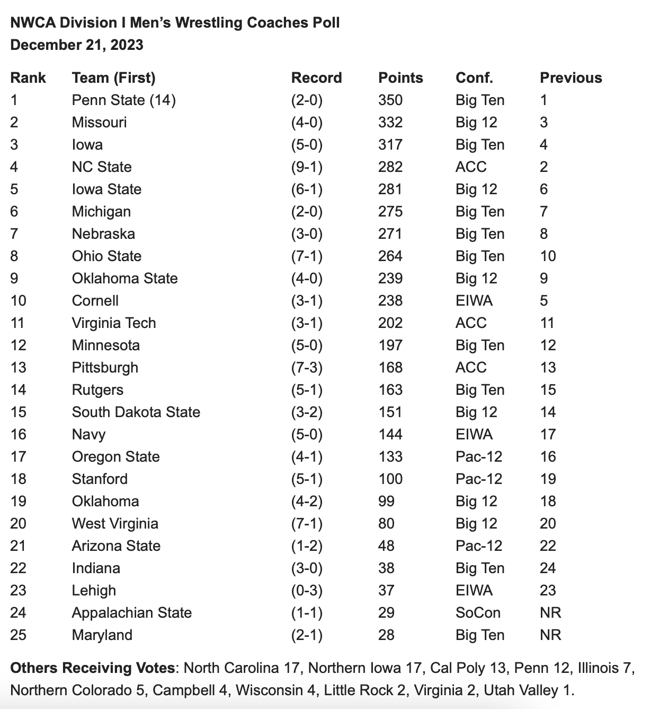

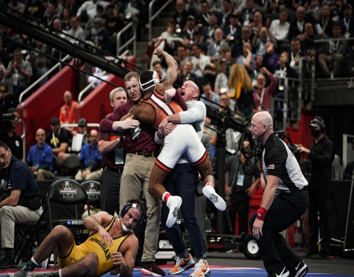
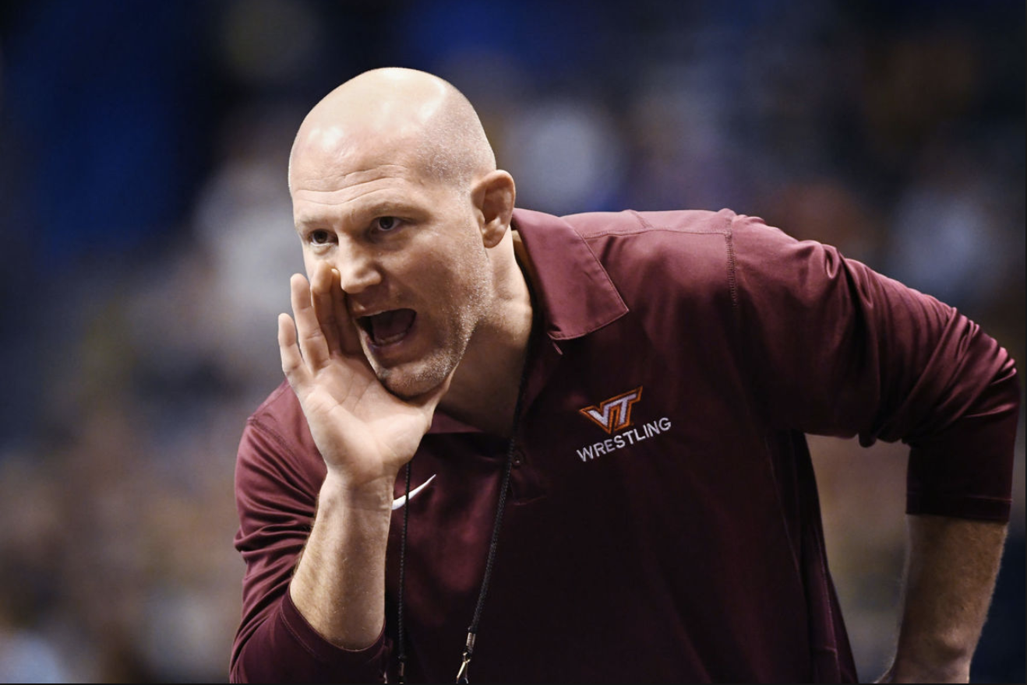
When Virginia Tech head wrestling coach Tony Robie arrived in Blacksburg in 2006, he was an associated head coach who inherited a barren program that had the potential to be great. Progressively he helped build the Hokies into one of the top programs in the ACC and a mainstay in the top-10 nationally. Six full seasons into his tenure as head coach, Robie is still leading the Hokies into new territory.
Year-By-Year Record
Most NCAA Appearances by Tech coaches
THE ROBIE FILE
Coaching Exp.: 24th season, 17th at Tech Head Coach: 8th season, 7th at Tech Record at Tech: 64-18
Overall Record: 64-18
College: Edinboro University (1997)
Playing Exp: Edinboro University; 1997 NCAA Finalist, two-time All-American, three-time EWL Champion, 126-23 career record, Edinboro Sports Hall of Fame.
Tony Robie

Robie led the Hokies to a record season in 2022-2023 to the beat of a ninth-place finish along with five All-Americans at the 2023 NCAA Championships in Tulsa. Tech placed the highest among ACC teams and the five All-Americans – Eddie Ventresca, Sam Latona, Caleb Henson, Bryce Andonian, and Mekhi Lewis – were the second-best in program history. The Hokies made history again under Robie’s leadership with ten automatic qualifiers for the first time in program history and just the second time Tech qualified ten wrestlers to the NCAA Championships. Robie also led Tech to a 10-3 dual record which saw the program garner an ACC regular season title and finish with two ACC champions. With a stellar season, Robie was named 2023 ACC Coach of the Year – the fourth honor in seven seasons for the head man.

History was made once again in the 2021-2022 season that saw Mekhi Lewis reach the NCAA finals for the second time in his career – the only two-time finalist in program history – under Robie’s tutelage. The Hokies also secured All-American finishes from Bryce Andonian and Korbin Myers to place eleventh in Detroit. Robie was once again named ACC Coach of the Year to add to his mantle.
TECH RECORD
YEAR | SCHOOL | RECORD
2017-18 | Virginia Tech | 14-3
2018-19 | Virginia Tech | 9-5
2019-20 | Virginia Tech | 11-3
2020-21 | Virginia Tech | 9-0
2021-22 | Virginia Tech | 9-4
2022-23 | Virginia Tech | 10-3
2023-24 | Virginia Tech | 1-1
TOTALS: |  | 64-19

Robie led the Hokies to a historic season in 2020-2021, piloting the first undefeated season in program history since 1956-57. At 9-0 under Robie’s guidance, the Hokies completed their longest undefeated season in program history, topping 1954-1955’s 8-0 mark. With the feat, Robie joined Frank Teske, George Herring, and S.B. Sutton. Tech won its fourth ACC Dual Meet title after posting a perfect 5-0 ACC dual record, the second such title in Robie’s tenure and fourth ACC Championship with Robie at the helm.

In 2019-2020, the program rose the ranks to No. 3 in the National Wrestling Coaches of America Coaches’ Poll, the highest rank under Robie and tied for the highest in its history at the time. He helped the progression of redshirt sophomore Hunter Bolen, who went on to win his first ACC title in 2020 and was the No. 2 seed for the 2020 NCAA Championships at 184-pounds.

In 2018-2019, Robie helped guide Mekhi Lewis to the program’s first national championship and Most Outstanding Wrestler honors at the 2019 NCAA Championships in Pittsburgh. Lewis’ title run at 165-pounds wrapped up a season that saw the Hokies finish in the top-11 at the NCAA Championships for the eighth consecutive season and a top-two placing at the ACC Championships for the seventh-straight year. Tech had three All-Americans and three ACC champions in Lewis, David McFadden, and Zack Zavatsky. Robie’s performance earned him 2019 ACC Coach of the Year accolades, the second time receiving the honor.

In his first season leading the program, Robie continued Virginia Tech wrestling’s run of success as the Hokies won its second consecutive ACC Championship and placed eighth at the NCAA Championships in Cleveland. Robie became the first coach in the history of ACC wrestling to guide his team to conference championships in his first two seasons. With Robie on staff, Virginia Tech has won 12 ACC titles over the last seven years and 10 conference trophies overall when including dual meet championships.

In Robie’s first full campaign, Virginia Tech placed at least three wrestlers on the podium at nationals for the sixth consecutive season. Jared Haught led the group of three All-Americans in 2018 by becoming the Hokies’ second-ever national finalist, joining Devin Carter in 2014. Four Hokies – Haught, David McFadden, Brent Moore, and Dennis Gustafson – won ACC titles, with Moore taking home Most Valuable Wrestler honors. Robie also coached McFadden to a regular season record of 30-0, the first undefeated season at Virginia Tech since 2001-02.

In duals, Robie led the Hokies to a 14-3 overall record, a 4-1 mark in ACC matches and a final ranking of No. 10 in the final NWCA Coaches’ Poll. Robie’s 14 dual meet victories ranks second in the ACC record book for most wins by a first-year head coach behind Wade Schalles’ 15 wins with Clemson in 1978. His .824 winning percentage ranks third all-time in ACC history for a rookie head coach. In Virginia Tech history, Robie’s winning percentage ranks first among rookie head coaches while his 14 wins ranks second behind Tom Brands’ 16 dual meet wins in 2004-2005. Robie, who started five freshmen in duals for a majority of the season, was also named a finalist for the Theraworx NWCA National Coach of the Year award.

On March 21, 2017, Robie was promoted to head wrestling coach at Virginia Tech after serving as interim head coach since February of that year. During that span, Robie led the Hokies to the team title at the ACC Championships and a sixth-place finish at the 2017 NCAA Championships in St. Louis – Tech’s fifth-straight top-10 finish at nationals.

Robie was an integral part of the Virginia Tech wrestling staff for 11 seasons as associate head coach under former head coach Kevin Dresser. Between that 2006-07 and 2016-17, the Hokies won three ACC Dual Meet Championships, three ACC tournament championships, and finished in the top-10 at the NCAA Championships five times. One of those top-10 team finishes included a then-ACC record and program best fourth place and six All-American finish in 2016. He also helped recruit and coach 17 ACC champions and 14 All-Americans.

Robie came to Blacksburg after serving as the head coach at Binghamton University, a program that had been discontinued after the 2003-04 school year because of budget constraints. Before taking over at Binghamton, he was an assistant coach for four seasons at the University of Michigan.

In seven years as a Division I assistant coach, Robie helped coach 23 All-Americans, nine Academic All-Americans, and one national champion. As the Wolverines’ top assistant coach, Robie recruited three top-10 classes, including the No. 2 ranked class in 2004. His one-on-one work with Michigan student-athlete Ryan Bertin culminated with Bertin’s 2003 NCAA championship – the school’s first national champion in 18 years. In all, Michigan’s team earned national top-10 status all four years that Robie was a coach there. His dedication and influence off the mat resulted in the team winning the 2003 community service award at the school.

Robie joined the Michigan staff after coaching stops at West Virginia (1998-99) and Edinboro (1999-00).

KEY STORYLINES, CTD.

WT. | 2023-2024  Name | Season  Record |  | VIRGINIA TECH  Career Record
157 | Bryce Andonian | 13-3 |  | 65-21
141 | Chris Bacchioni | 2-4 |  | 2-4
133 | Jack Bastarrika | 5-6 |  | 5-6
165 | Connor Brady | 8-4 |  | 51-35
174 | James Brown | 5-4 |  | 10-17
285 | Hunter Catka | 8-4 |  | 47-22
141 | Donovan Chavis | 8-5 |  | 8-5
141 | Mac Church | 6-6 |  | 6-6
174 | Kolton Clark | 6-5 |  | 27-20
149 | Tom Crook | 11-2 |  | 27-13
165 | Ty Finn | 9-6 |  | 33-17
184 | Sam Fisher | 13-6 |  | 42-19
125 | Cooper Flynn | 5-2 |  | 36-11
133 | Logan Frazier | 8-4 |  | 8-4
MD | Brandon Green | -- |  | --
133 | Caden Hagler | 3-6 |  | 9-18
149 | Caleb Henson | 17-1 |  | 48-6
157 | Rafael Hipolito | 11-3 |  | 11-3
184 | Dakota (Cody) Howard | 6-1 |  | 49-31
133 | Sam Latona | 13-3 |  | 90-26
174 | Mekhi Lewis | 4-0 |  | 116-11
141 | Hunter Mason | 12-4 |  | 12-4
157 | Kylan Montgomery | 9-6 |  | 22-18
285 | Jimmy Mullen | 8-2 |  | 8-2
149 | Luke Robie | 8-2 |  | 8-2
197 | Sonny Sasso | 10-7 |  | 10-7
197 | Andy Smith | 9-4 |  | 45-27
157 | Jackson Spires | 1-1 |  | 23-16
197 | Thomas Stewart, Jr. | 1-1 |  | 17-6
157 | Clayton Ulrey | 9-4 |  | 45-28
125 | Eddie Ventresca | 2-7 |  | 38-22
149 | Preston Walls | 4-6 |  | 8-13

HONORS & ACCOLADES
Eddie Ventresca
- 2023 All-American (7th Place, 125-pounds)
- 2023 ACC Finalist

Cooper Flynn
- 2023 U23 World Team Member
- 2023 U23 Freestyle National Champion

Sam Latona
- 2023 All-American (7th Place, 133-pounds)
- 2021 All-American (6th Place, 125-pounds)
- Three-time NCAA Qualifier
- 2021 ACC Champion
- 2021 ACC Freshman of the Year

Tom Crook
- 2023 NCAA Qualifier
- 2023 ACC Placer

Hunter Mason
- Four-time Undefeated TN State Champion
- 2023 Southeast Open Champion

Mac Church
- Two-time PA State Champion
- Four-time PA state placer

Caleb Henson
- 2023 All-American (5th Place, 149-pounds)
- 2023 ACC Champion
- 2023 ACC Freshman of the Year

Bryce Andonian
- 2023 All-American (7th Place, 157-pounds)
- 2022 All-American (3rd Place, 149-pounds)
- Four-time ACC Finalist
- Four-time NCAA Qualifier
- 2021 Junior World Bronze Medalist
- 2021 US Open Champion

Connor Brady
- Three-time NCAA Qualifier
- 2023 ACC Finalist
- Three-time ACC Placer

Rafael Hipolito, Jr.
- 2023 Southeast Open Champion
- Three-time State Champion (1x Alabama, 2x Virginia)
- Multiple-time Brazilian Jiu-Jitsu World Champion

Mekhi Lewis
- 2023 All-American (4th, 174-pounds)
- 2022 All-American (2nd, 174-pounds
- 2022 ACC Wrestler of the Year
- 2019 ACC Wrestler of the Year & Freshman of the Year
- 2019 National Champion and Most Outstanding Wrestler (165-pounds)
- 2019 ACC Champion
- 2018 Junior World Champion

Dakota (Cody) Howard
- 2021 NCAA Qualifier

Sam Fisher
- 2022 Pan-Am Champion
- 2022 US Open U20 Champion

Andy Smith
- Two-time NCAA Qualifier
- Two-time ACC Placer

Sonny Sasso
- 2023 Cliff Keen Placer
- Two-time PA State Champion
- Three-time PA State Placer

Hunter Catka
- 2023 NCAA Qualifier
- 2021 NCAA Qualifier
- 2021 ACC Finalist
- Cadet World Team Member

V

Eddie Ventresca, 125-pounds, 2-7
- Loss vs Brendan McCrone (Ohio State), 3-11
- Loss vs #15 Jack Maida (American), 0-9
- Loss vs Dean Peterson (Rutgers), 0-2
- Win vs Brady Pruett (UPenn), 19-4, 6:00
- Win vs Eric Howe (Franklin & Marshall), 14-3
- Loss vs Max Gallagher (UPenn), 5-8 SV
- Loss vs Logan Agin (Duke), Med For
- Loss vs Desmond Pleasant (Drexel), Med For
- Loss vs Dominic Mendez (Cal Poly), 4-14
- Loss vs Noah Luna (App State), 2-14

No. 10 Cooper Flynn, 125-pounds, 5-2
- Win vs No. 4 Nico Provo (Stanford), 5-2
- Win vs Jace Schafer (West Virginia), 9-2
- Win vs Ben Aranda (Cleveland State), 4-2
- Win vs Sean Spidle (Central Michigan), 4-1 TB-1
- Loss vs Luke Stanich (Unatt-Lehigh), 3-5
- Win vs No. 25 Diego Sotelo (Harvard), 3-2
- Loss vs No. 9 Eric Barnett (Wisconsin), 0-1

No. 5 Sam Latona, 133-pounds, 13-3
- Win vs Kase Mauger (Utah Valley), 12-2
- Win vs Kevin Lopez (Morgan State), 17-2, 4:31
- Loss vs Gabe Whisenhunt (Oregon State), 9-10
- Win vs Keyveon Roller (Virginia), 14-1
- Win vs Thaddeus Long (Life U), 12-4
- Win vs Nick Bouzakis (Ohio State), 7-5
- Win vs Maximillian Leete (American), 12-1
- Win vs Dylan Shawver (Rutgers), 4-1 SV
- Win vs No. 16 Tyler Knox (Stanford), 12-3
- Win vs Joshua Robinson (North Central IL), 5-3
- Win vs Andrew Austin (Central Michigan), 10-3
- Loss vs No. 31 Zeth Romey (Cal Poly), 2-3
- Win vs Zan Fugitt (Wisconsin), 5-4
- Win vs No. 19 Julian Chlebove (Arizona State), 4-2
- Loss vs No. 11 Michael Colaiocco (UPenn), 4-5
- Win vs Mason Leiphart (Franklin & Marshall), 6-2

Tom Crook, 141-pounds, 11-2
- Win vs Ty Smith (Utah Valley), 17-2 (149)
- Win vs Justin Rivera (Campbell), 9-4 (149)
- Win vs Callum Sitek (Campbell), 6:27 (149)
- Win vs Michael Gioffre (Virginia), 4-1 (149)
- Loss vs Ty Watters (West Virginia), 2-4 (149)
- Win vs Sebastiano Nini (Rutgers), 19-4, 4:45 (149)
- Loss vs Cross Wasilewski (PRTC), 4-5 (149)
- Win vs Luke Robie (Virginia Tech), 13-6 (149)
- Win vs Shaun Quirk (Messiah), 17-2, 3:21 (149)
- Win vs Melvin Miller (Unattached), 8-0 (149)
- Win vs Brandon Cannon (Ohio State), 6-4
- Win vs Pat Phillips (Franklin & Marshall), 2-1
- Win vs No. 24 Danny Pucino (Illinois), 8-1
- Loss vs No. 14 Jordan Titus (West Virginia), 6-9
- Win vs Jordan Hamdan (Michigan State), 8-2
- Win vs No. 24 Danny Pucino (Illinois), 8-4

Mac Church, 141-pounds, 6-6
- Loss vs Mitch Moore (Rutgers), 1-2
- Loss vs CJ Composto (UPenn), 2-9
- Win vs James Emmer (Utah Valley), 8-3
- Win vs Isaac Byers (App State), 1-4 SV
- Loss vs Pat Phillips (Franklin & Marshall), 2-4
- Win vs Kaden Keiser (App State), 9-6
- Win vs Bryce Kresho (Franklin & Marshall), 13-5
- Loss vs #27 Jason Miranda (Stanford), 0-3
- Win vs maj dec Bradley Rosen (North Central Illinois), 12-2
- Win vs Shannon Hanna (Campbell), 3-2 TB-1
- Loss vs No. 11 CJ Composto (UPenn), 2-5
- Loss vs Jordan Hamdan (Michigan State), 2-10 TB-1

Hunter Mason, 141-pounds, 9-2
- Win vs Isaiah Powe (Chattanooga), 5:53
- Win vs Clayton Gabrielson (Maryland), 15-3
- Win vs Logan Cravatas (Ohio), 16-7
- Win vs Garrett Hughes (Roanoke College), 3:17
- Win vs Mark Samuel (Roanoke College), 1:44
- Loss vs Jesse Mendez (Ohio State), 3-18, 5:00
- Win vs Cael McIntyre (American), 7-1
- Win vs Kaden Keiser (App State), 16-7
- Win vs Frank Antoelli (Navy), 22-2, 7:00
- Win vs Nico Nardone (UPenn), 8-5
- Loss vs Evan Mougalian (Unatt-PRTC), 3-16
- Win vs Danny Curran (Northern Illinois), 16-7
- Loss vs Dominic Hargrove (George Mason), 0:42
- Win vs Matt Berlin (Unattached), 5-3
- Win vs Nico Nardone (UPenn), 3:37
- Loss vs Jordan Hamdan (Michigan State), 2-4

No. 2 Caleb Henson, 149-pounds, 17-1
- Win vs Luca Errico (Virginia), 1:41
- Win vs Michael Dolan (West Virginia), 19-3, 3:27
- Win vs Callum Sitek (Campell), 1:33
- Win vs Shannon Hanna (Campbell) 5-1
- Win vs Ty Watters (West Virginia), 11-2
- Win vs Dylan D’Emilio (Ohio State), 10-5
- Win vs Ryan Zimmerman (American), 17-2
- Win vs Jacob Butler (Rutgers), 4-1
- Win vs Isaiah Delgado (Utah Valley), 11-0
- Win vs Sean Seefeldt (UPenn), 22-6, 4:24
- Win vs Kelly Dunnigan (UPenn), 20-4, 6:30
- Win vs Jackson Polo (UPenn), 19-3, 4:36
- Win vs Alek Martin (South Dakota State), 11-2
- Win vs Derek Raike (Ohio University), 15-0, 6:08
- Win vs Chance Lamer (Cal Poly), 10-6
- Win vs Kyle Parco (Arizona State), 5-0
- Loss vs Ridge Lovett (Nebraska), 3-4
- Win vs Dawson Sihavong (Stanford), 20-5, 5:38

No. 8 Bryce Andonian, 157-pounds, 13-3
- Win vs Paddy Gallagher (Ohio State), 7-4
- Win vs Kaden Hilheim (American), 1:36
- Win vs Al DeSantis (Rutgers), 13-5
- Win vs Connor Trowbridge (Drexel), 21-5
- Win vs Kyler Lake (Utah Valley), 19-3
- Win vs Jude Swisher (UPenn), 21-6
- Win vs No. 21 Tommy Askey (App State), 0:37
- Win vs Carter Baer (Binghamton), 19-4, 6:07
- Loss vs Meyer Shapiro (Cornell), 4-16
- Win vs Charlie Evans (Navy), 6:03
- Win vs Cael Swensen (South Dakota State), 7-3
- Win vs Cody Chittum (Iowa State), 1:16
- Win vs No. 14 Daniel Cardenas (Stanford), 17-7
- Loss vs No. 7 Ed Scott (NC State), 7-18
- Loss vs No. 8 Daniel Cardenas (Stanford), 7-15

No. 25 Connor Brady, 165-pounds, 8-4
- Loss vs Isaac Wilcox (Ohio State), 5-6
- Win vs Nicholas Franzen (Sacred Heart), 21-5, 4:22
- Win vs Kaya Sement (UPenn), 5-1
- Win vs Aiden Wallace (Duke), 10-3
- Loss vs Tyler Lillard (Indiana), 2-4
- Win vs Aiden Wallace (Duke), 10-3
- Win vs Cody Walsh (Drexel), 4-1
- Win vs Will Miller (App State), 11-4
- Win vs Domonic Baker (Campbell), 4-2
- Loss vs Garrett Thompson (Ohio University), 2:34
- Win vs Benjamin Haubert (Citadel), 4-2
- Loss vs Will Miller (App State), 1-5
- Win vs No. 16 Hunter Garvin (Stanford), 10-3

Rafael Hipolito, Jr., 165-pounds, 9-1
- Win vs Emilio Arellano (Tiffin), 1:48
- Win vs Gunner Endicott (Campbell), 19-3, 5:57
- Win vs Cullen Kane (North Carolina), 4:15
- Win vs Dom Parker (West Virginia), 17-4
- Win vs Chris Earnest (Campbell), 6-2
- Win vs Anthony White (Rutgers), 13-7
- Win vs Geatano Console (Duke), 17-2, 1:41
- Win vs Will Miller (App State), 10-5
- Loss vs Tyler Lillard (Indiana), 7-9
- Win vs Ty Finn (Virginia Tech), 4-2
- Win vs Bradley Gillum (SIU Edwardsville), 20-4
- Win vs Caden Ernd (Illinois), 17-5
- Loss vs No. 18 Maxx Mayfield (Northwestern), 1-17
- Loss vs Tate Geiser (Cleveland State), 2-11

No. 2 Mekhi Lewis, 174-pounds, 4-0
- Win vs Carson Kharchla (Ohio State), 4-2
- Win vs Lucas White (American), 20-3
- Win vs Jackson Turley (Rutgers), 8-3
- Win vs No. 20 Lorenzo Norman (Stanford), 8-0

No. 18 Sam Fisher, 184-pounds, 13-6
- Win vs Landon Lewis (Chattanooga), 28-6
- Win vs Caleb Hopkins (Campbell), 7-3
- Win vs Kyle Homet (Life U), 4-1 SV
- Loss vs Trey Munoz (Oregon State), 2-8
- Loss vs Ryder Rogotzke (Ohio State), 5:35
- Win vs Connor Bourne (American), 4-1
- Win vs Brian Soldano (Rutgers), 10-9
- Win vs Conor Becker (Duke), 11-2
- Win vs Roman Rogotzke (Indiana), 9-5
- Win vs Mahonri Rushton (Utah Valley), 4-1 SV
- Loss vs James Conway (Franklin & Marshall), 5-8 SV
- Win vs Adam Ortega (Citadel), 9-3
- Loss vs Gavin Hoffman (Ohio State), 1-2
- Win vs Aaron Ayzerov (Columbia), 2:15
- Win vs Quayin Short (Wyoming), 4-3
- Win vs Gavin Kane (North Carolina), 4-2
- Loss vs Dustin Plott (Oklahoma State), 1:44
- Loss vs Dylan Fishback (North Carolina State), 4-16

Dakota Howard, 184-pounds, 7-1
- Win vs Jack Darrah (Stanford), 13-3
- Win vs Shane Moran (Omega Training Center), 19-3
- inj def over No. 26 Dylan Connell (Illinois)
- Loss vs No. 17 James Conway (Franklin & Marshall), 8-11
- Win vs No. 27 Tony Negron (Arizona State), 14-6
- Win vs Hayden Filipovich (Purdue), 22-6
- Win vs Nate Dugan (Princeton), 22-8
- med for Niel Antrassian (Penn RTC)

No. 24 Andy Smith, 197-pounds, 5-2
- Loss vs Luke Geog (Ohio State), 7-11
- Win vs Carston Rawls (American), 20-3
- Loss vs John Poznanski (Rutgers), 2-4
- Win vs Daniel Bittner (Harvard), 19-2, 5:12
- Win vs Kwasi Bonsu (Duke), 19-3, 5:36
- Win vs Cole Urbas (UPenn), 2:21
- Win vs John Crawford (Franklin & Marshall), 17-6

Sonny Sasso, 197-pounds, 8-5
- Win vs Chris DeLana (Sacred Heart), 4:49
- Loss vs Evan Bockman (Utah Valley), 7-9
- Win vs Daniel Bittner (Harvard), 19-4, 5:29
- Win vs Gabe Sollars (Indiana), 1:50
- Loss vs Cole Urbas (UPenn), 4-11
- Win vs Evan Bockman (Utah Valley), Med For
- Loss vs Tanner Sloan (South Dakota State), 1-17, 5:40
- Win vs Bobby Striggow (Michigan), 3-1
- Win vs Levi Hopkins (Campbell), 11-3
- Win vs Luke Surber (Oklahoma State), Med For
- Win vs No. 16 Nick Stemmet (Stanford), 2:44
- Loss vs Jacob Cardenas (Cornell), 4-14
- Loss vs Silas Allred (Nebraska), 5-8
- Win vs No. 14 Nick Stemmet (Stemmet), 8-4

No. 20 Hunter Catka, 285-pounds, 8-4
- Loss vs Nick Feldman (Ohio State), 2-3
- Win vs William Jarrell (American), 10-4
- Loss vs Yaraslau Slavikouski (Rutgers), 1-4
- Win vs Levi Andrews (App State), 16-1, 3:28
- Win vs Harrison Shapiro (Franklin & Marshall), 18-0, 2:27
- Win vs John Stout (UPenn), 18-0, 4:37
- Win vs Jimmy Mullen (Virginia Tech), 4-1
- Win vs Kevin Zimmer (Wyoming), 15-0, 3:52
- Win vs Nolan Neves (Columbia), 14-1
- Loss vs Lucas Davison (Michigan), 2-11
- Loss vs Lewis Fernandes (Cornell), 3-9
- Win vs Peter Ming (Stanford), 8-4

