**Тема: «Відомі люди України».**

**Мета:** повторити й активізувати лексичний матеріал до теми, розвивати навички читання, усного мовлення, практикувати у вмінні ставити незаплановані запитання, що виникають під час бесіди, висловлювати власну точку зору, розвивати вміння знаходити і відбирати необхідну інформацію з прочитаного матеріалу, дотримуватися культури мовлення, виховувати шанобливе ставлення до відомих людей України.

**Обладнання:** картки з текстом і завданнями до тексту, фотографії відомих людей України, кросворд.

**Procedure**

**Greeting.**

Good morning pupils! Glad to see you. How are you? Ok, I’m glad that everything is fine with you.

**Presentation of the theme and the objectives.**

Look at the White board. Let`s read the Quotation:

*Outstanding people have one thing in common: an absolute sense of mission.*

Do you agree with this quotation?

The synonyms to the word ‘outstanding’ are the words prominent, excellent, remarkable. Can you name the outstanding people of our country?

The topic of our lesson is “Outstanding people of Ukraine”. Imagine you are in the gallery of famous and popular people of Ukraine. Today we will go on the excursion to the gallery of outstanding people of Ukraine. We will visit some exhibition halls. And of course we will do some tasks.

**Warm-up.**

Teacher. Look at the blackboard. Read the words of our father of Ukrainian literature – Taras Shevchenko. What do you think about them?

*Only look at it closer.*

*And read it again.*

*Bout this glory from beginning*

*To the very end.*

*Do not miss either comma, or the smallest title,*

*look into everything … and ask yourself*

*who are we, people?*

Teacher. Ukraine may be proud of its sons and daughters, who protected its rights with both: a sable and a word. There were a lot of them: hetmen, colonels, ordinary warriors, writers, painters, scientists etc.

**Pre-reading.**

Teacher. Look at these pictures of the Ukrainians who have become famous around the world. How many can you recognize?

**Reading.**

Teacher. Now look at the descriptions below and try to match the descriptions to the photos.

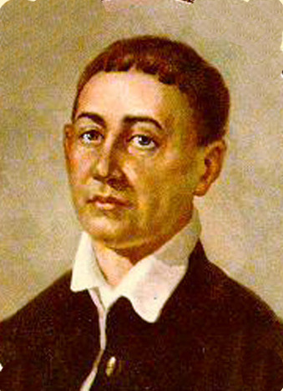 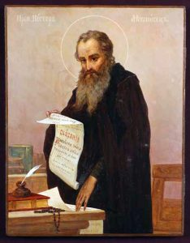 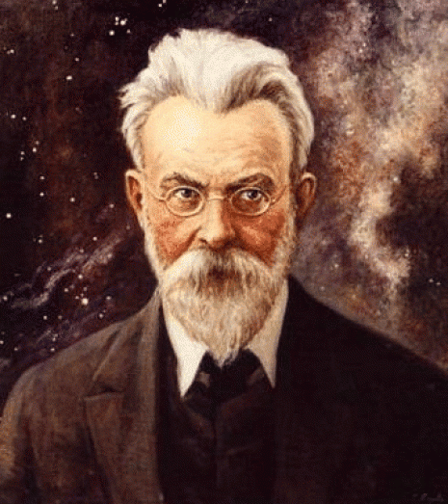

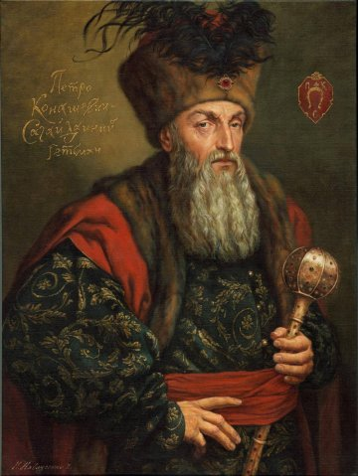 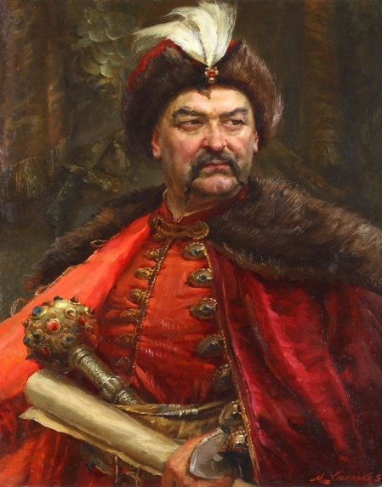

**His candle shines us through the ages**

Nestor the Chronicler resided in Kyiv in the time of Volodymyr and Yaroslav the Wise. He described the history of Kyiv Rus from the oldest times till the time of prince Yaroslav, created a unique Nestor’s Chronicle, was one of the compilers and editors of the Primary Chronicle, the author of hagiography: Life of St Theodosius, The Assassination of princes Boris and Gleb. Nestor’s works are viewed as written testimony to historical events, which took place on the territory of Ukraine.

**The invincible hetman**

**(1616-1622)**

Reasonadle deep-thinking, politician, Cossacks Chief and Hetman of Ukraine, Piotr Sahaidachny made the Cossacks serve to common goals of all the people. He converted Cossack troops into a support of national Ukrainian life. In all his campaigns against the Tatars and Turks he was successful and won both on land and sea, restored Kyiv as a centre of national Ukrainian life, was a member of Kyiv fraternity, founded the Academy.

**The fatal error**

**(1648-1657)**

Bogdan Khmelnitsky was seized by desire to revenge on Poles for the death of his son, when he returned to Sich (Cossacks’ headquarters, established on an island in the Dnieper beyond cataracts). By fiery speech he stirred the Cossacks to action and they elected him their Hetman. Battle near the settlement Zhelty Vody was the first victory in a series of victories in three peasant wars, but the results of the successful battles were not always used by Bogdan for the benefit of Ukraine. Finally, the glorious commander decided to put Ukraine under the guardianship of a mighty neighbouring state in order to gain peace for this country. And he had chosen Russia for this purpose. Pereyaslav Agreement negotiated in 1654 laid the foundation for Russification of Ukraine.

**Brow of Socrates and heart of a child**

**(1794)**

Ukrainian philosopher and moralist, scientist, poet and artist Grigoriy Skovoroda studied at Kyiv Ecclesiastical Academy, attended philosophy courses in Austria and Hungary. He worked as a tutor, travelled around the Ukraine with a stick in his hand and a bag on his back. His pedagogical ideas deserved universal recognition. He was a careless grow-up child, inclined to solitude, deep-thinking , restless, truthful and independent. He was a Ukrainian Socrates, he considered self-cognition and revelations of heavenly mind to be the basic goal of cognition and perfection of human being.

Grigoriy Skovoroda is buried in the village of Skovorodinovka, the Kharkiv Region. On his tombstone the following words are engraved: “World tried to catch me, but failed”.

**A noted scientist whom we take pride in**

**(1863-1945)**

Volodymyr Vernadsky was the first Ukrainian Academician and the first President of the Ukrainian Academy of Sciences.

He worked in research of radioactivity and organized the Radium Institute in Petrograd. Vernadsky was the founder of the modern doctrine on the biosphere. His ideas contributed to geology, mineralogy and hydrogeology. He was the author of the fundamental studies on Earth. His ideas about the chemical composition of atmosphere and the role of radioactive elements are valuable. His findings are universally recognized.

**Comprehension check.**

**Puzzle.**

Teacher. Look at the clues below, then write the missing words in the spaces in the grid.

|  |  |  |  |  |  |  |  |  |  |  |  |
| --- | --- | --- | --- | --- | --- | --- | --- | --- | --- | --- | --- |
| 1. |  |  |  |  |  |  |  |  |  |  |  |
| 2. |  |  |  |  |  |  |  |  |  |  |  |
| 3. |  |  |  |  |  |  |  |  |  |  |  |
| 4. |  |  |  |  |  |  |  |  |  |  |  |
| 5. |  |  |  |  |  |  |  |  |  |  |  |
| 6. |  |  |  |  |  |  |  |  |  |  |  |
| 7. |  |  |  |  |  |  |  |  |  |  |  |
| 8. |  |  |  |  |  |  |  |  |  |  |  |
| 9. |  |  |  |  |  |  |  |  |  |  |  |
| 10. |  |  |  |  |  |  |  |  |  |  |  |
| 11. |  |  |  |  |  |  |  |  |  |  |  |

***Down:***

When you cope with ***Across*** task you will find the word from ***Down.***

***Across:***

1. Ukraine may be proud of its ….. sons and daughters.
2. Nestor created a ….. Chronicle in which he described the history of Kyiv Rus.
3. Cossack ….. under Piotr Sahaidachny won both on land and sea.
4. Piotr Sahaidachny was ….. in his struggle against Tatars and Turks.
5. Nestor’s Chronicle is a ….. to numerous historical events.
6. V. Vernadsky was the first Ukrainian ….. .
7. V. Vernadsky was a …… scientist whom we took pride in.
8. Pedagogical ideas of Grigoriy Skovoroda ….. universal recognition.
9. Deep-thinking philosopher, Grigoriy Skovoroda in fact was a grown-up child ….. to solitude.
10. Pereyaslav Agreement, ….. in 1654, laid the foundation for Russification of Ukraine.
11. Bogdan Khmelnitsky decided to put Ukraine under the ….. of Russia in order to gain peace for Ukraine.

**Answers:**

*Down:* outstanding.

*Across:* 1. outstanding, 2. unique, 3. troops, 4. successful, 5. testimony, 6. academician, 7. noted, 8. deserved, 9. inclined, 10. negotiated, 11. guardianship.

**Listening and speaking.**

1. **Listen to the text “Life bright like glitter of the sword”.**
2. **Now listen to the text about Sviatoslav. Look at the text below and try to complete it by filling in the missing words.**

Sviatoslav , the only son of Olga and Igor, was a _____ and _____ warrior. For his _____ he ______ both by friends and foes. Before starting a _____ he always sent a _____ with a warning: “I go at You!” _____ and _____ he never took neither marquees nor cauldrons with him. He slept on _____ putting the saddle under his _____. Sviatoslav was one of those about whom _____ usually say: “First he kisses his ______ and then his ______”. He ______ Khazars near the Volga and Caucasus, Tmutorokan (a _____ situated in the _____ where the Kuban _____ into the Sea of Azov and the Black Sea) and Bulgarians. He besieged Constantinople and ______ Greeks to pay _____ . On the way back the ______ of Sviatoslav were treacherously _____ by the Pecheneges. They killed the _____ and made a _____ out of his skull with the following _____: “_____ for the property of the others, lost his own”.

1. **Practise making questions by filling in the gaps.**
2. Whose son _____ Sviatoslav?
3. What for _____ he respected by his friends and foes?
4. What way _____ he sleep during the war?
5. Whom _____ he conquer?
6. Who _____ the prince?
7. **Now make some more questions about Sviatoslav to get answer which follow.**
8. Sviatoslav was a talented and brave warrior.
9. Before starting a campaign he always sent, a messenger with a warning « I go at You!».
10. Sviatoslav was a man about whom the people usually said: «First he kisses his sword and then his wife».
11. He besieged Constantinople.
12. He forced Greeks to pay contribution.
13. The Pechenegs wrote the following inscription on his skull: «Seeking for the property of the others, lost his own».

1. **Now you know some facts about Sviatoslav. So tell your friends about him without looking at the text.**

**Choose one of the most famous people of Ukraine. Write some notes about him/her. Then discuss your notes with a partner/group/class.**

1. Is he/she alive or dead?
2. What is/was/he/she?
3. What works do you know? Do you like his/her works? Why? Why not?
4. What do you know about his/her life?
5. Your attitude to this person.

**Summing up.**

**Cinquain.**

Teacher. You have to write a cinquain - a five lines poetic form which consists of 1 noun, 2 adjectives, 3 actions, 4 feeling words, then 1 noun that is the same as top noun.The first line will be the name and the surname of one of the outstanding people of our country.

So, our lesson is over. Tell me, who is the closest in spirit to you from the represented well-known people and why? (pupils’ answers)

I am proud to be Ukrainian. And what about you? Are you proud to be Ukrainian? I think that to be Ukrainian means to be proud of our country and to be fond of our country. But there is the only thing that I’m really proud of. I`m proud of our people.

It seems to me that we should always move forward and be aspired by only the best. The most important thing for you now is not to waste time, to involve yourself in education, to bring up the leader`s skills and maybe some days your children will see your names at the history pages.

**Home assignment.**

Your task is to write the biography of the outstanding person of Ukraine.