Healthy and sport Day
9:00-9:30 Students arrive; ice-breakers and warm-ups until everyone arrives
9:30-10:15 Healthy way of life
10:15-10:30 Teambuilding games
10:30-11:15 How to keep fit
11:15-11:45 Snack/break
11:45-12:30 Sport in our life
12:30-14:00 Sports and games
14:00 Home

Outcomes/Objectives:
- to motivate pupils for practicing English and working in teams;
- to develop speaking and listening skills;
- to work in pairs, in groups;
- to improve pupils` pronunciation and acting skills.
- to be able to speak, share own opinion about sports and healthy lifestyle.
Vocabulary (health, actions, occupation, sports, food)
Equipment: cards for games, vocabulary cards, balloons, laptop, ball, posters, pencils, glue, coloured paper, hoop.
Sports and games
Procedure

BE HAPPY CAMPERS! (song)
- Hello, dear friends!
- Welcome to our English summer camp!
Teachers:
Good morning our dear friends!
Good morning boys and girls!
We open English summer camp.
Today we’ll have sport and healthy day, we hope that you’ll enjoy the camping rest and have a great time.
Let’s sing together, dance a bit and make fantastic time!

(Presentation of the teams teams and their motto of the day)
Team STARS, our motto:
Be brave!
Be smart!
Be cool!
Be friendly!
And never give up!
Team CHAMPIONS, our motto:
We will win and
make this world better!
We are the champions
We are the winners
We are united
We are the best!

( dance HOCKY COCKY)

Warm up: My Name is and I like to... (An outdoor activity)

Everyone in the group stands in a circle.
The first person says, "My name is and I like to ______ (insert hobby and act out a motion from that hobby.)
The rest of group then says, "(Person's Name) likes to (hobby) and acts out motion.

For example: "My name is Dave and I like Fish (action out casting a reel).
The next person repeats the process.
The rest of group then says that person's name, hobby, and motion and the moves onto the first person's info.
This continues until the last person goes, at which the entire group calls out the last person's info and moves along through the whole group and repeats everyone's info.

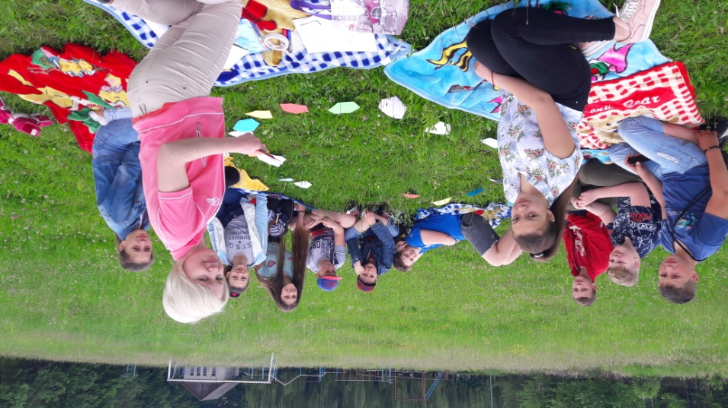
Main Part
Today healthy lifestyle is becoming more and more popular both with the old and the young. People have become more health-conscious. They say that the greatest wealth is health. And it’s so true. The healthier we are, the better we feel. The better we feel, the longer we live.
A healthy diet is an essential part of staying healthy. We know that we should not stuff ourselves with fast food, sweets, sausages, pastry and fat food. Due to medical research, this type of food shortens our life, it leads to obesity, heart and blood vessels diseases, diabetes, gastric problems and lots of other serious ailments. To prevent all these problems we should enjoy well-balanced home-made meals with a lot of organic fruits, vegetables, dairy products, grains and seafood. We are what we eat.
Keeping fit and going in for sports is also important for our health. Lack of exercise in our life is a serious problem. In big cities people spend hours sitting in front of computers, TV-sets and other gadgets. We walk less because we mainly use cars and public transport. We certainly don’t have to be professional sportsmen, but we should visit fitness clubs, go jogging, walk much, swim, go cycling or roller-skating or just dance. Doctors say that regular moderate physical activity is necessary for our body because it protects us from strokes and heart diseases, flue and obesity.
We must understand the harm of bad habits for our health.
Taking a proper rest and getting enough sleep, from 8 to 10 hours daily, are also great healthy habits. Healthy way of life concerns our body, mind and soul. Healthy people live longer, they are more successful and they enjoy their life. I believe that it’s not difficult at all to follow these simple rules, and they are worth it.
(Discussion about healthy lifestyle with the children.)
Song: “Good habits” (flash mob)
Reading and Speaking

One by one students read different healthy lifestyle tips for kids. The other listen and can add or share with other about their own lifestyle.
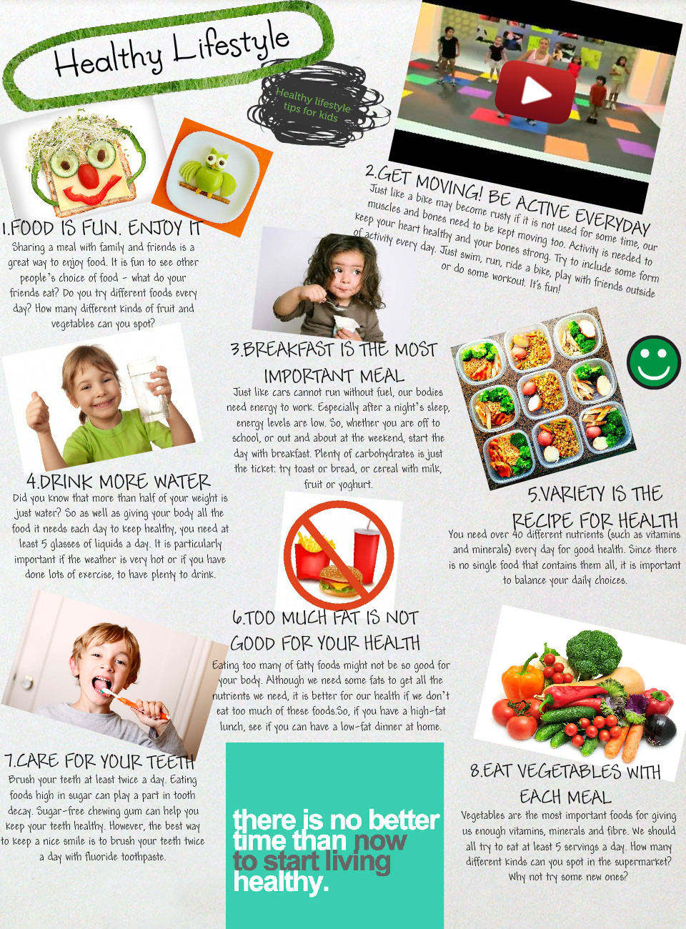 Speaking. Agree or disagree, say what you should / shouldn’t do to keep fit. Prouve your point of view.
For example: - We should sleep enough, because …
- We shouldn’t play computer games a lot, because …
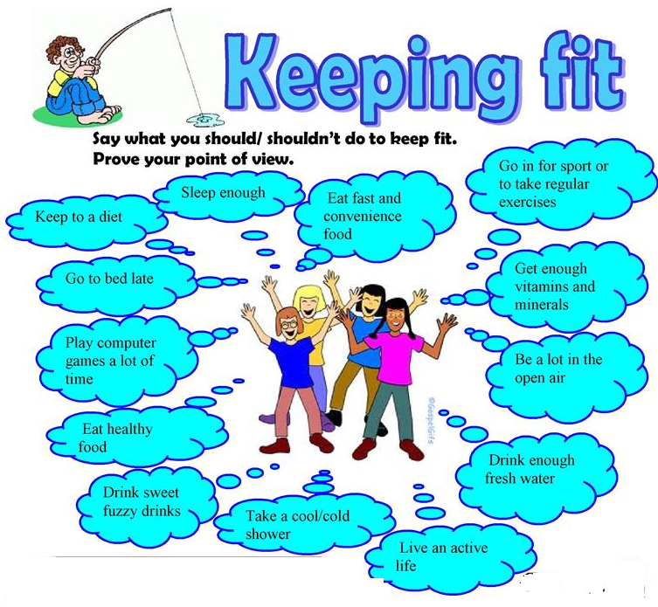

Rhyme “Who likes what?” Students make a circle. Each student who likes the listening food give the answer.
For example: - I like brown bread!
- I like white bread!
Some of us like brown bread
Some of us like white
Some of us eat cake and meat
Some don’t think it’s right!
Some of us like apples
Some drink juice at night
Some of us eat many sweets
Some don’t think it’s right!
Reading and Speaking.
Game “Be attentive”. You’ve got a list of words. Choose and write down the words connected with food!
1 Groupe: bread, tooth, sweets, a mother, soup, cake, breakfast, a teacher, juice, meat, seven, a tree, tea, ice-cream, fish, cheese, coffee, water, school.

2 Groupe: month, porridge, yesterday, hot dog, a sweater, pizza, salad, chicken, egg, leg, cola, milk, hamburger, year, sugar, pencil, carrot.

Game “Tic-tac-toe”
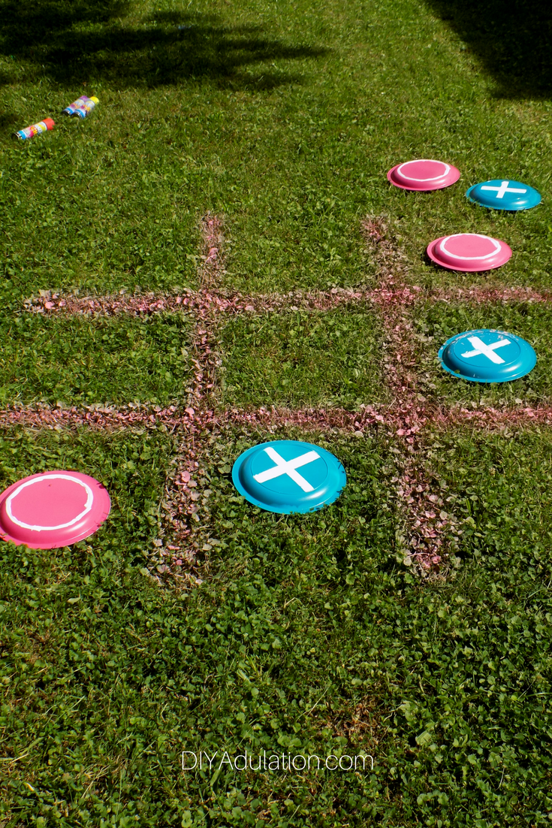
The rules of DIY giant backyard frisbee tic-tac-toe are the same as traditional tic-tac-toe with one twist. You can use your frisbees to knock another players frisbee from the space you need. The only exception is, of course, if the player has achieved 3 in a row. The first player to get 3 in a row is the winner! (The teacher reads riddles about food, fruit, vegetables, then students need to guess them. The winner is the team who has achieved 3 in a row. )
For example: Riddles.
- I yellow. I am made of milk. You eat me with bread. What is it? (Butter)
- I am white. I am good to drink what am I? (Milk)
- Oval and green in garden seen. What is it? (Cucumber)
- It is white and cold and sweet. All the children like it. (Ice-cream).

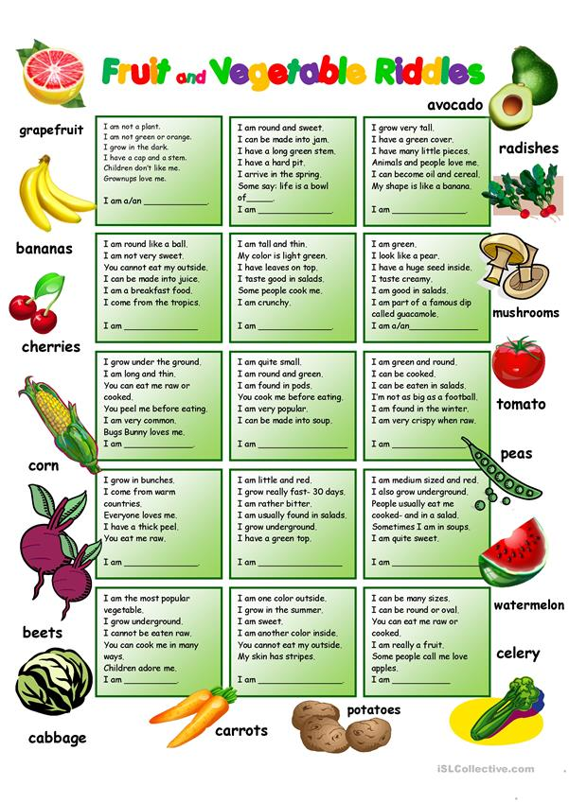
Project Work “Build a snack”. The teacher ask the teams to make a poster “ My favorite healthy food”.
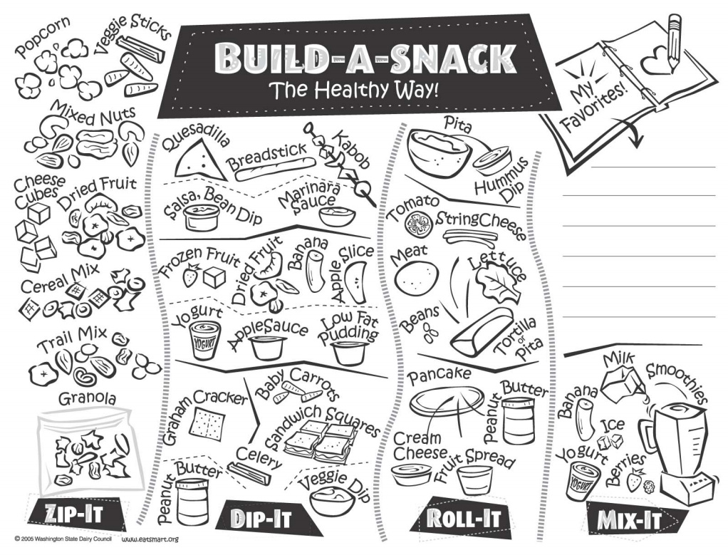 Make a healthy menu of the day. (the children use food flashcards)
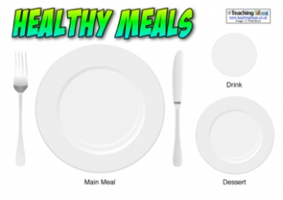
Game “Hurry up?” Teacher reads some products, they belong to one of groups.
After reading you must pick one of these words up and classify them. Let’s start!

Vegetables Meat Dairy products Fruit

- cheese, butter, yoghurt, milk, ice-cream (Dairy products)
- turkey, chicken, goose, duck (Meat)
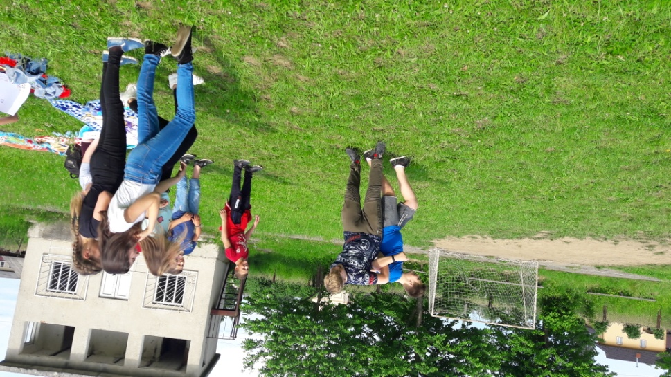
- cucumber, tomato, potato, cabbage (Vegetables)
- strawberry, cherry, apple, plum (Fruits)
- mushroom, radish, carrot, beet (Vegetables)
- apricot, pear, banana (Fruits)
- pork, beef, lamb, poultry (Meat).

Game “Hidden words”. Some names of fruit and vegetables are hidden among letters Find, read and translate them.

1Groupe: onionkqjcherryonxpluminpearbdapplekmobanana
2Groupe: penflowerapricotpencilgrapesonepearchten.

Game “Magic basket”. The students choose a card with a sentence, then they read given sentence and must say only one word “True” or “False”.
For example:
- Borsh is a favourite Ukrainian dish. +
- Englishmen like varenyky. –
- Ukrainians like varenyky very mush. +
- Englishmen like borsch very mush. –
- Ukrainians like tea with milk. –
- Englishmen like tea with lemon. –
- Holubtsi is a traditional English dish. –
- Deruny is a traditional English meal. –
- Kholodets is a traditional Ukrainian dish. +
- Pizza is a traditional Italian dish. +
- Typical English food is pudding. +
Vocabulary work
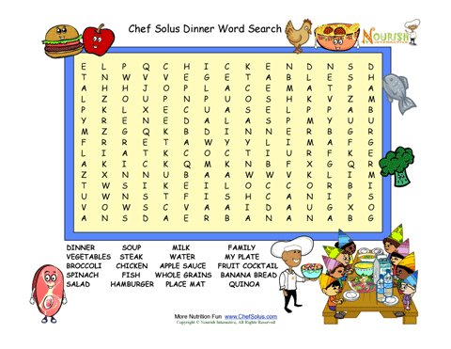
Teacher: Keeping fit and going in for sports is also important for our health. I’d like to read you a poem. Listen to it and then answer my question.

Sport is fun for girls and boys,
It’s much better than toys.
You can sledge and ski and skate
And throw snowballs with Kate.
You can swim and play football,
Hockey, tennis, and basketball.
You can jump and you can run,
You can have a lot of fun.
For example:
- What kinds of sports do you know?
- What games do you like to play?
- What are the most popular sports in Great Britain?
- What are the most popular sports in Ukraine?
- What are the most teenagers’ sports?
- Can you swim\ run\ jump?
- Where do you go to play tennis\ football\ to swim?
- Do you go to the swimming pool? To the skating rink?
- People go in for different sports. When we speak about sports what verbs do we use – do, play, go or ride?
Complete the chart.
 | soccer | table tennis | jumping | bike | running | tennis | swimming | judo | weight lifting
do
go
play
ride

Vocabulary pair work

Teacher: When we speak about sport we speak about equipment and rules of the game.
Which of the following equipment do you need to play badminton, ice hockey, football, tennis?
I’ll give you a paper with set of rules. Read, write the number of the sport or game in the correct line.
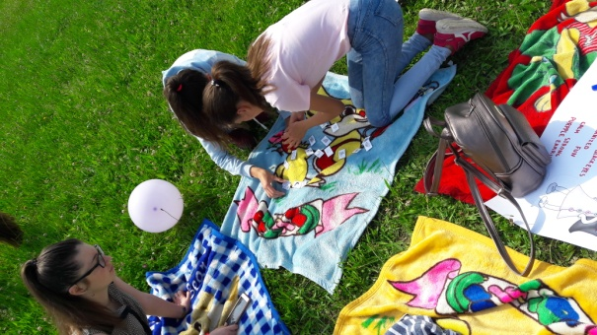

Sport Quiz.
Match the sport or game to the appropriate set of rules. Write the number of the sport or game in the correct box.
A _________
Each team may have up to eleven players, only seven of whom are allowed to play at the same time. One team should wear blue caps, the other white. Players must not splash water into an opponent’s face.
B___________
The two contestants must bow to each other at the start of the contest. They should wear white clothing. Contestants must only attack the arms and legs of their opponent. They should not get overexcited.
C__________
The game can be played by two or four players. The players must change positions after each game. The ball must touch the table on both sides of the net each time it is hit.
D___________
Competitors should wear a helmet. They must not stop another competitor from overtaking. Competitors are not allowed to help each other.
E __________
Each team may have up to ten players, only five of whom may play at the same time. Players are not allowed to leave the court without permission. The ball may be thrown but it must not be carried or kicked. A team must try for a goal within 30 seconds of getting possession of the ball.
F____________
Each team must have eleven players. The two teams should wear different colours. Only the goalkeeper is allowed to play the ball with his hands or arms.
G_____________
Each team must have six players. The server may hit the ball with his hand or any part of the arm. He must release the ball from his other hand before hitting it. Players must not touch the net.
H__________________
Each team may have up to seven-teen players, only six of whom are allowed to play at the same time. Players must wear skates and numbered shirts.
I_________________
Contestants are weighed before the contest. The contestants’ assistants must leave the ring before the fight begins. Contestants must wear gloves and must not hit an opponent behind the neck.

- Table tennis
- Water polo
- Basketball
- Volleyball
- Cycle racing
- Judo
- Ice hockey
- Boxing
- Football

Reading and Speaking.

Beach ball. (An out-/indoor activity)Let’s speak about your favorite sport
Tips:1. Get a cheap beach ball.
2. Using a permanent marker cover it with getting to know you questions.
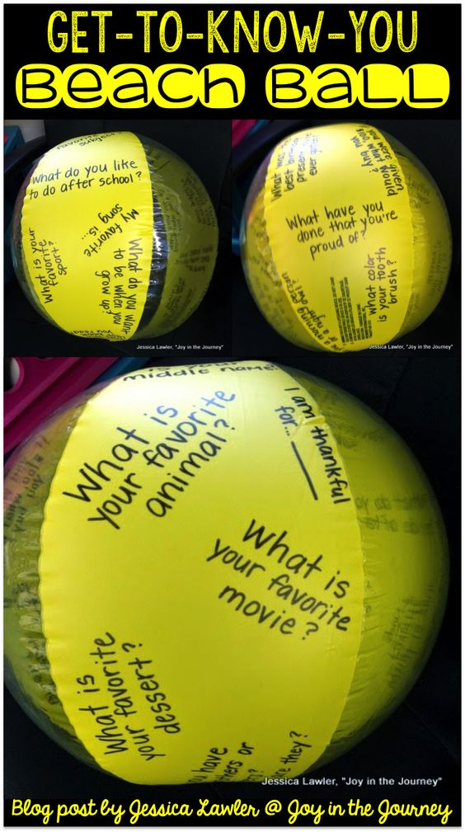
3. Throw the ball to someone. Tell them to answer the question that is touching their left/right thumb/index/middle/ring/pinky finger. For example, "Answer the question that is touching your right index finger".
4. After the question is answered the ball is thrown to another
person, and so on.

For example: Here are the questions I wrote on the ball:
- What kinds of sports are popular in our country?
- What kinds of sports are popular in Great Britain?
- Which British football teams do you know?
- Which Ukrainian football teams do you know?
- What is your favorite sport ?
- What sport do you like doing?..

Vocabulary work
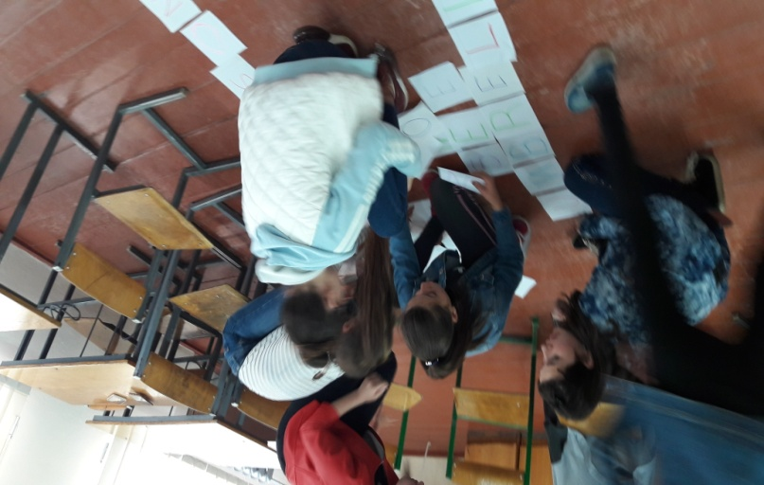
Backyard Scrabble (An out-/indoor activity)
We are making a set of masonite.
It's fun, interactive and you're still learning all at the
same time! We can do categories (food & drink,
sports, etc) . The children need to build a big
crossword using given letters. They need to
make the most words they can.

Icebreaking . (An out-/indoor activity)
Guess the most riddles you can.
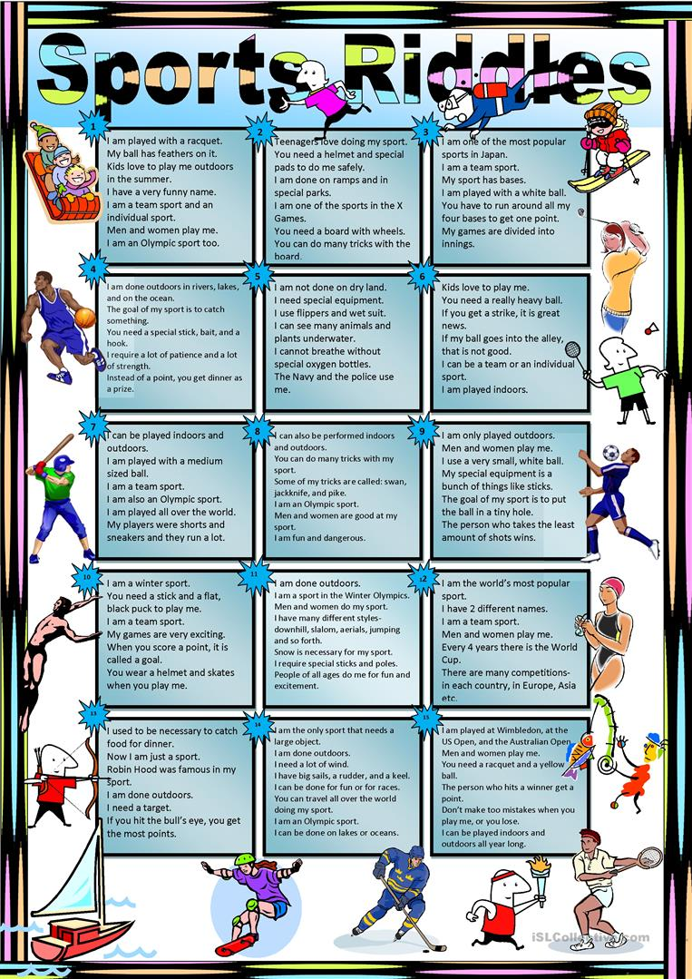

Sports and games
Hula Hoop Pass–fun activity (An outdoor activity)
This game is quick, easy and only involves people and a hula hoop! Have two teams and race to see who can get the hula hoop passed all the way to end and back! Make a line (or circle) of people…all holding hands. the hula hoop has to go up and over your entire body and pass to the next person. You can’t let go of the hand of the person next to you.
A bean bag toss game. (An outdoor activity).
To make the bean bags, The other part of this game is the saucers to toss the bags into. You can paint the saucers in any color or design you like, to match the occasion. I painted mine in a simple red, white, and blue design. We paint scores on each saucer, with the lowest score for the largest (easiest to hit) saucer, and the highest score for the smallest (hardest to hit) saucer. To play the game, just line up the saucers with the largest one closest to you, and the smallest one farthest away. The distance between the saucers can vary depending on the age and skill level of those playing. Then have the kids take turns tossing the bags onto the targets of their choice, and score them for any successful hits. Easy and fun! 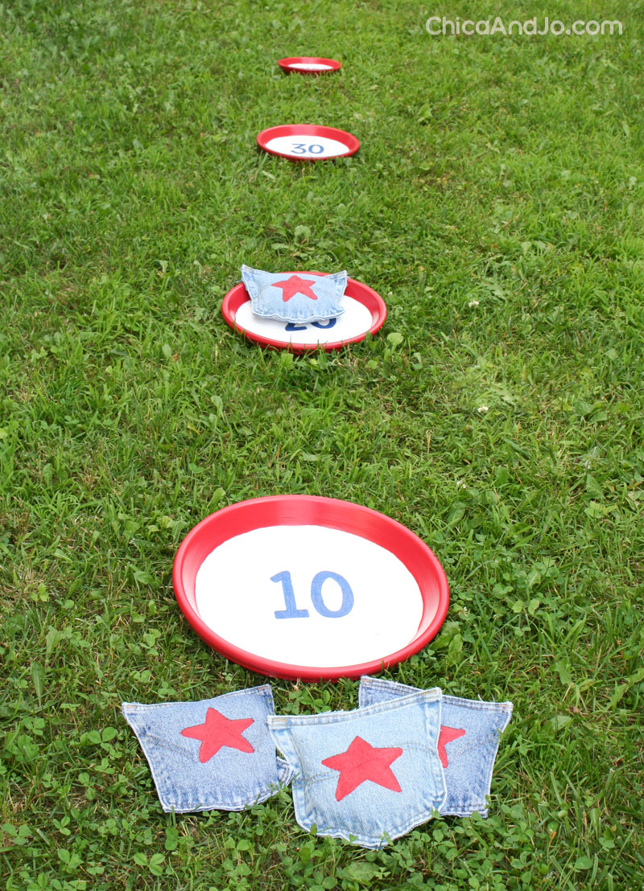

Hunters & Stalkers
Age Group: 8-12 years
Game Objective: In this wonderful kids camp games the teams have to accomplish a task before their opponents.
Game Learning: Observation, coordination and speed.
No. of Players: 10 or more.
Materials Required:
- Blue & green flags, 2 each.
- 2 small flashlights.
- A piece of chalk.
How to Play:
- Before the game starts, hide a “Green Flag” at a fair distance from the camp and a “Blue Flag” in the close proximity to the green flag.
- The flags can either be hung on a tree or hidden in the bushes.
- Make 2 outline maps. “Green Map” indicating the location of the green flag from the camp base and “Blue Map” indicating the location of the blue flag from the point of location of green flag.
- Make 2 teams and name them “Green Hunters” and “Blue Stalkers”.
- Give a Green Flag, a piece of chalk, a flashlight and the Green Map to Green Hunters.
- Give a Blue Flag, a flashlight and the Blue Map to Blue Stalkers.
- Let the Green Hunters leave for the flag hunt at least a couple of minutes before the Blue Stalkers.
- The Blue Stalkers, till that time, will wait inside a tent. So that they cannot see in which direction the Green Hunters have left.
- Green hunters have to make the directional arrows with the chalk on the trees and rocks for Blue stalkers to follow.
- Blue Hunters, when their time starts, will have to figure out quickly where the Green Hunters have gone by following the directional arrows marked by them.
- Both will carry their respective maps with them to reach their target. But Blue Stalkers have no choice except to stalk the Green Hunters till they find their green flag and from that point they can trace their Blue Flag as indicated in the map.
- The teams after finding their flags have to first, plant the other flag they brought with them on the ground and then rush back to the camp base with the prize flag.
- The first team (the flag bearer) to return to the camp base is the Winner!!!
My Tip :
- Play this game in the evening just before dusk. The fun will begin when the teams may want to use their flashlights to read the maps or read the directional arrows but avoiding it so that the opposition may not come to know their location by following the light.
Ending:
We have spoken about a sport and healthy way of life. I think that you will continue to go in for sport to be healthy.
I hope you’ve enjoyed our day. Good- bye!

