6-8 КЛАСИ
Обладнання:
- • карти з вказаними на них індивідуальним маршрутом
- • таблички з назвами станцій;
- • реквізит на станціях;
- • завдання для кожної станції;
- • сертифікати переможцям і учасникам;

- For doing the first task you have to find the number one! Where is one.
Діти з батьками шукають цифру 1 (станція №1) з завданням розказати про себе.
  - (I’m Masha. I’m a girl. I,m twelve. I live in…).
2) Now find the number two.
На станції №2 учасники читають карточки з запитаннями та відповідають на них.
What is the name of your mother?
What is the name of your father?
What is the name of your grandmother?
What is the name of your grandfather?
What is name of you friend?
What is the name of your daughter (son)?

  - Now find the number three.
Can you guess the riddles?
(учасники відгадують загадки, намагаючись заробити максимальну кількість балів)
- It’s a man. He makes a show in the circus. Children love him a lot. He is funny and friendly.(A clown)
- There are a lot of them in the classrooms and outside. You can find them in front of your school.(Flowers)
- It’s an animal. It’s wild. It doesn’t have glasses but you can see them on its face. (A panda)
- A dish. You need 3 eggs, some milk and salt (An omelet)
- It can be a boy or a girl. It can’t talk or walk. It sleeps and cry a lot.(A baby)
- It’s a thing. It can be blue, yellow, red and so on. It can be any shape. You can play with it. You can decorate your party with it.(A balloon)
- Mary’s father has five daughters – Nana, Nene, Nini, Nono. What is the fifth daughter’s name? (Mary)
- What is in the middle of Paris? (the letter R)
- What belongs to you but others use it more than you do? (your name)
- Imagine you are swimming in the sea and a bunch of hungry sharks surround you. How do you get out alive? (stop imagining)

  - Now find the number four.
Сreative task.
At this stage of the quest you have to write a rhyme from the given words

Write a rhyme
Hot – a lot
Sun – fun
Walk – talk
Swim – dream
EXAMPLE
Today is extremely hot, so I can swim a lot
We can see the sun and have fun
With my friends I often walk and we talk, talk, talk…
  - Song stop
Кожна сім'я повинна вибрати куплет та приспів з відомої англійської пісні і заспівати її.
Shape of my heart – Sting
Dan Balan- Hold on love
Diamonds Rihanna
Lady (Hear Me Tonight)
Let It Be The Beatles
Hall of Fame The Script

  - Describe the picture
Змагання батьків і дітей.
Батькам роздаються фото, на яких зображено різні життєві ситуації. Учні за допомогою запитань повинні здогадатися, що саме зображено на фото. Батькам дозволяється лише казати Yes/No . Виграє та пара, яка швидше здогадається, що ж на фото.

  - Brain rings Stop
Complete the table
Кожній сім’ї дається таблиця. Завдання максимально заповнити її словами за відповідними темами
Every family is given the table. The task is to complete it with related words. You should write as many as possible
Adjective | Body | Animals | Town | Food (fruit, vegetables) | Sport | Verbs
  - The last Stop – Make up quotes
( роздатковий матеріал - різноманітні прислів’я. Завдання: віднайти частинки прислів’я і правильно скласти його)
- “Nothing will work unless you do.”

- “Surround yourself with only people who are going to lift you higher.”

- “Your time is limited so don’t waste it living someone else’s life.”

- “Never give up. Today is hard, tomorrow will be worse, but the day after tomorrow will be sunshine.”

- If you want something done right, do it yourself.

- To be or not to be, that is the question.
- What doesn't kill us makes us stronger.

- Keep your face always toward the sunshine and shadows will fall behind you.

- Let us make our future now, and let us make our dreams tomorrow’s reality

- Try to be a rainbow in someone’s cloud.

- Each day provides its own gifts.

Завершується квест подякою за гарну працю, відзначенням всіх учасників нагородами.
(шаблони нагород за вибором вчителя)

МАТЕРІАЛИ

Tell us about yourself.
(What’s your name? Where do you live? How old are you?
Where do you work (study)?

What is the name of your mother?
What is the name of your father?
What is the name of your grandmother?
What is the name of your grandfather?
What is the name of you friend?
What is the name of your daughter (son)?
What colour are your son’s (daughter’s) eyes?
What colour are your mother’s (father’s) eyes?
What does your mother (father) like to do?
What does your son (daughter) like to do?
What’s your mother’s (father’s) favourite clothes?
What’s your son’s (daughter’s) favourite clothes?
Where your son (daughter) was yesterday at 7 o’clock in the evening?
What did your mother (father) do in the evening yesterday?

- It’s a man. He makes a show in the circus. Children love him a lot. He is funny and friendly.
- There are a lot of them in the classrooms and outside. You can find them in front of your school.
- It’s an animal. It’s wild. It doesn’t have glasses but you can see them on its face.
- A dish. You need 3 eggs, some milk and salt
- It can be a boy or a girl. It can’t talk or walk. It sleeps and cry a lot.
- It’s a thing. It can be blue, yellow, red and so on. It can be any shape. You can play with it. You can decorate your party with it.
- Mary’s father has five daughters – Nana, Nene, Nini, Nono. What is the fifth daughter’s name?
- What is in the middle of Paris?
- What belongs to you but others use it more than you do?
- Imagine you are swimming in the sea and a bunch of hungry sharks surround you. How do you get out alive?

Write a rhyme Write a rhyme
Hot – a lot Hot – a lot
Sun – fun Sun – fun
Walk – talk Walk – talk
Swim – dream Swim – dream

Write a rhyme Write a rhyme
Hot – a lot Hot – a lot
Sun – fun Sun – fun
Walk – talk Walk – talk
Swim – dream Swim – dream

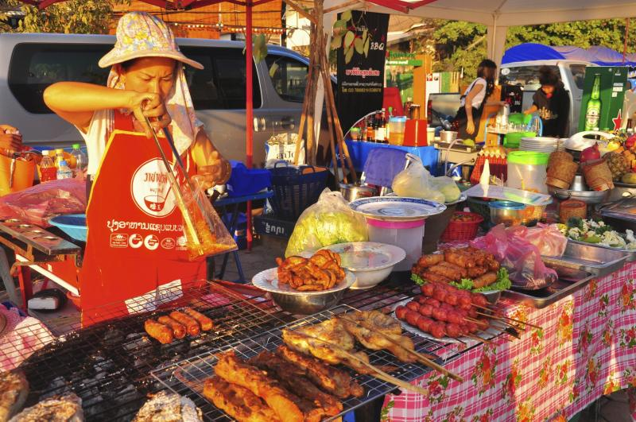
Animals | Weather | Food | Sport | Verbs

Animals | Weather | Food | Sport | Verbs

Animals | Weather | Food | Sport | Verbs

Animals | Weather | Food | Sport | Verbs

Animals | Weather | Food | Sport | Verbs

Animals | Weather | Food | Sport | Verbs

Animals | Weather | Food | Sport | Verbs

“Nothing will work…
unless you do.”

“Surround yourself with only people…
who are going to lift you higher.”

“Your time is limited…
so don’t waste it living someone else’s life.”

“Never give up. Today is hard,…

tomorrow will be worse, but the day after tomorrow will be sunshine.”

If you want something done right,…

do it yourself.
To be or not to be,…
that is the question.
What doesn't kill us…

makes us stronger.

Keep your face always toward the sunshine…

and shadows will fall behind you.

Let us make our future now, …

and let us make our dreams tomorrow’s reality

Try to be a rainbow…

in someone’s cloud.

Each day provides…
its own gifts.

DAN BALAN – HOLD ON LOVE
Wild
Inner fights
I won't ignore
Them anymore.
My crime
Is human kind
I'd bare it all
to change my world.
It sleeps more than often
It sleeps more than often
Free my hidden laughter
Free the wild man.
Hold On Love
All the love is there
Love is there
All the love is there.
Tied
Blindfold eyes
My sins are raw
Now and before.
All night
My instincts fight
These deepest wrongs-
Devided worlds.

Shape of my heart
He deals the cards as a meditation
And those he plays never suspect
He doesn't play for the money he wins
He doesn't play for respect
He deals the cards to find the answer
The sacred geometry of chance
The hidden law of a probable outcome
The numbers lead a dance

П-В:
I know that the spades are swords of a soldier
I know that the clubs are weapons of war
I know that diamonds mean money for this art
But that's not the shape of my heart

He may play the jack of diamonds
He may lay the queen of spades
He may conceal a king in his hand
While the memory of it fades

Lady (Hear Me Tonight)
Modjo

Lady, hear me tonight
'Cause my feeling is just so right
As we dance by the moonlight
Can't you see you're my delight?

Lady, I just feel like
I won't get you out of my mind
I feel loved for the first time
And I know that it's true
I can tell by the look in your eyes

Diamonds
Rihanna

Shine bright like a diamond
Shine bright like a diamond
Find light in the beautiful sea, I choose to be happy
You and I, you and I, we’re like diamonds in the sky
You’re a shooting star I see, a vision of ecstasy
When you hold me, I’m alive
We’re like diamonds in the sky
I knew that we’d become one right away
Oh, right away
At first sight I felt the energy of sun rays
I saw the life inside your eyes
So shine bright tonight,
You and I
We’re beautiful like diamonds in the sky
Eye to eye,
So alive
We’re beautiful like diamonds in the sky
Shine bright like a diamond
Shine bright like a diamond
Shining bright like a diamond
We’re beautiful like diamonds in the sky
Shine bright like a diamond
Shine bright like a diamond
Shining bright like a diamond
We’re beautiful…

Let It Be
The Beatles

When I find myself in times of trouble,
Mother Mary comes to me
Speaking words of wisdom, let it be
And in my hour of darkness she is standing right in front of me
Speaking words of wisdom, let it be
Let it be, let it be, let it be, let it be
Whisper words of wisdom, let it be
And when the broken hearted people living in the world agree
There will be an answer, let it be
For though they may be parted,
there is still a chance that they will see
There will be an answer, let it be
Let it be, let it be, let it be, let it be
There will be an answer, let it be
Let it be, let it be, let it be, let it be
Whisper words of wisdom, let it be
Let it be, let it be, let it be, let it be
Whisper words of wisdom, let it be

Hall of Fame
The Script

Yeah, you could be the greatest
You can be the best
You can be the King Kong banging on your chest
You could beat the world
You could beat the war
You could talk to God, go banging on his door
You can throw your hands up
You can beat the clock
You can move a mountain
You can break rocks
You can be a master
Don't wait for luck
Dedicate yourself and you can find yourself
Standing in the hall of fame
And the world's gonna know your name
'Cause you burn with the brightest flame
And the world's gonna know your name
And you'll be on the walls of the hall of fame
You could go the distance
You could run the mile
You could walk straight through hell with a smile
You could be the hero
You could get the gold
Breaking all the records that thought, never could be broke

Robbie Williams - Feel

Come and hold my hand
I wanna contact the living
Not sure I understand
This role I've been given
I sit and talk to God
And he just laughs at my plans
My head speaks a language
I don't understand
I just wanna feel
Real love feel the home that I live in
'Cause I got too much life
Running through my veins
Going to waste
I don't wanna die
But I ain't keen on living either
Before I fall in love
I'm preparing to leave her
Scare myself to death
That's why I keep on running
Before I've arrived
I can see myself coming
I just wanna feel
Real love feel the home that I live in
'Cause I got too much life
Running through my veins
Going to waste
And I need to feel
Real love and the love ever after
I cannot get enough

