**Theme: Hobbies and interests.**

**Objectives:** -to revise vocabulary on the topic;

-to develop students' speaking, reading, writing and listening skills;

-to generalize and enlarge students' knowledge about hobbies and interests;

-to teach pupils to work in pairs, groups;

-to encourage pupils to communicate in English

**Outcomes:**  by the end of the lesson students will be able to speak about hobbies and

interests.

**Equipment:** PB by O. Karpiuk, a Power Point presentation, a projector, a classboard,

videos, handouts.

**Procedure.**

**I. 1.** **Greeting.**

**A song “Hello, hello“.**

1.Hello, hello

Let’s shake hands/3 times

It’s English time again.

Everyone jump 3 times

1, 2, 3

Everyone clap 3 times

1, 2, 3

Everyone stamp 3 times

1, 2, 3

Everybody jump up high!

2.Hello, hello

Let’s all bow/3 times

It’s English time again.

Everyone spin 3 times

1, 2, 3

Everyone wink 3 times

1, 2, 3

Everyone nod 3 times

1, 2, 3

Everybody jump up high!

3.Hello, hello

Let’s all hug/3 times

It’s English time again.

Now let’s sit down.

T: Today we are going to speak about our friends, traits of character, the most popular free time activities, different hobbies and interests. We'll read, listen, write and speak, sing songs and play games.

So, smile and have a good time. We are beginning .

**2. Warm up.**

T:Read the poem “We are the best” and answer the questions. **Слайд 2**

**We are the best.**

The boys are handsome,

And the girls are pretty.

We all are clever and very witty.

We like to study.

We like to rest

We are always happy.

We are the best.

**1.What can you say about the boys?**

**2.What do the girls look like?**

**3.What do children like to do?**

**4.Are they happy?**

**3. T: Listen to the rap and describe Luka.**

**Luka’s rap** **Слайд 3**

Tock, tock, tock, troo, loo, loo,

I’m Luka.

Who are you?

I’ve got a lot of friends,

And they are all cool.

Every day we go

Together to school.

Tock, tock, tock,troo, loo,loo,

I am lazy,

What about you?

**II. Main part.**

**1.Revision of the material.**

**Practicing the vocabulary.**

T: Let's revise the words that means traits of character.

**a) Phonetic drills. Слайд 4**

**b) What do we say when a person:**

-helps other people**; (helpful)**

-always says the truth; **(honest)**

-acts like a real friend; **(friendly)**

-works and studies hard; **(hard- working)**

-does not want to help his parents, does not want to study well; **(lazy)**

-is never afraid; **(brave)**

-often smiles, jokes, sings; **(merry)**

-shows feelings of love, gives flowers, presents, sweets . **(romantic)**

**c) T: Now use these words and pay a compliment to your deskmate.**

e.g. Kira, you are clever, hard-working, shy and very pretty.

**2.Writing**

T: In groups do the task. Complete the mind-maps with the words from the box.  **HO1**

**3. T: We shall come over to hobbies and interests.**

1. **Look at the screen and repeat after the speaker.**

**b) Listen to the song ”What do you like to do?’’**

**Stand up and move!**

**с) And now it is high time to sing our favourite song *”I am singing…”***

**Слайд 5**

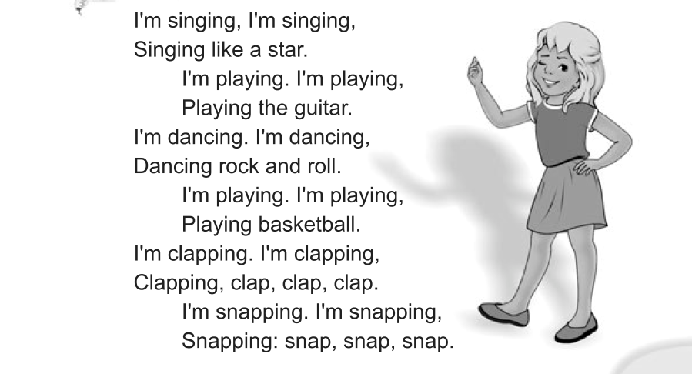

**4. T:Look at the screen and answer the question**

**- What does he/she like doing? Слайд 6**

**5. Speaking.**

**T: Speak about your classmates’ interests and hobbies. Слайд 7**

**6. Writing**

T: Write what you can and what you can’t do. **Слайд 8**

e.g. I can make a chocolate cake.

I can’t stand on my head.

Can you lift a bus?

**7. Reading**

**T: Read some texts about children’s hobbies and match them with the pictures. Слайд 9,**

**HO2**

Join the groups please.

**8. The relaxation minute Слайд 10**

Stand up

Hands up!

Hands on hips!

Hands on knees!

Sit down, please!

Sleep!

Get up!

Stand up!

Brush your teeth!

Wash your hands!

Wash your face!

Wash your ears!

Go to school!

Oh! We are late! Run!

Great! Sit down, please!

T:And now we are again at our English lesson. Let’s continue our work.

**9. Listening.**

T: Listen to a very interesting episode from Kate’s school life. Then answer the questions.

**1.What did Kate paint?**

**2.What colour are the things in her picture?** **Слайд 11,12**

**“Kate is something different”.**

It happened some years ago when she was in primary school.

Kate always tried to do something different, something new- to see what would happen and just for fun of it.

One day Kate’s teacher told her class to paint pictures.

“Make them interesting,”- she said. “Use your imagination”.

Mary painted a small island in the ocean with beautiful flowers and strange animals.

* There was a nice house in the garden in Jane’s picture.
* Andrew painted some children from another planet.
* And Kate…painted a nice place in the village with a pink sun, red and violet trees, a red bird, yellow clouds and blue grass.

When the other children saw Kate’s picture, they began to laugh. “Why did you colour them like this?”- they asked

“I know they look strange”, - Kate said.

“But I wanted to try something new”.

Kate’s teacher came up and looked at the girl’s picture with great interest.

“Well, you tried something different and I’m proud of you!” – she said.

**1.What did Kate paint?**

**2.What colour are the things in her picture?**

the sun is…**(pink)**

the trees are **(red and violet)**

the bird is …**(red)**

clouds are…**(yellow)**

grass is…**(blue)**

**10. Summary.**

T: Our time is coming to an end. I hope you enjoyed our lesson. I am sure you understood that our life would be boring without hobbies and interests.

You were active, worked hard. So you are hard-working.

I’m pleased with your answers.

What activities did you like most of all?

**11. Homework.**

T: Next time be ready to speak about your friends interests and hobbies. **Слайд 13**