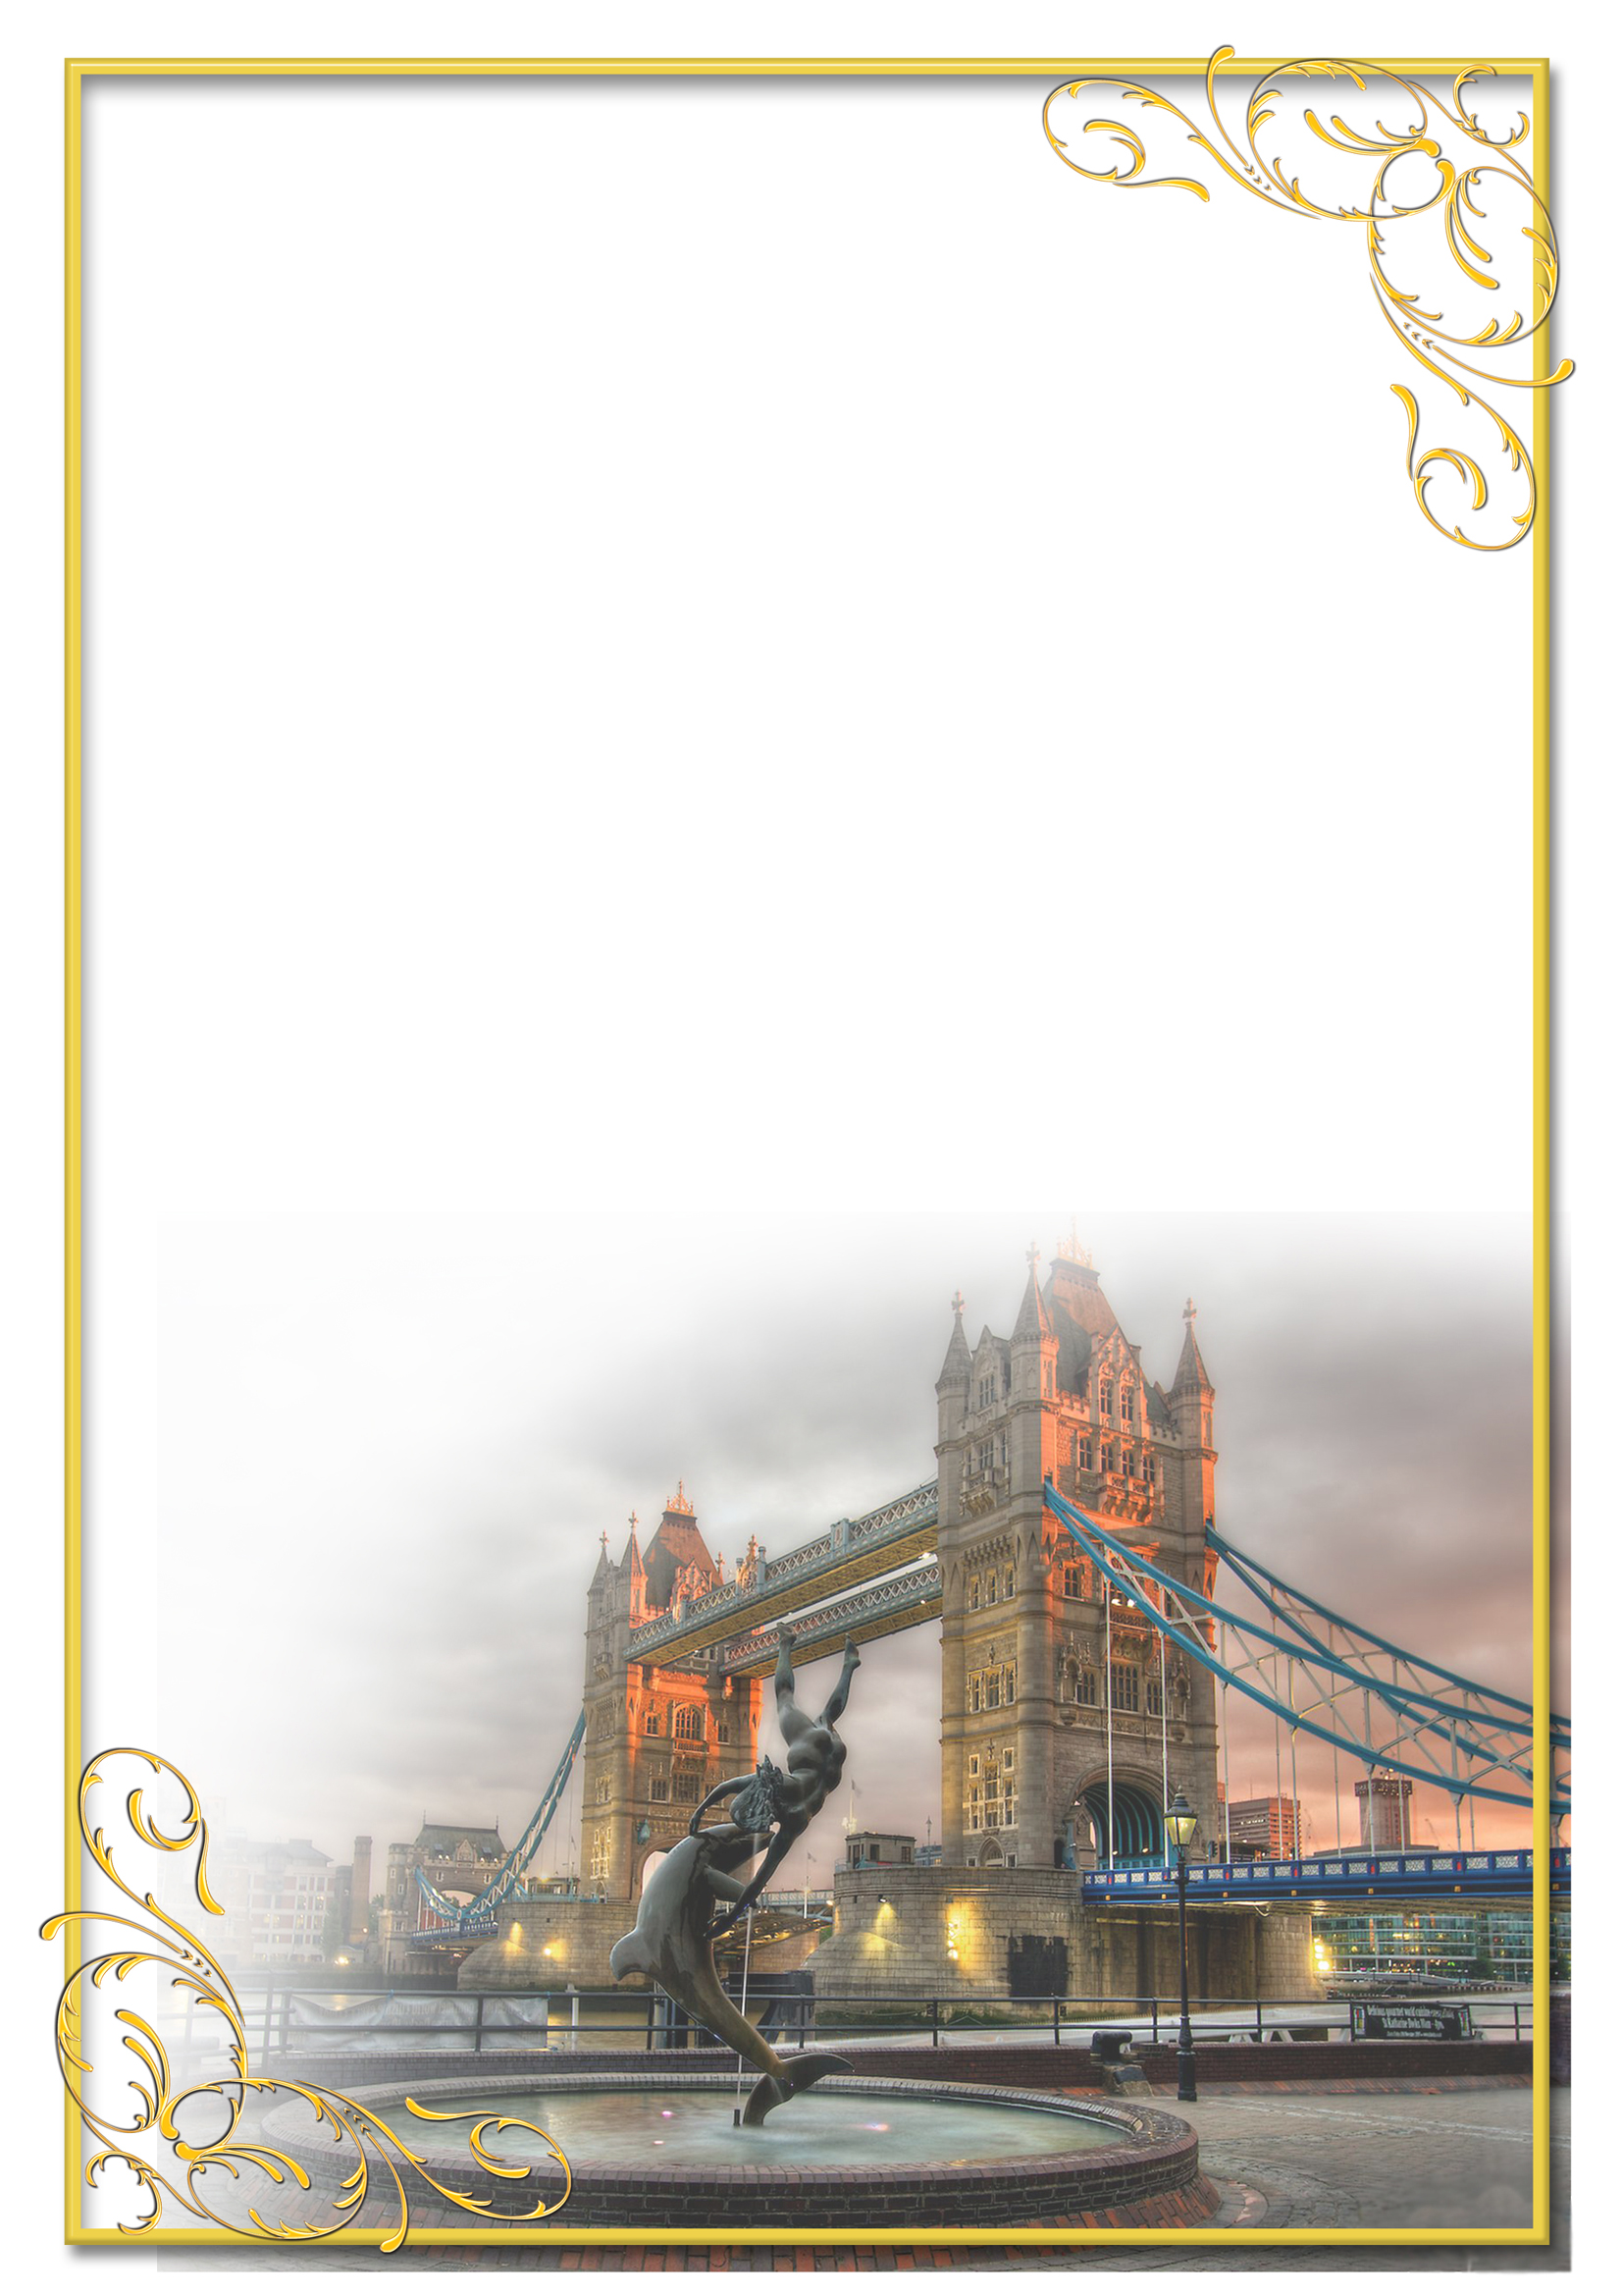

КОНСПЕКТ

ВІДКРИТОГО УРОКУ
на тему:
“MY SCHOOL IS COOL!”

Розробка
вчителя англійської мови
Гусєвої Анни Юріївни

КОНСПЕКТ УРОКУ З АНГЛІЙСЬКОЇ МОВИ
ВЧИТЕЛІ: Гусєва А.Ю.
КЛАС: 2-Б
ДАТА: 30.11.17
ТЕМА УРОКУ: “Μy School is Cool!”
ПІДТЕМА: Шкільні речі. Прийменники місця

МЕТА:
Навчальна:
- навчання спілкуванню англійською мовою;
- повторення та активізація вивчених лексичних одиниць за темою «Моя школа. Шкільні речі»
- повторення вживання прийменників місця
- числа 1-20
Освітня:
- розширювати кругозір та підвищувати загальну культуру учнів;
- формувати навички письма, говоріння, аудіювання;
- розвивати вміння вести бесіду щодо даної теми.
Розвивальна:
- розвивати пізнавальний інтерес, пам’ять, увагу, творчі здібності учнів.
- розвивати інтелектуальну, емоційну, мотиваційну сфери особистості учня.
Виховна:
- формувати навички та вміння інтелектуальної праці;
- сприяти формуванню інтересу до вивчення культури країни, мова якої вивчається

ТИП УРОКУ: узагальнюючий комбінований урок
ОБЛАДНАННЯ: підручник, робочий зошит, аудіо та відео
носії, таблиці, схеми, роздатковий матеріал.
ХІД УРОКУ:

І. ПІДГОТОВКА ДО СПРИЙНЯТТЯ ІНШОМОВНОГО МОВЛЕННЯ

- Привітання..
T: Good morning, my dear children. I am very glad and happy to see all of you today. Today we´ll have a wonderful opportunity to build our ideal school and you’ll revise material, you’ve studied before. Try your best! So, let’s start!

- Повідомлення теми та мети заняття
T: Our aim today is to build the ideal school bridging difficulties. On our way we’ll do different funny and very interesting exercises. But in order to do everything properly let’s motivate ourselves! So…Meet our teacher Mrs Hen and sing a Happy Song with her.

(a song “Na,na,na” without physical activities )

- Warming Up. Уведення в іншомовну атмосферу

    - Game “Clap&Number”
    - T: Let’s start our work! Here you can see the figure of school. (додаток 1) But where are classrooms, school things, teachers and pupils. Oh! We must do a puzzle, but it’s not easy. We must do different tasks and if you are successful, you’ll get a piece of this puzzle. At the end of the lesson we’ll arrange all the pieces and get a picture of our Ideal school.
    - So, now let’s start with the first exercise. Do you remember numbers 1-20? Who can remind me? Let’s count together and sing a song!
https://www.youtube.com/watch?v=Aq4UAss33qA

    - And now I’ll close some numbers and you mustn’t name them, just clap. But be very attentive! if some of you make a mistake, we’ll start from very beginning again. Do you want to win a piece of puzzle? So, let’s start! (додаток 2)

ІІ. ОСНОВНА ЧАСТИНА УРОКУ

- Revising and Practising the Vocabulary.

- Mind-Map “My School Bag”
T: My dear pupils, can find the school bag in our classroom? Ok, but what about things in it? What wrong with them? Yes, these are rebuses. Do you know what is it? Rebus - a puzzle in which words are represented by combinations of pictures and individual letters. Do you want to try and guess all these hidden words? Let’s try! (додаток 3)

- Listening

- “Pack your School Bag”

T: And now I want you to pack your own backpacks. Each of you’ll get a bag with the pictures of different school things. I’ll read you the text which tells you about things English pupils must take to school. You should listen very attentively and write the number of these things. But be careful, here we have some odd things. You should just cross them! (додаток 4)

- Physical Warming up

- “Head, Shoulders, Knees and Toes”
T: And now I’m asking you to sing and dance. Do you agree? Let’s have fun!

(Учні разом з учителем співають пісню, виконуючи відповідні рухи.)

- Grammar Revice
T: And now do you want to continue our building the ideal school? But our next task will be more difficult. And if you want to have the success, let’s remember HELFUL DWARFS. They are POLICEMEN in our Grammar city and they always know where to find missed things etc.
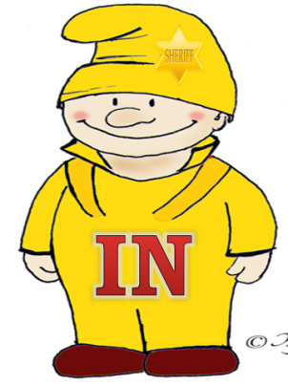
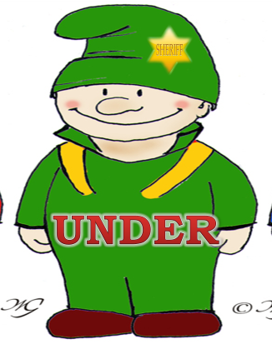

- Grammar Practice

- “Find It!”

T: Children, do you like playing hide-and-seek? And now the picture of the classroom is playing this game with us. I want to divide you in two teams. Each team will get a card with sentences describing this picture, but all the prepositions are missed. Your task is to come to the picture one by one, find necessary things and return to your team and write the right preposition (in, on, under). So, what team will be faster? Let’s start! (додаток 5)

- Reading
- “Who am I?”
T: Children, now you have all the pieces of our puzzle. Let’s make a picture! Look! What a wonderful school we have! Would you like to study there& Let’s imagine that you are the pupils of this school, but who exactly are you? (додаток 6)
Your task is to come to the blackboard and take a strip from the school bag. Blue strips are for boys, pink ones – for girls. Who wants to start finding him/herself in this picture? (додаток 7)

ІІІ. ЗАКЛЮЧНА ЧАСТИНА УРОКУ
- Homework
- Prepare for the test
- WB: ex. 1 (a,b), p.35
- Summarizing
- Our unusual lesson is finished. We spoke about School things today. Do you like our lesson? Would you like to repeat it?
- Заключна бесіда в режимі T – P₁ – P₂ - …

