Інструктивна картка №2 уроку англійської мови
7 клас
( Lessons 77-80 )
Тема. Лондон. Визначні місця столиці
Завдання для учня:
- вивчи лексичний матеріал з теми, вмій застосовувати його в говорінні та на письмі;
- вивчи інформацію про визначні місця столиці Британії;
- удосконалюй навички сприйняття на слух англомовного тексту з повним розумінням його змісту;
- розвивай навички говоріння, аудіювання та письма.

- How are you? Choose the smile and draw your mood at this moment.

2.Speaking

You know much about London. Let’s remember some basic information about this wonderful city.
- Look at the words and tell how they are connected with the topic.
Capital
Buckingham Palace
Thames
St Paul’s Cathedral
Big Ben

The City

- Capital, because London is the capital of Great Britain.
- St Paul’s Cathedral is one of the most beautiful English churches.
1. Capital, because London is the capital of Great Britain.
2. St Paul’s Cathedral is one of the most beautiful English churches.
- Big Ben, because it is the famous clock on the Houses of Parliament.
- Thames, because London stands on the river Thames.
- The City is the business centre of London.
- Buckingham Palace, because it is the official London residence of the Queen.

I have got a “Magic Questions”. Read them and show your knowledge about different aspects of London and Great Britain.

- What is the official name of Great Britain? (The United Kingdom of Great Britain and Northern Ireland.)
- What parts does the United Kingdom consist of? ( England, Scotland, Wales and Northern Ireland.)
- What is the official part of London? ( Westminster.)
- What is the oldest part of London? ( The City.)
- What is the capital of Scotland? ( Edinburgh.)
- What is the symbol of England? (The rose.)
- Where does the Prime Minister of Great Britain live? ( At 10, Downing Street.)
- What park is London Zoo in? (In Regent’s Park.)
- What is the London home of the Queen? ( Buckingham Palace.)
- Where are famous people of Great Britain buried? ( In Westminster Abbey.)

- Reading
Read the text “London” to know more about the city.
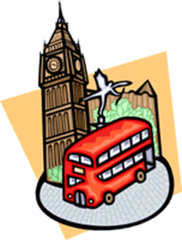
London
London is the capital city of England and of the United Kingdom. It is situated on the River Thames. It’s one of the world’s largest ports.
Many places in London are closely connected with the Crown. There are royal palaces, royal parks, roads and streets where beautiful ceremonies are held. The most important building is Buckingham Palace which is the official residence of Queen Elizabeth II. There are ten royal parks in and around London. They are open to the public free of charge. The most famous ones are Hyde Park and Regent’s Park with London Zoo.
London is full of things to see and to do. One of the best ways to watch the city is to take a sightseeing tour on a double-decker bus. The central square is Trafalgar Square with Nelson’s Column built in honour of Britain’s naval hero admiral lord Nelson.
Downing Street, 10 is the official home of prime ministers since 1731.

Pre – Reading.

Choose the right answer for each sentence.
- The most famous museum of wax figures.
- The most famous bridge over the Thames.
- One of the most famous zoos in the world.
- The oldest metro in the world.
- It is the best – known square in London.
- This castle has been a royal palace, a prison, a zoo and an observatory.
- It is the famous place where six streets meet.
- It has got a fine collection of paintings.

Madame Tussaud’s Museum, Tower Bridge, London Zoo, the Tube,

Trafalgar Square, the Tower of London, Piccadilly Circus, National Gallery

While – Reading.

Match the words.
The Thames River  Buckingham Palace  Regent’s Park  Trafalgar Square  Downing Street, 10 | Nelson’s Column  London Zoo  London  Elizabeth II  The Prime Minister

Post - Reading.

Correct the sentences.
- London is on the Severn River.
- Buckingham Palace is the official residence of the Prime Minister.
- There are light royal parks in and around London.
- London Zoo can be found in Hyde Park.
- The central square in London is Piccadilly Circus.
- Downing Street, 10 is the official residence of the queen Elizabeth II.

- Look at the pictures. Do you know that…

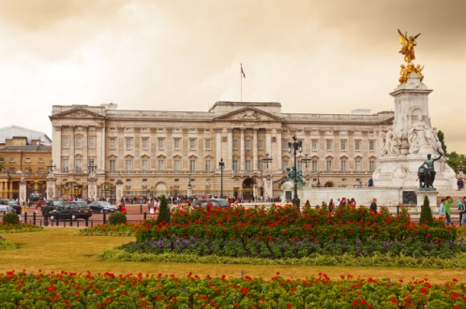
.
- Buckingham Palace is the most famous of London’s royal palaces. The Queen and her family live in a part of the palace. Other parts can be visited by tourists. The Changing of the Guard is a ceremony that takes place every day.
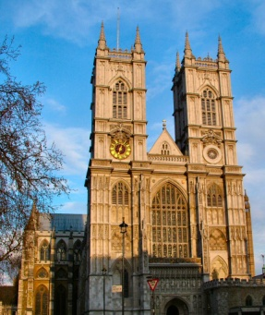
2. Westminster Abbey is located near the Houses of Parliament. Almost all of the country’s kings and queens have been crowned there. Monarchs and famous people are buried in the abbey . Among them are Charles Darwin and Sir Isaac Newton.
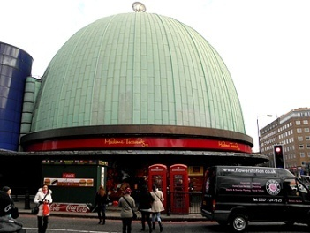

3.Madame Tussaud’s Museum. The most famous museum of wax figures was opened in 1835. Thousands of famous people, artists, writers, politicians and other celebrities have been created in wax.
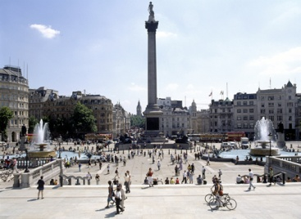
4.Trafalgar Square is the largest square in London . In the centre is Nelson’s Column, built in honour of Admiral Nelson, who defeated the French fleet at Trafalgar in 1805.

- Listening Task
Everyone knows Big Ben, Buckingham Palace and Tower Bridge, but what else
is there to the city of London? Learn about London's past, present and future in this video «The city of London»
https://learnenglishteens.britishcouncil.org/uk-now/video-uk/city-london

- Do the test
https://learnenglishteens.britishcouncil.org/sites/teens/files/the_city_of_london_-_exercises_0.pdf

- Hometask
Ex.6, p,132
Read and act out the situation. You have just come back from a trip to London. Tell your classmates about this city in the new millennium. Which part of London is full of reminders of its past?
Ex.7, p.132
Complete the paragraph from the London Sightseeing Tour. Fill in the missing articles where they are necessary.

Do these tasks and send the screenshot .

- How are you now? Choose the smile about your mood at this moment.

