Level - Intermediate According to Pearson books
Maksym Reznik and ‘Focus 4’ written by
Аlla Vovk, Daniel Brayshaw, and
a teacher of history and Bartosz Michalowski
a teacher of English, for the pupils of the tenth form
Kyiv,
Gymnasia ‘Kyivan Rus.’
Lesson 59.
Topic. The role of the USA in the development of European countries in the first part of the 20th century.
Sub – topic. The USA in the period of 1900 – 1939.
Objectives:
History:
- to explain to pupils the main stages of the USA development in the first part of the 20th century;
- to tell children about some famous Americans who contributed a lot in the development of the USA;
- to estimate the activities of the famous people;
- to develop critical thinking of the pupils.
- to teach them how to politely cooperate in groups.
English:
- to teach pupils how to write an article;
- to activate new words and expressions for writing tasks;
- to analyze articles about famous Americans;
- to develop children’s writing skills.
The form of conducting: integrated lesson.
The type of the lesson: learning new knowledge.
Equipment: text – books, portraits of the famous Americans, handouts, American symbols, a computer and a projector.
Procedure
Teacher of history:
- Good afternoon. Let’s make a roll – call.
Today our lesson will be in English. You can see the topic and sub – topic on the blackboard. So, by the end of the lesson you should be able to understand the main stages of the USA development in the period of 1900 – 1939 and you find out interesting facts about some famous Americans.
Teacher of English:
- Besides, you will have learnt how to write an article and consolidate all the material of today’ lesson.
Warming up.
Teacher of history:
- You had to find out some information about famous people of the first part of the 20th century. Who wants to be the first to tell us about anyone of them?
(Children’s approximate answer):
- Ernest Miller Hemingway (July 21, 1899 – July 2, 1961) was an American novelist, short-story writer, journalist, and sportsman. His economical and understated style which he termed the iceberg theory—had a strong influence on 20th-century fiction, while his adventurous lifestyle and his public image brought him admiration from later generations. Hemingway produced most of his work between the mid-1920s and the mid-1950s, and he was awarded the 1954 Nobel Prize in Literature. He published seven novels, six short-story collections, and two nonfiction works. Three of his novels, four short-story collections, and three nonfiction works were published posthumously. Many of his works are considered classics of American literature.
- George Gershwin, born September 26, 1898 – July 11, 1937) was an American composer and pianist, whose compositions spanned both popular and classical genres. Among his best-known works are the orchestral compositions Rhapsody in Blue (1924) and An American in Paris (1928), the songs "Swanee" (1919) and "Fascinating Rhythm" (1924), the jazz standards "Embraceable You" (1928) and "I Got Rhythm" (1930), and the opera Porgy and Bess (1935), which was the first jazz opera with black – skinned unprofessional singers. This opera icluded the hit "Summertime".

- Important movements in drama, poetry, fiction, and criticism took shape in the years before, during, and after World War I. The eventful period that followed the war left its imprint upon books of all kinds. Literary forms of the period were extraordinarily varied, and in drama, poetry, and fiction the leading authors tended toward radical technical experiments. It should be mentioned Henry James, Scott Fitzgerald, William Faulkner, Arthur Miller, Joseph Heller, Ernest Hemingway, Toni Morrison, John Steinbeck and others.
The main part of the lesson.
Teacher of history:
- Alright. Let’s recollect American history.
- – Where is the USA situated?
- It is situated in the central part of the North American Continent.
- - What is the USA washed by?
- It is washed by the Pacific Ocean, the Atlantic Ocean and the Gulf of Mexico.
- – What is the total area of the country?
- It’s over nine million square kilometres.
- – What are the principal rivers of the USA?
- The Mississippi river and the Hudson river.
- – How many states are there in the USA?
- There are fifty states.
- – What is the name of the American flag?
- ‘’Stars and stripes’’ or ‘’Old Glory’’.
- – What do stars and stripes symbolize?
- The 50 stars represent the 50 states, 13 stripes represent 13 original English colonies, which in 1776 became independent of England.
- – How and when did the Statue of Liberty appear in New York?
- It was a present from France in 1976 on occasion of the 100th anniversary of American independence. The statue’s parts were delivered by ships and then the statue was constructed.
- What is the nickname of New York?
- ‘’The Big Apple’’.
10. - What is the national emblem of America?
- The eagle. It became the national emblem of the country in 1782.
11. - How many states did the USA have at first?
- They had 13.
12. –Which states to join were the last two?
- Alaska and Hawaii.
13. – When did they join to the USA?
- They both joined in 1959.
14. – What type of land covers the USA?
- Forests, deserts, mountains and flat land.
15. – Where do the people of the USA come from?
- From all over the world.
16. When do Americans celebrate Independence Day?
- On the 4th of July.
Teacher of English:
1. – Do Americans like cooking?
- No, they don’t.
2. – What dishes are traditional in America for Thanksgiving Day dinner?
- Turkey, ham and apple pie.

3.- Is there an American tradition to treat anybody on Thanksgiving Day?
- Yes, there is.
4. – Are there any principles of American cuisine?
- Americans drink a lot of juice and coca - cola, eat much meat, fruit and vegetables, not much bread.
5. – Name the currency in America.
- Dollars.
6. – Is there the queen in the USA?
- No, there isn’t
7. – What state of America has got the lowest
population?
- Alaska has got the lowest population.
8. – How many states of America have got their name from American Indian origin?
- More than half the states.
9. – Has each state got a flag with colours that have a
special meaning for it?
- Yes, it has.
10. – Which president helped bring about the beginnings of a national recovery from the greatest domestic crisis?
- Franklin D. Roosevelt.
Teacher of English:
- Let’s recollect some facts about him reading the article extract written by
William E. Leuchtenburg. Try to understand the main gist of it.

FRANKLIN D. ROOSEVELT: LIFE IN BRIEF

Faced with the Great Depression and World War II, Franklin D. Roosevelt, nicknamed “FDR,” guided America through its greatest domestic crisis, with the exception of the Civil War, and its greatest foreign crisis. His presidency—which spanned twelve years—was unparalleled, not only in length but in scope. FDR took office with the country mired in a horrible and debilitating economic depression that not only sapped its material wealth and spiritual strength, but cast a pall over its future. Roosevelt's combination of confidence, optimism, and political savvy—all of which came together in the experimental economic and social programs of the "New Deal"—helped bring about the beginnings of a national recovery.
In foreign affairs, FDR committed the United States to the defeat of the fascist powers of Germany, Japan, and Italy, and led the nation and its allies to the brink of victory. This triumph dramatically altered America's relationship with the world, guiding the United States to a position of international prominence, if not predominance. By virtue of its newfound political and economic power, as well as its political and moral leadership, the United States would play a leading role in shaping the remainder of the twentieth century.
Franklin Roosevelt also forged a domestic political revolution on several fronts. In politics, FDR and the Democratic Party built a power base which carried the party to electoral, if not ideological, dominance until the late 1960s. In governance, FDR's policies, especially those comprising the New Deal, helped redefine and strengthen both the American state and, specifically, the American presidency, expanding the political, administrative, and constitutional powers of the office.
Under Roosevelt's leadership, the United States emerged from World War II as the world's foremost economic, political, and military power. FDR's contributions to domestic life during his presidency were just as vital. While his "New Deal" did not end the Great Depression, Roosevelt's leadership gave Americans hope and confidence in their darkest hours and fundamentally reshaped the relationship between the federal government and the American people. FDR so dominated American politics that he almost single-handedly launched the Democratic Party into a position of prolonged political dominance. During his tenure, FDR also lifted both the standing and power of the American presidency to unprecedented heights. More broadly, however, his New Deal programs, marked a substantial turning point in the nation's political, economic, social, and cultural life.
After – reading activity.
- What did Roosevelt’s leadership give Americans?
- Hope and confidence in their darkest hours and he reshaped the relations between the federal government and the American people.
- What party did Roosevelt lead?
- Democratic Party.
Teacher of history:
- Let’ turn to the beginning of the 20th century. What was America like then?
Before the 1914 war, the great economic potential of the U.S. was suppressed by its ineffective political system, dysfunctional financial system, and uniquely violent racial and labor conflicts. “America was a byword for urban graft, mismanagement and greedy politics, as much as for growth, production, and profit,” Tooze writes.
The United States might claim a broader democracy than those that prevailed in Europe. On the other hand, European states mobilized their populations with an efficiency that dazzled some Americans (notably Theodore Roosevelt) and appalled others (notably Wilson). The magazine founded by pro-war intellectuals in 1914, The New Republic, took its title precisely because its editors regarded the existing American republic as anything but the hope of tomorrow.
Yet as World War I entered its third year—and the first year of Tooze’s story—the balance of power was visibly tilting from Europe to America. The belligerents could no longer sustain the costs of offensive war. Cut off from world trade, Germany hunkered into a defensive siege, concentrating its attacks on weak enemies like Romania. The Western allies, and especially Britain, outfitted their forces by placing larger and larger war orders with the United States. In 1916, Britain bought more than a quarter of the engines for its new air fleet, more than half of its shell casings, more than two-thirds of its grain, and nearly all of its oil from foreign suppliers, with the United States heading the list. Britain and France paid for these purchases by floating larger and larger bond issues to American buyers—denominated in dollars, not pounds or francs. “By the end of 1916, American investors had wagered two billion dollars on an Entente victory,” computes Tooze (relative to America’s estimated GDP of $50 billion in 1916, the equivalent of $560 billion in today’s money).
That staggering quantity of Allied purchases called forth something like a war mobilization in the United States. American factories switched from civilian to military production; American farmers planted food and fiber to feed and clothe the combatants of Europe. But unlike in 1940-41, the decision to commit so much to one side’s victory in a European war was not a political decision by the U.S. government. Quite the contrary: President Wilson wished to stay out of the war entirely. He famously preferred a “peace without victory.” The trouble was that by 1916, the U.S. commitment to Britain and France had grown—to borrow a phrase from the future—too big to fail.
Tooze’s portrait of Woodrow Wilson is one of the most arresting novelties of his book. His Wilson is no dreamy idealist. The president’s animating idea was an American exceptionalism of a now-familiar but then-startling kind. His Republican opponents—men like Theodore Roosevelt, Henry Cabot Lodge, and Elihu Root—wished to see America take its place among the powers of the earth. They wanted a navy, an army, a central bank, and all the other instrumentalities of power possessed by Britain, France, and Germany. These political rivals are commonly derided as “isolationists” because they mistrusted the Wilson’s League of Nations project. That’s a big mistake. They doubted the League because they feared it would encroach on American sovereignty. It was Wilson who wished to remain aloof from the Entente, who feared that too close an association with Britain and France would limit American options. This aloofness enraged Theodore Roosevelt, who complained that the Wilson-led United States was “sitting idle, uttering cheap platitudes, and picking up [European] trade, whilst they had poured out their blood like water in support of ideals in which, with all their hearts and souls, they believe.” Wilson was guided by a different vision: Rather than join the struggle of imperial rivalries, the United States could use its emerging power to suppress those rivalries altogether. Wilson was the first American statesman to perceive that the United States had grown, in Tooze’s words, into “a power unlike any other. It had emerged, quite suddenly, as a novel kind of ‘super-state,’ exercising a veto over the financial and security concerns of the other major states of the world.”
Wilson hoped to deploy this emerging super-power to enforce an enduring peace. His own mistakes and those of his successors doomed the project, setting in motion the disastrous events that would lead to the Great Depression, the rise of fascism, and a second and even more awful world war. Herbert Hoover was president during the first part of the Great Depression and many people blamed him for the poverty and homelessness Americans were experiencing. As hundreds of shanty towns popped up across the country, people began referring to them as “Hoovervilles.” The dilapidated towns weren't the only Depression-era nicknames the president inspired. “Hoover Stew” was the soup handed out at food kitchens, and “Hoover Hogs” were the rabbits some Americans ate to survive.

What went wrong? “When all is said and done,” Tooze writes, “the answer must be sought in the failure of the United States to cooperate with the efforts of the French, British, Germans and the Japanese [leaders of the early 1920s] to stabilize a viable world economy and to establish new institutions of collective security. … Given the violence they had already experienced and the risk of even greater future devastation, France, Germany, Japan, and Britain could all see this. But what was no less obvious was that only the US could anchor such a new order.” And that was what Americans of the 1920s and 1930s declined to do—because doing so implied too much change at home for them: “At the hub of the rapidly evolving, American-centered world system there was a polity wedded to a conservative vision of its own future.”
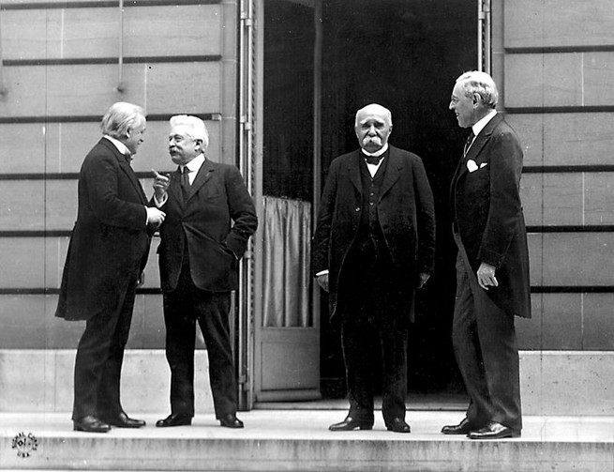
President Woodrow Wilson (far right) stands with other leaders of the Council of Four at the Paris Peace conference in 1919. (Wikipedia)
Periodically, attempts have been made to rehabilitate the American leaders of the 1920s. The most recent version, James Grant’s The Forgotten Depression, 1921: The Crash That Cured Itself, was released just two days before The Deluge: Grant, an influential financial journalist and historian, holds views so old-fashioned that they have become almost retro-hip again. He believes in thrift, balanced budgets, and the gold standard; he abhors government debt and Keynesian economics. The Forgotten Depression is a polemic embedded within a narrative, an argument against the Obama stimulus joined to an account of the depression of 1920-21.
As Grant correctly observes, that depression was one of the sharpest and most painful in American history. Total industrial production may have dropped by 30 percent. Unemployment spiked at perhaps close to 12 percent (accurate joblessness statistics don’t exist for this period). Overall, prices plummeted at the steepest rate ever recorded—steeper than in 1929-33. Then, after 18 months of extremely hard times, the economy lurched into recovery. By 1923, the U.S. had returned to full employment.
Grant presents this story as a laissez-faire triumph. Wartime inflation was halted. Borrowing and spending gave way to saving and investing. Recovery then occurred naturally, without any need for government stimulus. “The hero of my narrative is the price mechanism, Adam Smith’s invisible hand,” he notes. “In a market economy, prices coordinate human effort. They channel investment, saving and work. High prices encourage production but discourage consumption; low prices do the opposite. The depression of 1920-21 was marked by plunging prices, the malignity we call deflation. But prices and wages fell only so far. They stopped falling when they become low enough to entice consumers into shopping, investors into committing capital and employers into hiring. Through the agency of falling prices and wages, the American economy righted itself.” Reader, draw your own comparisons!
Grant’s argument is not new. The libertarian economist Murray Rothbard argued a similar case in his 1963 book, America’s Great Depression. The Rothbardian story of the “good” depression of 1920 has resurfaced from time to time in the years since, most spectacularly when Fox News star Glenn Beck seized upon it as proof that the Obama stimulus was wrong and dangerous. Grant tells the story with more verve and wit than most, and with a better eye for incident and character. But the central assumption of his version of events is the same one captured in Rothbard’s title half a century ago: that America’s economic history constitutes a story unto itself.
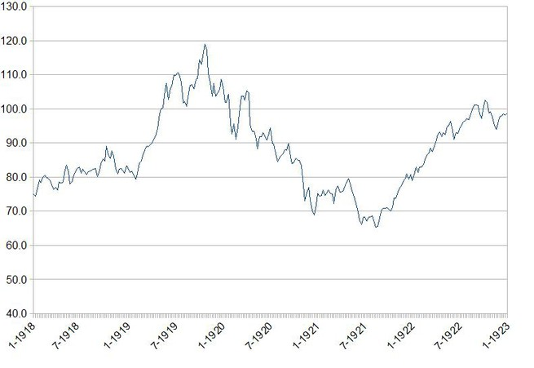America's "forgotten depression" through the lens of Dow Jones industrial averages from 1918 to 1923 (Wikipedia)
Widen the view, however, and the “forgotten depression” takes on a broader meaning as one of the most ominous milestones on the world’s way to the Second World War. After World War II, Europe recovered largely as a result of American aid; the nation that had suffered least from the war contributed most to reconstruction. But after World War I, the money flowed the other way.
Take the case of France, which suffered more in material terms than any World War I belligerent except Belgium. Northeastern France, the country’s most industrialized region in 1914, had been ravaged by war and German occupation. Millions of men in their prime were dead or crippled. On top of everything, the country was deeply in debt, owing billions to the United States and billions more to Britain. France had been a lender during the conflict too, but most of its credits had been extended to Russia, which repudiated all its foreign debts after the Revolution of 1917. The French solution was to exact reparations from Germany.
Britain was willing to relax its demands on France. But it owed the United States even more than France did. Unless it collected from France—and from Italy and all the other smaller combatants as well—it could not hope to pay its American debts.
In 1917, a group of women led by suffragist Alice Paul began protesting outside the White House, urging President Woodrow Wilson to support legislation granting women the right to vote. They held signs bearing slogans such as “How long must women wait for liberty?” and “Mr. President, what will you do for woman suffrage?” On Jan. 9, 1918, one year into their protest, Wilson announced his support for the women's suffrage amendment; however, it would be two years later before Congress got on board and ratified the Nineteenth Amendment to the Constitution on Aug. 18, 1920. “Hoover Hogs” were the rabbits some Americans ate to survive.
Americans, meanwhile, were preoccupied with the problem of German recovery. How could Germany achieve political stability if it had to pay so much to France and Belgium? The Americans pressed the French to relent when it came to Germany, but insisted that their own claims be paid in full by both France and Britain.
Germany, for its part, could only pay if it could export, and especially to the world’s biggest and richest consumer market, the United States. The depression of 1920 killed those export hopes. Most immediately, the economic crisis sliced American consumer demand precisely when Europe needed it most. True, World War I was not nearly as positive an experience for working Americans as World War II would be; between 1914 and 1918, for example, wages lagged behind prices. Still, millions of Americans had bought billions of dollars of small-denomination Liberty bonds. They had accumulated savings that could have been spent on imported products. Instead, many used their savings for food, rent, and mortgage interest during the hard times of 1920-21.
But the gravest harm done by the depression to postwar recovery lasted long past 1921. To appreciate that, you have to understand the reasons why U.S. monetary authorities plunged the country into depression in 1920.
Grant rightly points out that wars are usually followed by economic downturns. Such a downturn occurred in late 1918-early 1919. “Within four weeks of the … Armistice, the [U.S.] War Department had canceled $2.5 billion of its then outstanding $6 billion in contracts; for perspective, $2.5 billion represented 3.3 percent of the 1918 gross national product,” he observes. Even this understates the shock, because it counts only Army contracts, not Navy ones. The postwar recession checked wartime inflation, and by March 1919, the U.S. economy was growing again.
As the economy revived, workers scrambled for wage increases to offset the price inflation they’d experienced during the war. Monetary authorities, worried that inflation would revive and accelerate, made the fateful decision to slam the credit brakes, hard. Unlike the 1918 recession, that of 1920 was deliberately engineered. There was nothing invisible about it. Nor did the depression “cure itself.” U.S. officials cut interest rates and relaxed credit, and the economy predictably recovered—just as it did after the similarly inflation-crushing recessions of 1974-75 and 1981-82.
But 1920-21 was an inflation-stopper with a difference. In post-World War II America, anti-inflationists have been content to stop prices from rising. In 1920-21, monetary authorities actually sought to drive prices back to their pre-war levels. They did not wholly succeed, but they succeeded well enough. One price especially concerned them: In 1913, a dollar bought a little less than one-twentieth of an ounce of gold; by 1922, it comfortably did so again.
James Grant hails this accomplishment. Adam Tooze forces us to reckon with its consequences for the rest of the planet.
Every other World War I belligerent had quit the gold standard at the beginning of the war. As part of their war finance, they accepted that their currency would depreciate against gold. The currencies of the losers depreciated much more than the winners; among the winners, the currency of Italy depreciated more than that of France, and France more than that of Britain. Yet even the mighty pound lost almost one-fourth of its value against gold. At the end of the conflict, every national government had to decide whether to return to the gold standard and, if so, at what rate.
World War I made the U.S. the world’s leading creditor and the unofficial custodian of the gold standard.
The American depression of 1920 made that decision all the more difficult. The war had vaulted the United States to a new status as the world’s leading creditor, the world’s largest owner of gold, and, by extension, the effective custodian of the international gold standard. When the U.S. opted for massive deflation, it thrust upon every country that wished to return to the gold standard (and what respectable country would not?) an agonizing dilemma. Return to gold at 1913 values, and you would have to match U.S. deflation with an even steeper deflation of your own, accepting increased unemployment along the way. Alternatively, you could re-peg your currency to gold at a diminished rate. But that amounted to an admission that your money had permanently lost value—and that your own people, who had trusted their government with loans in local money, would receive a weaker return on their bonds than American creditors who had lent in dollars.
Britain chose the former course; pretty much everybody else chose the latter.
The consequences of these choices fill much of the second half of The Deluge. For Europeans, they were uniformly grim, and worse. But one important effect ultimately rebounded on Americans. America’s determination to restore a dollar “as good as gold” not only imposed terrible hardship on war-ravaged Europe, it also threatened to flood American markets with low-cost European imports. The flip side of the Lost Generation enjoying cheap European travel with their strong dollars was German steelmakers and shipyards underpricing their American competitors with weak marks.
Such a situation also prevailed after World War II, when the U.S. acquiesced in the undervaluation of the Deutsche mark and yen to aid German and Japanese recovery. But American leaders of the 1920s weren’t willing to accept this outcome. In 1921 and 1923, they raised tariffs, terminating a brief experiment with freer trade undertaken after the election of 1912. The world owed the United States billions of dollars, but the world was going to have to find another way of earning that money than selling goods to the United States.
That way was found: more debt, especially more German debt. The 1923 hyper-inflation that wiped out Germany’s savers also tidied up the country’s balance sheet. Post-inflation Germany looked like a very creditworthy borrower. Between 1924 and 1930, world financial flows could be simplified into a daisy chain of debt. Germans borrowed from Americans, and used the proceeds to pay reparations to the Belgians and French. The French and Belgians, in turn, repaid war debts to the British and Americans. The British then used their French and Italian debt payments to repay the United States, who set the whole crazy contraption in motion again. Everybody could see the system was crazy. Only the United States could fix it. It never did.
Peter Heather, the great British historian of Late Antiquity, explains human catastrophes with a saying of his father’s, a mining engineer: “If man accumulates enough combustible material, God will provide the spark.” So it happened in 1929. The Deluge that had inundated the rest of the developed world roared back upon the United States.
The Great Depression overturned parliamentary governments throughout Europe and the Americas. Yet the dictatorships that replaced them were not, as Tooze emphasizes in The Wages of Destruction, reactionary absolutisms of the kind re-established in Europe after Napoleon. These dictators aspired to be modernizers, and none more so than Adolf Hitler.
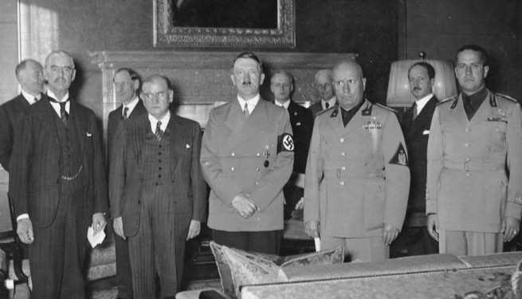From left to right, Britain's Neville Chamberlain, France's Édouard Daladier, Germany's Adolf Hitler, and Italy's Benito Mussolini and Count Ciano prepare to sign the Munich Agreement in 1938. (Wikipedia)
“The United States has the Earth, and Germany wants it.” Thus might Hitler’s war aims have been summed up by a latter-day Woodrow Wilson. From the start, the United States was Hitler’s ultimate target. “In seeking to explain the urgency of Hitler’s aggression, historians have underestimated his acute awareness of the threat posed to Germany, along with the rest of the European powers, by the emergence of the United States as the dominant global superpower,” Tooze writes. “The originality of National Socialism was that, rather than meekly accepting a place for Germany within a global economic order dominated by the affluent English-speaking countries, Hitler sought to mobilize the pent-up frustrations of his population to mount an epic challenge to this order.” Of course, Hitler was not engaged in rational calculation. He could not accept subordination to the United States because, according to his lurid paranoia, “this would result in enslavement to the world Jewish conspiracy, and ultimately race death.” He dreamed of conquering Poland, Ukraine, and Russia as a means of gaining the resources to match those of the United States. The vast landscape in between Berlin and Moscow would become Germany’s equivalent of the American west, filled with German homesteaders living comfortably on land and labor appropriated from conquered peoples—a nightmare parody of the American experience with which to challenge American power.
Could this vision have ever been realized? Tooze argues in The Wages of Destruction that Germany had already missed its chance. “In 1870, at the time of German national unification, the population of the United States and Germany was roughly equal and the total output of America, despite its enormous abundance of land and resources, was only one-third larger than that of Germany,” he writes. “Just before the outbreak of World War I the American economy had expanded to roughly twice the size of that of Imperial Germany. By 1943, before the aerial bombardment had hit top gear, total American output was almost four times that of the Third Reich.”
The basis of the modern European order was America’s rise to dominance a century ago. That dominance may soon end.
Germany was a weaker and poorer country in 1939 than it had been in 1914. Compared with Britain, let alone the United States, it lacked the basic elements of modernity: There were just 486,000 automobiles in Germany in 1932, and one-quarter of all Germans still worked as farmers as of 1925. Yet this backward land, with an income per capita comparable to contemporary “South Africa, Iran and Tunisia,” wagered on a second world war even more audacious than the first.
The reckless desperation of Hitler’s war provides context for the horrific crimes of his regime. Hitler’s empire could not feed itself, so his invasion plan for the Soviet Union contemplated the death by starvation of 20 to 30 million Soviet urban dwellers after the invaders stole all foodstuffs for their own use. Germany lacked workers, so it plundered the labor of its conquered peoples. By 1944, foreigners constituted 20 percent of the German workforce and 33 percent of armaments workers (less than 9 percent of the population of today’s liberal and multicultural Germany is foreign-born). On paper, the Nazi empire of 1942 represented a substantial economic bloc. But pillage and slavery are not workable bases for an industrial economy. Under German rule, the output of conquered Europe collapsed. The Hitlerian vision of a united German-led Eurasia equaling the Anglo-American bloc proved a crazed and genocidal fantasy.
Tooze’s story ends where our modern era starts: with the advent of a new European order—liberal, democratic, and under American protection. Yet nothing lasts forever. The foundation of this order was America’s rise to unique economic predominance a century ago. That predominance is now coming to an end as China does what the Soviet Union and Imperial Germany never could: rise toward economic parity with the United States. That parity has not, in fact, yet arrived, and the most realistic measures suggest that the moment of parity won’t arrive until the later 2020s. Perhaps some unforeseen disruption in the Chinese economy—or some unexpected acceleration of American prosperity—will postpone the moment even further. But it is coming, and when it does, the fundamental basis of world-power politics over the past 100 years will have been removed. Just how big and dangerous a change after the World War I. American politicians retreated the USA from the world ti isolation which undermined the League of Nations and the new political order.
- I want you to consolidate this information. What was the nickname of the shanty towns that many displaced Americans lived in during the Great Depression?
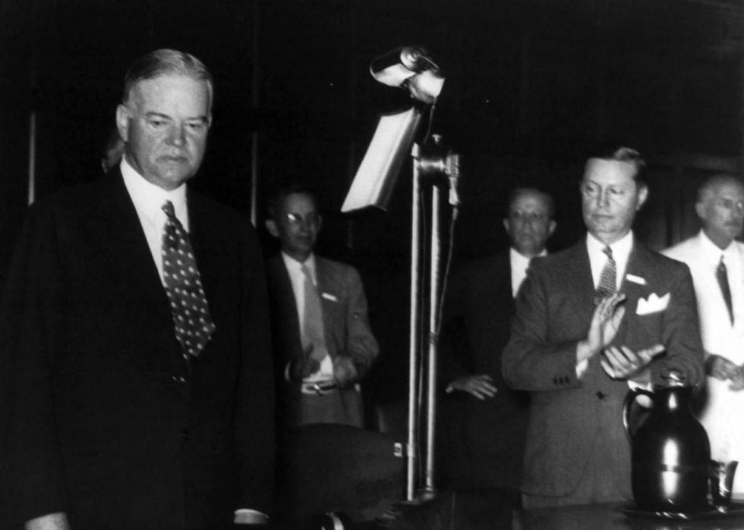

Hoovervilles
Herbert Hoover was president during the first part of the Great Depression and many people blamed him for the poverty and homelessness Americans were experiencing. As hundreds of shanty towns popped up across the country, people began referring to them as “Hoovervilles.” The dilapidated towns weren't the only Depression-era nicknames the president inspired. “Hoover Stew” was the soup handed out at food kitchens, and The Silent Sentinels protested in front of the U.S. White House from 1917 to 1919 in support of what?
The Silent Sentinels protested in front of the U.S. White House from 1917 to 1919 in support of what?

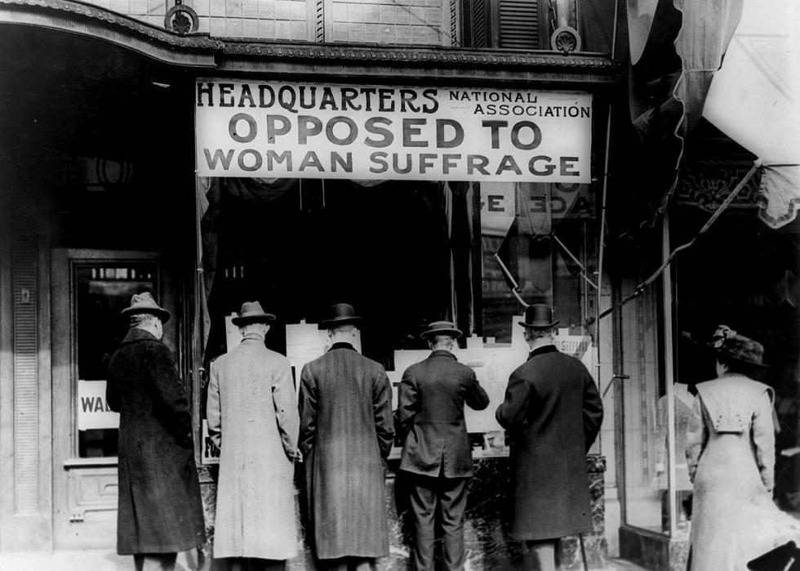

Women's right to vote
In 1917, a group of women led by suffragist Alice Paul began protesting outside the White House, urging President Woodrow Wilson to support legislation granting women the right to vote. They held signs bearing slogans such as “How long must women wait for liberty?” and “Mr. President, what will you do for woman suffrage?” On Jan. 9, 1918, one year into their protest, Wilson announced his support for the women's suffrage amendment; however, it would be two years later before Congress got on board and ratified the Nineteenth Amendment to the Constitution on Aug. 18, 1920.
“Hoover Hogs” were the rabbits some Americans ate to survive.
- What did American politicians do after World War I?
- American politicians retreated the USA from the world to isolation which undermined the League of Nations and the new political order.
(Children watch a documentary about America in the first part of the 20th century.)
Teacher of English:
- Let’s go to articles. There are seven primary types of articles you could write and submit to publications.
1. Essay: Most essays are short to medium-length pieces about a personal experience or an opinion. Typically, an essay revolves around one subject and presents your views.
2. How-To: These prescriptive pieces contain steps, ways, or tips that help the reader do something specific. They provide the Rx (solution) for a problem or the answer to a question. (For example, recipes.)
3. Question and Answer: This is an article based upon an interview. However, with the exception of the lead or introductory paragraphs, you do not analyze or build a story around the interviewee’s answers to your questions. Instead, you pose your questions and provide the answers you receive.
4. Personality Profile: This type of article revolves around a person’s life (not yours) and accomplishments. Based on an interview, you provide an in-depth look at her life, including early beginnings, significant life events, accomplishments, quirks, faults, character, and strengths. (Think People magazine.)
5. Trend: Just as the name implies, a trend article show cases an increasing or decreasing movement over time, such as in housing prices, the number of people playing Pokemon Go, or couples getting divorced.
6. Lifestyle: These articles focus on a lifestyle issue, such as health, relationships, or recreation, and can include interviews as well as statistics. Such a piece might discuss the private school options in a city, how to use a new walking path in a town, or the best restaurants around town.
7. Shorts: Many publications feature short pieces. These might be 150-500 words in length. The topics vary but always focus on the target market of the particular publication. Sometimes a magazine will have a section on health and fitness, for example, and it might consist of four to five short pieces on the topic.
You can find variations on any of these article formats.
You also might find an opportunity to write additional pieces, such as:
- book reviews
- movie reviews
- restaurant reviews
- op-ed pieces (opinion)
Writing articles provides a wonderful opportunity to get out in front of your ideal audience, get paid, and pursue your interests. Now I will explain you how to write an article. Firstly, you should create an eye - catching title. Secondly, you mustn’t repeat it in the first paragraph. You should paraphrase it. Thirdly, it’s necessary to organize your article in 4 or 5 paragraphs.
Eye – catching title.
Introduction: Start by grabbing the reader’s attention. Write something that is interesting and engaging to begin with. Try to summarise what the article will be about, so the reader knows what they are reading.
Middle / Main Content: If you are covering an argument or debate, you can divide points of view into paragraphs. Give the first point of view in one paragraph, the second in another, and then use a third paragraph to compare the two and draw conclusions / add opinion. If you are presenting information, instructions or a narrative, give different events or ideas their own paragraphs, in a logical order that builds on the previous details. For example, if you were writing about the brief history of a war, you might have these five paragraphs: 1 – origins of the war, 2 – how it started, 3 – what happened of note, 4 – how it ended, 5 – the aftermath.
Conclusion: The conclusion should present the main points of the article in a clear and succinct way. You should not add new information in the conclusion, just summarise what you have discussed, with your closing thoughts or opinions.
Universal template of an essay
Nowadays, the problem of … causes great argument and controversy. Some people believe that … while others think … . Who is right?
In my opinion, … . To begin with, … . What is more, … . Additionally,… .
However, there exists another point of view on this issue. First of all, … . Besides, … .
Despite my respect for this opinion, I cannot share it because… . … .
In conclusion, I would like to say that the problem of … is still to be discussed. As far as I am concerned, the point is to…
107 words.
- I’ll hand out you some printed templates to use.

A sample of an assay.
Could Franklin Roosevelt do more for his nation and other ones?
Nowadays, the problem of the role of Franklin Roosevelt in the world history causes great argument and controversy. Some people believe that he is the hero while others think he made a lot of mistakes. Who is right?
In my opinion, he reshaped the relationship between the federal government and the American people. To begin with, he leaded Democratic Party which contributed a lot to stop domestic crises. What is more, Franklin liked his Motherland very much. Additionally, he could sit at home and do nothing because he was paralyzed but he did his best to stop depression in America.
However, there exists another point of view on this issue. First of all, some people think that Roosevelt should have changed the political system to develop America. Besides, they say he being a disabled person shouldn’t have ruled the country.
Despite my respect for this opinion, I cannot share it because he did more than other healthy presidents. Due to his reforms the economy of America recovered which leaded to positive world changes.
In conclusion, I would like to say that the problem of Roosevelt role in history is still to be discussed. As far as I am concerned, the point is to respect the devoted people who saved people’s lives, made them richer and happier. We must be grateful to those who gave their life for us.

- Open your SB on page 47. Let’s do exercise 5.
Complete the WRITING FOCUS.
A ‘for and against’ assay
Introduction
- Begin with general factual comments on the topic.
- End with a statement that mentions both sides of the issue.
Main paragraphs
- Present arguments for in one paragraph and arguments against in another.
/ The first/ One/A further/Another/ 1 ---/ another benefit/plus/drawback/downside of…
There are numerous potential/ clear/ considerable plusses/2 --- to…
One of the most 3 ---/ persuasive/ strongest arguments for/ against …is…
- Develop and support some of your arguments with additional comments or examples.
- Make comparisons.
In the same 4 ---, Similarly/Equally/5 ---
Conclusion
- Make a summarizing statement.
All things, 6 ---/All in all/ On balance, there are pros and cons to…
- End with your personal opinion.
Personally, I think/ believe/7 ---.
Pupils’ answers: 1 – yet, 2 – minuses, 3 – convincing, 4 – way, 5 – Likewise, 6 – considered, 7 – imagine.

- Let’s go to ex. 6 in writing form.
Read the sentences and choose the correct option.
- One of the most persuasive/ potential arguments for living at home is the amount of money that can be saved.
- There are several numerous/ clear upsides to living independently while at university.
- The daily commute is one of the drawbacks of/ fpr living a long way from the university campus,
- Living alone, students learn to cook and clean for themselves. On balance/ Equally, they gain experience in managing their money.
- All at all/ Personally, there are plusses and minuses to remaining in the family home while at university.
Pupils’ answers: 1- persuasive, 2 – clear, 3 – of, 4 – Equally, 5 – All in all.
Teacher of history:
- Let’s play a game. I’ll divide you into four groups and give you handouts. You should choose the captain of your team. The task is to put sentences in
the correct timeline order.
Interactive activity.
Task for the first team. Card 1.
- US intervened in World War I, but rejected membership of League of Nations.
- Women were given the right to vote under Nineteenth Amendment.
- Congress gave indigenous people right to citizenship.
- More than 13 million people were unemployed after the Wall Street stock market crash of 1929 triggers the Great Depression. The president Herbert Hoover rejected direct federal relief.
- The president Franklin Roosevelt launched ‘’New Deal’’ recovery program which included major public works.
Task for the second team. Card 2.
- Breakup of Northern Securities.
- Sinking of the Lusitania and killing 128 Americans.
- Stock Market Crash. The Great Depression started.
- FDR’s First Fireside Chat which contributed to reforming the American social mentality.
- The Atomic Bombing of Hiroshima and Nagasaki.
Task for the third team. Card 3.
Make the Presidents Timeline.
- Grover Cleveland.
- Benjamin Harrison.
- William McKinley.
- Theodor Roosevelt.
- William Howard Taft.
Task for the fourth team. Card 4.
Make the Presidents Timeline.
- Woodrow Wilson.
- Warren Harding.
- Calvin Coolidge.
- Herbert Hoover.
- Franklin Roosevelt.
The teacher of history announces the team – winner.
Summing up.
- Answer my questions, please.
What did American politicians do after World War I?
(Pupils’ approximate answers.)
- American politicians retreated the USA from the world to isolation which undermined the League of Nations and the emerging new political order.
- What president contributed the most to stop domestic crises?
- Franklin Roosevelt.
- Did American example help other countries to stop economic crises?
- Yes, of course. Many of them followed America’s example to develop their economy.
- Did you like our lesson?
- …
- Was it useful for you?
- …
- Today you worked hard. Thank you for it. Open your daybooks, We’ll come up and put you marks.
Homework.
History: read p. 52 – 58, answer questions below the paragraph;
English: WB p. 47, ex. 9

