Тема: Weather Forecast

Мета:

* Ознайомити учнів з новим лексичним матеріалом та удосконалити його вживання в усному мовленні
* Удосконалити вживання структури It’s adj+noun
* Удосконалити навички читання
* Поглибити знання про англійську мову
* Розширити кругозір учнів
* Прививати дбайливе ставлення до природи
* Виховувати учнів мовну культуру

Хід уроку

1. **Підготовка до сприйняття іншомовного мовлення**
2. Greeting

*Good morning everyone*

*Good morning everyone*

*Are you ready for some fun?*

*Stand up and turn around*

*Then touch the ground*

*Give me a great big clap*

*Now fold your hands in your lap.*

2. The aim and the topic of the lesson

*T.: Today we are going to talk more about weather. So, today’s topic of the lesson is “Weather Forecast”. By the end of the lesson you will learn more about nature, you can give the information about the weather conditions and give the weather forecast.*

3. Warming-up

*Weather song*

<https://www.youtube.com/watch?v=XcW9Ct000yY>

4. Checking the home assignment

1. Основна частина уроку
2. Revision of the vocabulary

*Weather Bingo*

2. Listening

*T.: Let’s listen to the weather report and then tell me what the weather is like?*

<https://www.youtube.com/watch?v=x2ZAYPGz7bs>

2.1.After-listening task

*T.: Listen to the weather forecast again and complete the table*

|  |  |  |
| --- | --- | --- |
| Canada |  |  |
| South America |  |  |
| Europe |  |  |
| Asia |  |  |
| America |  |  |

3. Reading

T.: Here is a letter from Bill. Let’s find out what the weather like in Britain.

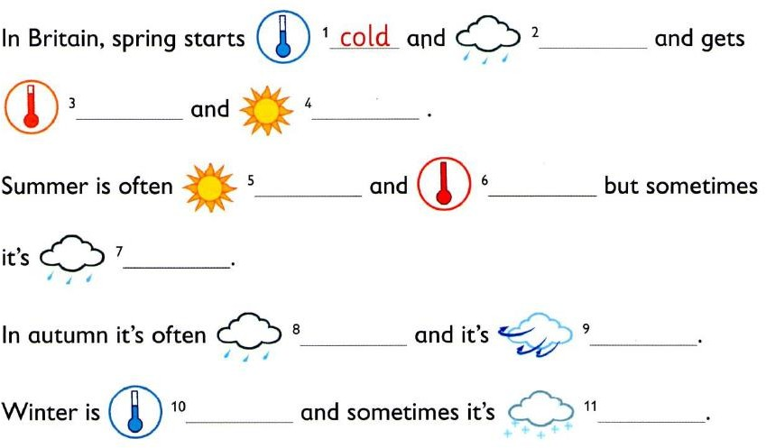

4. Writing

*T.: Match the seasons with the expressions that describe them and then make up sentences with these expressions.*

5. Speaking

*T.: I have an interesting game for you “Tic Toe”. Choose any number and answer the question.*

|  |  |  |
| --- | --- | --- |
| 1  What are the winter months? | 2  What is the weather like in spring? | 3  What is the weather like in summer? |
| 4  What is the weather like today? | **5**  **What are the summer months?** | **6**  **What is the like in winter?** |
| 7  What is your favorite season? | **8**  **What can you do in winter?** | **9**  **What is the weather like in autumn?** |
| 10  What are the spring months? | **11**  **What can you do in summer?** | **12**  **What are the autumn months?** |

1. Заключна частина уроку

1. Homework

*T.: Write down your home task for the next lesson. At home you are to describe the weather in Ukraine.*

2. Summary

*T.: Did you like the lesson? What was new for you? What was difficult? Thank you for the work. You all get good marks!*