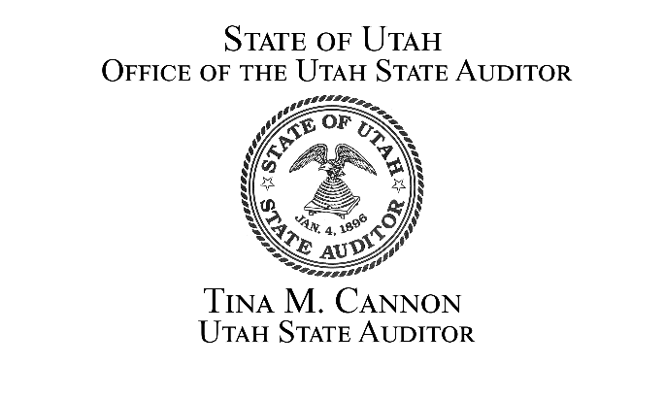
PRESS RELEASE
February 20, 2026
Office of the Utah State Auditor
UTAH STATE CAPITOL, SUITE 260
SALT LAKE CITY, UT 84114

THE OFFICE OF THE UTAH STATE AUDITOR COMMENTS ON HB 545
Auditor’s Role Must Remain Independent to Demonstrate Respect for the Separation of Powers and Maintain Independence in Both
Fact and Appearance

Salt Lake City, UT—Today, the Office of the State Auditor is expressing concern regarding
HB 545 Budgetary Modifications, which contain provisions that removes the authority of the Utah State Auditor with respect to selection of personnel and the “reasonable and necessary expenses of the State Auditor’s budget.”
The role of the Utah State Auditor is statutorily defined to conduct audits to determine honesty and integrity in fiscal affairs; accuracy and reliability of financial statements; effectiveness and adequacy of financial controls; and compliance with the law. This is to be done with independence from influence of any other office or branch of government (Utah Code 67-3-1).
“The current statutory language unanimously passed the legislature in 1943. This marks the first time in 83 years that the Utah Legislature has made any change to the language concerning the budgetary and personnel authority of the Auditor’s Office,” said Tina M. Cannon, Utah State Auditor. “In a system of checks and balances, this provision is the only check that the Office of the Utah State Auditor has to ensure independence. The fact that this provision exists, respecting the independence of the Utah State Auditor, may be the reason it has never been used. This check ensures independence!”
Auditor Cannon continued, “Utah’s citizens entrust public officials with taxpayer dollars and expect them to be managed lawfully, efficiently, and transparently. As Utah’s statewide elected Auditor, my constitutional role is to independently verify that this public trust is being honored. Independence is not a best practice or a technical footnote to the work of the Office of the Utah State Auditor, it is the foundation upon which meaningful oversight depends. As Utah’s statewide, independently elected Auditor, my responsibility is to the people of Utah. Protecting that independence is not optional. It is the cornerstone of effective oversight and the promise of responsible governance I intend to keep.
About the Office of the Utah State Auditor:
The Office of the Utah State Auditor provides Utah taxpayers and government officials with an independent assessment of financial operations, statutory compliance, and performance management, including the development of Transparent.Utah.Gov, for state and local government. The State Auditor is a Constitutional Officer of the Executive Branch of government for the State of Utah. Learn more about the Office of the Utah State Auditor at auditor.utah.gov.

# # #

Contact Information:

Rahn Rampton
Director of Communications, Office of the Utah State Auditor
rrampton@utah.gov or 801-628-2097

