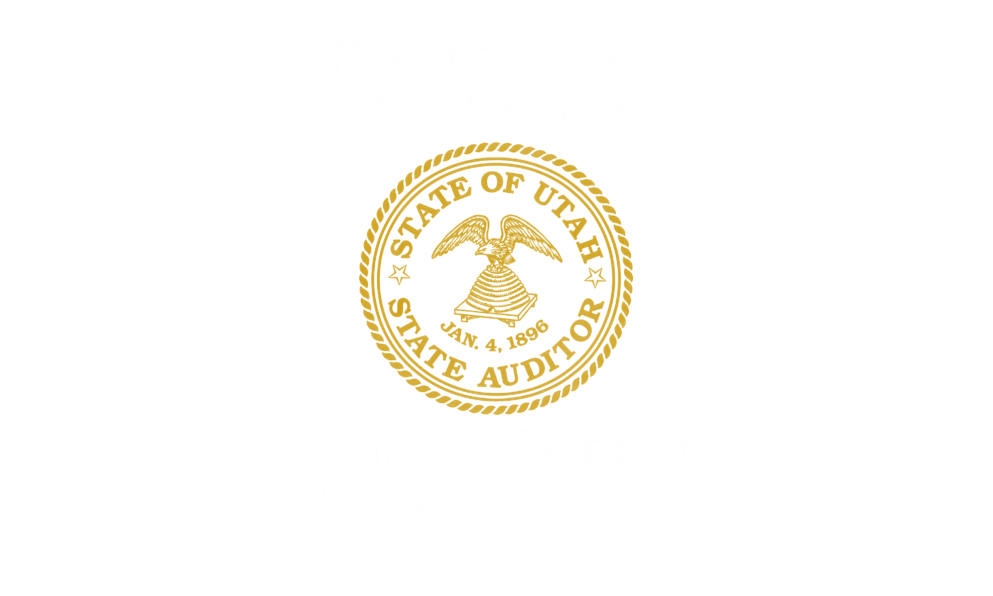

Annual Privacy Report

Fiscal Year 2026

Utah State Capitol, Suite 260, Salt Lake City, UT 84114, (801) 538-1025

Office of the Utah State Auditor
Audit Leadership:
Tina M. Cannon, State Auditor
Warisara Watanawongworakula, CPA, CISA, Information Systems Audit Supervisor
Mark Meyer, CIPM, Assistant State Privacy Auditor
Michael Yglesias, CISA, Information Systems Staff Auditor

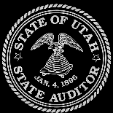
Table of Contents
Background 3
Executive Summary 3
Privacy Audits 4
Completed Audits 4
Systemic Risks and Common Themes 4
Reforms in Response to Audit Findings 5
Audits in Progress 5
Hotline Activity 5
Legislative Review 6
Fiscal Year 2027 Priorities 6

Background
During Fiscal Year 2026, the privacy audit function of the Office of the Utah State Auditor (OSA) fully transitioned into its role as an independent audit body. This transition marks a significant shift from prior years, where the function included privacy training and implementation assistance. As of July 1, 2025, the privacy audit function is now exclusively focused on its primary statutory mandate: to conduct independent privacy audits of governmental entities.
This dedicated audit function ensures independence and avoids any conflicts of interest. The team operates separately from the Utah Office of Data Privacy, which is housed under the Department of Government Operations and focuses on creating the state privacy framework and providing implementation guidance to governmental entities.
In accordance with Utah Code §67-3-13, the OSA is tasked with:
- Developing and maintaining a risk-assessment methodology to prioritize for auditing those governmental entities whose privacy practices may pose the greatest risk to individuals’ privacy.
- Conducting timely audits to evaluate how entities handle personal data, including its acquisition, storage, disposal, protection, and sharing.
- Issuing recommendations that advise the audited entity on necessary reforms to address findings, while ensuring the entity’s management designs and implementing the specific controls.
- Reporting annually to the Legislature on audit results, any reforms made by entities, and potential areas for legislation.
This report covers the activities performed under this focused audit authority for the period of July 1, 2025, to June 30, 2026.

Executive Summary
Through its independent audits in Fiscal Year 2026, the Office of the State Auditor (OSA), under the leadership of State Auditor Tina Cannon, drove needed reforms in how government entities protect Utahns’ personal data. The OSA‘s privacy audit team completed two major privacy audits of the Department of Health and Human Services and the Promontory School of Expeditionary Learning, both initiated following hotline complaints. These audits uncovered critical and high-risk deficiencies, resulting in recommendations to strengthen data protection practices. Two significant themes of risk emerged from this year’s work: inadequate incident response frameworks and the improper use of emerging technologies like Generative AI with sensitive data.
In addition to the completed audits, the OSA initiated three new audits of Moab Charter School, Ogden City, and Nebo School District, which are currently in progress. The activities undertaken in Fiscal Year (FY) 2026 reflect the OSA’s commitment to protecting and promoting privacy as a basic human right. This report outlines the results of our audits, common themes identified across entities, and our priorities for the upcoming fiscal year.

Privacy Audits

Completed Audits
- Department of Health and Human Services (DHHS): An audit performed in response to a hotline tip identified critical and high-risk deficiencies in three main areas:
  - Inadequate Access Controls: The audit found that systems containing millions of records on children and families permitted overly broad access to more than 1,200 users without enforcing a "need-to-know" principle or adequate monitoring.
  - Lack of Quality Control for Records Requests: The team handling public records requests operated without sufficient quality control, leading to a high risk of errors and significant processing delays.
  - Inadequate Incident Response: The audit revealed significant gaps in incident response preparedness, including an ineffective policy, a lack of staff awareness, and no centralized process for managing privacy incidents.
- Promontory School of Expeditionary Learning: This audit, also initiated from a hotline complaint, identified the following high-risk and critical-risk findings:
  - Inadequate Incident Investigation and Documentation (High Risk): The school failed to properly document or investigate a data incident, lacking a consistent methodology for assessing severity, taking corrective action, or documenting key decisions.
  - Improper Use of ChatGPT for Sensitive Data (Critical Risk): The audit discovered that school personnel used ChatGPT with sensitive personnel-related data without having a policy or technical controls in place to prevent the data from being used for AI model training, creating an irreversible risk of loss of control over confidential information.

Systemic Risks and Common Themes
The findings from this year’s completed audits point to two significant cross-cutting themes of risk for governmental entities:
- Deficient Incident Response: Both audited entities struggled with formally identifying, documenting, and responding to data incidents. This indicates a potential statewide weakness in the ability of government bodies to effectively manage and mitigate data breaches when they occur.
- Risks of Emerging Technology: The use of Generative AI without proper governance or technical safeguards presents a new and critical vector of risk. Public entities may be exposing sensitive data to third-party AI models without fully understanding the consequences, including the potential for permanent loss of data control.

Reforms in Response to Audit Findings
In accordance with Utah Code §67-3-13(5)(b)(ii), this section outlines the reforms that governmental entities have reported making in response to the privacy audits completed in FY 2026.

Department of Health and Human Services (DHHS)
In response to audit findings, DHHS has reported taking corrective actions, including:
- Initiating a formal review of system access to enforce "need-to-know" principles.
- Updating its internal incident response policy and conducting mandatory staff training.
- Implementing a peer-review quality control process for its public records team.

Promontory School of Expeditionary Learning
In response to audit findings, the Promontory School has reported implementing the following reforms:
- Adopting a formal methodology for data incident investigation and documentation.
- Implementing a new school-wide policy that prohibits using sensitive data with public-facing Generative AI tools and blocking network access to unapproved platforms.
Unless stated in a subsequent audit or follow-up review, OSA’s reporting of corrective actions reflects information provided by the audited entity and should not be interpreted as independent verification that each recommendation has been fully implemented or that the underlying risk has been completely resolved.

Audits in Progress
As of the end of the fiscal year, audits of Moab Charter School, Ogden City, and Nebo School District are in progress. Our office is in the process of communicating findings formally with the entities and awaiting their responses.

Hotline Activity
The State Auditor Hotline remains an essential tool for public oversight. This fiscal year, the OSA received tips that directly led to the audits of both the Department of Health and Human Services and Promontory School of Expeditionary Learning. We will continue to monitor the hotline for tips from the public, which helps our office identify and prioritize high-risk areas for future audits.

Legislative Review
While the Office of the Utah State Auditor’s privacy function did not identify a specific statutory amendment to recommend based on FY 2026 audit results, the findings from this year’s audits highlight areas that may warrant continued legislative attention. Deficiencies in incident response and the risks associated with new technologies underscore the importance of clear and effective statewide standards for data protection.
Specifically, the use of Generative AI tools with sensitive data, as identified in the Promontory School audit, demonstrates an emerging privacy risk that may warrant further evaluation as governmental entities use of these technologies expands. The OSA will continue to assess whether existing laws and standards provide sufficient safeguards or whether additional clarification may be appropriate.
The OSA will continue to monitor these and other issues identified through its audits. Should systemic problems persist across multiple governmental entities, OSA will develop formal recommendations for the Legislature to strengthen Utah’s privacy framework and better protect our citizens’ data.

Fiscal Year 2027 Priorities
In FY 2027, OSA will continue to strengthen its risk-based privacy audit program by completing audits already in progress, identifying governmental entities and privacy practices presenting elevated risk, and responding to privacy-related audit requests. Moving forward, OSA will continue refining its audit methodology and using completed audit results to identify recurring weaknesses, emerging privacy risks, and areas where additional oversight may be warranted.
Additionally, in accordance with our ongoing oversight responsibility, the Office will monitor corrective actions taken in response to prior audits and evaluate whether recurring issues indicate a need for broader guidance or legislative clarification. Through these efforts, OSA will continue promoting accountability and helping ensure that governmental entities appropriately protect Utahns’ personal data.

