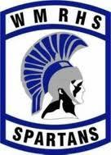
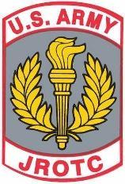
C/SFC Rin Sherman

Contact JROTC Office
Phone- 837-2287
LTC (Ret) Gearhart Email: Dgearhart@sau36.org
SGM (Ret) Bruno Email: Mbruno@sau36.org

RECENT EVENTS
Goodbye Seniors, Hello New Chain of Command!
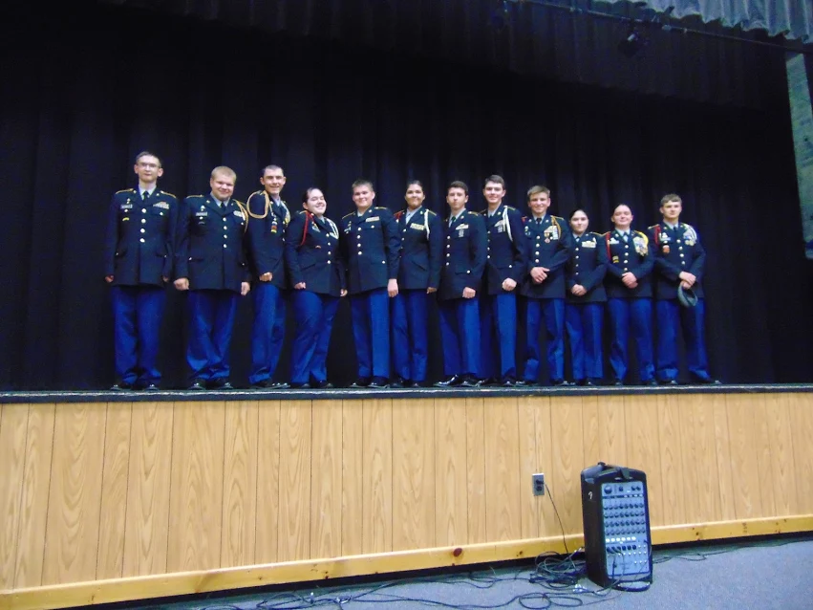

The last Saturday of May brought a very exciting event to our cadets and their families. The annual awards ceremony was a sensational display of what cadets have worked hard for throughout the year. The first half consisted entirely of awards to be given to the best of us. The second half was when we promoted a multitude of cadets, announced the chain of command for next year (right), and said farewell to our seniors in style, although you could argue that that was their own doing.  Joke of the Month:  A short Polish immigrant went to the DVLA to apply for a driver's license.  First, of course, he had to take an eyesight test.  The optician showed him a card with the letters. On the bottom row were these letters:  'C Z W I X N O S T A C Z.'  'Can you read this?' the optician asked.  'Read it?' the Polish guy replied - 'I know the fellow.' | 2017-18 Chain of Command  Battalion Commander:  C/LTC Clayton Mersing  Executive Officer:  C/MAJ Jacqueline LaFlam  Deputy Commanding Officer:  C/2LT Amie Dauphine  Command Sergeant Major:  C/CSM Andrew Smith  Administrative Officer (S1):  C/SFC David Rose  Security Officer (S2):  C/SFC Nicholas Kenison  Plans and Operations Officer (S3):  C/2LT Vitoria Sheptor  Supply and Logistics Officer (S4):  C/SFC Ronald Mackillop  Public Affairs Officer (S5):  C/SFC Tracie(Rin) Sherman  Automation Officer (S6):  C/MSG Christopher Rose  Battalion Historian (S7):  C/MSG Nicholas Hatfield  Fundraising Officer (S8):  C/SGT Joshua Womble

Adopt A Highway
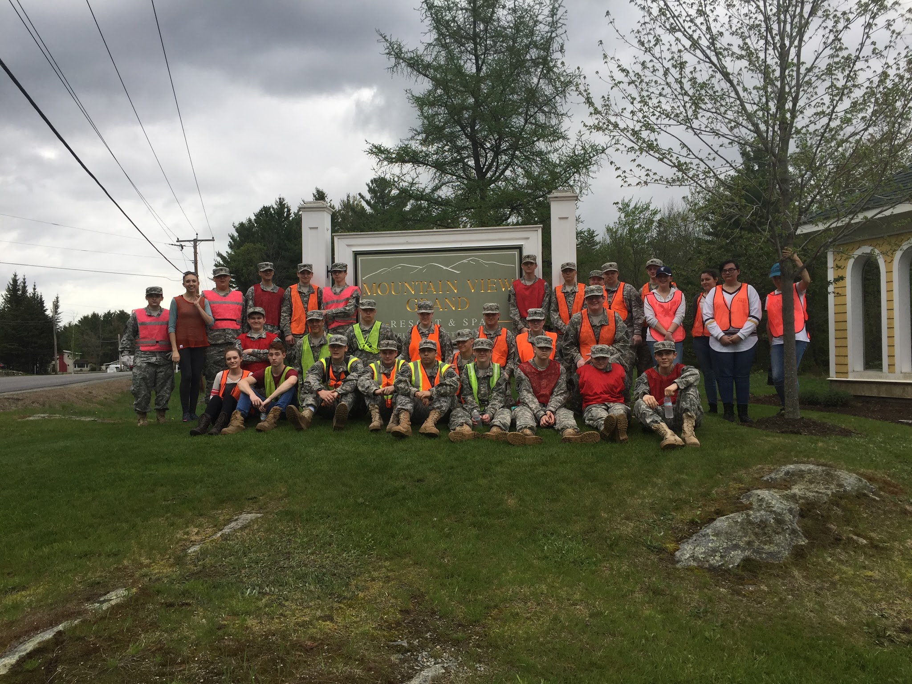
On May 19 several of our cadets, as well as the green team, participated in cleaning our stretch of highway (from the Mountain View Grand to Martin Meadow Pond Rd). We started at the White Mountains Regional High School and made our way up the road, and then back down again, until the roadsides were satisfactorily clean. Despite the ticks and achy feet, the cadets had a great time and look forward to doing it again next year.

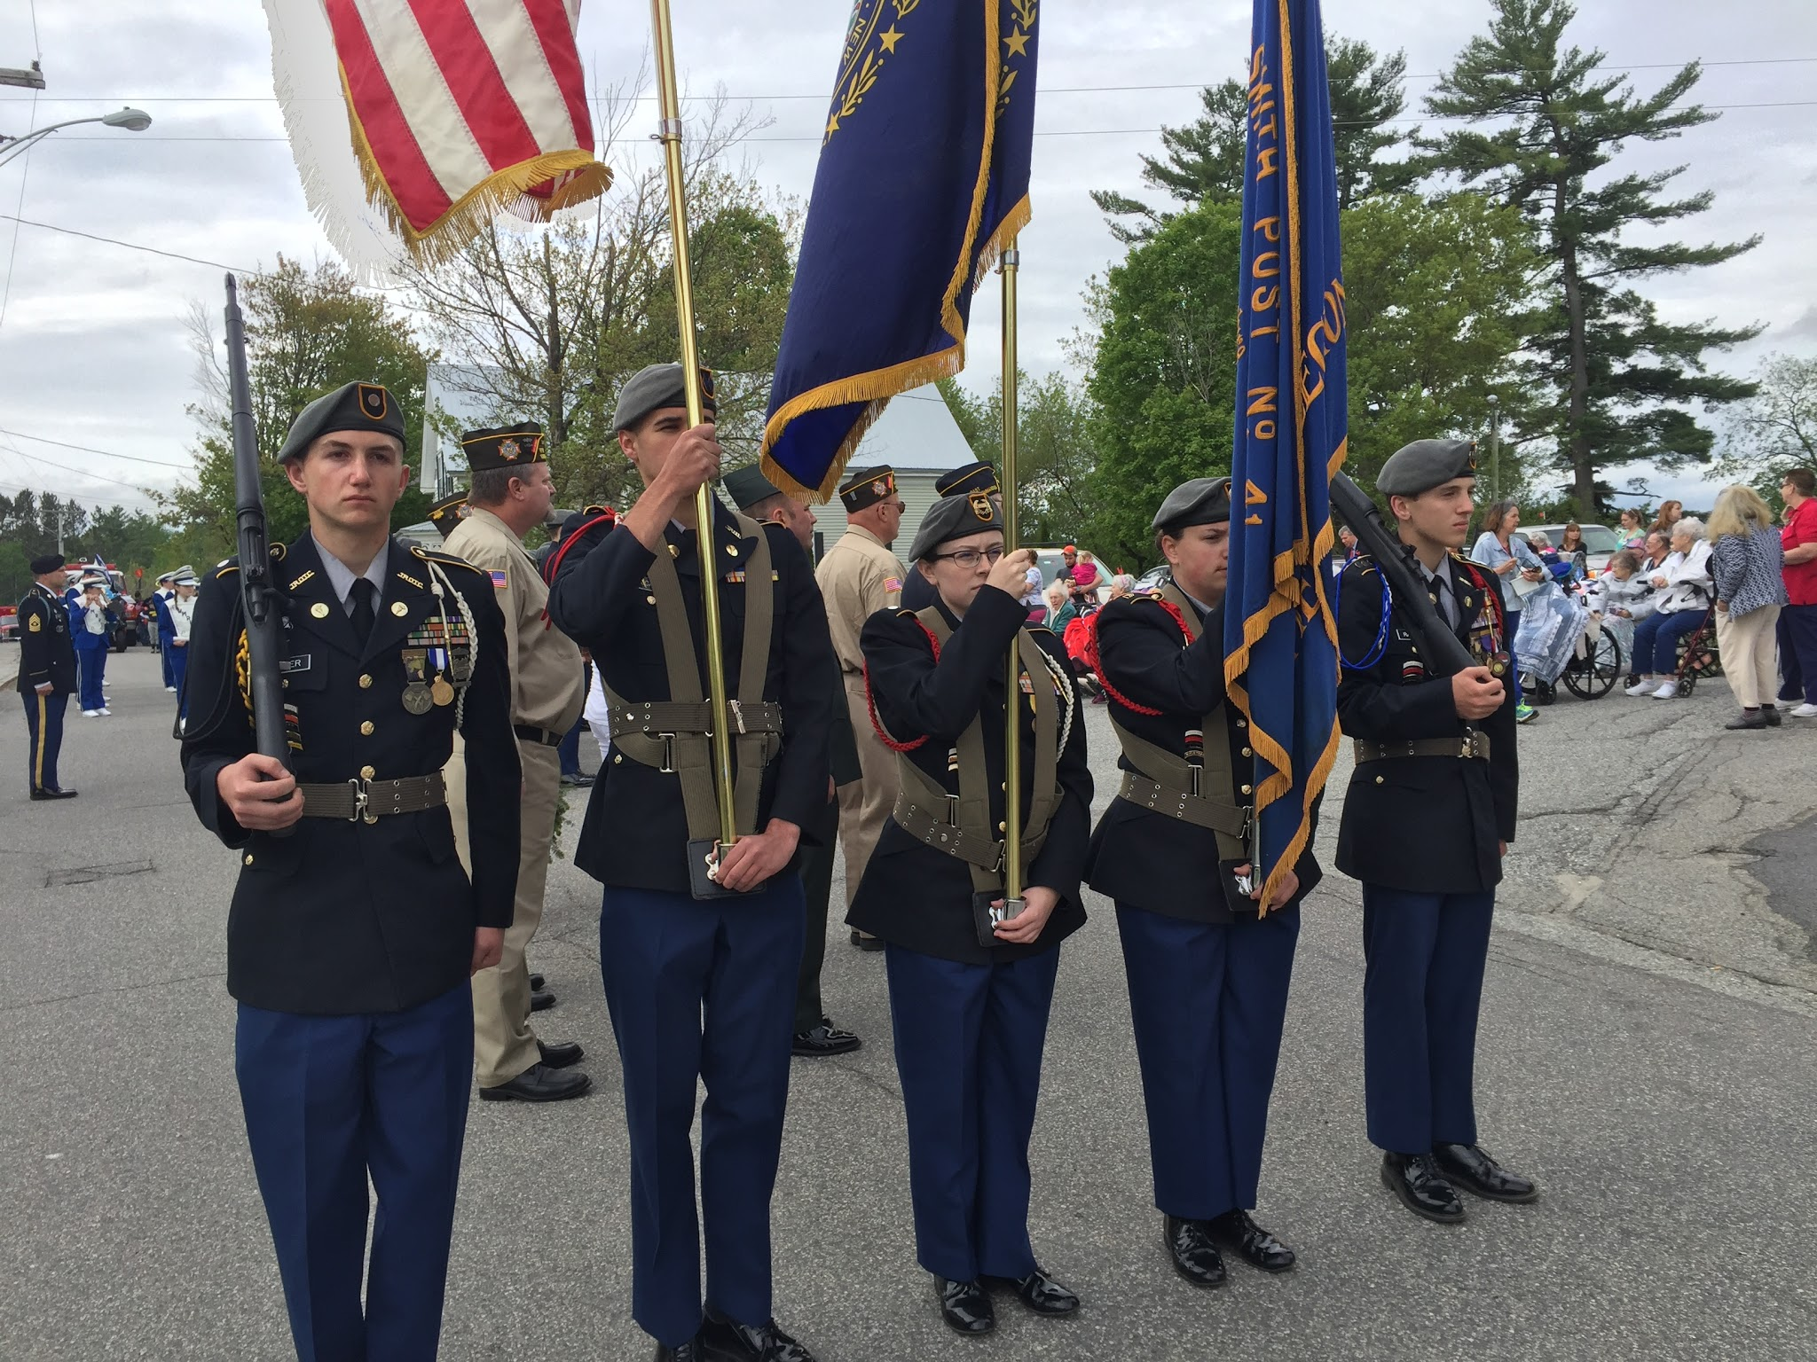
Memorial Day
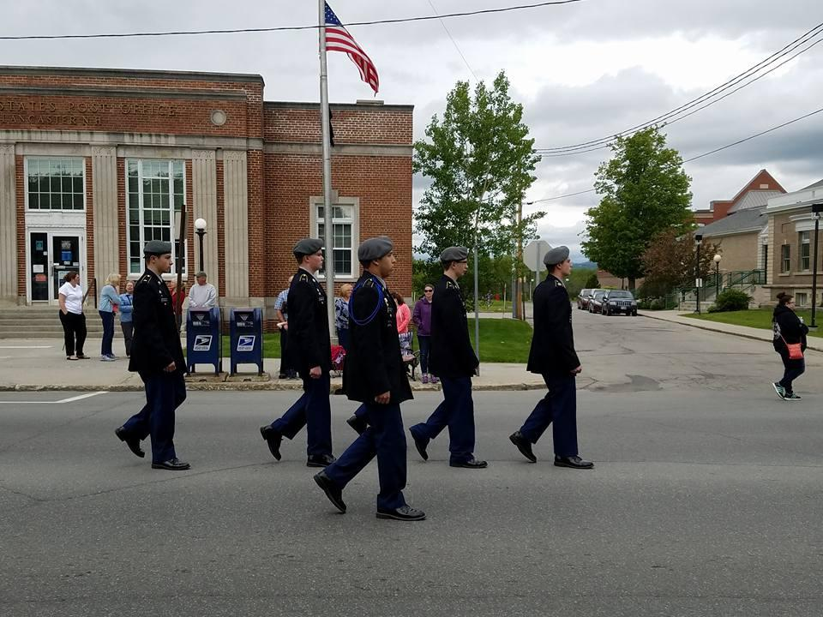
On this day we remembered our fallen soldiers. For many people, Memorial Day celebrates the grand introduction of summer, and they neglect to consider what it really means. The JROTC cadets were not of the people tolerated to forget. We had a class to talk about the origin of, and why we should remember this day. About half of our battalion participated in parades in the area. We had four different color guards, one for each parade. The list of cadets that participated in the color guards will be available on the next page.

UPCOMING EVENTS  UH-60 Flight June 7  JCLC June 19-23  Last Day of School June 20  Relay for Life June 24  Whitefield Air Show June 24-25  Boys & Girls State June 25-30  Bretton Woods Parking July 4  NHMS Parking July 14-16  Lancaster Fair Parking Sept 1 & 3 | Memorial Day Color Guards  Whitefield-  C/LTC Accardi  C/2LT Briggs  C/2LT Fisher  C/CPT Ratliff  C/SSG Russo  Littleton-  C/LTC Mersing  C/SFC Sherman  C/2LT Fisher  C/CPT Winchester  Lancaster-  C/2LT Briggs  C/MSG Rose  C/SSG Roy  C/SSG Russo  Twin Mountain-  C/LTC Accardi  C/MAJ Caouette  C/SFC Rose  C/2LT Sheptor

