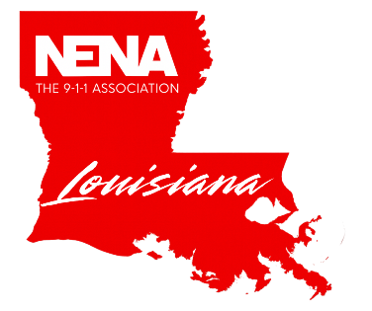
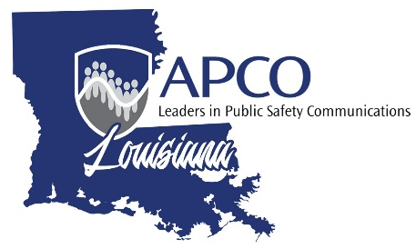
_____________________________________________________________________________________
2026 Symposium April 27-29, 2025 Live! Casino & Resort Bossier City , LA

[Insert Date]
Dear Chief,
I am writing to formally request approval to attend the upcoming 2026 APCO/NENA Symposium scheduled for
April 27-29, 2026 in Bossier City. As an emergency professional dedicated to enhancing my skills and knowledge, I strongly believe that participation in this symposium will not only foster my personal development but also significantly benefit our team and organization.
The symposium will feature a diverse array of presentations and workshops led by experts from various agencies across the state, providing invaluable insights into innovative practices, emerging trends, and advanced technologies in the field of emergency response. Attending these sessions will allow me to gather critical information that can directly impact our operations and improve our collaborative efforts with other emergency service providers.
Moreover, this event is an excellent opportunity for networking with peers from other regions, developing relationships that can lead to future collaborative missions or joint training exercises. Building connections within the wider community of emergency professionals enhances our ability to share resources and best practices, ultimately enriching our response capabilities and ensuring we are better prepared for crises.
In addition to the immediate benefits of attending the symposium, all of the classes offered qualify for both APCO and NENA Continuing Education Credits. Once completed, I plan to develop a comprehensive report summarizing key takeaways and actionable strategies to share with our team upon my return. This will ensure that the knowledge gained is disseminated throughout our organization, amplifying the value of this experience.
In conclusion, I respectfully request your approval to attend the 2026 APCO/NENA Symposium as it will serve as a crucial step in my continuous educational journey and contribute to our collective mission of serving and protecting our community effectively. Thank you for considering my request. I look forward to your positive response.
Respectfully,

