WHITE PAPER

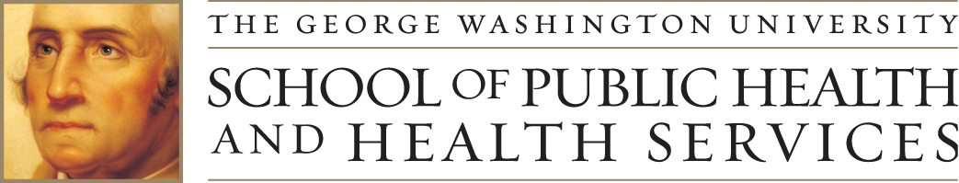

THE NEXT GENERATION OF
LONG TERM CARE LEADERS
Professionals Leading Passionate Innovation
2011 National Emerging Leadership Summit for Long Term Care Administrators | June 14-17, 2011

AUTHORS
Douglas Olson, Ph.D., University of Wisconsin-Eau Claire
Roulla Nau, MHSA, The George Washington University
Robert Burke, Ph.D., The George Washington University
CONTENTS
ACKNOWLEDGEMENTS 3
FORWARD 5
EXECUTIVE SUMMARY 6
BACKGROUND 7
PURPOSE OF SUMMIT 10
SUMMIT PARTICIPANTS AND STRUCTURE 11
SUMMIT RECOMMENDATIONS 13
2010 Recommendation # 1 Community-Oriented Activities 13
2010 Recommendation #2 Partaking In Professional Association Activities 13
2010 Recommendation #3 Summit Participants Becoming Active Change Agents 13
2010 Recommendation #4 Identifying and Addressing Barriers to Entry 13
2011 Action Area #1: Developing Standardized State Licensure and Reciprocity agreements 14
2011 Action Area #2: Supporting the effort to standardize the LTC vocabulary 15
2011 Action Area #3: Identifying and supporting the development of mentoring opportunities 15
2011 Action Area #4: Develop a marketing plan and begin promoting the NELS as an event for professionals leading passionate innovation 16
2011 Action Area #5: Publish the 2011 recommendations and action plans in a White Paper 16
CALL TO ACTION 18
SUMMIT PROCEEDINGS 20
References 26
All appendices can be found at the end of this document.

ACKNOWLEDGEMENTS
Remembering Dr. Paul Willging

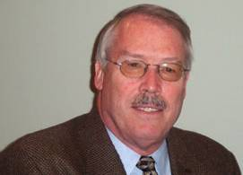Former American Health Care Association/National Center for Assisted Living (AHCA/NCAL) leader Paul Willging passed away on May 25th 2011 after a battle with cancer.

Those of us who were fortunate enough to work alongside Dr. Paul Willging quickly learned of the depth of his commitment to long-term care and to those people who dedicate their lives to providing such care. He was an unmatched teacher and always nurtured those who had a passion for the profession.

Through his work at AHCA, Dr. Willging pushed initiatives that helped make great strides in improving quality in America's nursing homes. He was a true visionary in this area. Dr. Willging's professional legacy lives on in the accomplishments of the many people he taught and the minds he shaped in his lifetime.

AHCA and NCAL will honor his legacy by supporting the education of the next generation of long-term care professionals. Donations received in memory of Dr. Willging will be used to set up a scholarship for the 2012 National Emerging Leadership Summit.

Thank you to the following organizations and individuals for their donations:

Cornelius and Martha Murray | American Health Care Association
Todd Smith | National Center for Assisted Living
Janet Justice | Kentucky Association of Health Care Facilities
Janet Ranaldi | North Carolina Association of Health Care Facilities
Laurence Lane | Clement Manor
David Beck | Stonebridge Advisors
James Durante | Circle B Enterprises
Bruce Yarwood | Colorado Health Care Assoc.
Steven Chies

The authors appreciated the insights and support from the steering committee members and the support from Fafa Kumassah and Marleah Kueler from The George Washington University and University of Wisconsin-Eau Claire, respectively. We also want to give special recognition to Elizabeth Knight for her editorial review of the paper.

2011 NELS Steering Committee Members:
- Randy Lindner, President and CEO, NAB
- Marianna Grachek, President and CEO, ACHCA
- Wendy Green, Director, Leadership Development, LeadingAge
- Sharon Parver, Manager, Education Development, LeadingAge
- Jennifer Shimer, Chief Operating Officer, AHCA
- Christy Sharp, Director, Member Services, AHCA
- Jana McDonald, Executive Director for Sante of Surprise
- Matt Mauthe, CEO, Marquardt Village
- Dinah Martin, Campus Administrator, Saint Therese at Oxbow Lake, Inc.
- Bridget Morrow, Director of Operations, Golden Living
- Rachel Kruth, Administrator, HCR ManorCare
- Daniel Schwartz, COO, Addus Healthcare
- Jean Hartnett, Adjunct Lecturer, GW

Thank you to our Co-Sponsors:

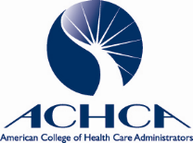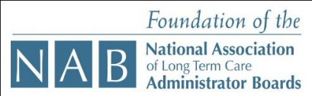

Thank you to our sponsors:



The Wertlieb Family

FORWARD
The National Emerging Leadership Summit’s purpose is to provide Generation X and Generation Y leaders in the field of health and aging services administration to:
- Engage in discussions of current best practices with other leaders;
- Meet with representatives of key professional organizations;
- Gain an inside perspective on the legislative process;
- Explore solutions for attracting and retaining other Generation X and Generation Y leaders.

The Summit combines current best-practices with a facilitated dialogue to provide a new perspective for both Summit participants and the broader field. This report is a reflection of the Second Annual National Emerging Leadership Summit, and the inaugural Summit in 2010 served as the spring board to develop an action-oriented agenda.

The 2011 participants made significant progress to advance the 2010 recommendations. The purpose of this White Paper includes:
- Setting a foundation for planning the 2012 Summit;
- Serving as an additional resource for this next cohort; and
- Providing evidence and support for the professional field of health and aging services administration to advance positive changes.

EXECUTIVE SUMMARY
The 2011 National Emerging Leadership Summit (NELS) brought together emerging leaders in the field of health and aging services administration from across the country. This second cohort of participants reviewed the foundational work of the inaugural group, and set out to clarify and refine the needs and opportunities for future leaders, in order to advance the profession. This report is the culmination of the efforts and outcomes of the action-oriented event. Key takeaways, calls to action, attendee perspectives and session summaries from the Summit are included in this white paper.

During the Summit, the four thematic areas identified by the 2010 NELS participants and the perspective of the current participants helped frame the discussion. In this white paper, each recommendation will be defined along with a detailed set of actions from which future actions and agendas will be developed. The recommendations from 2011 NELS included the following:
- Developing standardized state licensure and reciprocity agreements
- Supporting the effort to standardize the long term care (LTC) vocabulary
- Identifying and supporting the development of mentoring opportunities
- Developing a marketing plan and beginning to promote NELS as an event for professionals leading passionate innovation
- Publishing the 2011 recommendations and action plans in a white paper

For each of these recommendations, the development of formal committees and action plans demonstrates the readiness of the Generation X and Generation Y healthcare administrators in aging services to transform the profession and strengthen the demand for NELS and its activities. With designated leaders, the committees for each strategic area plan to meet quarterly to move this work forward and begin the process of transforming the LTC administration profession. From a broader perspective, the NELS group is carefully considering the importance of strategic partners, such as American College of Health Care Administrators and The National Association of Long Term Care Administrators Boards, to leverage current energies and initiatives.

The steering committee and participants reviewed this white paper prior to this broader dissemination. The information noted in this document is a reflection of the voice of the 2011 NELS participants, yet there is clearly an interest in beginning an effort to invite all NELS participants and interested stakeholders to participate and support achieving the next action oriented phase of this work. The NELS steering committee presented these recommendations with sponsoring organizations, and will use this White Paper as a spring board for the 2012 NELS. The 2011 NELS participants also developed a new descriptor of their identity, “professionals leading passionate innovation,” and each of the 2010 and 2011 NELS participants are the epitome of this new brand for this noble profession.

BACKGROUND
With unprecedented growth rates for the senior citizen population, the United States faces a tremendous challenge to improve and maintain the quality of care and service provided in long term care (LTC) organizations. Data from the U. S. Census Bureau estimate that the elderly (age 65 and over) accounted for nearly 15% of the American population in 2010, and will account for nearly one quarter of the population by 2050. As Americans continue to live longer and with more co-morbidities than ever before, the associated costs of providing quality care grows incrementally and the stresses to our nation’s long term care system mount.

Data from the Centers for Medicare and Medicaid Services (CMS) determined the 2009 national health care expenditures to be over $2.4 trillion, of which approximately 10% is directly attributed to nursing home and home health services. CMS projections estimate in 2019 total national health expenditures to be nearly $4.5 trillion with nursing home and home health services expenditures being nearly $400 billion. The 2009 total healthcare expenditures account for 17% of the gross domestic product (GDP), and projections indicate that it will consume nearly 20% of the GDP by 2019. Internationally, the Organization for Economic Cooperation and Development (OECD) estimated in 2005 that LTC expenditures accounted for about 1% of the GDP in OECD countries, and it projects this percentage to double and even quadruple by 2050. “Spending on long term care as a share of GDP rises with the share of the population that is over 80 years old, which is expected to triple from 4 percent to 11-12 percent between 2005 and 2050 [in OECD countries].”

Healthcare reform legislation in the United States creates a daunting challenge for LTC administrators to improve quality while reducing costs. Current administrators struggle with numerous challenges including, meeting the needs of a multigenerational workforce, an increasing workforce shortage, changing regulatory demands, maintaining quality services across the continuum of LTC organizations, and addressing the public’s overall negative perception of long term care. Working in long term care administration requires individuals to be versatile and dynamic to successfully manage all of the challenges.

LTC organizations and services range from skilled nursing facilities, assisted living settings, continuing care retirement communities, home care, hospice, and daycare services. Each of these settings targets the same senior population, but often lacks the coordination and integration needed to offer residents and their families a comprehensive mix of services. Many recognize there is a need to prepare future LTC leaders to work beyond silos of service and adapt to the changing consumer demands. This work includes integrated service delivery in a new resident-centered health model of care.
Since 1998, the number of nursing home administrator examinations administered to candidates seeking initial licensure declined by more than 40%, with only a slight increase in recent years. LTC is facing an employment cliff with more people leaving the administrator profession than entering it. Several factors contributing to this turnover phenomenon include a fragile educational field, challenging societal views, a difficult and reactive regulatory environment, and a tendency to focus on management rather than leadership.

In addition to the breadth of services provided and the decline of LTC administrators, the LTC administration profession struggles with one of the highest staff turnover rates nationally. Factors that contribute to the turnover rate include low pay, poor benefits, inadequate training, limited opportunities for career advancement, and heavy workloads. The combination of the increasing demand for these services, the disjointed system currently in place, and the imperative to reduce cost while improving quality all requires strong leadership to champion improvements in the delivery system. A driving force and impetus to organize the NELS included the need to understand how to increase, improve, and support the value of the administrative profession for future leaders.

The current and future generation of administrators varies tremendously from previous generations. Baby Boomers (born between 1946 and 1964) feel defined by their jobs and remain very loyal to an organization. This generation willingly works long hours and sacrifices family time to succeed at work. The Boomers' children struggled with this demanding work ethic and its impact on family time. Generation Xers (born between 1965 and 1981) strive to be more successful in balancing work and family time, and are willing to change jobs to achieve an optimal work-life blend. Generation X adapts to technology and finds creative ways to achieve their goals. With the growth of more technology, the next generation is even more proficient in integrating technology in the workplace. Generation Y (born between 1981 and 2001), also known as Millenials, further demands a better work life balance and attempts to do this by integrating more technology into the work place. These three generations comprise the current LTC workforce. This multigenerational workforce adds to the complex environment LTC administrators must handle.

LTC leaders recognize the need to restructure and re-energize the LTC administration profession. As the national and international crisis to address the needs of an aging population continues, the NELS provides a venue to address the field’s most pressing professional challenges. A steering committee composed of leaders from higher education and professional associations tasked itself with addressing leadership challenges within the LTC administration profession. To address the many facets of the LTC administrative profession, the NELS brought together today’s LTC leaders with a group of the most talented Generation X and Generation Y administrators. These professionals are eager to transform the LTC administration profession. These individuals recognize and accept the responsibility to effect and realize the needed change. LTC administration requires the best and brightest individuals leading these critical human service organizations to provide and coordinate the highest level of care for elders.

The 2010 NELS established a framework that identified four key issues that need to be addressed. These recommendations included:
- Community-oriented activities;
- Participating in professional association activities;
- Becoming active change agents; and
- Identifying and addressing barriers to entry.

The 2011 NELS agenda placed an emphasis on developing strategic action plans to begin addressing the current challenges. Combined with developing action plans, the 2011 participants identified that NELS as a venue to facilitate change needed a goal and vision to help establish its premise and focus. The 2011 participants developed the holy grail –“Professionals leading passionate innovation” – as the NELS goal and vision.

PURPOSE OF SUMMIT
The 2011 NELS participants’ perspectives served as the framework to begin discussions about the need to change the LTC administration profession in the future. The participants shared a variety of experiences and trends that helped them gain a broader view of possibilities in their careers. These experiential approaches and mechanisms provided an environment and foundation for an engaging and thoughtful discussion about the future generation of LTC administrators. Participants had the opportunity to access legislators and association staff during their DC based Summit (see Appendix A). Throughout the Summit proceedings, participants had the opportunity to reflect on creating a better profession for themselves and future generations while at the same time leading organizations and systems with coordinated, high quality, yet low cost LTC services.

The 2011 participants interacted with 2010 NELS representatives to learn how and why the 2010 recommendations were identified. At the conclusion of the four day Summit, these current LTC administrators developed key action plans targeting specific areas to revitalize the LTC administrative profession. The action plans address a breadth of current issues to ultimately improve the LTC administration profession and attract more potential administrators from Generation X, Generation Y, and Generation Zippies (those individuals under the age of 25).

SUMMIT PARTICIPANTS AND STRUCTURE
NELS focuses on long term care administrators who typically have been in the field for less than ten years and/or are under forty years of age. These Generation X and Generation Y leaders hold positions in skilled nursing facilities, assisted living communities, continuing care retirement communities, rehabilitation hospitals or aging service agencies. In order to attend the NELS, participants submitted an application to the steering committee, which included a professional reference and a personal statement outlining their experience in and commitment to long term care.

Upon selection, participants completed a pre-Summit survey (see appendix B) from which the committee learned about attendee demographics, work experience, and work preferences. While the majority of participants were in their mid-thirties, their average tenure in the long term care (LTC) service setting was three to ten years. Key reasons these individuals enjoy their jobs include the importance of resident and family interaction and the daily variety of tasks that makes their work interesting. On the other hand, the regulatory environment, maintaining a strong financial position and the public's negative impression of LTC challenge the participants to feel satisfied with their positions. Other NELS participant perspectives included the following:
- The next generation of leaders has a negative view of the LTC field, which is consistent with overall public perception.
- Early job experiences, a reference by a colleague, and/or an educational track served as the three most common ways to enter the LTC administrative field.
- An open work environment, opportunities to learn and grow, and a proper work/life balance were all important work cultures to the group.
- Mentoring played a significant role in career choice and success.
- Participants’ job satisfaction was at a very high level, and interests were strongly orientated toward developing LTC careers within present employment settings especially within the next 5 years.

By understanding the background and perspectives of the NELS participants, the steering committee ensured that presentations emphasized the importance of actively engaging them in activities to meet the following goals:
- Identify mechanisms to overhaul the “face” of the LTC administrative profession;
- Develop interdisciplinary interactions between LTC providers within a community; and
- Create an understanding of the legislative process.

To prepare for discussions, the NELS participants received the book, They’re Not Aloof…Just Generation X, by Michael R. Muetzel, and the 2010 NELS White Paper to read prior to attending the Summit.

Lynn Goldman, M.D., MPH, Dean of the School of Public Health and Health Services and Professor of Environmental and Occupational Health, opened the Summit by focusing on the importance of the LTC field to her personally. She shared how her family utilizes long term care services, and she discussed her excitement about bringing together such a dynamic group of administrators. Dean Goldman challenged the participants to use their predecessors’ work to begin actively transforming the LTC administration profession by listening to, and learning from, current LTC leaders. Their discussion grappled with balancing the complexity of LTC services and the public’s perception. She encouraged the participants to share with policy makers and current leaders the challenges of addressing the LTC administration profession needs. As a parting thought, Dean Goldman charged the participants to become the long-awaited LTC change agents.

Following Dean Goldman's provoking message, Robert Burke, Ph.D. Chair, Department of Health Services Management and Leadership, The George Washington University, welcomed the participants and echoed many of Dean Goldman's sentiments to seize the opportunity to identify and develop constructive plans to address the many challenges facing current and future administrators. After briefly discussing some key facts about Washington, DC, Dr. Burke led the group in ice breaker activities that revealed the group consisted of a wide array of professionals ranging from clinicians to lawyers. The second activity required the participants to creatively describe why they chose to attend the NELS. Groups used poems, skits, songs, and drawings to depict their group's reasons for participating. Their interactions and final products created a positive and energetic atmosphere that set the stage to delve into the key premise of the NELS: Transforming the LTC administration profession.

Douglas Olson, Ph.D., Associate Professor of Health Care Administration and Director, Center for Health Administration and Aging Service Excellence, University of Wisconsin-Eau Claire, reviewed with participants their pre-survey responses, the 2010 NELS findings, and set the stage for the work to be done over the four days. Participants challenged and discussed at length the current state of the LTC administration profession including the diverse workforce, dealing with the public's negative perception of LTC, and the breadth of differences in licensing standards for LTC administrators. Dr. Olson highlighted key characteristics describing the multigenerational work, and facilitated a discussion with participants that continued over the four days of the NELS. As the facilitator, Dr. Olson urged the participants to critically think about how LTC administrators can induce nation-wide changes for the profession by reflecting on the experiences and presentations from peers and industry experts.

The NELS structure was arranged to encourage the group to think beyond their day-to-day essential work responsibilities and to begin evaluating the administrative profession from a broader perspective. The first day provided an overview of the Summit, highlighted some leadership trends and perspectives, and called participants to action. The NELS group was given the opportunity to fully experience and understand legislative processes and association perspectives. Multiple sessions and discussions resulted in a crystallization of themes and recommendations to help change the face of the LTC administrative profession. The overall experience and results have received favorable reviews from participants, sponsors, steering committee members, and those who have been engaged in this effort.

SUMMIT RECOMMENDATIONS
Strategically hearing the voice of Generation X and Generation Y LTC leaders was paramount during the NELS. Over the course of the NELS, the group reviewed and elaborated on the 2010 NELS recommendations that are summarized in the below section. Organized into distinct groups, the participants worked together to brainstorm ideas that were shared with the broader group. Michael Muetzel and Dr. Olson facilitated, solicited, and subsequently compiled the participants’ perspectives to reflect the consensus of the group.

The following are the 2010 NELS recommendations that the 2011 participants used as a framework.

2010 Recommendation # 1 - Community-Oriented Activities
This recommendation focuses on ensuring administrators are engaging in their local communities. LTC leaders regularly reach out beyond their settings and services, and there is a need to raise the awareness of these activities. Incorporating local media into these activities needs to be a priority for LTC leaders. Raising public awareness and enhancing positive coverage results in a heightened sense of prestige and value for the administrative profession.

2010 Recommendation #2 - Partaking In Professional Association Activities
Partaking in professional association activities is critical to the success of raising the professional bar. Participation requires leaders to personally engage and advance a collective voice with professional associations. This goal entails a re-commitment of individuals to stay active or reconnect in a professional association while at the same time championing a focus on the leadership elements that were part of the NELS in organizational associations.

2010 Recommendation #3 - Summit Participants Becoming Active Change Agents
Changing the image of LTC leadership requires attention and time. The driving force of this recommendation was the need to have a positive sense of the administrative profession and eliminate issues of low professional. The NELS participants emphasized working within the group and reaching out to other associations.

2010 Recommendation #4 - Identifying and Addressing Barriers to Entry
The current LTC administrative environment does not encourage or promote professional entry and access across the country. From a next generation perspective, the field is fragmented for entry to practice standards. Recommendations to address this fragmentation include working with existing initiatives, refining higher education programs, and creating a more positive image for LTC administration.

These recommendations established the framework from which the 2011 NELS participants started to develop formal action plans to help advance the profession and future NELS. Each action plan addresses one or more of the 2010 recommendations and establishes a strategic plan and partnerships. (See Appendix C for detailed action plans). The following summarizes each action area.

2011 Action Area #1: Developing Standardized State Licensure and Reciprocity agreements

BACKGROUND: Today the criteria to become a licensed LTC administrator vary dramatically between each state. Some states require completion of higher education courses specifically focused on the LTC administration and a full year as an "administrator-in-training." Other states only require a bachelor's degree with on-the-job training, and some states require even less education. The National Association for Long Term Care Administration Boards (NAB) offers an exam that, if passed, administrators receive reciprocity in some states. Many states still lack reciprocity agreements to recognize out-of-state LTC licenses based on standards developed with the affiliated American College of Health Care Administrator (ACHCA) certification. The wide variation in the licensing process and the lack of reciprocity agreements may contribute to the differing levels of proficiency and ultimately may impact the quality in LTC organizations, which in turn shapes the public's perception of this sector. Limiting where LTC administrators can work reduces the appeal to the profession and it stifles administrators' interest and desire to expand their professional experiences.

PURPOSE: The 2011 NELS participants recognize how the licensing criteria and reciprocity agreements greatly impact the future of LTC administrators. Many feel it deters talented individuals from pursuing this career and forces many to leave the profession.

ACTION PLAN: The 2011 NELS participants developed a strategic plan to collaborate with the NELS co-sponsor, NAB, to begin exploring and taking the necessary steps to standardize the long term care administrators’ licensing requirements across all 50 states. The groups will also be reviewing information related to current studies that aim to provide additional evidence needed to develop legislative policies. This collaboration brings together a multiple-disciplinary group to lead this effort.

2011 Action Area #2: Supporting the effort to standardize the LTC vocabulary

BACKGROUND: Long term care currently utilizes a broad vernacular to describe similar jobs and organizations. This wide range of terms creates confusion and frustration for those in long term care as well as the general public.

PURPOSE: The 2011 NELS participants identified this strategic area as a mechanism to facilitate developing standard nomenclature that will help the community better understand LTC services and professional roles. This effort will address one of the barriers to establishing a positive perspective of LTC and will serve as an example of the NELS goal and vision: Professionals leading passionate innovation.

ACTION PLAN: The 2011 NELS committee will collaborate with associations and organizations, e.g. Pioneer Network, to identify and define key terms. This committee will discuss this list of terms with the steering committee and 2011 participants. Upon approval, they will attempt to inculcate these terms within their respective organizations. On a quarterly basis, the committee will report on the progress of adopting the refined terms. If successful, the committee will collaborate with professional association leaders to develop a plan to spread the terms nationally.

2011 Action Area #3: Identifying and supporting the development of mentoring opportunities

BACKGROUND: The pre-NELS surveys completed by the participants indicated that mentoring was valuable and critical to their professional success. Unless LTC administrators complete formal academic or training programs, many begin their careers without the guidance and support of a seasoned professional. Numerous 2011 NELS participants attributed commitment and professional success to having and being a mentor. Currently, no formal program exists to encourage this critical resource.

PURPOSE: Mentoring bonds professionals and often provides the necessary encouragement to deal with challenging situations. The 2011 NELS participants placed a heavy priority on this strategic area because it focuses on one of the 2010 recommendations of addressing barriers to recruiting and retaining talented LTC administrators.

ACTION PLAN: ACHCA recently established a mentoring program to address the same issues. The 2011 NELS committee will partner with ACHCA to refine the mentoring program and become active mentors.

2011 Action Area #4: Develop a marketing plan and begin promoting the NELS as an event for professionals leading passionate innovation

BACKGROUND: In its second year, the NELS participants and steering committee recognized the need to define its purpose and then market the NELS within the LTC community. Facilitated by Michael Muetzel, the 2011 participants collaboratively described the event as a Summit that brings together professionals eager to identify and lead passionate innovation.

PURPOSE: It is essential to invest time and energy to share the purpose and value of the NELS with the LTC community. This marketing plan will define the target communities and venues to disseminate the NELS information and materials. Through this marketing effort, the goal is to also indirectly attempt to shift the public's perception of LTC.

ACTION PLAN: Three committees will lead this effort to develop a plan, write and publish a press release, and identify appropriate venues to present information about the NELS. The press release committee will define the criteria to include in the release and will strive to distribute the release to target publications within 3 months of NELS. The marketing plan committee will conduct research on effective marketing tactics to reach the LTC community and will identify partnerships with professional associations. At the same time, the committee focused on identifying venues that will target LTC conferences to share with the purpose and value of the NELS.

2011 Action Area #5: Publish the 2011 recommendations and action plans in a White Paper

BACKGROUND: The NELS gathers early to mid-career administrators who are eager to improve the greater LTC community as well as the LTC administration profession by identifying and addressing the many challenges affecting their personal and professional growth. Learning about generational differences, factors that affect policy development, and current best practices poise the participants to become professionals leading passionate innovation. To share the 2010 achievements, the steering committee developed and released a white paper that served as a foundation for the 2011 NELS.

PURPOSE: The participants and steering committee concurred that capturing the 2011 NELS activities and strategic action plans is necessary. This white paper serves as a mechanism to educate the greater LTC profession and the general community of the efforts being made to transform the image and face of LTC administration.

ACTION PLAN: Steering committee members will initially develop the white paper and then share it with this committee. Upon collective review and agreement, the paper will be published in the Fall of 2011 through professional associations’ respective websites and publications. The findings from the 2010 and 2011 NELS pre-surveys and recommendations will establish the foundation for a research article as well.

The development of formal committees and action plans demonstrates the readiness of the Generation X and Generation Y administrators to transform the LTC administration profession and strengthen the demand for the NELS. Each action area identified a specific mechanism to address the recommendations defined during the 2010 NELS including:
- Addressing the negative stigma associated with LTC by becoming more engaged in the community;
- Reducing the barriers to recruiting and retaining talented individuals; and
- Increasing participation in professional associations by partnering with and supporting current programs.

The committees for each strategic activity meet quarterly to begin the process of transforming the LTC administration profession. To maintain group continuity and cohesiveness, the committees identified internal leaders that collaborate with steering committee members to develop and meet key milestones for each strategic area. An effort will be made to invite 2010 NELS participants to contribute and support achieving the next phase of this work. Each of the 2010 and 2011 NELS participants are the epitome of professionals leading passionate innovation. From a broader perspective, the NELS participants and steering committee are actively developing strategic partners that will serve as good connections to leverage existing resources and initiatives that will help promote transforming the LTC administration.

CALL TO ACTION
To demonstrate the growth and evolution of the NELS over the course of one year, the overall findings from the 2010 NELS included:
- The need to develop and refine the NELS goal and vision to concisely describe the work being done by the Summit;
- Establishing a greater involvement with professional associations;
- Pursuing the topic of barriers to entry into the profession (reciprocity issues); and
- Emphasizing the community connection/impact of the profession.

The action plans presented above highlight the 2011 NELS participants’ intent to actively address the recommendations defined during the 2010 NELS.

Each of the 2011 participants recognized the necessary energy and time required to begin transforming the LTC administration profession internally and externally. Developing the action plans with timelines provides evidence that these Generation X and Generation Y leaders desire to address the issues affecting them as individuals and as a collective group. It is timely that these LTC administrators recognize the need to improve the community's perception of their profession, as well as LTC providers and organizations because this affects each of them as well as their staff, residents, families, and the community at large. The results of this improvement framework will include bringing the necessary attention to issues that create challenges in attracting and retaining capable and proficient administrators. It is imperative that these individuals provide higher quality services at lower costs in order to achieve the greatest success. The national impact will be felt through the improvements and commitments made by strong leaders for their chosen profession.

A key message of the 2010 NELS included a participant conviction to take ownership and personal interest in implementation of these recommendations. The 2011 NELS participants recognized and appreciated the 2010 participants' fervor, and accepted the challenge to move forward by defining tangible areas requiring attention. Over the next year, the work accomplished by each committee and the partnerships with professional associations will be shared via three key platforms including LinkedIn, Facebook, and respective association websites and journals.

In addition to each of the committees, the 2011 NELS participants requested quarterly webinars to stay abreast of progress made. After six months, all of the NELS participants will receive a post-Summit survey to gauge individual and professional growth. Capturing this data enables the steering committee to quantify the value of attending the NELS. Understanding the value of the Summit and demonstrating successful progress in each strategic area will formally mark the onset of transforming the LTC administration. .

Thank you for taking the time to read and review this Second Annual White Paper reporting on the progress and results of this critical effort. Please utilize this document to help advance related efforts for the health and aging services administration field.

Please send any comments directly to Dr. Douglas Olson, who serves as the Project Director, at olsondou@uwec.edu. To view the 2010 NELS White Paper, visit www.gwumc.edu/ltcsummit.

SUMMIT PROCEEDINGS
Robert Burke, Ph.D., Chair, GW Department of Health Services Management and Leadership and Gordon A. Friesen Professor of Health Care Administration, welcomed the participants to the 2011 National Emerging Leadership Summit for Long Term Care Administrators. He expressed great enthusiasm and excitement about bringing such a diverse group of people together who have the potential to significantly influence the increasingly imperative field of LTC.

Lynn R. Goldman, M.D., M.S., M.P.H, Dean, GW School of Public Health and Health Services and Professor of Environmental and Occupational Health, welcomed and thanked the participants for being dedicated to improving the LTC administration profession. Dean Goldman expressed her personal interest in the LTC care field and in the NELS since she has a background as a pediatrician and family members who need LTC services. She re-emphasized the crucial need for LTC and its continuous improvement, thus the importance of the NELS. In order to change the field of long term care, she reminded the participants of the value in influencing policy makers, making Washington D.C. the perfect place for the NELS. Dean Goldman’s energetic welcome prepared the stage for group-building exercises.

Serving as the program facilitator, Douglas Olson, Ph.D., Associate Professor of Health Care Administration and Director, Center for Health Administration and Aging Service Excellence, University of Wisconsin-Eau Claire, took the stage and spoke of his enthusiasm about working with LTC administrative leaders. Dr. Olson reviewed the current environment and perspectives in LTC and LTC administration. The changing labor force, fragile education field, and unfavorable public perception of LTC are proving to be considerable challenges for moving the field forward. He also reviewed different models of leadership and change to give the participants a foundation for initiating adjustments. Dr. Olson reminded the participants that being leaders in this field includes carrying the responsibility to be proactive change agents. He concluded the session with several ideas to help them throughout the NELS: have a clear vision, desire change, be open to communication, maintain a visible presence, and uphold a set of values.

Matt Mauthe, Chief Executive Officer, Marquardt Village, Dinah Martin, Campus Administrator, Saint Therese at Oxbow Lake, Inc., and Dr. Olson provided an overview of the 2010 NELS. They described the key takeaways and four thematic areas that the 2010 participants thought were most essential. As a group, the three speakers discussed the importance of making the NELS sustainable, and the importance of collaboration between current and future leaders of the field.

Following the group discussion, Dr. Olson recapitulated the findings of the 2011 participants’ pre-NELS survey responses. Using this as a platform, he engaged the participants in an active discussion about the reasons contributing to varied perceptions of the LTC administration profession. Several reasons included educational barriers and a systemic misunderstanding of what LTC administrators actually do. The group collectively agreed that work needs to be done to help the public understand what a LTC administrator does, and the difficulty and importance of it. As a result, the participants discussed different mechanisms that can be developed to help educate the public, such as developing newsletters, partnering up with high schools and colleges, marketing, and increasing community involvement. Energized by interaction and brainstorming, the group was prepared for two full days of interacting with LTC and legislative leaders.

David Kyllo, Executive Director, National Center for Assisted Living (NCAL), opened the session by reviewing the LTC continuum and how it has changed to set the stage for discussing how issues are, and will, affect the assisted living sector. These issues include Medicare and Medicaid cuts, dwindling LTC insurance sales, health care reform, state regulatory trends, and fraud. One of NCAL’s key strategic efforts includes maintaining an active role with state and federal policy makers. Another challenge Mr. Kyllo reviewed was the disparate ideas that Americans favor assisted living but are not impressed with its quality of care. He challenged the group to consider how to reconcile this conflict. He concluded the session by engaging the participants in a discussion on the importance of accomplishing person-centered care by putting the resident’s needs first. When this occurs, residents, their families and staff can thrive.

Ted LeNeave, Board of Governors, American Health Care Association, and President & CEO, American Healthcare LLC, opened the session with sharing his own professional development through the LTC administration profession. By reviewing AHCA’s strategic efforts, Mr. LeNeave emphasized the importance of sustainable public awareness and education of the LTC administration profession. He reviewed the importance of identifying key customers and earning their trust by providing ultimate customer service. Mr. LaNeave’s concluding thought reminded the participants that they have an opportunity to create positive change, make peoples’ lives better, and speak up to make a difference.

Randy Lindner, President and CEO, National Association of Long Term Care Administrator Boards (NAB), started his presentation with a call to action. He encouraged the participants to become involved with organizations and give back to the LTC administration profession. He highlighted NAB’s current research and partnership with the Pioneer Network and the Advancing Excellence campaign. Mr. Lindner engaged the group in a discussion about how each entered LTC administration and what could be done to improve the process for future LTC administrators. The participants highlighted that LTC education and administrator-in-training programs need to conform to best practices and be consistent across the nation. Recognizing the importance of LTC administrators’ educational programs, he also explored with the group the challenges in recruiting and retaining LTC administrators, including the highly regulated environment and lack of public interest and understanding. He concluded the presentation by reminding the participants how they can shape the future of the profession by being active in professional and trade associations and becoming a mentor.

A senior human resources executive panel including Michael Rodis, Senior Vice President, Human Resources, Sunrise Senior Living; David Mills, President, Division 4, Golden Living; Cynthia Thorland, Vice President/Director, Educational Resources, Life Care Services LLC; Brad Reynolds, Chief People Officer, Asbury Communities; and Daniel Schwartz, Chief Operating Officer, Addus Healthcare, Inc., who was the facilitator, defined key attributes of leaders. The panelist highlighted good communication skills, an ability to inspire and build trust, and being able to recognize one’s strengths and weaknesses. Many participants commented on the challenges of retaining strong staff members, which led to a lively discussion about useful retention techniques. Several panelists emphasized the importance of giving staff the right tools to be successful, creating individualized professional development plans, mentoring, and creating opportunities for professional growth. The panel also discussed the most frequent mistakes made in talent acquisition. Two common errors include organizations filling a position instead of waiting to hire the right person and leaders hiring staff that have similar styles as themselves instead of hiring smarter and more talented individuals. The panelists and participants concluded the discussion by brainstorming ways to attract and retain the next generation of LTC administrators.

Wendy Green, Director, Leadership Development, LeadingAge; Andrew W. Applegate, Executive Director, Asbury~ Solomons Island; and Melissa M. Fortner, Vice President, Supportive Living for Virginia Mennonite Retirement Community, highlighted the importance of being actively involved in associations, such as serving on task forces and committees. Using the LeadingAge Leadership Academy as an example, all three panelists reminded the participants the value of making a commitment to life-long learning. Through an interactive discussion, the participants and panelists explored the significance of recognizing one’s strengths and weaknesses, and learning how to utilize your weaknesses and improve your strengths. Each panelist shared examples of how terrible events are often the best learning opportunities. The keys to succeeding through the difficult situations include knowing one’s capabilities and being an adept facilitator.

Marianna Kern Grachek, President and CEO, American College of Health Care Administrators (ACHCA), and Timothy Dressman, Chair, Board of Directors, ACHCA, provided an overview of ACHCA’s mission, vision, and values before highlighting many of ACHCA’s programs, such as Peer to Peer and the national mentoring program. These programs strive to provide LTC administrators with the opportunities and skills to improve the profession. With the participants, Ms. Grachek and Mr. Dressman discussed how good administrators encourage the staff to make decisions, and give them the confidence and knowledge to make the right decision. The discussion transitioned to identifying how to strengthen the LTC administration profession, and the collective group identified the need to change public perception of LTC and LTC administration. Ms. Grachek and Mr. Dressman embraced the group’s energy and passion to improve the perception and identified some mechanisms to begin this work including the use of YouTube©, Facebook©, advertisements, “National LTC Administrator day”, news releases and other communication channels.

Malcolm J. Harkins, III, J.D., Partner at Proskauer Rose, honed in on the inconsistent surveying process that struggles to effectively define quality care. He reviewed the history of policies and regulations that started in the 1960’s with the passing of the Medicare and Medicaid Acts. Nearly every decade since the passing of these Acts, an attempt is made to measure and define good quality in LTC. Mr. Harkins purported there are no specific survey standards, not enough training for surveyors, and ultimately the overall system needs to be reformed. When the participants inquired what could be done to change the survey process for the better, he recommended focusing on state policy makers and encouraged advocating residents and their families to call their legislators and voice their opinions. Mr. Harkin left the group with the thought that only through united efforts can the issue of quality be framed appropriately to force a policy change that implements national LTC quality standards.

Senator Herb Kohl, D-WI, Chairman, U.S. Senate Special Committee on Aging and Anne Montgomery, Senior Policy Advisor, U.S. Senate Special Committee on Aging, discussed how the Aging Committee and the Affordable Care Act have implemented and continue to implement standards towards improving the field. Standards that have been developed include: improving training for dementia care, reducing monetary penalties for reporting incidents by 50%, and guaranteeing federal funding for states who want to improve their background check system. Senator Kohl and Ms. Montgomery reviewed how the Elder Justice Act addresses adult protective service systems at a state level, and how the lack of geriatricians creates workforce challenges. Both Senator Kohl and Ms. Montgomery also addressed the how the lack of federal standards for assisted living creates challenges. They reported how members of the Aging Committee visited LTC facilities to understand the implications of the lack of standards. The participants were encouraged to actively partake in working the Aging Committee and respective federal and state legislators.
Congressman Jason Altmire, U. S. House of Representatives, welcomed the participants to the Capitol and opened the discussion by acknowledging the tremendous amount of uncertainty about where the health care field is going. He reviewed how the large, proposed budget cuts will affect everyone. The participants asked him about his perspective of the LTC regulatory process, and Congressman Altmire readily acknowledged the opportunity for improvement. He left the group with a challenge to empower a resident or a CNA to voice their opinion to a legislator to show how government decisions affect real people and not just business.
Michael Muetzel, Mx Marketing, Management Solutions, opened the last day of the NELS with a lively discussion on how generational values differ. He explored how these differences impact organizations and the critical relationship between the staffs’ work environment and metrics for success. He provided tips for integrating generational values and expectations into the workplace without spending a lot of money, and methods for employee orientation, communication, and coaching that will help build trust and engagement. Mr. Muetzel queried the participants to think of words that describe LTC administrators’ work. Without hesitation, the participants developed a lengthy list of words that ultimately developed the NELS goal and vision, “Professionals leading passionate innovation”. Using the goal and vision, Mr. Muetzel facilitated a rigorous exercise to develop short term action plans that included creating a marketing plan, becoming more actively involved in associations, writing a White Paper, actively changing key LTC terms, and increasing mentoring. These plans helped organize the group and establish a quarterly conference call system to report progress. The participants concluded the NELS by expressing how inspired they were by the Summit. Many of the participants committed to becoming more involved in associations, to not underestimate the power of collaboration, and the importance of improving the public image of LTC. This energy created the platform from which the work continues.

Appendix A: Event Program

The 2011 National Emerging Leadership Summit for Long-Term Care Administrators

June 14 – 17, 2011
Washington, D.C.

Co-Sponsored By:
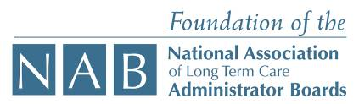

Special thanks to:

The Wertlieb Family

Tuesday, June 12, 2011 AGENDA
The George Washington University, Marvin Center, Washington, D.C.

9:00am - 12:00pm | Welcome and Opening Session (Light Refreshments)  - Lynn Goldman, Dean, GW School of Public Health and Health Services  - Robert Burke, Professor and Chair, GW Department of Health Services Management and Leadership
12:00 – 1:00pm | Lunch
1:00 – 2:00 pm | Examining the New Face of Leadership in Long-Term Care  - Douglas Olson, Associate Professor, University of Wisconsin at Eau-Claire
2:00 – 3:30 pm | Discussion Session: Overview of 2010 Recommendations and Summit Attendees’ Profile  - Douglas Olson, Associate Professor, University of Wisconsin at Eau-Claire  - Matt Mauthe, Chief Executive Officer, Marquardt Village  - Dinah Martin, Campus Administrator, Saint Therese at Oxbow Lake, Inc.  - Rachel Kruth, Administrator, HCR ManorCare
5:00 – 7:00 pm | Capital Yacht Charters Tour and Dinner  Special thanks to Golden Living for sponsoring this dinner tour.  

Wednesday, June 15, 2011 AGENDA

Engaging with Professional Connections and Opportunities

8:00 – 9:00 am | Discussion and Reflections from Profiles and Recommendations  (Light breakfast available)  - Douglas Olson, Associate Professor, University of Wisconsin at Eau-Claire
9:00 – 10:15 am | American Health Care Association/National Center for Assisted Living  - Ted LeNeave, President and CEO, American Healthcare, LLC.  - David Kyllo, Executive Director, National Center for Assisted Living
10:15 – 10:30 am | Break
10:30 – 11:30 am | National Association of Long Term Care Administrator Boards  - Randy Lindner, President and CEO, National Association of Long Term Care Administrator Boards
12:30 -2:00 pm | Senior Executive Panel Discussion Session with Lunch  - David Mills, President, Division 4, Golden Living  - Michael Rodis, Senior Vice President Human Resources, Sunrise Senior Living  - Cynthia Thorland, Vice President/Director of Educational Resources, Life Care Services LLC  - Brad Reynolds, Chief People Officer, Asbury Communities  - Daniel Schwartz, Chief Operating Officer, Addus HealthCare, Inc. (Facilitator)
2:00 – 3:00 pm | LeadingAge’s Leadership Development  - Wendy Green, Director, Leadership Development, LeadingAge  - Andrew W. Applegate, Executive Director, Asbury ~Solomons Island  - Melissa M. Fortner, Vice President of Supportive Living, VMRC
3:00 – 3:15 pm | Break
3:15 – 4:15 pm | American College of Health Care Administrators (ACHCA)  - Marianna Kern Grachek, President and CEO, ACHCA  - Timothy Dressman, Chair, Board of Directors, ACHCA
4:15 – 4:30 pm | Concluding Reflection
Special thanks to:

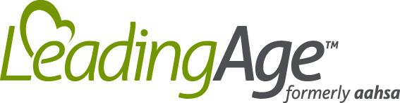

Thursday, June 16, 2011 AGENDA

Raising Legislative Awareness and Comfort Level

9:00 – 11:00 am | Developing and Implementing Public Policy for LTC Administrators  - Malcolm Harkins, Proskauer Rose, LLP  - Robert Burke, Professor and Chair, HSML Dept., GW  The Driving Force Behind Policy Development  - Anne Montgomery, Senior Policy Advisor, U.S. Senate Special Committee on Aging  - Senator Herb Kohl (D-WI, Invited)  An Insider’s Perspective on the Legislative Process  - Congressman Jason Altmire, (D-PA-04, Invited)
12:00 – 12:45 pm | U.S. Capitol Building Tour

Friday, June 17, 2011 AGENDA
Listening to the Next Generation

8:00 – 9:00 am | Leading the Next Generations/The Next Wave - Interactive Keynote  - Mike Muetzel, Mx Marketing, Management Solutions
9:00 -10:30 am | Discussion Session: Sorting out the Issues and Priorities  - Mike Muetzel, Mx Marketing, Management Solutions (Facilitator)
10:30 – 10:45 am | Break
10:45 – 11:45 am | Taking things to the next level and beyond: Developing an action plan  - Mike Muetzel, Mx Marketing, Management Solutions (Facilitator)  - Douglas Olson, Associate Professor, University of Wisconsin at Eau-Claire
11:45 – 1:00 pm | Lunch and closing session – Making Things Happen: A Professional Commitment  - Mike Muetzel, Mx Marketing, Management Solutions (Facilitator)  - Douglas Olson, Associate Professor, University of Wisconsin at Eau-Claire  - Matt Mauthe, Chief Executive Officer, Marquardt Village  - Dinah Martin, Campus Administrator, Saint Therese at Oxbow Lake, Inc.  - Rachel Kruth, Administrator, HCR ManorCare

Appendix B: 2011 Pre-NELS Survey Results
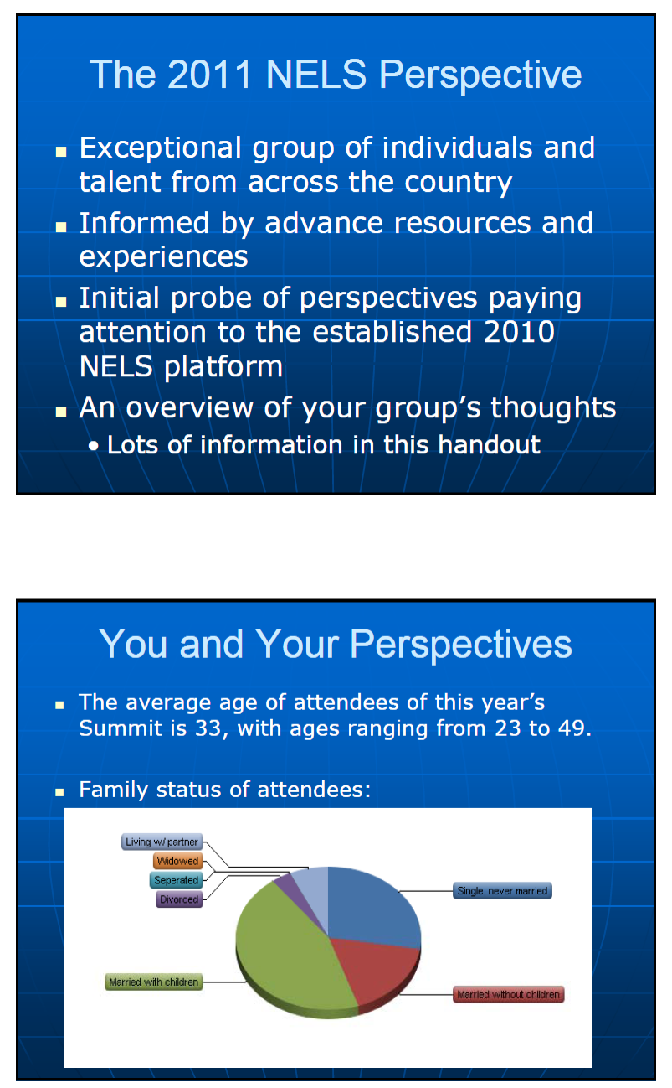
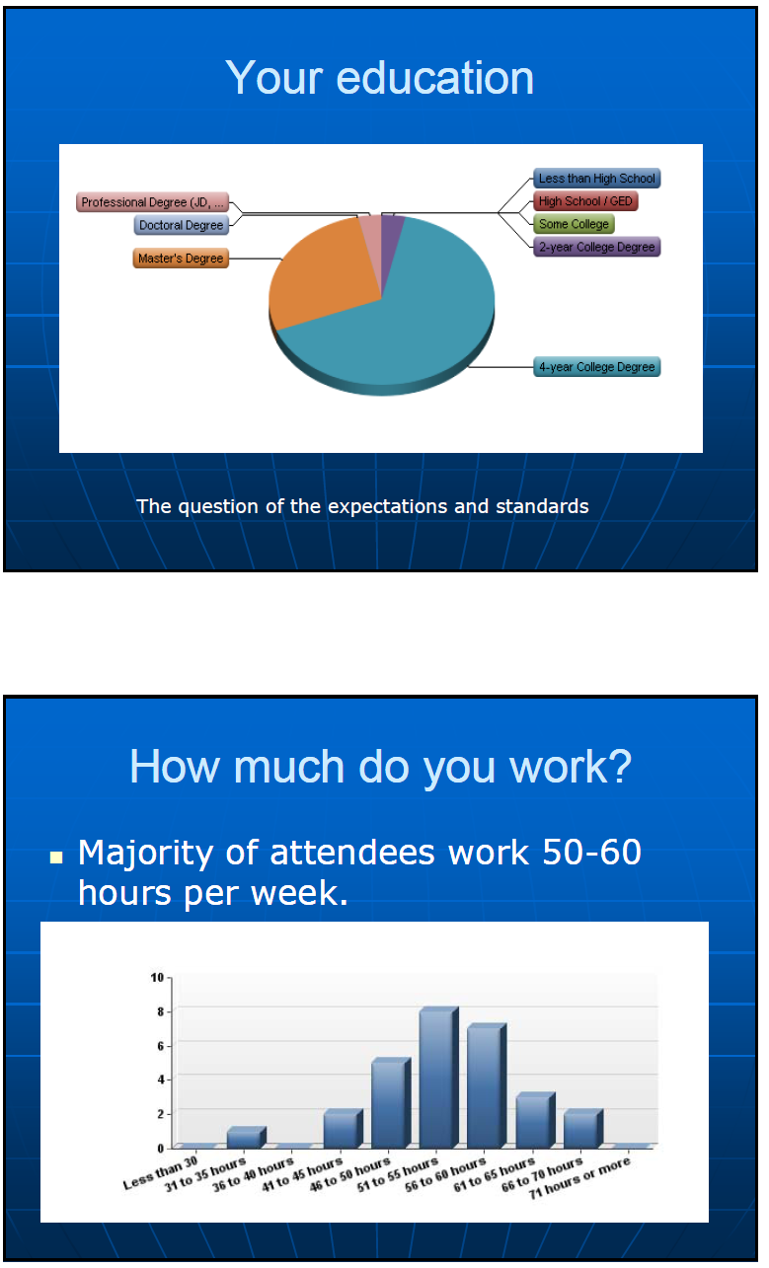
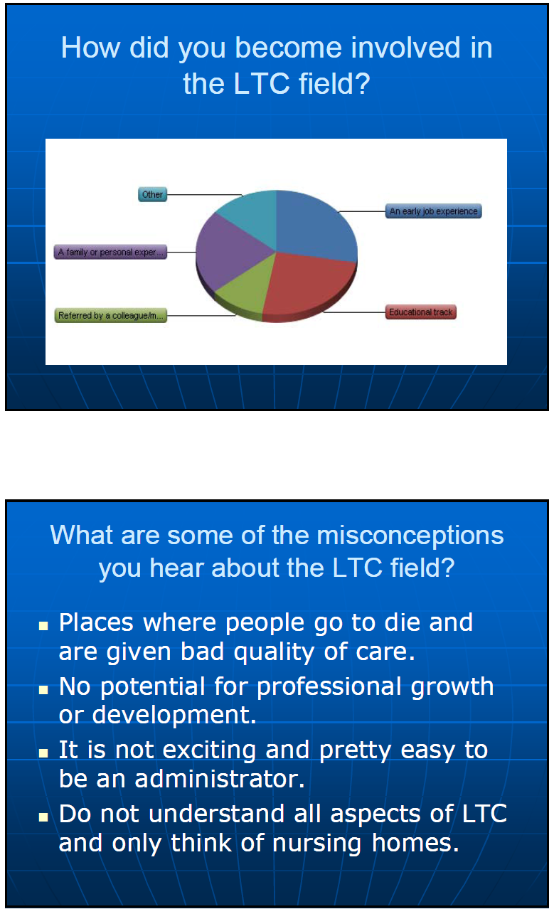
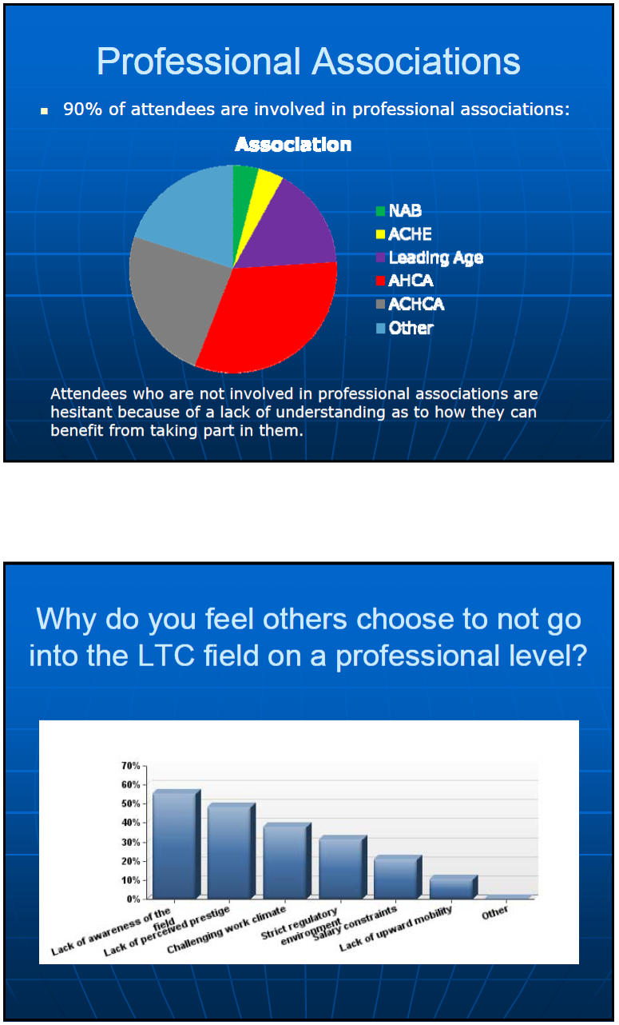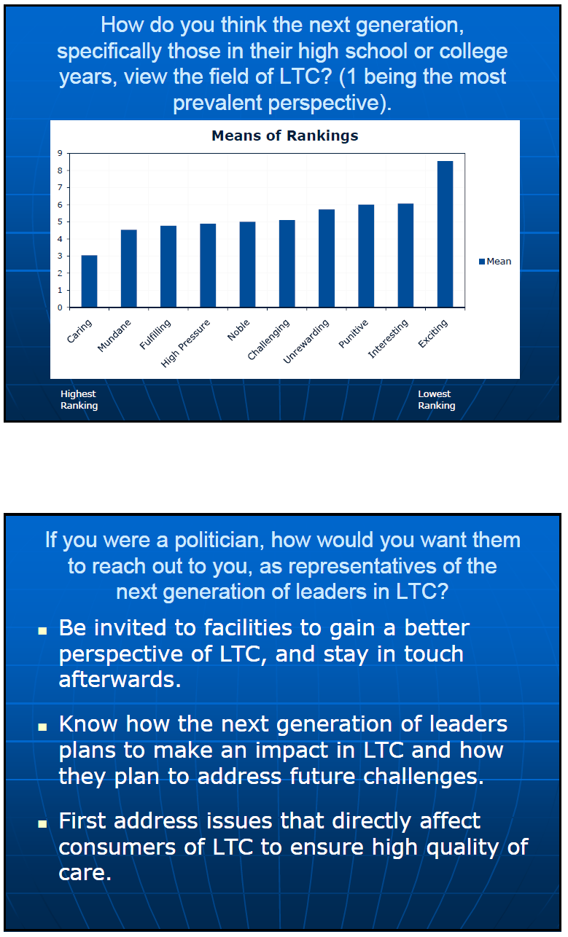
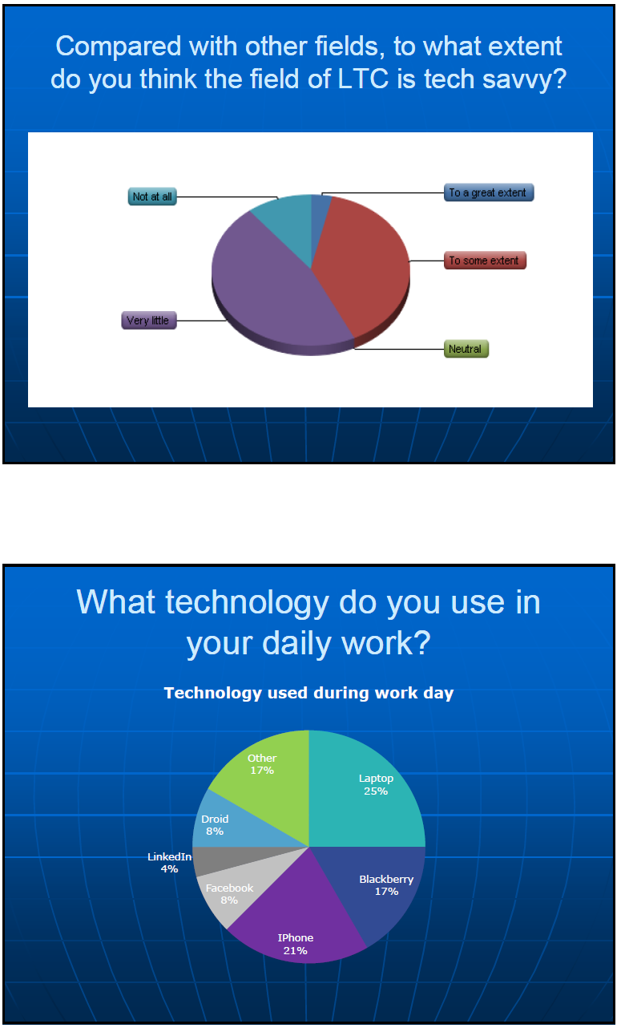
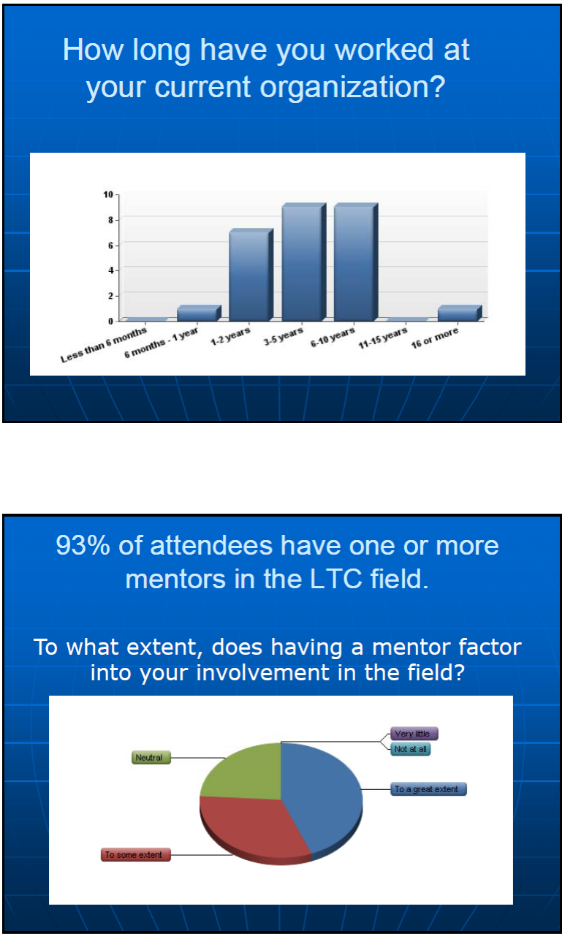
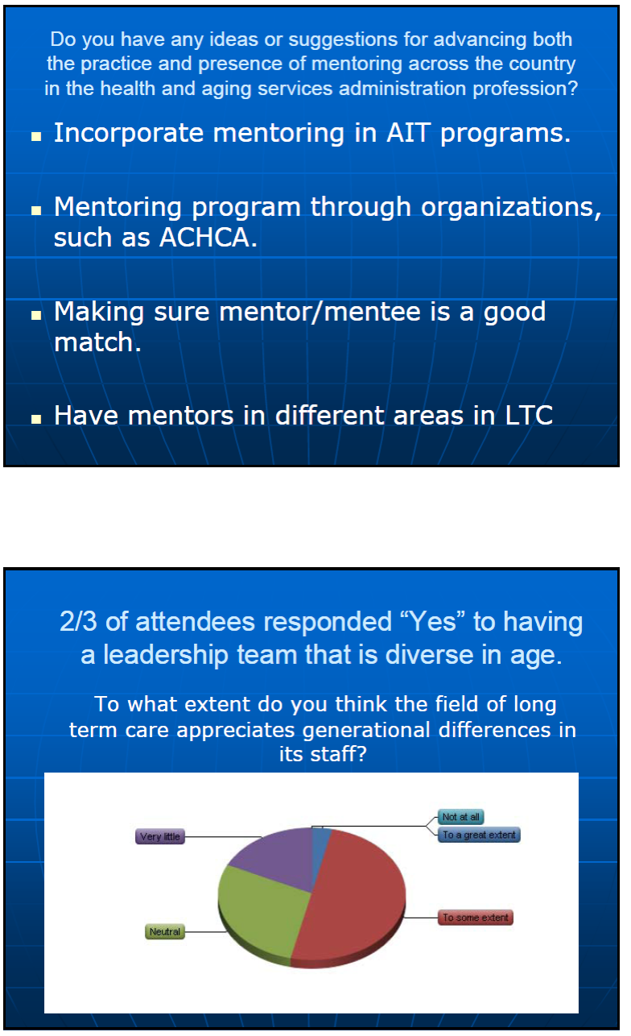
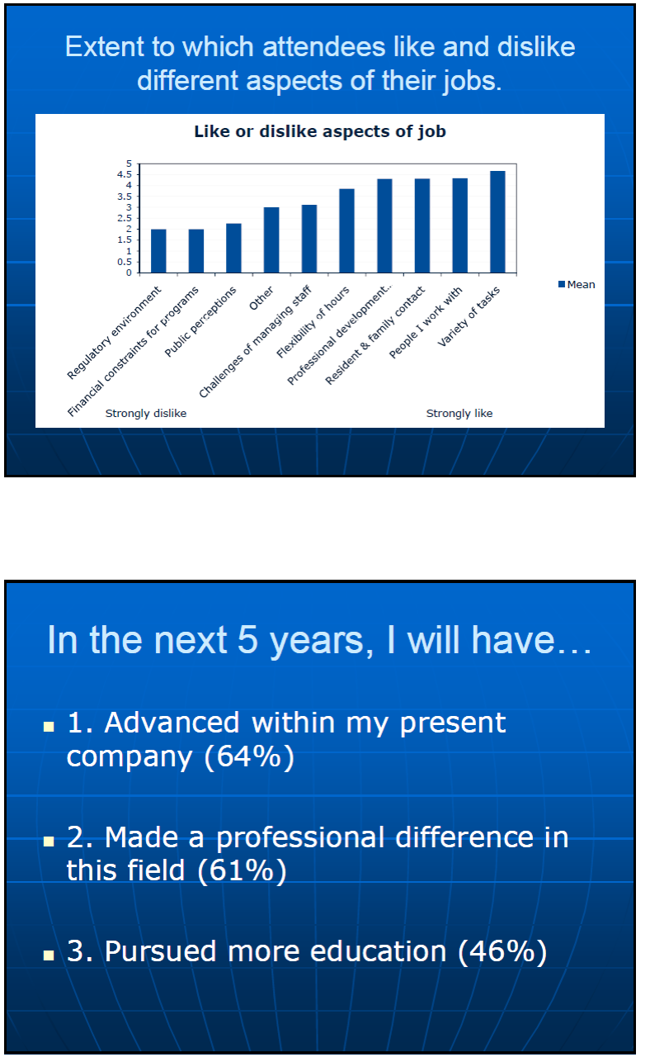
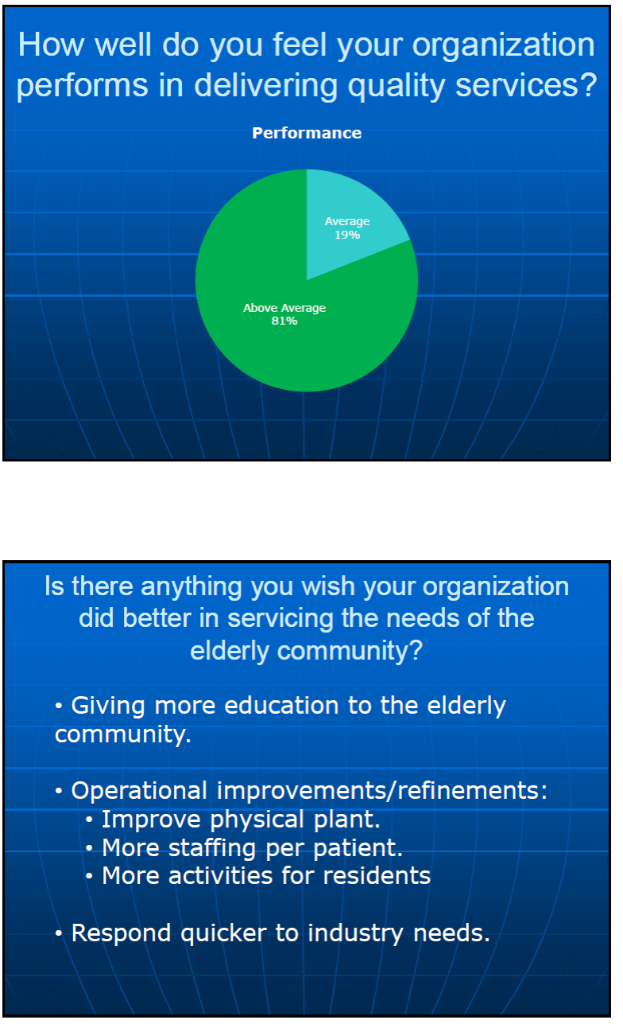
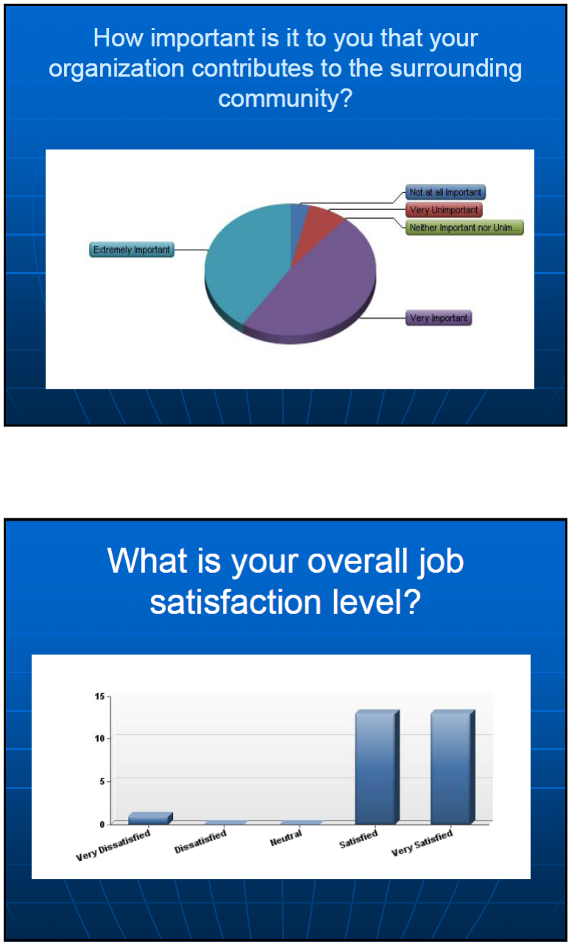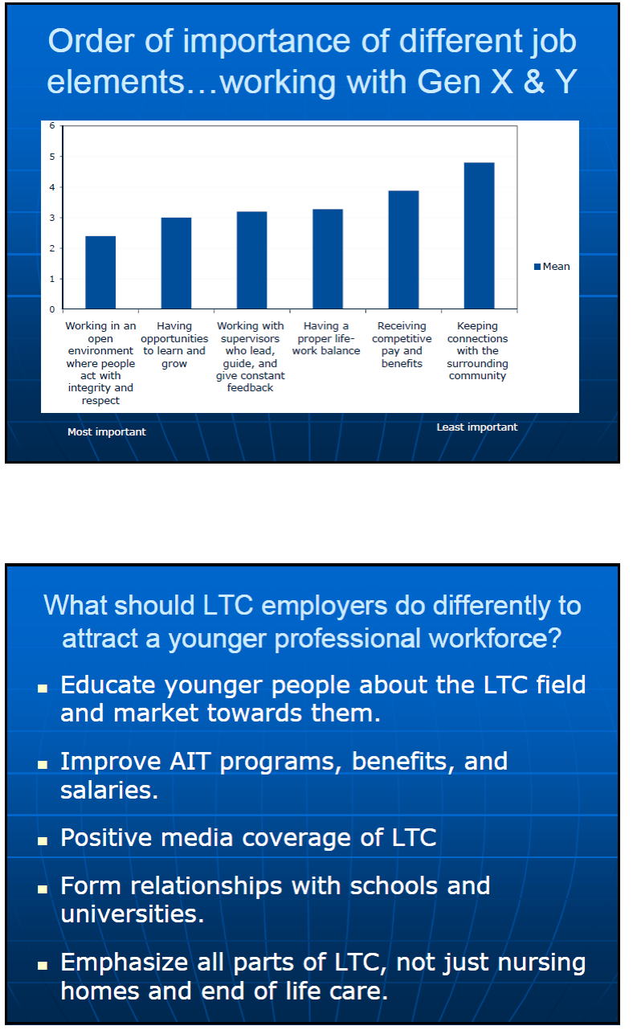
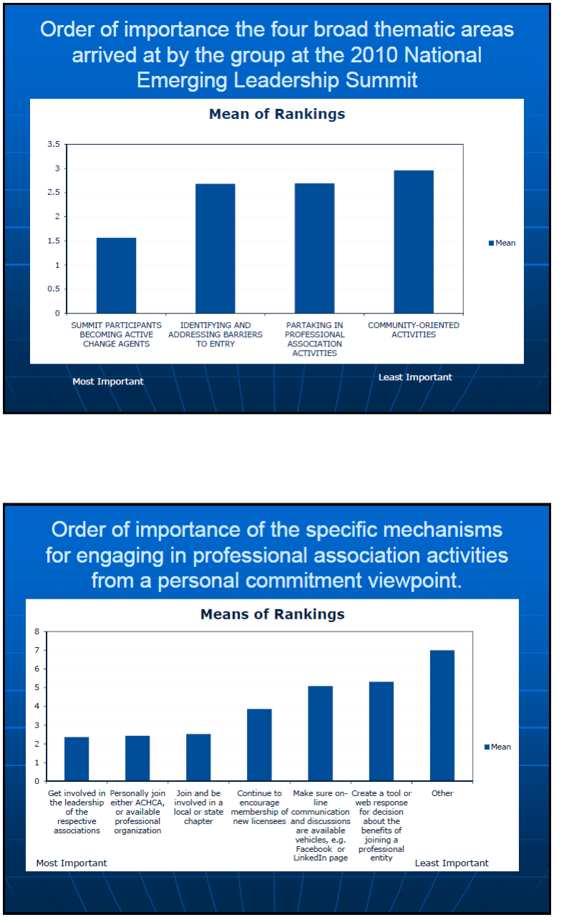
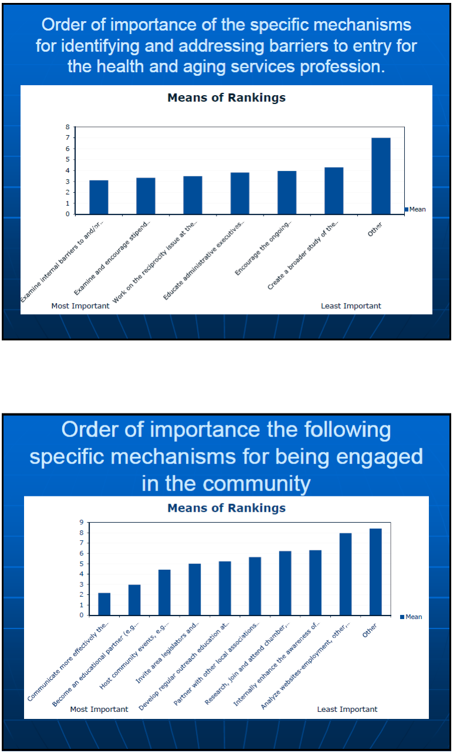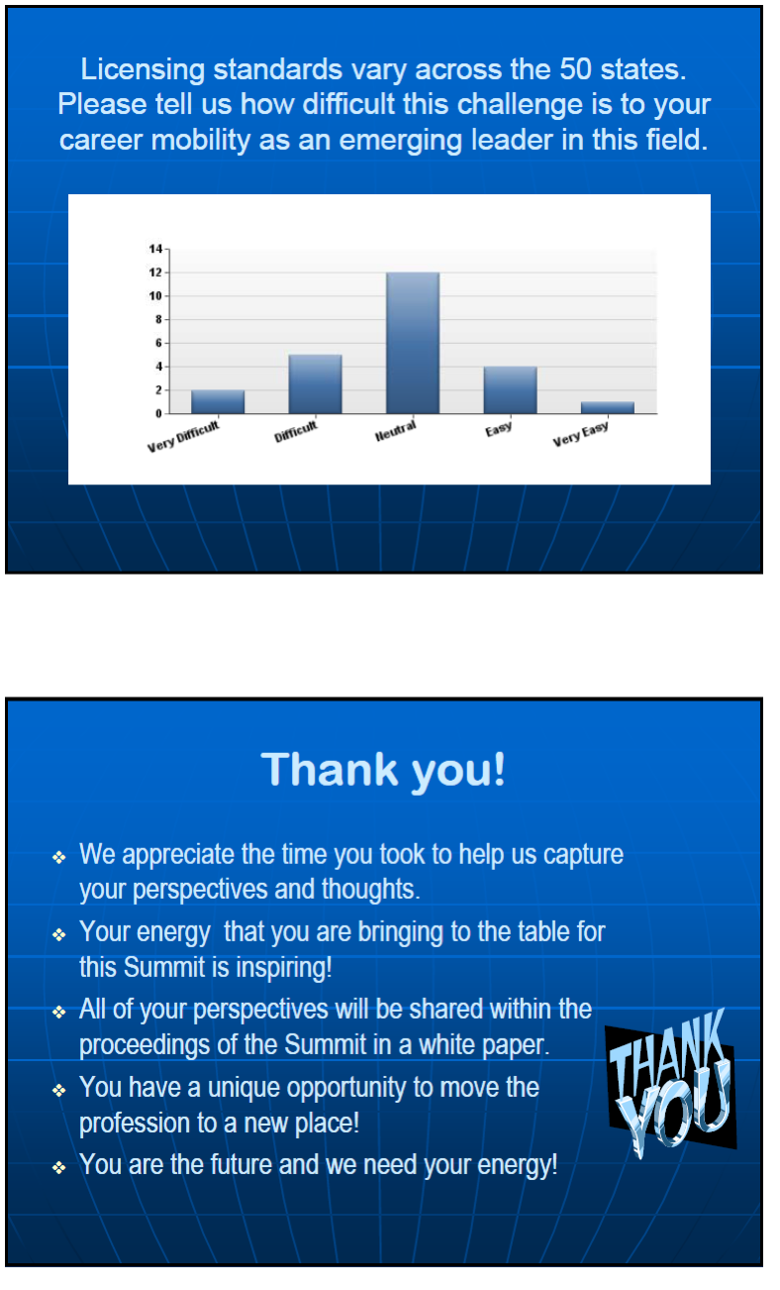

Appendix C: 2011 Action Plans

ACTION AREA: Facilitate standardized state licensure and reciprocity agreements

BACKGROUND: State-level long-term care administrator licensing boards and agencies have licensing requirements that vary greatly from state to state, which limits the mobility of long-term care administrators. We believe there is also an impact of the quality of care and services.

PURPOSE: To begin exploring standardizing the long term care administrators licensing requirements across all 50 states

PLAN OF ACTION
Objective | Action Steps | Completion Date
Receive professional support behind issue of reciprocity | - Send reciprocity information out to all administrators in different states that we have connections with (possibly former NELS attendees), with an emphasis on finding out more information about why states haven’t endorsed the reciprocity agreement | August 1
Receive professional support behind issue of reciprocity | - Obtain feedback about the issues and a list of key stakeholders from committee members | August 1
Receive professional support behind issue of reciprocity | - Set up meeting with professional associations such as AHCA, NAB, ACHCA, and Leading Age to discuss the issue and present to association leaders results from survey | August 1
Receive professional support behind issue of reciprocity | - Report back to the NELS group | Sept.15
Obtain evidence that this really does affect the quality of care and service | - Receive updated report from Dr. Olson about current study exploring issues and impact of varying state standards. | September 1
 | - Receive results of NAB Foundation study, which will include position paper and next steps | Nov 15
Create a sense of urgency to let legislators know the severity of the problem | - Invite legislator to meet with you, take a tour of your care center, and discuss the problems associated with differing licensure standards from state to state, and emphasize how this affects residents and the quality of care they receive | Jan 1
 | - Set aside time at the 2012 NELS Summit for a ‘round table” policy discussion on this issue and stay in contact with your own legislator to make sure they stay informed on the issue and the importance to our profession. | On-going

Volunteers: (* chair)
- Darlene Rocco * | Darlene/rocco@sbcglobal.net | - Jason Strnad | Jason.strnad@goldenliving.com
- Christina Gamaldi | Christina.gamaldi@bhshealth.org | - Timothy Ballas | Tballas@watermarkcommunities.com
- Dawn Miller | dawn.miller@rshaz.com | - Pilo Cano | pcano@marquiscompanies.com
- Jeff Fritzen | jfritzen@goldcrest.net | - Candace LaRochelle | cjlarochelle@ehealthdatasolutions.com

ACTION AREA: Vocabulary Change Committee

BACKGROUND: Long term care currently utilizes a broad vernacular to describe similar jobs and organizations. This wide range of terms creates confusion and frustration for those in long term care as well as the general public.

PURPOSE: To create standard nomenclature for long-term care professionals that will encourage positive change and decrease the public’s negative perception of the field.

PLAN OF ACTION
Objective | Action Step | Completion Date
Create vocabulary for the field that has a positive connotation | - Members of committee find best practices, e.g. Pioneer Network, around a list of terms that need to be changed (ex. “nursing home administrator”, “facility”, “beds”) | Aug. 15
 | - Identify and present the list of terms and replacements for these terms at the first webinar | September 15
Implement vocabulary changes on a small scale | - Committee members implement vocabulary changes in their organizations. Encourage staff to use the new vocabulary and explain to them the importance of it. | Oct. 1
Implement vocabulary changes on a small scale | - Report back to the committee two months later to discuss the progress made in each organization and whether or not changes need to me made to make the nomenclature more effective. If changes are needed, make them and then start implementation process over in each organization. | Dec. 1
Implement vocabulary changes on a small scale | - An agreed upon list of standard and effective vocabulary should be finalized with the group. | Jan. 2012
Obtain support from professional associations | - Present list of new vocabulary and findings from implementation in individual organizations to professional associations such as ACHCA, AHCA, Leading Age, and NAB. Discuss with them their opinion of new nomenclature and if there needs to be any changes or additions to the list. | Feb 2012
Obtain support from professional associations | - Discuss with them how we can implement changes on a larger scale. | Mar. 2012
Implement vocabulary changes on larger scale | 1. Send finalized list of standard vocabulary to organizations across the nation with an explanation of why it is so important, including 2012 NELS Participants. | April 2012
Implement vocabulary changes on larger scale | 2. Obtain feedback from organizations about the progress they have made and how effective the changes have been. | May 2012
Implement vocabulary changes on larger scale | 3. If necessary, make changes to nomenclature, or decide where project should go from here at the 2012 NELS Summit. | June 2012

Volunteers: (*chair)
- Dawn Miller* | dawn.miller@rshaz.com | - Jason Strnad | Jason.strnad@goldenliving.com
- Matthew Pool | mpool@marquiscompanies.com | - James Rosenman | rosenmanjames@edgewoodrc.com

ACTION AREA: Developing and refining mentoring opportunities

BACKGROUND: Mentoring is a vital learning experience for both mentors and mentees, and this is why it is important for NELS attendees to commit to being involved in the mentoring experience.

PURPOSE: To identify and/or develop and refine mentoring opportunities

PLAN OF ACTION
Objective | Action Step | Completion Date
Research existing/current mentoring programs (ACHCA and universities) | - Share ACHCA Mentoring program with all NELS participants | Sept 1, 2011
 | - Develop a list of other mentoring programs and resources | Oct 1, 2011
Collaborate with existing mentoring programs to share info with NELS participants | - Identify NELS participants interested in the ACHCA mentoring program and provide information. | Nov 1, 2011
 | - Track which NELS participants are actively involved in a mentoring/protégé relationship. | Dec 1, 2011
 | - Support current mentoring programs and solicit opportunities for improvement from NELS participants that currently mentor. | On-going

Volunteers: (* chair)
- Michelle Berry* | michelle@achca.org | - Nicole Easley | neasley@marquiscompanies.com
- Christina Gamaldi | Christina.gamaldi@bhshealth.org | - Timothy Ballas | Tballas@watermarkcommunities.com
- Brenda Ewers-Nordhues | bewers@vhsmail.com | - Matthew Pool | mpool@marquiscompanies.com
- Michelle Berryman | mberryman@themanors.net | - Tamara Geiwitz | tgeiwitz@lvnh.com
- Jennifer Hagen | Jhagen@marquiscompanies.com | - Tami Smith | administrator-gri@vhsmail.com

ACTION AREA: Speaking for Professional Associations Committee

BACKGROUND: The National Emerging Leadership Summit is a new venue for long term care administrators, and many are still unfamiliar with the opportunity. This committee will help to educate peers and colleagues about NELS.

PURPOSE: To speak about the value and potential of participating in the National Emerging Leadership Summit

PLAN OF ACTION
Objective | Action Step | Completion Date
Further develop speaking skills to become a more effective speaker. | - Identify strengths and weaknesses of speaking ability. | On – going
 | - Identify what you can do to improve the weaknesses. | On – going
 | - Practice, practice, practice. | On – going
Identify what should be presented about NELS | - Group defines what information about NELS to present at conferences for professional associations. | Sept 1, 2011
Identify what should be presented about NELS | - Create powerpoint of desired information. | Oct. 1, 2011
Obtain support from professional associations | - Contact the co-sponsoring organizations, (NAB and ACHCA) to give an update at their fall meetings | August 1, 2011
Obtain support from professional associations | - Decide with which of the other professional and trade associations would be interested in having a session at an upcoming conference. | Sept 1, 2011
Obtain support from professional associations | - Connect with these associations and get permission to speak at their meetings and conferences. | Nov 1, 2011
Implement presentations at smaller venues. | - Decide who will speak at which conferences. | Dates depend on when meetings and conferences take place. (Nov 2011-June 2012?)
Implement presentations at smaller venues. | - Speak at smaller meetings and conferences for professional associations.
Implement presentations at smaller venues. | - Seek feedback from attendees of meeting or conference.
Implement presentations at smaller venues. | - Make improvements to presentation if needed and report back to the group
Implement presentations at larger venues. | 1. Decide who will speak at which conferences. | Dates depend on when meetings and conferences take place.
Implement presentations at larger venues. | 2. Speak at larger meetings and conferences for professional associations. | Dates depend on when meetings and conferences take place.
Implement presentations at larger venues. | 3. Seek feedback from attendees of meeting or conference. | Dates depend on when meetings and conferences take place.
Implement presentations at larger venues. | 4. Develop next steps | Dates depend on when meetings and conferences take place.

Volunteers: (*chair)
- Michelle Berry * | michelle@achca.org | - Tami Smith* | administrator-gri@vhsmail.com
- Jennifer Hagen | Jhagen@marquiscompanies.com | - Machelle Harris | machelle_harris@LCCA.com
- Darlene Rocco | darlene.rocco@sbcglobal.net | - Timothy Frank | tfrank@themanors.net
- Nicole Easley | neasley@marquiscompanies.com | - Michelle Berryman | mberryman@themanors.net

ACTION AREA: Committee for NELS/LTC Administration Marketing Campaign

BACKGROUND: The current perception of long term care is varied and predominately negative. A goal identified by the 2011 NELS attendees is to begin a campaign to amend the public’s perception of the LTC administrative profession.

PURPOSE: To develop and implement a marketing campaign to change the public perception of the long-term care administrative profession starting with NELS.

PLAN OF ACTION
Objective | Action Step | Completion Date
Better understand how to effectively communicate message | - Research effective marketing campaigns for similar causes and see what an effective way to present image/message is, and find out whom else is doing this type of action for the broader field. | Sept. 1, 2011
Better understand how to effectively communicate message | - Contact marketing departments in own organizations and universities for their feedback and advice on approach and goal and vision. | Sept. 15, 2011
Better understand how to effectively communicate message | - Connect with other similar efforts, e.g. AHCA and Leading Age, and | Nov 1, 2011
Communicating marketing plan to NELS participants | - Create synopsis of marketing campaign, and how we would collaborate with other efforts | Dec. 1, 2011
Gain support from professional associations | - Meet with professional associations to get their feedback and support to launch campaigns for the public and universities. | Feb. 1, 2012
Create initial enthusiasm and launch campaign | - Put goal and vision on NELS Facebook and LinkedIn  - Spread the public message by talking about it within our networks | Fall 2011  Apr. 1, 2012

Volunteers: (*chair)
- Brooke Viegut * | brooke.viegut@goldenliving.com | - Candace LaRochelle | cjlarochelle@ehealthdatasolutions.com
- Tamara Geiwitz | tgeiwitz@lvnh.com | - Allison Murkowski | allison.murkowski@goldenliving.com
- Jennifer Hagen | Jhagen@marquiscompanies.com | - Timothy Ballas | Tballas@watermarkcommunities.com

ACTION AREA: Press Release Committee

BACKGROUND: The National Emerging Leadership Summit is a new venue for long term care administrators, and many are still unfamiliar with the opportunity. This committee will help to educate peers and colleagues about NELS.

PURPOSE: To develop and distribute a press release educating professional associations, journals, universities, colleagues, and peers about the NELS.

Plan of Action:
Objective | Action Step | Completion Date
Create draft press release | - Create outline for format of press release. | July 15
Create draft press release | - Decide what information about NELS to put in press release. | July 15
Create draft press release | - Put together draft press release. | July 15
Edit press release | 1. Send to members of press release committee to give feedback | Aug. 15
Edit press release | 2. Make necessary changes to press release | Aug. 15
Edit press release | 3. Compose final draft of press release | Aug. 15
Edit press release | 4. Send to members of press release committee for final approval | Aug. 15
Send out press release | Decide where to send press release:  -universities  -organization’s newsletter/website  -post to NELS Facebook and LinkedIn  -other? | Sept. 15

Volunteers:
- Jennifer Hagen | Jhagen@marquiscompanies.com | - Michelle Berryman | mberryman@themanors.net
- Darlene Rocco | darlene.rocco@sbcglobal.com | - Pilo Cano | pcano@marquiscompanies.com
- Chad Blackard | cblackard@covenantdove.com

ACTION AREA: White Paper Committee

BACKGROUND: The National Emerging Leadership Summit reports its findings each year in a white paper. It is critical to incorporate the 2011 NELS participants in the development and release of the white paper.

PURPOSE: To capture the findings from the 2011 NELS in a white paper that is disseminated within 120 days following the completion of NELS.

Plan of Action:
Objective | Action Step | Completion Date
Create draft of white paper | - Organize and edit notes taken at the Summit | Aug. 1, 2011
Create draft of white paper | - Prepare outline for white paper (possibly use 2010 NELS white paper as a template) | Aug. 1, 2011
Create draft of white paper | - Marleah, Roulla, and Doug create draft of paper. | Aug. 1, 2011
Edit draft and publish | - Send draft to members of white paper team to look over and give feedback | Aug. 15
Edit draft and publish | - Send draft to professional editor | Sept. 1-Nov. 1
Edit draft and publish | - Make necessary changes | Sept. 1-Nov. 1
Edit draft and publish | - Send again to members of white paper team and professional editor for final feedback and revisions | Sept. 1-Nov. 1
Edit draft and publish | - Publish final draft | Sept. 1-Nov. 1

Volunteers
- Darlene Rocco | darlene.rocco@sbcglobal.com | - Candace LaRochelle | mberryman@themanors.net
- Timothy Frank | tfrank@themanors.net | - Christina Gamaldi | Christina.gamaldi@bhshealth.org
- Chad Blackard | cblackard@covenantdove.com | - Timothy Ballas | Tballas@watermarkcommunities.com
- Matthew Pool | mpool@marquiscompanies.com | - Regina Casabal | Regina.A.Casabal@HUD.gov

Appendix D: 2011 NELS Participants
Name | Email
Allison Murkowski | allison.murkowski@goldenliving.com
Brenda Ewers-Nordhues | bewers@vhsmail.com
Brooke Viegut | brooke.viegut@goldenliving.com
Candace LaRochelle | candacejeffers@gmail.com
Chad Blackard | cblackard@covenantdove.com
Christina Gamaldi | christina.gamaldi@bhshealth.org
Darlene Rocco | darlene.rocco@sbcglobal.net
Dawn Miller | dawn.miller@rshaz.com
Doug Olson | olsondou@uwec.edu
Fafa Kumassah | fkumassa@gwmail.gwu.edu
James Rosenman | rosenmanjames@edgewoodrc.com
Jason Strnad | jason.strnad@goldenliving.com
Jeff Fritzen | jfritzen@goldcrest.net
Jennifer Hagen | jhagen@marquiscompanies.com
Katie Davis | kdavis9@good-sam.com
Machelle Harris | machelle_harris@lcca.com
Marleah Anne Keuler | keulerma@uwec.edu
Matt Pool | mpool@marquiscompanies.com
Michelle Berry | mberry@achca.org
Michelle Berryman | mberryman@themanors.net
Nicole Easley | neasley@marquiscompanies.com
Pilo Cano | pcano@marquiscompanies.com
Regina Casabal | rcasabal@ymail.com
Stephanie Tozbikian | stephanie.tozbikian@genesishcc.com
Tamara Geiwitz | tgeiwitz@lvnh.com
Tami Smith | tsmith@vhsmail.com
Timothy Ballas | timothymballas@yahoo.com
Timothy Frank | tfrank@themanors.net
Zachary Zerbonia | zzerbonia@brookdaleliving.com

References

OECD countries include: Australia, Austria, Belgium, Canada, Chile, Czech Republic, Denmark, Finland, France, Germany, Greece, Hungary, Iceland, Ireland, Israel, Italy, Japan, Korea, Luxembourg , Mexico, Netherlands, New Zealand, Norway, Poland, Portugal, Slovak Republic, Slovenia, Spain, Sweden, Switzerland, Turkey , United Kingdom, and United States.
The term “reciprocity” is the vernacular term for the legal term endorsement.
Table 2. Projections of the Population by Selected Age Groups and Sex for the United States: 2010 to 2050. Population Division, U.S. Census Bureau. August 14, 2008.
National Health Expenditure Projections 2009-2019. Center for Medicare and Medicaid Services. https://www.cms.gov/NationalHealthExpendData/downloads/proj2009.pdf. Accessed 10-07-11.
Ibid.
DIRECTORATE FOR EMPLOYMENT, LABOUR AND SOCIAL AFFAIRS Employment, Labour and Social Affairs Committee; Health Committee. Organization for Economic Cooperation and Development. http://www.oecd.org/officialdocuments/displaydocumentpdf?cote=delsa/elsa/wp2/hea%282009%291&doclanguage=en. Accessed 10-07-11.
National Association of Boards of Examiners of Long Term Care Administrators (2000). Decline in license exam applicant study. Washington DC. NAB.
Dana, B. and Olson, D. (2007) Effective Leadership in Long Term Care; The Need and Opportunity. American College of Health Care Administrators Position Paper . (www.achca.org).
Supplemental Research Brief: 2009 National Business Ethics Survey, Millenials, Gen X, and Baby Boomers: Who’s Working at Your Company and What Do They Think About Ethics? Ethics Resource Center. 2010.

