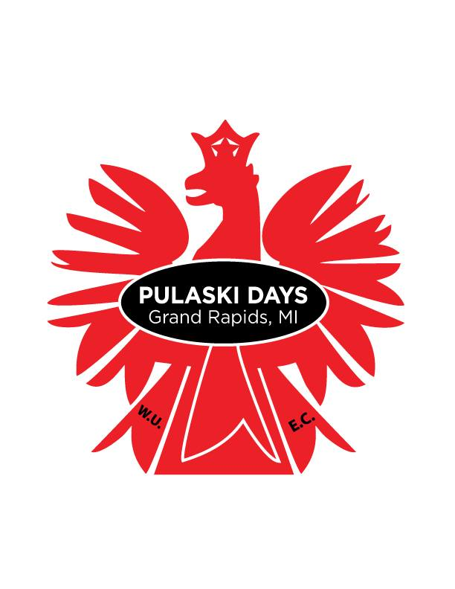

**26TH ANNUAL**

**PULASKI DAYS**

**KIELBASA EATING CONTEST**

Wednesday, October 3

6th Street Hall

649 6th Street NW Grand Rapids

Contest begins at 7:00PM

**REGISTER TODAY AT**

**www.pulaskidays.org/kielbasa**

**Event is limited to 20 teams:**

$20 / Team - Registered by 10/2

$30 / Team – Register at Event

*\* All Payments to be made in Cash at the Event*

* Teams of 3 must include at least 1 man and 1 woman.
* Teams will compete to see who can finish a total of 4 kielbasa dogs the fastest.



Cash Bar and Food Available