FHEA Bylaws Suggested Revisions
11/8/25

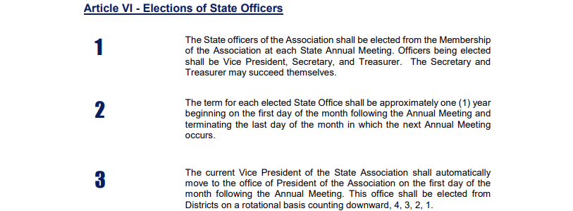
Revision 1: Should a district have a board-approved reason to not provide a candidate
for Vice President, a candidate will be elected from the next district on
the rotation.

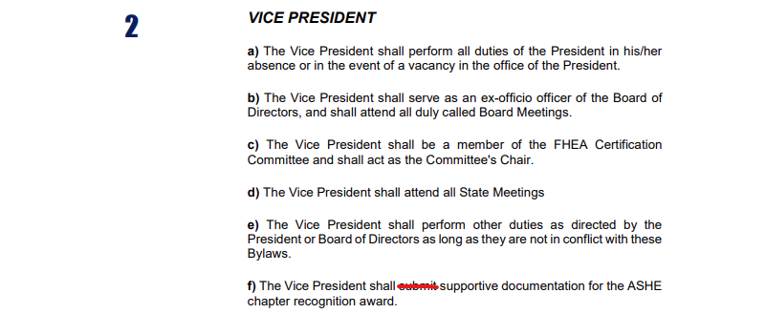
Revision 2: f) The Vice President shall approve the supportive documentation for the
ASHE Chapter recognition award to be submitted by the Executive Director.

Revision 3: g) The Vice President shall serve as the board’s liaison to the Supporting
Members and will schedule time to meet at FHEA Conferences.
Both conference or just one?

Article VIII - Executive Director
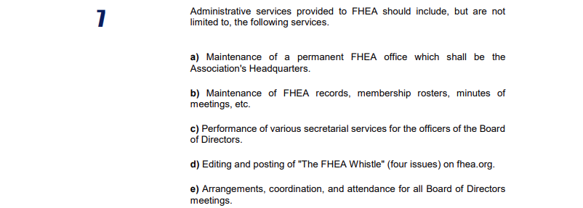
Revision 4: The Executive Director shall submit supportive documentation for the
ASHE recognition award.

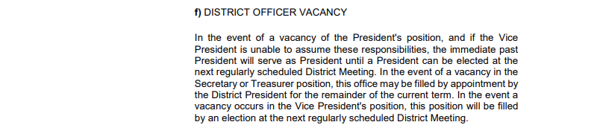
Revision 5: In the event of a vacancy of the President’s position, the Vice President
will serve as the president for the balance of this term and the following term.
If the Vice President is unable to assume these responsibilities, the immediate
past President will serve as President until a President can be elected at
the next regularly scheduled district meeting.
This mirrors the State President vacancy.

