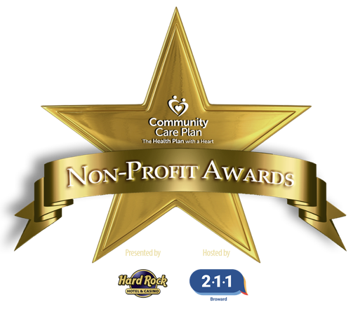
Nomination Information Sheet

AWARDS INFORMATION
14th Annual Community Care Plan Non- Profit Awards, Presented by Seminole Hard Rock Hotel & Casino, hosted by 211 Broward

On Friday, March 7, 2025, Broward County non-profit organizations and leaders will be recognized for their tireless efforts and impact. At the 14th Annual Community Care Plan Non-Profit Awards Presented by Seminole Hard Rock Hotel & Casino and hosted by 211 Broward, we will celebrate our collaborative community with an Awards ceremony and luncheon.
211 Broward is now accepting nominations for outstanding individual and organizational efforts (please visit www.211-broward.org/non-profit-awards for more information, frequently asked questions, and deadline information). All 501(c)(3) organizations are encouraged to submit a nomination in one or more categories for consideration. Please note that organizations/leaders will only be named as a finalist in one category based on scoring. Organizations that have won in a specific category prior to 2021 are eligible to submit again.

IMPORTANT NOTES

- Nominations are scored ONLY by our carefully selected Judges based on submissions only.
- Award Category partners do not review submitted submissions.
- 211 Broward and its representatives do not discriminate on the basis of race, color, sex, religion, national origin, disability, age, marital status, political affiliation, sexual orientation, pregnancy, or gender identity and expression. Any providers must abide by similar practices in order to be considered for nomination.

Up to three finalists will be selected in each category by a panel of impartial judges from across the nation. Finalists will be revealed at the VIP Announcement Show on January 28, 2025 at 6:00 pm (streamed via our YouTube channel). Winners will be revealed at the Awards ceremony and luncheon on March 7, 2025. Winning leaders/organizations will receive a $1,000 grant to their organization, and up to two finalists per category will receive a $500 grant to their organization in May at the Awards Celebration Luncheon (date TBD). Nominating organizations will receive publicity and awareness of their organization’s mission through event press, media materials, electronic newsletters and social media coverage. Qualified nominees not named as finalists will be eligible to win the Community Choice Award. The community will select a winner for this Award by voting online for their favorite organization (voting begins in early 2025). Organizations that have won this Award prior to 2021 will be eligible to win again. The winner will be announced at the Awards luncheon and the organization will receive a $1,000 grant (Please note that grants awarded for the collaboration category will be divided equally among the collaborating organizations by the submitting agency.)
211 is Broward County’s 24/7/365 crisis helpline and gateway to much needed community resources. 211 Broward is an essential utility for Broward County residents. Since our inception, 211 Broward has managed over 3 million contacts and connected people in need with more than 3,100 programs and services. 211 plays a significant role in responding to all types of disasters, pandemics, local tragedies, etc., providing key services to the community. We also manage incoming calls to 988 that originate in Broward County.
Nomination Information Sheet

CRITERIA & INSTRUCTIONS
14th Annual Community Care Plan Non- Profit Awards, Presented by Seminole Hard Rock Hotel & Casino, hosted by 211 Broward

Award Criteria & Nomination Instructions
- Please visit https://211-broward.org/non-profit-awards to obtain nomination forms and instructions. Please visit our website for deadline date and time.
- Email completed package/s and required attachments to development@211-broward.org (please be sure to include all required attachments – note: Staff Leader nominations need headshots as well).

All nominees must meet the following criteria:
- Organizations have a presence in Broward County and regularly deliver services to residents of Broward County.
- Individuals/organizations may self-nominate or be nominated by others.
- Organizations may be nominated in more than one category.
- Organizations that have won in a specific category prior to 2021 may submit again for that category.
- An organization may only be a finalist in one category (the category in which the organization ranked highest).
- Those not chosen as a finalist are eligible to win the Community Choice Award. If you won this Award prior to 2021, you are eligible to win again.
- The Lifetime Achievement and Excellence Awards winners will be determined by 211 Broward.
- If you are not already in the 211 Broward provider database, please email datamanagement@211-broward.org for information, however it is not necessary to submit nomination(s).

Application instructions and required attachments
- Required attachments: The completed cover page and all questions for the appropriate award category; a copy of your organization’s 501(c)(3), headshot (if applicable), and your company logo in a 300dpi jpeg/png format. We do not accept links. You are invited to include ONE recommendation letter.
- Please answer each question fully and succinctly. The answer portion of the application may not exceed 2 pages and must be submitted using the application formatting. Convey your passion as you explain why your nominee/organization is deserving of this honor.
- Nominations are scored only by carefully selected judges. Our panel of esteemed judges from across the nation will score based solely on information provided in the nomination application package. Web or video links are not permissible. You are invited to include ONE recommendation letter.
- Visit our Awards website page at www.211-broward.org/non-profit-awards. You will find information about the event (tickets, partners, FAQ’s, etc.).
- If you have any questions, please contact development@211-broward.org. You may also contact our Awards Nomination Liaison, Tony Beall, President/CEO of Mister Nonprofit, at 754.281.8728 or tony@misternonprofitconsultancy.com.

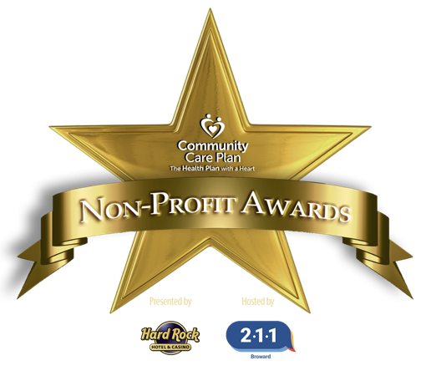
Nomination Application

NON-PROFIT ORGANIZATION
OF THE YEAR: RISING STAR
14th Annual Community Care Plan Non- Profit Awards, Presented by Seminole Hard Rock Hotel & Casino, hosted by 211 Broward

A “Rising Star” organization is young, and it may be small, but their impact is huge. The organization has been in existence for less than 10 years. The nominee:

- Has a clearly defined mission and future vision
- Has effective leaders who work in partnership to overcome challenges
- Is recognized and respected for impacting the lives of those it serves
- Is well positioned for lasting community impact

NOTE: Event information will be sent to all those that provide email addresses.

CEO/ED Name (please indicate title):

CEO/ED Email:

Name of Organization:

Address:

Website:

Facebook Handle: Instagram Handle:

Phone: 2024 Operating Budget:

Organization ID #: Year of Incorporation:

Organization’s Mission (this information will be in the event program, if chosen as a finalist)

Nominator Information:
Name: Title:

Organization:

Phone:

Nominator Email:

Relationship to Nominee:

Nomination Application

NON-PROFIT ORGANIZATION
OF THE YEAR: RISING STAR
14th Annual Community Care Plan Non- Profit Awards, Presented by Seminole Hard Rock Hotel & Casino, hosted by 211 Broward

Please answer each question using Bookman Old Style 11 point font and current margins. Please do not exceed 2 pages. Links are not permissible.

211 Broward and its representatives do not discriminate on the basis of race, color, sex, religion, national origin, disability, age, marital status, political affiliation, sexual orientation, pregnancy, or gender identity and expression. Any providers must abide by similar practices in order to be considered for nomination.

- Why was your organization created, and how has it demonstrated a significant impact on the lives of the people it serves?

- What has been the greatest challenge in the development and/or growth of the organization, and how have the Board, staff, and stakeholders worked together to address and overcome this challenge?

- Please describe the organization’s vision for the future and why it is expected to have a lasting impact on our community.

