Maquoketa River Focus Group Meetings 2018
Final Report
Submitted to the Jones County Conservation Board (JCCB)
Prepared by
Northeast Iowa RC&D Inc.

Report Purpose:
Northeast Iowa RC&D Inc. was contracted by the Jones County Conservation Board as a neutral party to distribute information and measure public opinion about projects associated with the Mon/Maq Dam, the Mon/Maq Access, and the Maquoketa River. Northeast Iowa RC&D was specifically asked to facilitate eight focus group meetings, to complete a survey of 2,000 Jones County voting residents (households) and to help with a public meeting. The purpose of the activities was to 1) Gather the public’s opinions so that residents felt they could be open and honest with their views. 2) Provide opportunities for the public to inform county decision making so that more residents felt comfortable with final decisions made by the JCCB in relation to the Mon/Maq Access. 3) Gather input from a greater number of Jones County residents. 4) Gather input from different types of special interest groups.
Because some of the participants of the small group meetings reported feeling disenfranchised or intimidated by other community members, or fearful of publicly expressing themselves, this report provides a summary of the input provided by the eight focus group participants in a manner that protects the anonymity of the participants to the greatest extent possible.
Focus Group Meeting Structure and Content
The JCCB was responsible for inviting participants to the eight focus group meetings. JCCB personnel reported they contacted individuals, organizations and/or group representatives from different interest groups and asked them to send a specific number of representatives (members, employees, or board members) to a focus group meeting. Organizations were responsible for selecting the individual representatives to attend. The JCCB reported that representatives from economic development, multiple chambers, tourism, paddling and other recreational entities, youth organizations, educators, natural resource professionals, anglers, adjacent and other Jones County businesses that utilize the river, adjacent landowners, city and county political representatives, emergency services (fire, ambulance, DNR law enforcement, police), and historical and nonprofit organization representatives. Attendees representing each of these different interests did show up at the meetings with every meeting having attendees who represented more than one interest. A general summary of participation by group type is included in the results section of this report by Focus Group number. With the exception of one person, all meeting attendees reported residing in Jones County with 20 reporting from Monticello, 12 Anamosa, 2 Center Junction, 1 Stone City and 1 Scotch Grove resident. (The one exception was a professional who has duties associated with public lands in Jones County.) One of the eight meetings was conducted at noon. The remaining meetings were conducted in the evenings. All meetings were conducted in either Anamosa or Monticello. Participants were informed of the purpose of the meeting. Different numbers of participants attended each meeting. Although notes were utilized by the facilitator to maintain continuity between meetings, the participants were allowed to interrupt and ask question and engage in dialog between themselves and with the facilitator so as to encourage genuine and open dialog and engagement. As a result, the total content and dialog of every meeting varied slightly.
During the meetings, background information was verbally provided to the participants, including information related to the history of the Mon/Maq Access and the Mon/Maq Dam. An excerpt of content from the Office of the State Archeologist’s Summary and Recommendations section of OSA Technical Report 322 and information from the IDNR 2010 Dam Inventory - Table 2 - was conveyed when related questions came up during discussion. Participants were encouraged to speak with intention, listen to understand, choose to be curious, focus on the purpose, be fully present -shut off cell phones, respect the speaker (refrain from side-conversations), and to let go of assumptions. They were also told that the focus group meetings, the survey, and the public meeting were all intended to inform the JCCB and so each meeting was only part of a larger process. They were encouraged to listen to different opinions, and foster empathy in the meetings and in future public interactions. They were also encouraged to return the written survey if they received it and to encourage others residents to do so as well. They were informed of the upcoming public meeting place and time and encouraged to attend. When the public meeting date was postponed, small group participants were notified via email or through a phone call.

Background information given to attendees included the 10-year length of the planning process, the formation of the Mon-Maq Dam group, and belief of the Friends of the Mon Maq Dam group that the dam’s history and recreational setting should not be changed. The participants were informed that, out of respect for the Friends of the Mon-Maq Dam’s views, the county, state and federal partners in the project had opted to take a pause and measure opinions in Jones County.

The grants that the JCCB had secured were noted and the reasons that the JCCB had pursued those grants was explained. Every group of participants was very specifically informed that the grants that the CCB had secured to date would not be able to be used to repair the dam and they were also told for what those grants were awarded and how the use of grant funding was tied to the goals of the funder and could not be changed. This was explained upfront as well as during explanation of specific options so that the participants could understand that some grants could not be used for specific options and others would be appropriate. (i.e. If the dam were left in place with a fish passage developed beside it, then a grant to restore aquatic systems could still be used for development of the fish passage, but a grant focused on elimination of the dam hydraulic would not be able to be used to only develop the fish passage.)

The goals of the project and the reasons that the JCCB had pursued a project at the site and thus submitted and secured the grants were detailed for every group as follows.
- The dam hydraulic below the dam that can trap a person and result in drowning. There are 1.7 fatalities/year in Iowa caused by dams. In Iowa, between 1998 and 2017 there were 20 fatalities. Although the hydraulic was not present at all flow ranges, the Jones County Conservation Board (CCB) wants to eliminate the dangerous hydraulics at all flow ranges.
- The age of the dam, 1913/1914, indicated to the CCB that it was nearing its engineered life span. According to engineering firms that work with partners to conduct repairs on dams, the average lifespan of a dam is 50 to 100 years. Given the age of the dam (104 years), the CCB wants to reduce long-range costs for the county, while avoiding negative effects on other infrastructure (bridges, levees, etc.)
- When the dams in Iowa were constructed, the impact to aquatic species and communities was not considered. The CCB now recognizes how the dam inhibits aquatic species, including fish and mussels and other species movement through the system, and they want to improve upstream passage of native fish and aquatic species at all flow ranges.
- The Maquoketa River passes through several Iowa Counties. It flows roughly 35 miles through Jones County, 7 miles between the Mon/Maq Dam and Pictured Rocks is one of the most popular State designated Water Trails in Iowa. Tens of thousands of people a year, with thousands a day on busy weekends, use the river in Jones Co. The Maquoketa River has become an important economic and recreational resource, especially as related to canoeing and river recreation, but river users must exit the river at the Mon/Maq Dam or risk injury or death associated with the dam and the hydraulic. The CCB wants to enhance river navigation, recreation and use and make sure it is safe for people using the river above and below the dam.
- Projects at dam sites in Iowa and the Midwest have resulted in increased fish populations and fish diversity. The CCB desires to improve the fishing resource at and above the Mon/Maq Dam Access.
- If possible, the CCB desired to reduce upstream flooding.
- The CCB feels the historical and cultural significance of the dam should somehow be represented through interpretation at the site or by other means.
- Grants to improve fish passage, fish populations, fish health, help mussel and other aquatic species, improve lengths of aquatic river systems and grants to improve safety/reduce the threat of drowning are available from state and federal and even private grantors. There are few known grants available to restore the dam but private funding may be raised and the voters within a county may choose to spend county funds on dam restoration and maintenance.
- The CCB wants to minimize costs related to the site for county taxpayers.
Public Input
Participants were asked to provide input in multiple ways. However, participants were not required to answer every question or participate in every, or any, activity. Participants were asked to answer specific questions. In some instances, individuals were asked to limit their answers to one word. At other times, they were allowed to provide a more in-depth answer. In some instances, to maximize individual participation, participants were given sticky notes of two or three different colors. Sticky note colors were used to distinguish order of preference or rank when multiple answers to a question were allowed with blue as a primary response, pink secondary and yellow tertiary. In another instance, blue was a positive response and pink a concern. Participants were asked to provide their input in writing on the sticky notes. After writing they were asked to share they answers one at a time with the larger group. Each group had a different level of discussion. Attendees were each given an opportunity to participate and after verbal discussion the sticky notes were passed to the facilitator to maximize the accuracy of this report.

Methods
First Exercises
The first set of questions the participants were asked to answer were related to their views of the Maquoketa River. This exercise helped the participants feel comfortable with the sharing process, helped build common language and rapport between participants, and the responses given may help the JCCB understand how the participants think of the Maquoketa River and what they think the JCCB should be doing in relation to the Maquoketa River. It may also help the JCCB gain limited insight into why the participants might prefer various scenarios that were presented for consideration.

During the first phase of this exercise, participants were asked to answer questions related to their views of the Maquoketa River. They were each given three different colored sticky-notes and asked to write one word on each to identify the top three things they associated with, or thought of in association with, the Maquoketa River. (Blue as most important, Pink as second most important and Yellow as the third most important.)

The answers given during this part of the first exercise are conveyed in this report to the JCCB using two different Word Clouds. Word Clouds, also known as text clouds or tag clouds, are used to convey responses visually. Word Clouds can be used to group responses either by specific words or by like words. The more frequently a word was used, the larger and bolder that word appears in the Word Cloud. The less frequently a word was used as an answer/response, the smaller and less bold that word appears in the Word Cloud. The Word Clouds are intended to convey the frequency of specific answers or thoughts of participants in relationship to the frequency of other words. The content of the first Word Cloud conveys the answers given for the number one/top word that all participants in all groups thought of or associated with the Maquoketa River (answers on the blue sticky notes). The content of the second Word Cloud conveys all answers given by all groups as weighted with the first choice of each participant receiving 3 points, second choice receiving 2 points and third choice receiving 1 point. Words were clustered and then total points for each word were calculated by adding up the points as assigned. In the second exercise, because there were so many different words, some words were clustered together so that the Word Cloud could be inclusive of words that were not common. (Points for like words, Canoe, Kayak and Paddle were combined and represented as Paddle. Drinking Beer and Beer points were combined and represented as Beer. Scenery and Scenic points were combined and represented as Scenic.)

During the second phase of this exercise, participants were asked to answer questions related to their views of the Maquoketa River. They were each given three different colored sticky-notes and asked to write the top three things they thought the JCCB should be doing to improve the Maquoketa River. (Blue as most important, Pink as second most important and Yellow as the third most important.)
The answers given during this exercise are conveyed in this report to the JCCB as they were written. They are organized by topic rather than by small group or by participant. The organization of these thoughts is solely intended to help the JCCB read through the answers in an efficient manner.
Second Exercises
During this exercise participants were asked to relate their views of the Mon-Maq Access, which was defined as the property managed by the JCCB including the access/portage areas above and below the dam and the dam itself. This exercise helped the small group participants move into more deliberate thought and discussion about the Mon-Maq Access and the dam. It may help the JCCB understand how the participants think of the Mon-Maq Access and what they think should happen at the site. It may also help the JCCB gain limited insight into why the participants might prefer various scenarios that are later presented for consideration.
- Please write one note that conveys the most positive aspect of the Mon-Maq Access.

The answers given during this exercise are conveyed in this report to the JCCB as written and organized by similar ideas rather than by small group or by participant. The organization of these thoughts is solely intended to help the JCCB read through the answers in an efficient manner.

- Please write one note that conveys your greatest concern related to the Mon-Maq Access.

The answers given during this exercise are conveyed in this report to the JCCB as written and organized by similar ideas rather than by small group or by participant. The organization of these thoughts is solely intended to help the JCCB read through the answers in an efficient manner.

- Please take three sticky notes and identify the 3 most important things related to the Mon-Maq Access going forward. (Blue as most important, Pink as second most important and Yellow as the third most important.)

The answers given during this exercise are conveyed in this report to the JCCB as written and organized by similar ideas rather than by small group or by participant. The organization of these thoughts is solely intended to help the JCCB read through the answers in an efficient manner.
Third Exercises

The participants were all informed that JCCB had secured preliminary estimates and preliminary drawings for five different options, ranging from removing the dam and restoring the river, to leaving the dam and other options in between. It was stressed that the cost estimates and drawings associated with each option were very preliminary and were expected to be further developed once public opinion was collected. At no time in any meeting were any of the estimates, which were wide ranging, or the drawings, represented as final plans or estimates. Large scale depictions of each of the five options, with written descriptions were used at each meeting to better explain the options. The written descriptions were also read out loud by the facilitator. The participants were encouraged to discuss the options among themselves.

Large diagrams and descriptions of each of the 5 alternatives were provided via the CCB to participants who discussed them, asked questions, and commented. Although changes in opinion were not quantified or recorded to allow for quantitative measurement of the impact of the discussions, in some cases group discussion and questions appeared to influence final votes. Each participant was asked to vote for 3 of the 5 Alternatives knowing that their 1st Choice would receive 3 points as indicated by a blue sticky note, 2nd choice 2 points as indicated by a pink sticky note, and 3rd choice 1 point as indicated by a yellow sticky note. Participants were not required to select any alternatives and they were allowed to select one, two or three choices. Participants were not allowed to use multiple choices on the same alternative. The following descriptions were read and provided with the diagrams.

Alternative A – No Action (Leave the Dam)
Alternative A leaves the dam in place and preserves the site’s history. Current uses and hazard remain the same, including the slow-moving pool upstream of the dam. The 104-year old dam may be left to let “nature take its course.” If recommended repairs become urgent, fixing a breached levee extending south of the dam and repairing concrete, would range in cost between $400,000 to $1.2 million. Engineer-recommended long-term maintenance costs are highest, relative to other options. Alternative A has no adverse impact on the dam, which is eligible for the National Register of Historic Places.

Alternative B – Dam Removal – Constructed; 3 to 4’ Boulder Riffle and Habitat Features
Alternative B includes removing most of the dam. It replaces the dam’s rushing water with a 3-to 4-foot-tall boulder riffle and fish habitat features. The riffle would be passable to canoeists and kayakers, and intentionally constructed for angler access. This option keeps a rushing water feature in the area. Estimated cost: $1,310,000-$2,190,000. Long-term maintenance: Moderate.

Alternative C – Dam Removal with Constructed Habitat Features
Alternative C includes removing most of the dam and installing fish habitat features. The river is restored to its original level. Cost does not reflect minor stabilization of upstream infrastructure, but is expected to be low. This option has no rushing water feature at the dam area, but habitat structures improve fishing. It is the most restorative to natural conditions for fish passage, biological recovery, and long-term water quality improvement. Estimated cost: $900,000-$1,500,000. Long-term maintenance cost: Lowest.

Alternative D – Dam Remains and Fish Bypass Constructed
Alternative D includes leaving the dam in place and installing a fish bypass channel. This option has little to no adverse impact on the historic structure. The dam’s hazard is not reduced. It maintains the same or comparable pool of slow water upstream. The high end of the cost range below includes dam repairs noted in Alternative A. Some funds already raised could be used, others would be returned under this alternative. Estimated cost: $890,000-$2,000,000. Long-term maintenance cost: Highest

Alternative E – Dam Modification and Constructed; 6 to 8’ Rapids and Habitat Features
Alternative E includes modifying the dam and constructing a 6-8’ rapids with fish habitat features. This option increases active recreation. One side of the channel falls more gently for fish and canoe passage. The other channel around the island falls more rapidly and noisily. Angler’s access and fishing success are considered in the way the rapids are constructed. Some slow-moving pool is maintained upstream. Estimated cost: $2,060,000-$3,440,000. Long-term maintenance cost: Moderate
Additional Comments
Before the meeting ended many participants chose to add comments regarding specific options, particularly those participants that felt that the JCCB should consider or reconsider a specific component of an option. Other participants decided to make broader comments or comments on other topics. While the facilitator limited input from participants, some additional comments related to process or other neutral topics were included in this report. The comments are conveyed in this report to the JCCB as written and organized by similar ideas rather than by small group or by participant.

Results
First Exercises:
Highest priority word conveying the thing associated with or thought of in association with the Maquoketa River with each person’s top priority receiving one point, clustered with like responses, and reported for all participants of all small groups by Word Cloud.
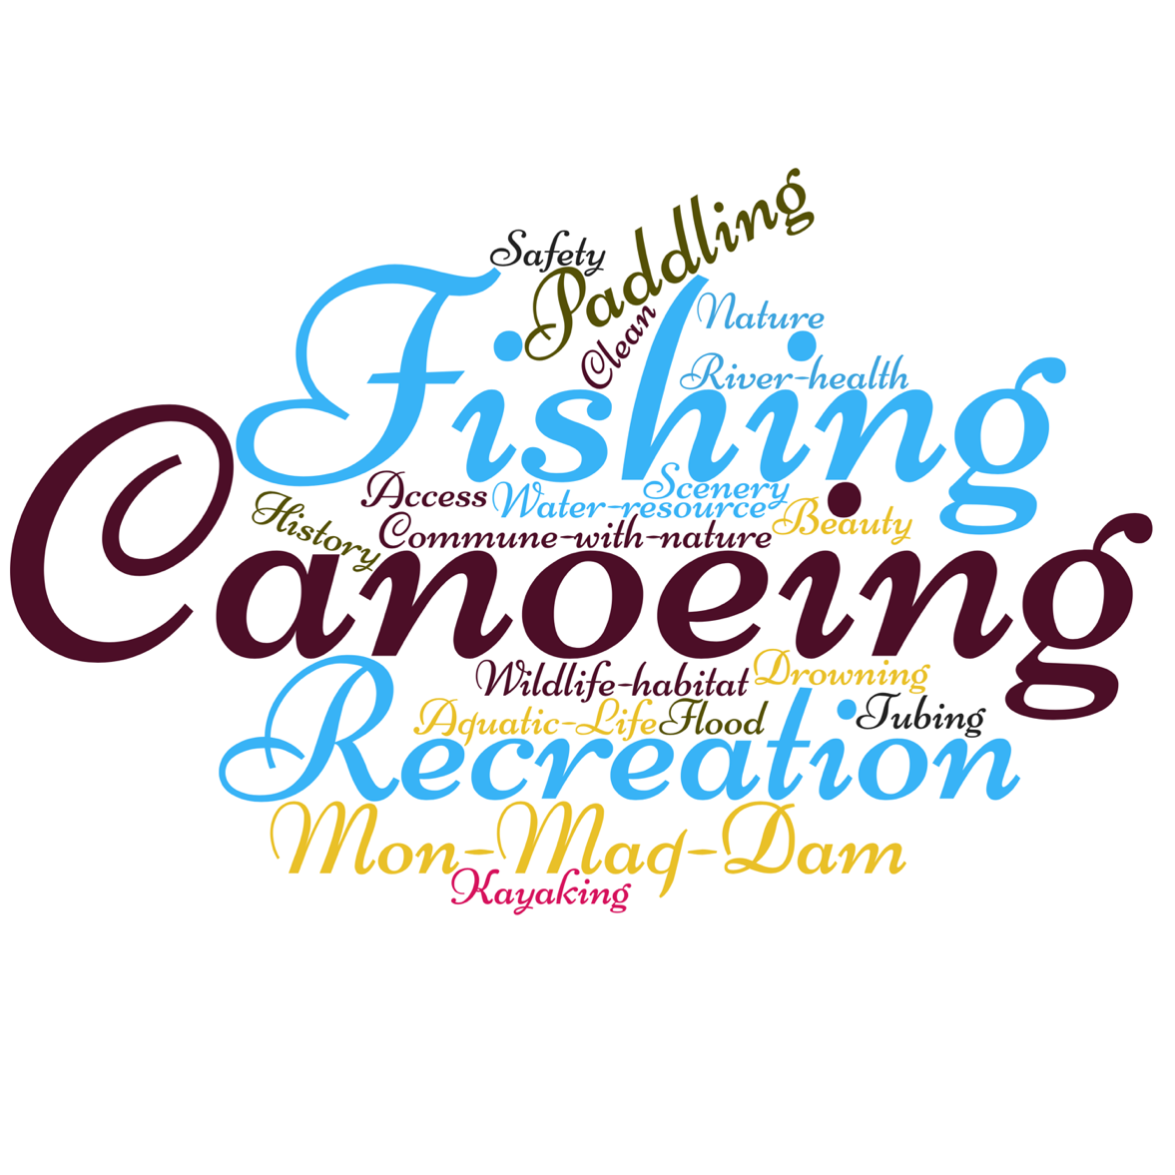

All words conveying the things associated with or thought of in association with the Maquoketa River as reported by participants of all small groups as represented by one Word Cloud. (Answers were weighted with #1 answer receiving three points, #2 answer receiving two points, and #3 answer receiving one point.)
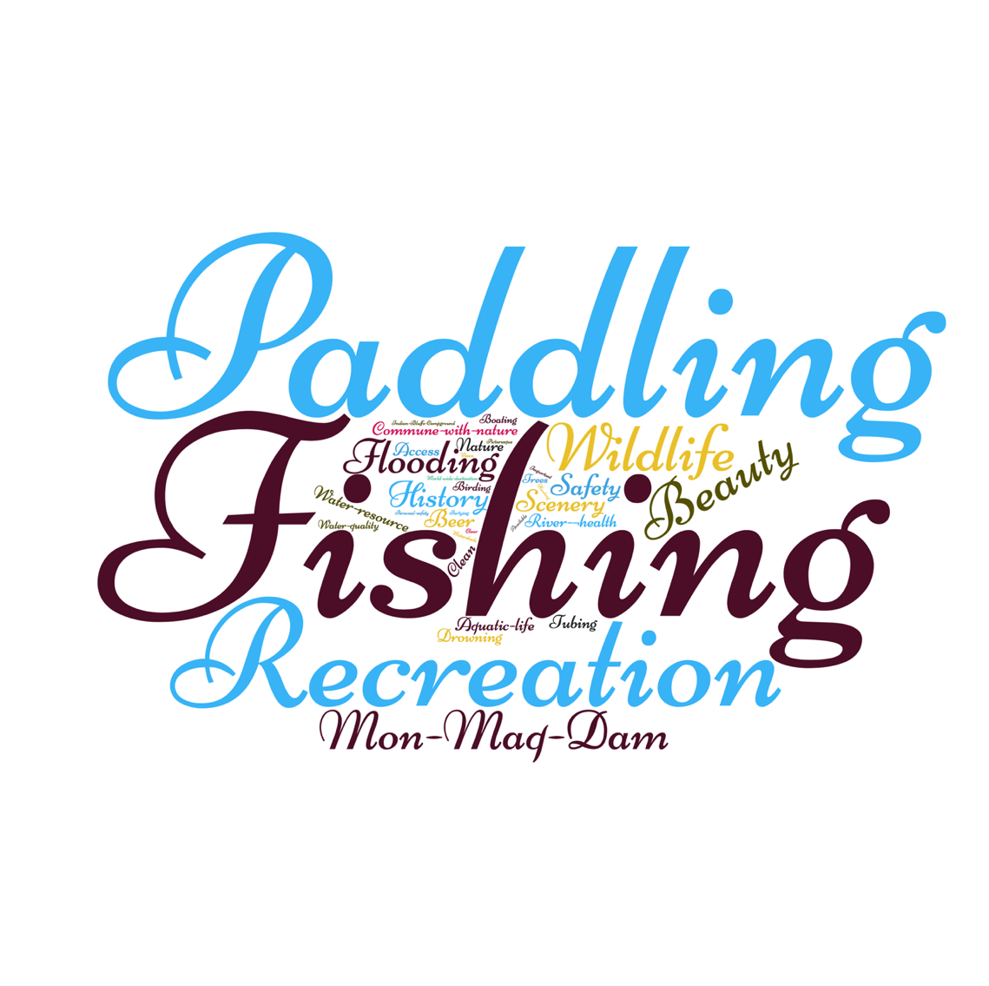

The “Most Important thing that the CCB should be doing to improve the Maquoketa River” Answers for all participants from all groups as clustered by like answers.

- Keep it clean
- Pollution/clean-up/farm/junk
- Regular clean-up of the river, dam site, surrounding areas, remove garbage
- Help keep water clean
- Water quality
- Water quality study
- Cleaning projects for watershed
- Watershed projects in sub watersheds to reduce sediment and nutrient loading to river
- Reduce runoff – buffer zones
- Stop erosion
- Remove the dam partially
- Modify dam
- Dam project
- Remove dam to improve area
- Remove the dam
- Repairing the dam
- Repair the dam
- Keep boat ramp open and put ramp below dam
- Fix up area from overlook to boat ramp to make it handicap friendly handicap fishing
- Bad launch downstream of dam
- Fix Boat ramp
- Check out the effect removing the dam does to area around
- Improve Accessibility
- River Access improved
- More and better access
- Safety
- Safety
- Safety
- Develop Identifiers on the river and maintain them to help emergency responders find people
- Work to improve aquatic life
- Improve river wildlife
- Improve wild areas along river
- Fish Structure management
- Invasive species control
- Acquiring land
- Getting information out to public
- Opening under Main Street Bridge to stop flooding because the dam is not the reason for it

The 2nd Most Important thing that the CCB should be doing to improve the Maquoketa River
Answers for all participants from all groups as clustered by like answers.

- Aquatic migration
- Improve the fishing
- Fish counts
- Improve fish health
- Stock Fish
- Fishing
- Wildlife
- More water clean up
- Remove trash near Hwy 38
- Improve water quality
- Clean
- Riparian buffers and filter strips along river and tributaries
- Work w/landowners on riparian buffers
- Take care of surrounding banks land
- Bank restoration
- Keep runoff reduced
- Safety
- High water safety precautions postings
- Working with landowners to increase accessibility
- Increase communication among canoe and location of person in need
- Accessibility for citizens
- More land owner cooperation – private/public conflict of land ownership related to day users
- Safe access to the river from landowners (no guns pointed to people trying to access river for EMS)
- Rules, enforcement
- Promote recreation
- Education
- Fish class for youth
- Develop history of the area promotion
- Improve boat ramps
- Keep it recreational
- Improve recreational opportunities
- Keep Boat ramp open and put ramp down below
- Fix up area from overlook to boat ramp to make it handicap friendly handicap fishing
- Boat launch downstream of dam
- Improve and/or Complete River access. (River access for kayaks and canoes especially at dam Eby’s Mill access that was never finished)
- Put in handicap access at Mon Maq Dam
- Beautify the area along the river/dam

The 3rd Most Important thing that should be doing to improve the Maquoketa River
Answers for all participants from all groups as clustered by like answers.

- Accessible
- Create and maintain more public river access points
- Keep safe = safe for users
- More access for EMS
- Clear logs
- Safe Access allowing river trails
- Improve Communication on floods, no floating etc.
- Safety
- Increase enforcement
- Water safety for youth class
- Poll public
- Talk to public
- Educate public
- Promote stewardship
- Promote/advertising tourism
- Inform southern people of the county about the (Mon-Maq) area
- Promote as an economic resource for County
- Promote and increase historic tourism opportunities; explore options by saving the (Mon-Maq) dam
- River clean up
- Create fish passage
- Improve fishing
- Stock more fish
- Insure wetlands above the dam to make sure it stays wetland
- Stock fish
- Stream bank stabilization
- Wildlife Conservation habitat maintenance
- Additional recreation
- Additional recreation
- Make a kayak run like Manchester
- Improve recreational opportunities
- Put hard surface road to dam
- Improve access at Eby’s Mill
- Consider the Tax payer
- Plan for the future –longevity
- Develop options for trash disposal
- Remove the (Mon-Maq) dam

Second Exercises:
Most positive aspect/thing about the Mon/Maq access
Answers for all participants from all groups as clustered by like answers.
- Aesthetics of it
- Natural beauty
- Picturesque
- Everyone can use it
- Beauty and historical significance of the access
- Historic value to area / interpretive info
- Historic and beautiful
- Historic interpretation site – displays etc
- Overlook access
- Lookout platform is nice
- Dam historical aspect
- History of the dam
- Historical Mon Maq Dam and its beauty
- The Mon Maq Dam
- Dam and its history
- Dam and Beauty
- Dam the Old Mill overlook
- Beauty of the water cascading over the dam
- Recreational activity
- Access to river
- Access
- Great launch point for canoes and kayaks
- More river access
- Boat launch
- Recreational and economic impact
- Easy access to recreation
- Port for recreation
- Promoting recreational opportunities
- Attraction for out of town people
- Peaceful scenic place to visit reminds of youngers days with family
- Resurfacing of the road 2003 now paved
- Fishing
- Park area is very nice compared to before
- Safety
- Good upkeep

Greatest concern related to the Mon/Maq access
Answers for all participants from all groups as clustered by like answers.
- Safety
- Safety
- Safety
- Overall safety including people and wildlife
- It isn’t safe as current condition or for recreation passing along the river
- Dam fail – safety
- Safety of dam
- Safety
- Boat launch is near the dam
- Flooding and the danger around the dam
- Life of dam
- Removing the dam and the loss of the wetlands above the dam
- Removal of the dam
- Environmental impacts of the dam removal of upstream and downstream areas
- The historical Mon Maq Dam will be destroyed
- The loss of the dam and its heritage
- They won’t take this piece of Monticello heritage away
- Keeping original
- The dam being destroyed
- Can it be taken away?
- Cost to tax payers
- Cost of repairs
- Costs related to dam failure
- No maintenance creates risk of dam breach and unfunded costs of clean up after breach/failure
- Overall cost to maintain, tree removal, debris clean up from flooding, etc.
- Moving forward and not knowing what will happen…will people become more risky with the change. How will people get help, will there be a place for help
- Upkeep of the road
- Road is rough and needs work
- Current and future upkeep
- Blocked fish passage
- Diminishing fish movement
- Access to all area is poor – eroding bank (affects people o foot) silted in boat ramp, walk in launch downriver is poor
- People
- People
- Finding common ground for all constituents with the decision made
- The dam parking
Most important thing to consider when going forward with Mon/Maq access
Answers for all participants from all groups as clustered by like answers.
- Access
- Accessibility
- Accessibility
- Cost vs access
- River Access - more
- Make it more accessible
- Establish step down w/increase bank access
- Beautify the area and improve the access Safety
- Mon Maq Dam and its historical aspects
- Save the dam
- Leave dam alone
- Save the dam as it Do NOT remove or modify
- Save the dam
- Repairing it
- Maintenance and preservation of the dam site in its original state
- Safety
- Safety considerations
- Keep safe
- Safety
- Put-in spots that are easier for everyone i.e. Universal accessibility
- Balance of history/preservation and safety and environmental concerns
- Best solution for conservation and wildlife and aquatics
- Natural habitat
- Fish habitat or stocking for more numbers
- How it effects fish/wildlife
- As it sits now repair eroding bank
- Removal benefits out-weigh keeping it
- Remove dam
- Monitor dam for structural issues
- Fix road and parking lot
- Well-being of all the people
- County funds
- Do something as soon as possible
- Recreation
- Hear all stakeholders in decision making process

2nd most important thing to consider when going forward with Mon/Maq access.
Answers for all participants from all groups as clustered by like answers.
- Cost of any project to tax payers and long-range planning “no band aid fixes”
- Costs
- Economic impact on all concerned (tourism, historic, recreational tax payers etc)
- Long term maintenance costs of the options
- Long term cost
- Funds available
- Cost in construction/ maintenance
- Spend the money wisely – don’t have me pay a bunch
- Safety
- Safety
- Safety
- Safety
- Keep clean
- Clean up around dam and access areas
- Brush hog all willows on sand bar
- Fishing
- Fish wildlife
- Create fish ladders for easy fish passage
- Preserve the water resource
- Real natural resource conservation not just what the public wants
- Better input and out takes
- Public access, boat ramp, handicap accessibility, fish passage solution
- Put boat ramp right below it
- Leave ramp and tear out dam
- Handicap access, fix up for handicap to be able to enjoy the area
- Educational history – interpretive signage
- Life of the dam
- Maintain the dam in perpetuity
- Preservation of dam/area
- Downstream
- Walking trails
- Road work
- Better markings
- The Mon Maq Dam and its connection to the wetlands and riverside gardens/golf course and Jelly Park
- Find best common ground for all parties
- Do something as soon as possible

3rd most important thing to consider when going forward with Mon/Maq access.
Answers for all participants from all groups as clustered by like answers.
- Improve access below the dam. boat launch, beach access, recreation
- Make every part above and below of the area Accessible
- Keep it accessible
- More control over access
- Improve the 2 access points
- Making the area a viable location pleasing for all types of citizens and tourists and visitors
- Economic impact to Jones County
- Use the site to improve – make the community more enticing
- Promote tourism of the site and improve the area
- Improve recreation – utilize the resource
- Recreation
- Recreation
- Recreation
- Trails and shore access
- Cost factors access, dam
- Cost
- Upfront project costs
- Least future maintenance
- Historic Value
- Historical preservation
- Maintain historic displays
- Preserve history
- Fishing
- The beautiful area and good fishing
- Adding buffers and fish habitat (trees and shallow)
- Downstream effects
- Taking out dam will destroy fishing for a period of years because of disruption of river and downstream silt
- Maintain dam to protect wetlands and water at riverside gardens
- Wetlands and Riverside gardens
- Water Quality
- Maintain quality of water and ecosystem
- More parking
- Put a good road to it
- Public opinion
- Let it (the dam) deteriorate naturally and not fix
- Do something as soon as possible

Third Exercises:
Results of Voting for “Alternatives”
Total Scores for All Answers Combined
The following chart reflects the total NUMBER OF ALL POINTS added together for all participants of all Focus Groups by Alternative. Each participant in every Focus Group was asked to rank their 1st, 2nd, and 3rd choice. Their 1st choice was given 3 points, 2nd choice 2 points, and 3rd choice 1 point, resulting in each participant being able to award a total of 6 points. (Only one of their choices could be placed on any single Alternative and not all participants chose to use all their choices.) All the answers for all the Focus Groups were assigned points and then all points were added together for each Alternative. For example: Alternative A was selected as 1st place 8 times (24 points), second place 2 times (4 points), and third place 2 times (2 points) – thus, Alternative A received a total of 30 points.
(Alternative A: 30, Alternative B: 51, Alternative C: 69, Alternative D: 7, Alternative E: 44)

“Alternative” Descriptions
Alternative A: No Action – Leave the Dam
Alternative B: Dam Removal – Constructed; 3 to 4’ Boulder Riffle and Habitat Features
Alternative C: Dam Removal with Constructed Habitat Features
Alternative D: Dam Remains and Fish Bypass Constructed
Alternative E: Dam Modification and Constructed; 6 to 8’ Rapids and Habitat Features

Score Distribution by Group
The following chart reflects the total NUMBER OF POINTS each Focus Group awarded to each Alternative. Each participant in every Focus Group was asked to rank their 1st, 2nd, and 3rd choice. Their 1st choice was given 3 points, 2nd choice 2 points, and 3rd choice 1 point, resulting in each participant being able to award a total of 6 points. (Only one of their choices could be placed on any single Alternative and not all participants chose to use all their choices.) The answers for each Alternative in each group were tallied and are represented in order by color and presented by Focus Group. For example: In Focus Group 1 the greatest number of points was given to Alternative E, with Alternative B receiving the second greatest number of points, Alternative C the third greatest number of points, Alternative D the forth greatest number of points and no participant selected Alternative A. Please note that the majority of focus groups, 1, 2, 3, 6, 7, and 8 have one or more Alternatives that were not selected by any participant (as their 1st, 2nd, or 3rd choice) and so no points were awarded to those Alternatives.

Focus Group participants included representatives from the following groups
- Focus Group 1: Chamber of Commerce and Tourism
- Focus Group 2: River Users, Snowmobile Group, Multiple Nonprofits Who Serve Disabled and Youth River Users
- Focus Group 3: City and County Elected and Appointed Representatives
- Focus Group 4: Adjacent Landowners and Businesses
- Focus Group 5: Natural Resource Professionals
- Focus Group 6: Fishermen
- Focus Group 7: Fire, Ambulance, Police, and Law Enforcement
- Focus Group 8: Historic and Preservation Groups

“Alternative” Descriptions
Alternative A: No Action – Leave the Dam
Alternative B: Dam Removal – Constructed; 3 to 4’ Boulder Riffle and Habitat Features
Alternative C: Dam Removal with Constructed Habitat Features
Alternative D: Dam Remains and Fish Bypass Constructed
Alternative E: Dam Modification and Constructed; 6 to 8’ Rapids and Habitat Features
Choice of Alternatives by Rank
The following chart reflects the total NUMBER OF PARTICIPANTS from all the Focus Groups that selected any given Alternative as either their 1st, 2nd, or 3rd choice. For each Alternative, blue indicates the total number of participants from all the groups collectively who selected the Alternative as their first choice, red the total number of participants who selected the Alternative as their second choice, and green the total number of participants who selected the Alternative as their 3rd choice. In this chart, points are not assigned to the rank. Instead rank is denoted by color. The number of points associated with the voting is directly related to the actual number of people from all groups that gave each Alternative a specific vote. For example, no participant in any group selected Alternative D as their 1st choice, a total of 3 participants out of all the groups selected Alternative D as their 2nd choice and only one participant out of all the participants in all the groups selected Alternative D as their 3rd choice. (Please note: participants were only allowed to place one choice on any single Alternative and not all participants chose to use all their choices.)

“Alternative” Descriptions
Alternative A: No Action – Leave the Dam
Alternative B: Dam Removal – Constructed; 3 to 4’ Boulder Riffle and Habitat Features
Alternative C: Dam Removal with Constructed Habitat Features
Alternative D: Dam Remains and Fish Bypass Constructed
Alternative E: Dam Modification and Constructed; 6 to 8’ Rapids and Habitat Features

Additional Comments
Answers for all participants from all groups as clustered by like answers.
(Please Note: The words “Alternative” and “Option” were used interchangeably by participants.)

- Leave it alone should not have a cost. (Alternative A)
- There is not a cost to ‘leave it alone’. (Alternative A)
- Leaving the dam alone and allowing it to take the natural course is a potential option. I cannot believe the cost noted is truly what it would be to leave it alone. (Alternative A)
- The crack has been in the dam for MANY years and has not caused any issues. (Alternative A)
- If it ain’t broke…. don’t fix it. (Alternative A)
- With the 3 most chosen options B<C<E…(in the small group) is it possible to keep more of the dam intact?
- Can you notch some of the dam and only take out about 50 feet to allow water to go over the dam, similar to Quasqueton?
- Did the CCB consider an option like Manchester, is it possible, can they provide input on what they did, they have whitewater even with flooding? (Alternative B and E)
- Use river rock not limestone because limestone breaks down and it is not typically in the river here. Also, river rock is smoother for water to easily flow across it. (Alternative B, C and E)
- Make sure the ramp angles downstream rather than entering the water perpendicular so that it is useable and so that it survives flood events. (Alternatives B, C, E)
- The CCB could check with Iowa Ready Mix on the construction and how to take out a section for historic preservation. (Alternatives B, C, E)
- Option C is really ever changing and every 2 years there will be maintenance. It is also not as inviting to me as a river user.
- With Option C you don’t spend a lot, you increase fish passage, your access is good, and the dam is gone. If the rocks wash away during flooding, that is not that big of a loss or construction problem.
- From a conservation standpoint, habitat should be the most important consideration. (Alternative C)
- From a conservation standpoint Option C is best, Option D is out because there is no portage.
- Would Option C, with the water narrowing and the water rushing faster, affect people downstream (what is going to happen to the lower boat ramp) how will people get in out down below
- The island in Option D: how can that island be sustained with the flooding that occurs on the Maquoketa River even with using the bigger boulders.
- Will the fish passage really stay in place with flooding and will the fish really use it? What about adding a kayak/portage? (Alternative D)
- Could we use the old channel/concrete wall (on the road side of the dam) to create fish passage - for Option D - rather than creating a new channel?
- You would have to find a place to get in and out. Option E offers a better option to launch canoe/kayak.
- The river will change – new beaches, sand bars, new turns etc. if the dam is removed, so therefore, won’t the ‘island’ be temporary? (Alternative E)
- I like Option E because the separation of anglers and recreational users.
- How long will the middle (island) stay as the river changes. (Alternative E)
- Option E offers more options for different users and provides for more uses of the river.
- On any of the options we should include presentation of the historic information and images to keep the “history” of the dam and that site alive. (All Alternatives)
- Regardless of design, interpretation should be included - aquatic life, as well as educational and recreational information, should be provided with historic information. (All Alternatives)
- I appreciate the process so more people can provide input and so people feel safe giving their opinion.
- Although we have been trying to express how we feel about the dam, I feel like this is the first time we have been heard.
- Thank you to the CCB for this process so everyone’s voice can be heard. When people yell and dominate public input time, we don’t all get a voice.
- Its great the JCCB is reaching out to voters/getting opinions of the County.
- Other counties like Linn or Johnson would not let the public have input like we are getting in Jones County.
- I appreciate the opportunity to provide input. I made a “remove the dam sign” for my yard and within an hour of being in my yard it (the sign) was removed.
- Can we find out how Monticello residents feel from the survey - compared to the rest of the county?
- Dam removals are listed on the DNR website, including general information and photos of before and after. The CCB could use those as options. The facts are there and success stories of huge benefits.
- Focus groups need to be invited to the Public Meeting. Use the contact info provided by the groups.
- As a local neighbor, I have been involved since the original meetings about 8 years ago. It has generally been positive, but I’m not happy lately with the people/public that make it not so positive.
- Public input is great but voting has already happened. It occurred during the last election for County Supervisor when someone ran on the platform of ‘remove the dam’ and they were not elected.
- Our recreational users/visitors from outside the County should be heard from. Many river trail users don’t live in Jones County but they contribute financially/$$ to economy and small businesses in the county.
- Out of County livery -might be able to give input on river use. Can they be invited to the process in some way?
- Will there be news coverage or information sent to the public to let them know what’s coming with the survey – encourage participation and let people know why, what etc. to give them a heads up?
- What will the effects be downstream when/if dam is removed?
- If the dam is taken out, someone should let people know about the downstream sedimentation that will occur when (the dam) is removed?
- You don’t want your historic marker to say “someone died here” so don’t wait until someone dies to do something.
- Has anyone thought about a potential future Law that requires removal of dams without funding?
- I have concerns with the loss of wetlands as well as the cost of mitigation of wetlands if the dam is removed.
- I am concerned about the impact to ponds in Riverside Gardens.
- The dam area experiences worldwide use by canoers and kayakers (paddlers). For example, the day-after Labor Day is Coe College day with students from around the world using the river.
- The Maquoketa is the most traversed and the most-filthy water and the Coliform levels are not good for people.
- What will dam removal do to water upstream?
- Starting and stopping points on the river are prohibiting river use.
- We lose river users to other rivers that have longer stretches or more options.
- With these designs, how or who is going to remove the 100-year-old cottonwood that gets hung up on these rock areas? Will there be funding to remove debris that gets caught?
- Financially if the dam was taken out and you had to pay to replace the wetlands at a rate of $5 to $1 it would be expensive. If it fell apart on its own you wouldn’t have to pay to mitigate any impacted wetlands.
- We’re more likely to have an overdose in the parking lot than to have someone hit their head on rock rapids and die.
- Accessibility and public or emergency easements along the river need to be developed for EMS to use and should be considered important for future funding.
- It’s a right-of-passage for kids to go out and play on the dam. It’s perfectly safe.
- The danger of the dam has been overstated. The aprons are very wide and they dissipate the energy of the river.
- I don’t know how this dam got so far up on the DANGER list when we have the Wapsi Dam that has had deaths and more danger.
- Hanging Rock has had 3 drownings and it’s more dangerous than the Mon Maq Dam.
- The dams in Iowa that have had more deaths should be the ones where the funding to remove dams for safety considerations goes.
- Anything you can do to increase our visibility is better for our community and the economy.
- Obviously, people understand that there is an emotional connection to something (the dam) that maybe other people don’t have if they live in Anamosa or not near the dam.
- People worried about preserving the history of the dam should remember that the RIVER is the most historic (1st) thing at the site, not the dam.
- This is a great opportunity to say this is what we did – a good project for people to see.
- %$#%^& the dam!
- It’s a great thing for the community to create a recreational future.
- Riverside Gardens should be preserved.
- It would be very sad to have Jones County lose the dam.
- Class Reunions are when people come back to view the dam and it would a shame to lose it.
- Fiscal responsibility for the county should be the main responsibility.
- How long until the rest of the grant money is lost?

