

August 2026
SUNDAY | MONDAY | TUESDAY | WEDNESDAY | THURSDAY | FRIDAY | SATURDAY
(A)-Wedding Anniversary  (B) Birthday |  |  |  |  |  | 1  Church Directory Pictures  10:00am-4:30pm
2 9:00am Holy  Communion Service  10:15am BC/SS  (A)-Robert & Miranda Redford  6 yrs.  (A)-Ryan & Cindi Sims  29 yrs. | 3 | 4  (A)-Jared & Tara Brewer  25 yrs.  (A)-Truman & Jan Kirschner  42 yrs. | 5 10:00am  Women’s  Bible Study | 6  (B)-Ronnie Vogelsmeier- | 7  (A)-Lee & Ronda Nienhueser  50 years | 8  (A)-Brian & Suzanne Vogelsmeier  34 yrs.
9 9:00am Divine  Service  10:15am BC/SS  10:15am VOTERS | 10 10:00am Board of Finance  Church Directory Pictures  2-8:30pm | 11  6:00pm Board of Properties | 12 10:00am Women’s Bible Study  (A)-Steve & Debbie Vickrey  48 yrs.  (B)-Lisa Hall  (B)-Kandi Knipmeyer  (B)-Dana Melies | 13  (B)-Clairessa Renken | 14 | 15
16 9:00am Holy  Communion Service  10:15am BC/SS  (B)-Calvin Petersen | 17  (B)Debbie Vickrey- | 18  8:30am Braille | 19  10:00am Women’s  Bible Study  (B)-Judy Holland | 20  1:00pm Orphan Grain Train | 21 | 22  (A)-John & Connie Dohrman  45 yrs.
23 9:00am Divine  Service  10:15am BC/SS | 24  10:00am Board of Finance | 25  6:00pm Elders | 26  10:00am Women’s  Bible Study | 27 | 28 | 29
30 9:00am Holy  Communion Service  10:15am BC/SS | 31  (B)-Suzy Engwall  (B)-Allan Koch |  |  |  | 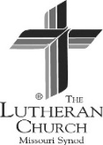    Powered by the Holy Spirit  the work of the Son  adoration of the Father  Immanuel Lutheran Church  110 Main, Sweet Springs, MO 65351  Phone: (660)335-4141  Email ssimmanuellutheran@gmail.com

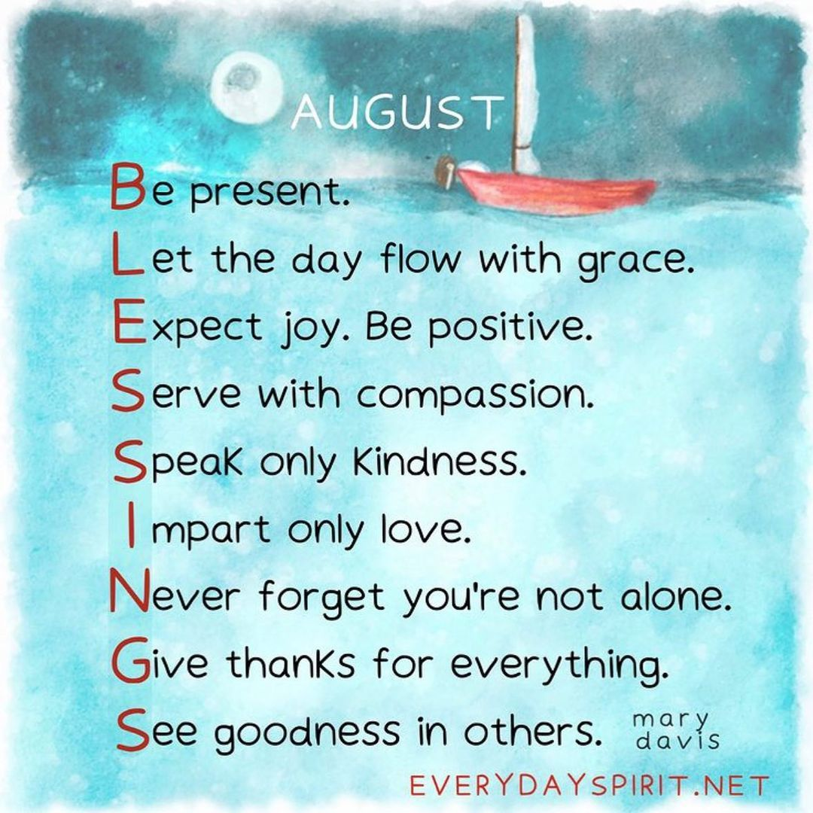

SYNODICAL LEADERSHIP
Rev. Joel Kurz…………………….660-441-5710
Rev. Lee Hagan, Missouri District Office
314-590-6200
Rev. Mathew C Harrison, Pres. of LCMS
314-996-1402
CONTACT INFORMATION
Church Office 660-335-4141

Rev. John Engwall 865-206-1603
Email: johnengwall54@gmail.com
Pete Melies, Head Elder 660-641-0812

Bill Renken, President of Congregation 660-641-4241

Judy Teufel, Church Secretary 660-202-2993
E-mail: jteufel3354141@gmail.com or
ssimmanuellutheran@gmail.com
USHERS
August

Head Usher: Lee Nienhueser

Ushers: Gus Luetjen
Mark Luetjen

Communion Committee
August

August 2 Barb Renken

August 16 Connie Bonar

August 30 Debby Hughson

ALTAR GUILD
August

Janet Brandt
Elders- August

Nelson Guier
Pete Melies
COMMUNION
ASSISTANTS

August
Nelson Guier
Steve Vickrey

September
Chad Ohrenberg
James Nowland
ACOLYTES
August

August 2 Hudson Roscher
August 9 Cayden Gieselman
August 16 Addison Schroeder
August 23 Braelyn Johnson
August 30 Sena Ohrenberg

