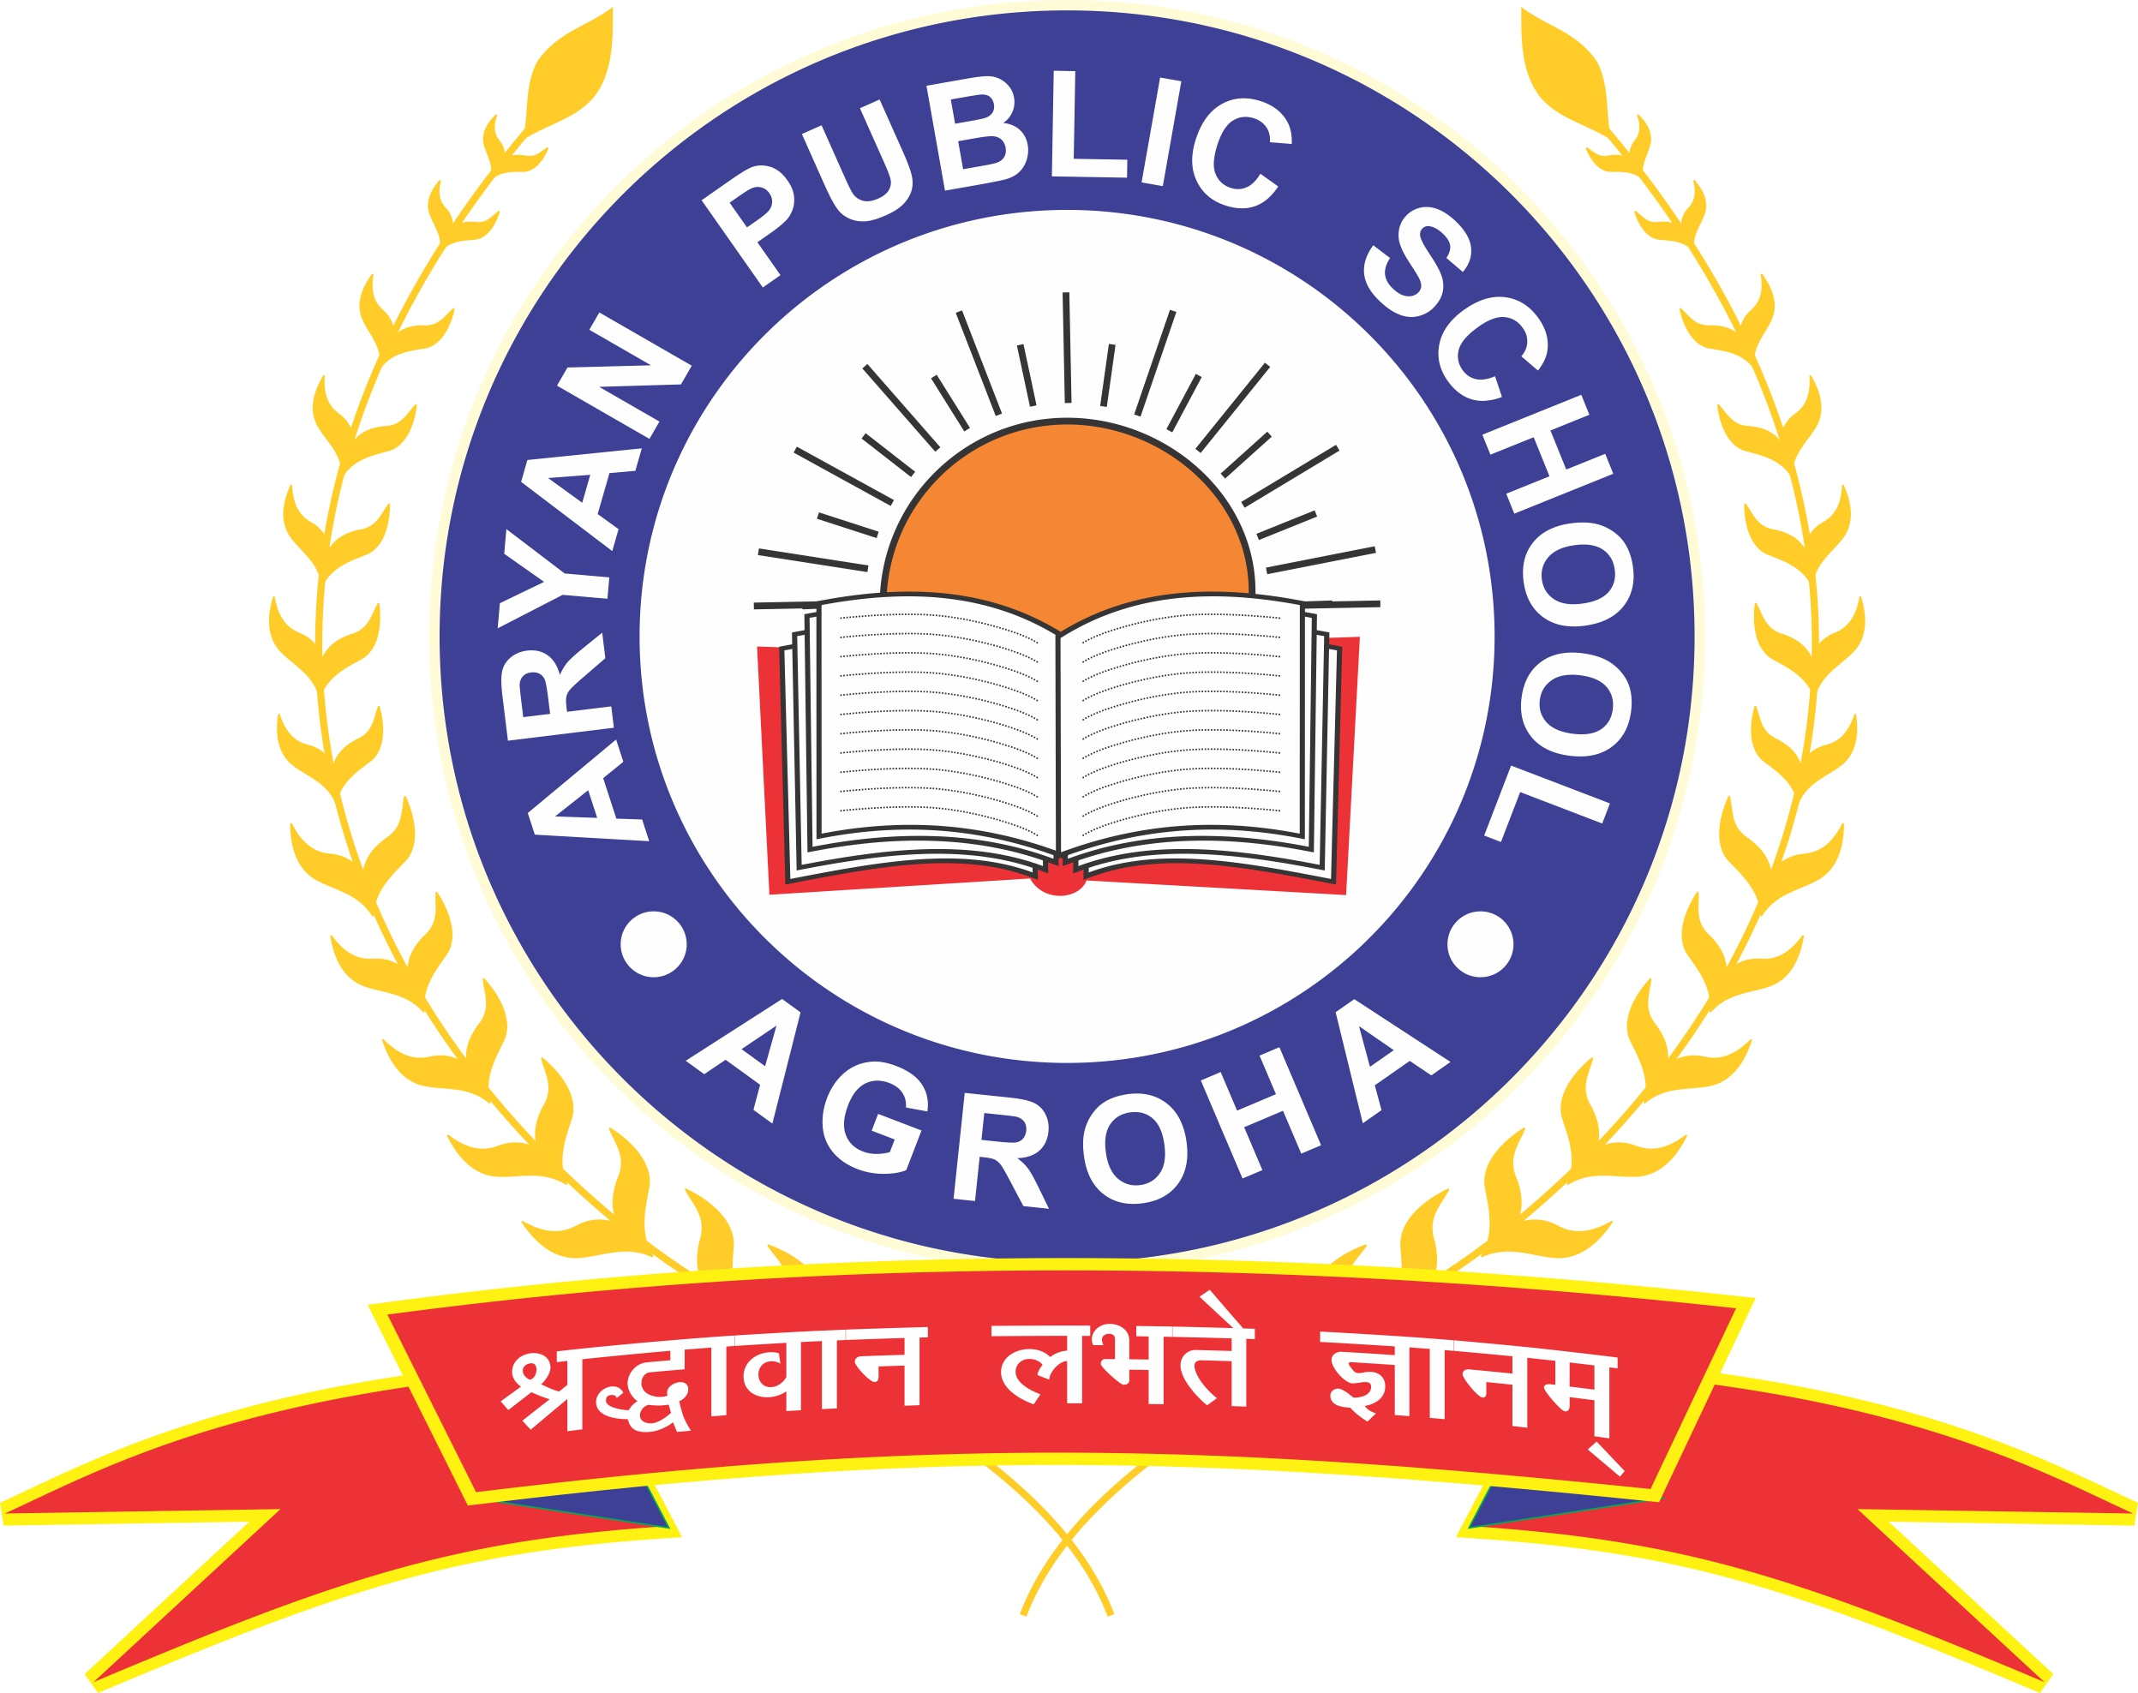
Aryan Public School, Agroha
Syllabus of Class – 3rd (2022-23)
English
April
Reader: - Lesson – 1 (The magic garden), Poem (Good morning)
Grammar: - Lesson – 2 (Nouns) Lesson – 3 (Nouns types)

May
Reader: - Lesson - 2 (Nina and the baby sparrows), Poem (Bird Talk),)
Lesson - 3 (The enormous turnip), Poem (Little by Little)
Grammar: - Lesson – 4(Nouns: countable - uncountable) Lesson -5 (Nouns – singular and plural),
Lesson – 6 (nouns gender) Lesson – 8 ( Adjectives)
Periodic Test (May):
Syllabus: Reader – Lesson – 1 to 2 Grammar – Lesson – 1 to 7.
July:
Lesson - 3 (The enormous turnip), Poem (Little by Little)
Reader: - Lesson - 4 (A little fish story), Poem (Sea song)

Grammar: - Lesson -8 (Adjectives), Lesson - 9 (Degrees of Comparison),
Lesson – 10 (A, An, The) Revision Test – 1
August
Reader: - Lesson - 5 (The Yellow Butterfly), Poem (The Balloon Man)
Grammar: - Lesson - 11 (Pronouns), Lesson – 12 (verbs),
Lesson - 13 (Tenses), Letter Writing.
September Half Yearly Exam (Syllabus covered from April to September)
October
Reader: - Lesson – 6(The Story of the road, Poem (Trains)
Lesson – 7(Little tiger, Big tiger), Poem (Puppy and I)
Grammar: - Lesson – 14 (Simple past), Lesson – 15 (Simple Future),
Letter Writing, revision Test – 2
November
Reader: - Lesson - 8 (What’s in the mail box?), Poem (My silly Sister)
Grammar: - Lesson-16 (Can, cannot, should, should not), Lesson – 17 (Short Forms),
Lesson – 18 (Adverbs)
December
Reader: - Lesson – 9 (He is my Brother), Poem (Don’t tell)
Grammar: - Lesson – 19 (Prepositions), Lesson – 20 (Conjunctions), Lesson – 21 (Interjections) Revision Test – 3
Periodic Test (December):
Syllabus: Reader – Lesson: 7 to 9,
Grammar – Lesson: 14 to 19
January
Reader: - Lesson – 10(The Ship of the Desert), Poem (How Creatures move)
Grammar: - Lesson – 22 (Comprehension), Lesson - 23 (composition),
Lesson – 24 (Words), Lesson – 25 (Listen and Speak)
Letter Writing.
February Revision of Annual Exam Syllabus
March Annual Exam (Syllabus covered from October to March)

हिंदी
अप्रैल:
पाठ्यपुस्तक : पाठ - 1(कक्कू), पाठ – 2 (शेखीबाज मक्खी)
व्याकरण : पाठ – 1 (भाषा), पाठ – 2 (वर्णमाला)
मई:
पाठ्यपुस्तक : पाठ – 3 (चाँद वाली अम्मा), पाठ – 4 (मन करता है)
व्याकरण : पाठ – 3 (मात्राएँ), पाठ – 4 (शब्द और वाक्य)]
पाठ - 5 (संज्ञा)
सामयिक परीक्षा (मई) पाठ्यक्रम : पाठ्यपुस्तक : पाठ - 1 से 3, व्याकरण : पाठ 1 से 3 ।
जुलाई:
पाठ्यपुस्तक : पाठ - 5 (बहादुर बिता)
व्याकरण : पाठ – 6 (लिंग), पाठ – 7 (वचन), अभ्यास प्रश्न पत्र -1।
साम
अगस्त:
पाठ्यपुस्तक : पाठ – 6 (हम सब कहते), पाठ – 7 (टिपटिपवा)
व्याकरण : पाठ – 8 (सर्वनाम), पाठ – 9 (विशेषण), पाठ – 10 (क्रिया)
सितम्बर: अर्द्धवार्षिक परीक्षा ।
अर्द्धवार्षिक परीक्षा पाठ्यक्रम : अप्रैल से सितम्बर तक का सम्पूर्ण पाठ्यक्रम ।
अक्टूबर:
पाठ्यपुस्तक : पाठ – 8 (बंदर बाँट), पाठ – 9 (कब आऊं)
व्याकरण : पाठ – 11 (पर्यायवाची), पाठ – 12 (विलोम शब्द), कहानी लेखन
नवम्बर:
पाठ्यपुस्तक : पाठ – 10 (D;ksathey vkSj dSls dSlsfy;k)
व्याकरण : पाठ – 13 (अनेक शब्दों के लिए एक शब्द), पाठ – 14 (मुहावरे)
दिसम्बर:
पाठ्यपुस्तक : पाठ – 11 (मीरा बहन और बाघ), पाठ – 12 (जब मुझे सांप ने काटा)
व्याकरण : पाठ – 15 (v”kqn~f/k-शोधन), पाठ – 16 (गिनती), अभ्यास प्रश्न पत्र – 2 ।
सामयिक परीक्षा (दिसम्बर) पाठ्यक्रम:- पाठ्यपुस्तक :पाठ – 8 से 10, व्याकरण : पाठ – 11 से 14, कहानी लेखन ।
जनवरी:
पाठ्यपुस्तक : पाठ – 13 (मिर्च का मजा), पाठ – 14 (सबसे अच्छा पेड़)
व्याकरण : पाठ – 17 (पत्र लेखन), पाठ – 18 (अनुच्छेद लेखन),
पाठ – 20 (अपठित xn~;ka”k, ज्ञान परीक्षा)
फरवरी: पाठ्यक्रम की दोहराई ।
मार्च: वार्षिक परीक्षा ।
(अक्टूबर से मार्च तक पाठ्यपुस्तक का पाठ्यक्रम व व्याकरण का अप्रैल से मार्च तक का संपूर्ण पाठ्यक्रम ।)

Mathematics
April Unit –1 Numbers up to 100 Tables 2 to 5.
May Unit – 2 Addition of 2- digit numbers
Unit – 3 Subtraction of 2-digit Numbers
Table 6, 7.
Periodic Test (May: Syllabus: Unit 1, 2 & Tables 2 to 15
July Unit – 4 Numbers up to 1000 Unit – 5 Addition and subtraction of 3-digit Numbers Table 8,9,10
August Unit – 6 Multiplication
Table 11, 12
Revision of Half Yearly Exam Syllabus
September Half Yearly Exam (Syllabus: Syllabus covered from April to September.)
October Unit – 7 Multiplication, Tables: 2 to 12
Unit – 8 Division
November Unit – 9 Patterns
Unit – 10 Money Table: 13
December Unit – 11 Time and Calender
Unit -12 Measurement, Table: 14
Periodic Test (December): Syllabus: Unit 7 to 10 and Tables 2 to 20
January Unit – 13 Data Handling
Table 2 to 15
February Revision of Annual Exam Syllabus
March Annual Exam (Syllabus: Unit 7 to 13 and Tables 2 to 15)

Environmental Studies
April Lesson – 1 In the Family, Lesson – 2 Our Sense Organs
May Lesson – 3 Work People Do,
Periodic Test (May): Syllabus: Lesson 1 to 3

July Lesson – 4 Games are Fun Lesson – 5 Plants our Friend Lesson – 6 Leaves,

August Lesson – 7 The Animal World Lesson – 8 Insect and Worms, Lesson – 9 Birds Around Us , Lesson – 10 Food for Everyone
Revision of Half Yearly Exam
September Half Yearly Exam (Syllabus: Lesson – 1 to 10)
October Lesson – 11 Cooking Food, Lesson – 12 Houses we live in,
Lesson – 13 Animals in our Family
November Lesson – 14 Maps and directions, Lesson – 15 Water for all, Lesson – 16 Storing Water
December Lesson – 17 How we Travel
Periodic Test (December): Syllabus: Lesson – 11 to 14
January Lesson – 18 How we communicate, Lesson – 19 Pottery,
Lesson – 20 Clothes we wear
February Revision of Annual Exam Syllabus
March Annual Exam (Syllabus: Lesson 11 to 20)

Computer
April Lesson – 1 Hardware and Software
May Lesson – 2 Tux Paint
Periodic Test (May): Syllabus: Lesson – 1
July Lesson – 3 Understanding Windows
August Lesson – 4 Introduction to MS Word 2010 and Worksheet – 1 (Lesson: 1-4)
Revision of Half Yearly Exam
September Half Yearly Exam (Syllabus: Syllabus covered from April to September)
October Lesson – 5 Introduction to Scratch Programming
November Lesson – 6 Animation in Scratch
December Lesson – 7 Working with Paint
Periodic Test (December): Syllabus: Lesson – 6 and 7
January Worksheet – 2 (Lesson: 5-7), Project Work and Practical
February Revision of Annual Exam Syllabus
March Annual Exam (Syllabus: Lesson 5 to 7 & Worksheet – 1, 2)

General Knowledge
April Lesson – 1 Medicinal Plants Lesson – 2 Plant quiz
Lesson – 3 Amiable Animals Lesson – 4 Wildlife Wonders
Lesson – 5 Clean Green Environment Lesson – 6 Major Landforms
Lesson – 7 Modern Marine Machines Lesson – 8 Amazing Aircraft
May Lesson – 9 Physical Face of India Lesson – 10 Famous Freedom Fighters
Lesson - 11 Our Prime Ministers Lesson – 12 Festival Quizzes
Lesson – 13 Monuments and Temples Brain Boosters + Puzzling Patterns
Lesson – 14 Famous First Lessons – 15 Powerful Personalities
Periodic Test (May): Syllabus: Lesson – 1 to 15
July Lesson – 16 Fascinating Facts Lesson – 17 Famous Landmarks

August Lesson – 18 Continents and Countries Lesson – 19 Spell Well
Lesson – 20 Indian Folktales Lesson – 21 Proverbs and similes
Lesson – 22 Solar Systems Lesson – 23 States of Matter
Lesson – 24 Healthy Human Bodies Lesson – 25 Sports and field Lesson – 26 Sport Symbols Lesson – 27 Folk Dances of India Lesson – 28 Great Musician Test Paper - 1
September Half Yearly Exam (Syllabus: Syllabus covered from April to September.)
October
Lesson – 29 Parts of Plant Lesson – 30 Animal Crosswords
Lesson – 31 Beaks and Claws Lesson – 32 Important Days
Lesson – 33 Our Religions Lesson – 34 Signs and symbols
November Lesson – 35 States and Union Territories Lesson – 36 Metropolitan City-Kolkata,
Lesson – 37 Famous Female Lesson – 38 Surprising Superlatives
Lesson – 39 Awards and Accolades + Activity-3
December Lesson – 40 Capitals and countries Lesson – 41 Capital Quiz
Lesson – 42 Cool costumes Lesson – 43 Wonders Words
Lesson – 44 Gender/one word/Groups Lesson – 45 Superb Storybooks + Activity – 4
Lesson – 46 Computer Crossword Lesson – 47 Incredible Inventions
Periodic Test (December) : Syllabus: Lesson – 29 to 40
January Lesson – 48 Modern Measurements Lesson - 49 Ace Achievers
Lesson – 50 Celebrated Sports Stars Lesson – 51 Musical Instruments
Lesson – 52 Speaking Logos + Test Paper – 2
February Revision of Annual Exam Syllabus
March Annual Exam (Syllabus: All syllabus covered from Sept. to Feb.)

