**Class 3rd English**

## Dear Parents

Please take note of the following instructions:

* Encourage your child to converse in English.
* Encourage your child to read books.
* You are requested to guide your child only while doing the homework.
* Originality of the work will be appreciated.

1. Write a paragraph on”My best birthday gift” in 80-100 words in the notebook.
2. Identify and name the phrases in the sentences given below.

a) The magistrate was a kind man.

b) Rashi answered rudely.

c) We will meet after the meal.

d) The girl wants to go home.

**E.V.S**

1. Draw and colour the flag of India on an A-4 size Sheet and learn a few lines about it for the class activity.

1. List any five ways to conserve energy during the summer season.
2. Draw the picture given below on a sheet of paper in the scrapbook. Decorate it with waste material. List any 2-3 advantages of using an earthern pot during summers.

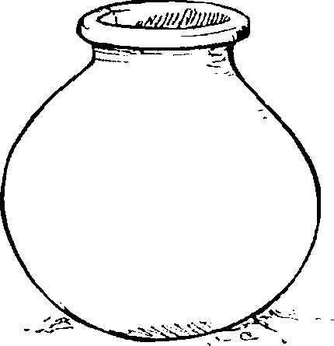

1. Look at the picture below.

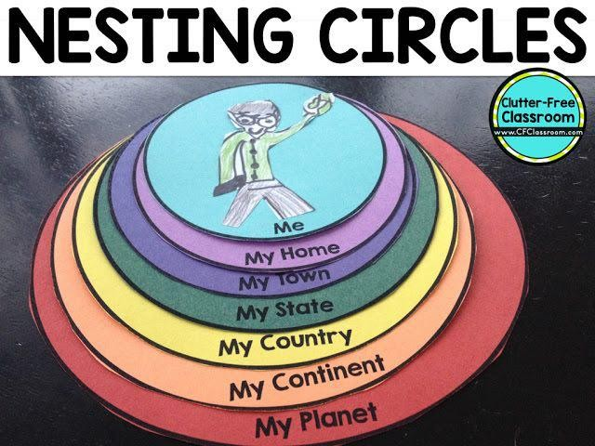 5.Write the information and paste pictures on each of the **nesting circles** according to the topic given.

HINTS:

* 1. My Planet: Paste the picture of Earth and write two facts about its landforms.
  2. My Continent: Name the continent in which India lies.
  3. My Country: Write the number of States and Union Territories.
  4. My State: Paste pictures of any two attractions of your state.
  5. My Home: Paste pictures of any two things used to keep your house clean.
  6. Me: Paste a picture of ‘ What I aspire to become …. ‘.Please refer to the given image.

**MATHEMATICS**

1. Learn tables **2 to 18**.
2. Following are the names of seven places in our country, India

|  |  |  |
| --- | --- | --- |
| **S.NO** | **CAPITAL** | **AREA(SQ. KM)** |
| 1 | Pondicherry | 480 |
| 2 | Chandigarh | 114 |
| 3 | Gangtok | 7096 |
| 4 | Silvassa | 491 |
| 5 | Daman | 112 |
| 6 | Delhi | 1,483 |
| 7 | Panaji | 3,702 |

Arrange them in ascending order of area

Arrange them in descending order of area.

* Draw an Abacus for each area and write its number name.
* Do 20 sums of multiplication and division

**Hindi Grammar**: Read chapter 1& 2 and solve book work