LDC PUBLIC SCHOOL
SYLLABUS (2025-26)
Class-LKG
Month - April
Colour - (Red & Green )
Subject | Circle time | Written + Oral | Teaching Aids | Key words
English | A-Z (a-z) Orals, A-H (With 4 picture of per letter), Rhymes, Action words and children expected to make rows, Reading and Recognization.  Poem: (a) Buubbles.  (b) Jack in the box.  Story: Thirsty crow  Phonics: Letters A-Z  Phonic Sounds | A-H Related exercises,  Introduction to small letter a-h with picture. | Stencils, Blocks, Pictures,  Sand, Flash card, Visual Chart, Paper drilling, Action and enactment, Pluck cards.  Repetition. | Thirsty, Crow, Village, Search, Pot.
Hindi | अ से अ: तक मौखिक ज्ञान, चित्रों तथा अक्षरों को पहचानना |  कविता – बन्दर मामा, सपना  कहानी – प्यासा कौआ | 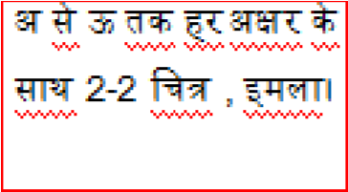 | 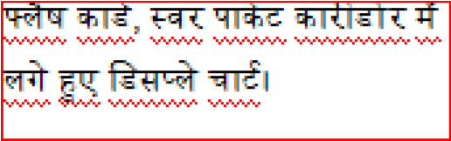 | 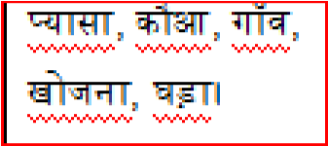
Math | 1-50 Oral picture recognization. Big and Small. Long and short . | 1-10 With related exercise.  Big & Small, Long and Short. | Pencil, Chalk, Sticks, Eraser,  Sharpener, Benches chair,  Flash card, Marbles beads etc. | Big  Small  Long  Short  Number
E.V.S | Self related simple question.  Touch & name every body parts. | Body parts(My Body)  My self | Dustbin, Pencil, Eraser, Chairs bag bottles, Eyes, Nose etc . | Eyes  Nose  Ear  Tongue  Lips
Conversation | Q. What is your name?  Q. What is your father name?  Q. What is your mother name?  Q. How old are you?  Q. How many eyes do you have?  Q. Touch your cheeks.  Q. What is your school name?
Activity | Eng. – Find Alphabet activity.  Maths – Comparison for kids.  E.V.S. – Guess the body parts.  Hindi –
VBL | Earth Day / Nature walk show & tell
Art/SUPW | Collage work related to red colour.
Music | 
Game | In - Out
Out Door  Activity | Plantation

Month May
Colour-( Blue & Yellow)
Subject | Circle time | Written + Oral | Teaching Aids | Key words
English | A-Z (a-z) Orals with picture, A-P (with 4 pictures of per letter), Reading and Recognization .  Poem: (a) BaaBaa black Sheep  (b) My dog Dandy  Story: Fox & Crow  Phonics: Beginning Letter Sounds .  Ending Letter Sounds . | A-P introduction to  small letter  (A-H), (I-P)  (a-p) Related exercise (a-h), (i-p) . | Repetition with correct pronunciation and flash card and Face mask. | Sound, Fox  Hungry, Forest, Tree.
Hindi | अ से अ: तक मौखिक ज्ञान, चित्रों तथा अक्षरों को पहचानना |  कविता – धूर्त बगुला, फूल  कहानी – लोमड़ी और कौआ | 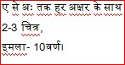 | 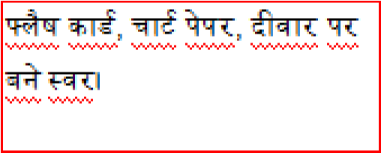 | 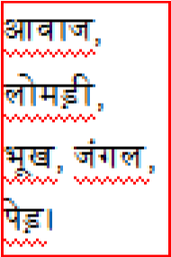
Math | 1-50 Oral, Children expected to make a row or stand according their number up and down, circle activity. | 1-10 Revision, 1-50  with related exercise, measurement  Heavy/Light, Tall/Short, Inside/Outside . | Pebbles counting outside in School surrounding, Name card counting things inside and outside the classroom . | Tall, Short,  Long,  Heavy,  Light  Inside,  Outside
E.V.S | Touch every sense organs. Recognization of sense organs . | Sense organs, My family , Things in the class room. | Flash card of family members and chart paper of sense organs. | Mother,  Father,  Brother,  Sister,  Grand  Father
Conversation | Q. What do you do with your ears?  Q. What do you do with your eyes?  Q. Name five sense organs?  Q. How many senses do you have?  Q. How many members are there in your family?
Activity | Eng. – Make an Alphabet spinning wheel.  Maths – Counting chart activity. E.V.S – Sense organs activity.  Hindi –
VBL | Mother’s day card/ Yoga Day
Art/SUPW | Papaya colour
Music | Prayer – Dear God
Game | Frog Race .
Outdoor  Activity | Is my plant healthy and growing? How many leaves does it have?

Month July
Colour-(Red, Green, Yellow)
Subject | Circle time | Written + Oral | Teaching Aids | Key words
English | A-Z (a-z) Orals with 4 picture of each letter, jumble alphabet set in correct sequence. Pick up correct alphabet reading and recognization.  Poem: (a) Chubby Cheeks  (b) Hush-a-Bye-Baby  Story: The Crane and the fox  Phonics:(a) Vowels and Consonants | Q-Z, A-Z  Introduction to small  letter (q-z) (a-z). | Flash card, Pluck cards, Repetition Role play, Enactment . | Clever,  Animal,  Crane, Fool,  Thanks
Hindi | अ से ज्ञ तक अक्षर ज्ञान करना |  कविता – पक्षी, सीखो  कहानी – सारस और लोमड़ी | 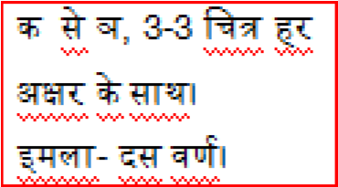 | 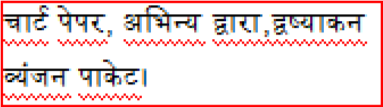 | 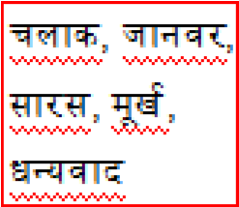
Math | 1-50, 51-100 Counting, Backward , Counting, object related to shapes. | 1-50 Revision 51-100 Counting backward counting 10-1, Shapes. | Ask to bring various dal and cereals outside activity, role play, duster, ball, table, cut and paste in drawing copy in various shapes . | Shapes  circle Triangle square rectangle
E.V.S | Fruits, Vegetables, Flowers picture Recognization, sharing exchanging . | Fruits, Vegetables, Flowers , Things in the Bathroom. | Original fruits, vegetables, flower colour pocket . | Apple,  Mango,  Banana,  Potato,  Tomato,  Rose,  Sunflower,  Lotus, Soap,  Shampoo, Mirror.
Conversation | Q. Name five fruits.  Q. Name five vegetables.  Q. Name five flowers.  Q. Tell the color of Apple, Potato, Rose.  Q. Tell the vegetables names which we eat raw.
Activity | Eng. - Making letter in the sand.  Maths - Matching Tiles (Shapes).  EVS:- Fruit and vegetables salad activity, cut and paste picture.  Hindi -
VBL | Rainy season party with crops/ Making Boat /Making Umbrella
Art/SUPW | Draw and colour Fruits .
Music | Prayer – Dear God
Yoga | सूर्य नमस्कार Step - 1
Game | Race
Indoor Activity | Blind folded

Month - August
Colour-(White & Orange)
Subject | Circle time | Written + Oral | Teaching Aids | Key words
English | A-Z (a-z) Orals children expected to make alphabet tree .  Poem: a)Little Bird  (b) Drink Milk  (c ) Jack & Jill  Story: Hare and Tortoise  Phonics: Two letter sight words | Revision of A-Z, Revision of a-z and related exercises and dictation | Repetition with correct  Intonation 4 pronunciation | Hare,  Tortoise, Slow, Story,  Hard work.
Hindi | अ से ज्ञ तक अक्षर ज्ञान करवाना |  कविता- तोता, गुब्बारे, सेब  कहानी – कछुआ और खरगोश | 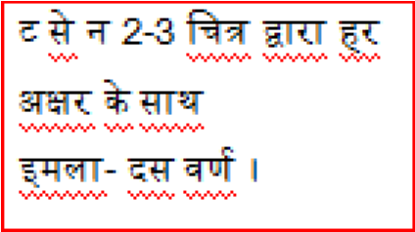 | 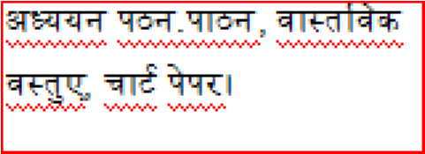 | 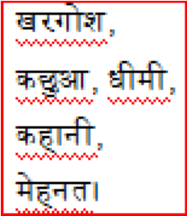
Math | Pairing/Matching children to form row . | Counting (1-100) After, Before and Between . | Flash card | After  Before  Between  Backward  Counting
E.V.S | Sounds of Animals ( Lion, Horse, Cat) Reorganization of different type of birds. | Animals ( Wild, Pet,  Domestic, water  Animals, Animals Homes). Birds and Insects. | Flash Card, Pluck Card of wild animals, Pet animals and birds. | Lion, Tiger,  Cat, Dog,  Hen , Ant,  Cow, Goat,  Sparrow,  Crow,  Peacock,  Elephant,  Horse,  Monkey
Conversation | Q. Name 5 wild animals.  Q. Name 5 pet animals.  Q. Name 5 domestic animals.  Q. Name 5 birds.  Q. Where does a lion live?
Activity | Eng. – Recognization P – Z with picture alphabet. Maths –Backward counting, 10 – 1 Activity.  Hindi –   EVS – Cut and paste 5 animals (Domestic)
VBL | Table Manners, Making Sandwich
Art/SUPW | Making Flag, Rakhi Activity.
Music | 
Yoga | Rainbow pose
Game | Team work race
Outdoor  Activity | Paper flag from students.

September
Colour-(Pink & Purple)
Subject | Circle time | Written + Oral | Teaching Aids | Key words
English | Revision of all above syllabus, Introduction of phonic sound with picture . Poem: (a) Tea pot  (b) I love little Pussy  (c) Hickety, Pickety  Story: revision  Phonics: Short ‘a’ Fmily  Short ‘e’ Family | Revision of all above syllabus and  Introduction of vowels a, e, i, o, u. | Chart paper, Sound recognization Repetition, Finger puppets. | Revision
Hindi | अ से ज्ञ तक अक्षर ज्ञान, चित्र की सहायता से पहचानना |  कविता – केला, पतंग, बस्ता  कहानी – दोहराना | 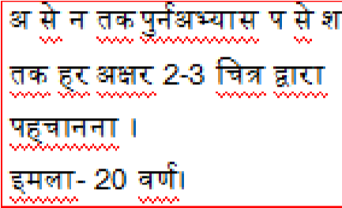 | 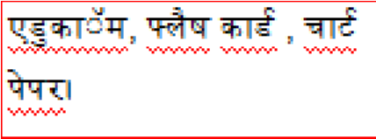 | 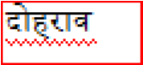
Math | Pairing/Matching oral 1-100. | Number name 1-5, 1-one, 2-Two, 3-Three, 4-Four, 5-Five . | Digital cut and paste  1-One  2-Two | One, Two  Three, Four  Five
E.V.S | Discuss about food, children will know about healthy and unhealthy food. Value of food. | Healthy food, Junk food Festivals, Birthday Party. | Flash Card, Food chart, wall of healthy and unhealthy food. | Holi, Diwali, E-id Healthy Food, Junk Food.
Conversation | Q. Who cook food in your house?  Q. What kind of food should we eat?  Q. In which festival we play with colours?  Q. In which festival we decorate our house with light?  Q. In which festival ladies make sewai?
Activity | Eng. - Fill alphabet pockets.  Maths - Number name, Jumble word activity.  E.V.S - Fun food activity.  Hindi -
VBL | Teachers Day/ Jungle Day
Art/SUPW | Making Flute and Pot, Teacher’s Day card
Music | Teacher’s day song 
Yoga | Tree pose
Game | Action word
Indoor Activity | Sound activity (Animals/Birds) .

October
Colour - (Orange, White, Pink, Purple)
Subject | Circle time | Written + Oral | Teaching Aids | Key words
English | Phonic sound a,e,i related pictures and puzzles .  Poem: (a) Bits of paper,  (b) Flower  (c) I am special  Story: Monkey and Crocodile  Phonics: Short ‘i’ Family  Short ‘o’ Family | Vowels related two letter words of a,e,i, an ed, ig, pan, bed, big van . | Different sound pluck cards and visuals chart word wall in the classroom story with the help of display chart. | Monkey,  Crocodile, Pond, Blackberry, Invitation.
Hindi | अ-ज्ञ तक पुनरावृत्ति, स-ज्ञ तक चित्र की सहायता से पहचानना, अक्षर वृक्ष बनाना  कविता – मेरा कुत्ता, दिवाली आई, मेरी बिल्ली  कहानी – बन्दर और मगरमच्छ | 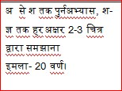 | 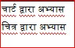 | 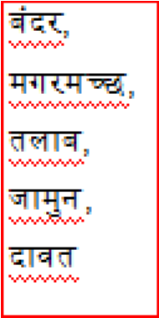
Math | Pairing arrange in sequence.  - One, Two buckle my shoe.  - One, Two, Three, Four, Five, I saw a fish alive. | Number name 1-5  revision  Number name 6-10 with related exercise (Clock  Activity). | Flash card, Stencils | Six  Seven  Eight  Nine  Ten
E.V.S | Means of transport, Introduction of four helper, how they help us. Family dress of helpers . | Our helpers, Our transports, games | Picture of helper, pluck cards picture of tools, outside the class room.  Show the garden, teacher, transport around us. | Peon, gardener,  Bus, Train, Ludo, Cricket, Carrom board, Chess, Basket ball,  Volleyball.
Conversation | Q. Who drive the bus?  Q. Who mend your shoes?  Q. Who cut your hair?  Q. Name five indoor games  Q. Name five outdoor games.
Activity | Eng. – Phonics joining sound making words activity.  Maths -Flash card activity (Numbers name).  E.V.S –Introduction of helper by display chart in corridor.  Hindi -
VBL | Victory of Good over Evil (Ramayana)
Art/SUPW | Arrow and Bow (Dushera Activity)
Music | 
Yoga | Star pose
Game | Balancing Race
Outdoor  Activity | Show and explain Flex Fruits, Vegetables and flowers (Describe Plants) Or Show and explain Season Flex.

November
Colour - (Brown)
Subject | Circle time | Written + Oral | Teaching Aids | Key words
English | Revision of all above and phonic sound a,u, related two letter words with pictures recognition.  Poem:(a) Two keys  (b) Taddy Bear - Taddy Bear  (c) I Hear Thunder  Story: Greedy dog  Phonics: Short ‘u’ Family Recap | Revision of a,e,i,o,u related two letter words og, un, fog, sun, log, bun. | Word wall, chart paper, Flash card. | Greedy, Bread,  Enjoy,  Reflection, Run.
Hindi | अ से ज्ञ तक पुनरावृत्तिश, दो वर्णों वाले शब्दों का ज्ञान एक-एक शब्द को पहचान कर एवं मिलकर और सुनकर उनको बोलना |  कविता – मीठे आम, आलू कचालू, कोयल  कहानी – लालची कुत्ता | 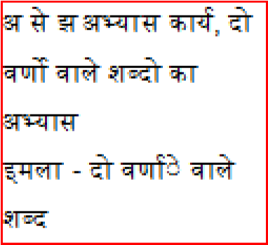 | 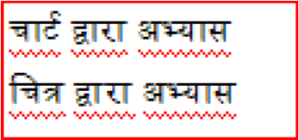 | 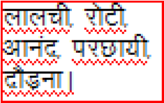
Maths | Form row, group critical or thinking skill. | Backward counting 1-  20, Addition  Horizontally & vertical (Single Digit). | Flash card, Chart Paper. | Circle, triangle, oval, square and rectangle.
E.V.S | Different Season and their clothes | Seasons (what’s the weather) clothes, places near me . | Umbrella, Weather, gumboots, season related clothes boxes. | Summer,  winter, frock, Temple, shops.
Conversation | Q. In which season we eat ice-cream?  Q. In which season we use umbrella?  Q. How do you feel in summer?  Q. Name five places near your house.  Q. What do we wear in summer?
Activity | Eng. - Puzzles activity with flash card.  Maths – single digit addition activity. E.V.S –cut and paste woolen activity. Hindi - Reading card activity.
VBL | Puppet Show, Children’s day celebration
Art/SUPW | Diwali Activity (Making Diya)
Music | 
Yoga | Butter fly
Game | Catch the throw
Outdoor  Activity | Class Picknic

December
Colour - (Silver, Goldern)
Subject | Circle time | Written | Teaching Aids
English | Revision | Revision
Hindi | 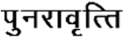 | 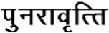
Math | Revision | Revision
E.V.S | Show classroom related things like chalk, duster  . | My class room, In the bed room, In the living room, In the Kitchen. | Flash card, Pluck card of classroom, spelling, books, etc.
VBL | Winter Season Celebration, Colour recognition
Art Integration | Colour the bell

Month – January
Colour - (Magenta, Violet)
Subject |  | Circle time | Written | Teaching Aids
English | Revision |  | Revision
Hindi | 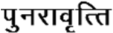 |  | 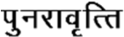
Math | Revision |  | Revision
E.V.S | Revision |  | Revision
Activity

Month – February
Subject |  | Circle time | Written | Teaching Aids
English | Revision |  | Revision
Hindi | 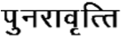 |  | 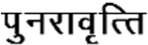
Math | Revision |  | Revision
E.V.S | Revision |  | Revision

