Class 5th Syllabus – 2026 -27 Subject – Art
TERMS | MONTH | ART | TECHNIQUE | CRAFT
TERM 1 | April to September | Nature Drawing [SCENERY]  Still life drawing | Water colour, sketch pen  Pencil colour, pencil shading | Post Making Competition  Rakhi making from waste material
TERM 2 | October to February | Story drawing on Dussehra [Madhubani art] | Pencil, crayon, water colour, brush pen | Diya making

Class 5th Syllabus 2026-27 Subject’s – Computer

Month | Chapter name | D.O.B | D.O.E | Activity
April | Ch-1 Evolution of computers Ch-2 File management in windows | 06/04/2026 | 25/06/2026 | Word Wizard – Learn term like - file, folder, save , delete, restore
May | Ch- 3 Table and mail merge :MS word | 02/0 5/2026 | 15/05/2026 | Create Student data table and invitation letter using mail merge
July | Ch-4 More on PowerPoint 2019 Ch-5 Animation in PowerPoint | 01/07/2026 | 25/07/2026 | Make 5 –slide presentation on my school “
August | Ch-6 Operator Blocks in scratch | 01/08/2026 | 20/08/2026 | Create simple math or quiz Project using operators.
September | Ch-7 Your creativity with canva | 01/09/2026 | 22/09/2026 | Create a Marks Sheet in Excel
October | Ch-8 Designing with canva | 01/10/2026 | 20/10/2026 | Draw a simple Bar chart From Given data
November | Ch-9 Internet services and Email Ch-10 Robotics Trends in AI | 02/11/2026 | 20/11/2026 | Images Based Story Telling on Robots helping Humans Identify Devices Used in daily Life
December | Revision
January | Revision
February | Revision
March | Revision

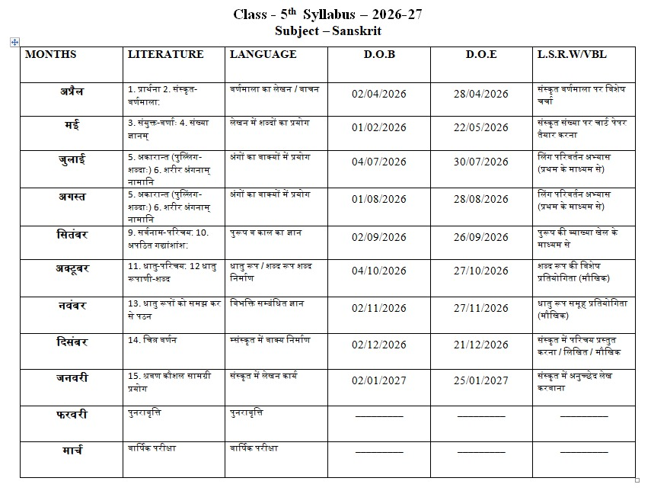

Class 5th Syllabus 2026-27 MORAL VALUES

 | Month | Chapter Name | D.O.B | D.O.E
 | Arp | Keep Clean and Be Healthy | 02/04/2026 | 20/04/2026
 | ay | Devotion | 04/05/2026 | 20/05/2026
 | Jul | Keeping Promise | 04/07/2026 | 22/04/2026
 | Aug | Determination | 02/08/2026 | 25/08/2026
 | Sep | Helpfulness | 04/09/2026 | 25/09/2026
 | Oct | Loyalty | 03/10/2026 | 22/10/2026
 | Nov | Teamwork | 04/11/2026 | 05/11/2026
 | Dec | Be Independent | 04/12/2026 | 04/12/2026

Class 5th Syllabus 2026-27
Subject’s – EVS

Month | Syllabus | D.O.B | D.O.E | VBL activity
April | Ch-1 Reproduction in plants  Ch-2 plants and animal products | 02/04/2026 | 20/04/2026 | Nature walk and seed plantation Activity – Students plants and plant seeds
May | Ch-3 animal senses Ch-4 The Adivasis | 02/05/2026 | 15/05/2026 | Achievement Activity –Endangered animals awareness Chart / Presentation
July | Ch-6 houses we live in  Ch-7 Different clothes in different Regions  Ch- 13 communication: connecting the world | 01/07/2026 | 25/07/2026 | Innovation & Model Making – different types of houses
August | Ch-5 food and health Ch- 9 Safety Rules | 01/08/2026 | 25/08/2026 | Recipe Writing Activity – healthy recipe nutrition explain its nutrition
September | Ch- 12 medical science  Ch- 8 Water and its Sources | 01/09/2026 | 25/09/2026 | Value of Conservation Activity – Poster making on saving water
October | Ch-14 transportation Ch-15 pride of India Ch-16 our heritage | 01/10/2026 | 25/10/2026 | Impact of Pollution and its Resolution – Article or story writing about pollution and solution
November | Ch-17 Celebration of Special Days Ch-18 locating places on maps and globes  Ch-19 Natural Disaster | 02/112026 | 25/11/2026 | Picture Based Observation map Activity – Identify Places on map or globe
December | Ch-10 first aid (Helping Hand) Ch11diseases and their prevention | 01/12/2026 | 22/12/2026 | Practical demonstration and Revision – first-aid demonstration and healthy awareness .
January | Revision
February | Revision
March | Revision

Class 5th English Syllabus 2026-27

 |  | Literature | Language | Phonics | D.O.B | D.OE. | LSRW/SE
 |  | Fly Safe, Godavan!  A Miracle to Behold (Poem) | The Sentence,SubjectandPredi cate, Parts of Speech, Nouns(Number, Gender, Possession) Application | en,an,ap,at,et,ig,in,ip,it,op,ot  ,ug  Consonant Blends with L Consonant Blends with R | 02/04/2026 | 24/04/2026 | Story Telling (fly Safe Godavan )  Speaking skill, creativity.
 |  |  |  | Consonant Blends with W
 |  |  |  | Consonant Blends with C Consonant Blends with K
 | May | The Story of the Third Tree (Play) | Pronouns,Article,Verbs,Adjective Letter | Consonant Blends with C Consonant Blends with K | 01/05/2026 | 25/04/2026 | Paragraph writing (A lesson for Nakul)  Writings kill & communication skill.
 |  | A Lesson for Nakul
 | Jul | Don’t Quit (Poem)  Jhalkari Bai (Graphic Story) | TheTensesandtheir uses. Paragraph Writing |  | 03/07/2026 | 25/07/2026 | make a file on  Jhalkari Bai.  Experiential earning
 |  |  |  | Words With a Vowel before |  |  | &teamwork.
 |  | Ready? Yes! Play!  The Power of Teamwork (Poem) | Transformation of sentences, | R | 02/08/2026 | 26/08/2026 | Role Play on my favourite character cricket Player Listening, writing, speaking and thinking.
 | Aug | Ready? Yes! Play!  The Power of Teamwork (Poem) | Modals, degrees of adjective.
 |  | Ready? Yes! Play!  The Power of Teamwork (Poem) | Letter writing Eassy Picture
 |  | Ready? Yes! Play!  The Power of Teamwork (Poem) | Comprehension
 | Sep | Dhyan Singh ‘Chand’: Hockey’s Magician  How Old is Muttaji? | Comparison of Adverbs, Prepositions,Conjunctions | Words With C K Words With K | 02/09/2026 | 26/09/2026 | Poem writing on Dhyan Chand  Observation skill and  writing skill.
 |  | Dhyan Singh ‘Chand’: Hockey’s Magician  How Old is Muttaji? |  | Words With V
 |  | Dhyan Singh ‘Chand’: Hockey’s Magician  How Old is Muttaji? |  | Words With S S
 | Oct | Bharat, Our Land (Poem) Exploring Ladakh | Figure of speech, Synonyms and Antonyms, Comprehension | Words That in F F and L L | 04/10/2026 | 27/10/2026 | Speech on Bharat our land Research, creative & communicate on skill.

 | Nov | Lakhan’s Story  The Secret of the Machines (Poem)  13) | Writing a Letter, ParagraphWriting,  Essay Writing, Writing a Story | Words That in F F and W O | 02/11/2026 | 27/11/2026 | Puppet show on machine Speaking & writing Skills
 |  | Lakhan’s Story  The Secret of the Machines (Poem)  13) | PictureComprehension
 | Dec | The Exciting World of Virtual Reality | Revision |  | 02/12/2026 | 28/12/2026 | Movie Screening on (AI) Thinking or
 |  |  |  | Words with the Prefixes |  |  | ganising skill, Writing
 |  |  |  | U N, MIS, NON, and DIS |  |  | skill.

Class 5th Subject – G. K
Syllabus - 2026-27

Terms | Month | Chapters Name | D.O.B | D.O.E | Current Affairs
1st Term (Sep) | April | - Our National Flag  - Wonder Kids  - Toys of Tomorrow | 02/04/2026 | 20/04/2026 | Current Affairs news on General news.
1st Term (Sep) | May | - Greetings from the World  - Lessons from Animated Movies  - Be Like a Bee. | 02/05/2026 | 22/04/2026 | Current Affairs news on Education news.
1st Term (Sep) | July | - Eco-Friendly Destinations  - Home Remedies  - Amitabh Bachchan – A Legend | 04/07/202 | 25/07/2026 | Current Affairs news on Bollywood news and write the society impact of it.
1st Term (Sep) | Augus t | - Indoor Plants  - Joyrides Around the World  - Defeating Dengue | 02/08/2026 | 22/08/2026 | Current Affairs news on Sports news.
1st Term (Sep) | Septe mber | - Cross Road  - World of Robots  - Exotic Fruits | 04/09/2026 | 25/09/2026 | Current Affairs news on Health news.
2nd Term (Feb) | Octob er | - Schools Around the World  - Statues in India  - The 5 R’s | 04/10/2026 | 22/10/2026 | Current Affairs news on Weather Environment news.
2nd Term (Feb) | Nove mber | - Unique Sports  - Tech Inventions  - Shaping the Code | 05/11/2026 | 26/11/2026 | Current Affairs news on International.
2nd Term (Feb) | Decem ber | - Friends from Poles  - Yoga  - Being a Good Citizen | 04/12/2026 | 25/12/2026 | Current Affairs news on Business news.

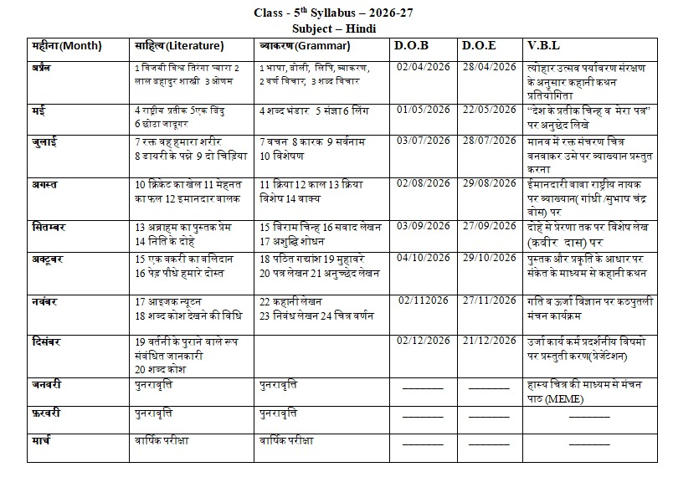
Class 5th Syllabus - 2026-27 Subject – Mathematic

Month | Chapter Name | D.O.B. | D.O.E. | Application of Learning / SE
April | Ch-1: Large Numbers | 02/04/2026 | 15/04/2026 | Place Value – Form 5-digit numbers
 | Ch-2: Addition and Subtraction | 16/04/2026 | 30/04/2026 | using number cards.
May | Ch-3: Multiplication and Division | 01/05/2026 | 15/05/2026 | Show multiplication and division using
 | Ch-4: Factors and Multiples |  |  | objects.
 |  | 16/05/2026 | 31/05/2026
July | Ch-6: Decimals | 01/07/2026 | 15/07/2026 | Make a model of a clock.
 | Ch-9: Time and Temperature | 16/07/2026 | 31/07/2026
August | Ch-5: Fraction | 1/08/2026 | 15/08/2026 | Fun with fractions – Make a paper pizza
 | Ch-7: Applications of Four | 16/08/2026 | 31/08/2026 | divided into equal parts.
 | Operations
September | Ch-10: Geometry | 07/09/2026 | 15/09/2026 | Shapes Exploration.
 | Ch-12: Shapes, Nets, and Symmetry | 16/09/2026 | 30/09/2026
October | Ch-11: Perimeter, Area and Volume Ch-12: Measurement | 01/10/2026  16/10/2026 | 15/10/2026  31/10/2026 | Hands-on measurement – Measure classroom objects using rulers or measuring tape.
November | Ch-13: Data Handling | 02/11/2026 | 15/11/2026 | Classroom data survey activity.
 | Ch-14: Mapping Skills | 16/11/2026 | 30/11/2026
December to February | Revision |  |  | Revision

LDC Public School Syllabus2026-27
Class – 5
Subject - Music

 |  | Oral | Theory | Instrument
 | April | Dairy songs SaraswatiVand ana National Song National Anthem Bhajan | Swar,Typesof Swar | Harmonium & keyboard  & Table
 | May |  | Swar,Typesof Swar | Harmonium & keyboard  & Table
 | June |  | Swar,Typesof Swar | Harmonium & keyboard  & Table
 | July |  | Swar,Typesof Swar | Harmonium & keyboard  & Table
 | August |  | Swar,Typesof Swar | Harmonium & keyboard  & Table
 | September |  | Swar,Typesof Swar | Harmonium & keyboard  & Table
 | October |  | Swar,Typesof Swar | Harmonium & keyboard  & Table
 | November |  | Swar,Typesof Swar | Harmonium & keyboard  & Table
 | December |  | Swar,Typesof Swar | Harmonium & keyboard  & Table
 | January |  | Swar,Typesof Swar | Harmonium & keyboard  & Table
 | February |  | Swar,Typesof Swar | Harmonium & keyboard  & Table
 | March |  | Swar,Typesof Swar | Harmonium & keyboard  & Table

Class 5th
Subject –Physical and Health Education
Syllabus - 2026-27

Terms | Month | Outdoor/Indoor | Yoga/P.T. | Competition
 |  | Kho-Kho Practice, | Anulo | Taekwondo / Boxing
 | Apr il to Ma y | Carrom Practice, Taekwondo & Boxing curriculum games | m-  Vilom, Ex P.T.  - 1 & 2,  Padmas | Drill, Kho-Kho  Competition
 |  |  | ana, Ex
st |  |  | P.T. - 3
1 Term |  |  | & 4
 |  | Fun games, Running 30m, 40m, 50m,  70m | Vajrasana, Ex P.T. - 5 | Carrom competitions,
 | July to | Fun games, Running 30m, 40m, 50m,  70m | & 6, Brahmari, Ex  P.T. - 7 & 8 | Mini Race / Yoga  Competition
 | Aug | Fun games, Running 30m, 40m, 50m,  70m
 | Sep | Kabaddi, Athletics, Traditional Games | Surya namaskar, Ex  P.T. - 1, 2 & 8 | Hungama Competitions
2nd  Term | Oct to Nov | Extra Curriculum Games, Football Passing side & front | Tadasana, Ex P.T. 9 & 10, Vrikshasana,  Ex P.T. 11 & 12 | P.T. Drill, Preparation | Sports | Day
2nd  Term | Dec to Jan | Dodge the ball, Basic knowledge of Yogic exercises | Ardhachandrasana, Ex P.T. 13 & 14,  Trikonasana, Ex P.T. 15 & 16 | Kite flying, Yoga Drill

Class 5th
Subject – Reasoning and Aptitude Syllabus - 2026-27

 |  | Months | Chapter Name | D.O.B | D.O.E
T) e  r Se  m (  p  st  1 | 1P.  A. | Apr | Analogy | 02/04/2026 | 25/04/2026
T) e  r Se  m (  p  st  1 | 1P.  A. | May | Classification (Odd one Out) | 02/05/2026 | 15/05/2026
T) e  r Se  m (  p  st  1 | 1P.  A. | Jul | Series (What come nest...) | 01/07/2026 | 25/07/2026
T) e  r Se  m (  p  st  1 |  | Aug | Coding – Decoding | 01/08/2026 | 20/08/2026
T) e  r Se  m (  p  st  1 |  | Sep | Direction Sense Test | 01/09/2026 | 25/09/2026
 |  | Oct | Mirror Image | 01/10/2026 | 20/10/2026
)  Fe b ( Te | P2 .  A. | Nov | Water Image Alphabet Test | 02/11/2026 | 25/11/2026
rm
nd |  | Dec | Revision
2
2 |  | Jan | Revision
 |  | Feb | Revision

