
9 TO 1 SCHOLAR’S HEAVEN SCHOOL
SIKANDERPUR
Think Room : 5 Subject. EVS

Week first
Chapter :-1 (Internal Organs and their Functions)
Write Q/Ans and new words on note book
Activity for the students:-
Make a “My Body Book” with one page for each organ systems and paste pictures or drawing on scrapbook
Write five habits for keeping the system healthy.

Week 2nd
Chapter :-2 (Need and Want)
Write new words and Q/Ans on note book
Activity for students:-
Home survey Activity
Students ask family members what are the most important need at home?
What are some wants?
Students make a simple list and share in group

Week 3rd
Chapter ;3(Cultivation)
Write new words and Q/Ans on note book
Activity for the students
Seed Germination Activity:- Students to plant seeds , beans , wheat, in small pots. They can record Date of planting
Height of plant
No of leaves

Week 4th (Paste on Scrapbook)
Chapter :-4 (Deficiency Diseases)
1st day
Read page no 25,26
A balanced diet chart and Vitamin A, Vitamin B paste on scrapbook and write some lines .
2nd day
Read page no 27,28
Paste the picture of Sources of Vitamin C,D,E,K write some lines about these vitamin
3rd Day
Read page no 29,30
Paste the picture
Source of calcium, Iron, Iodine, Sodium write some lines about these nutrients

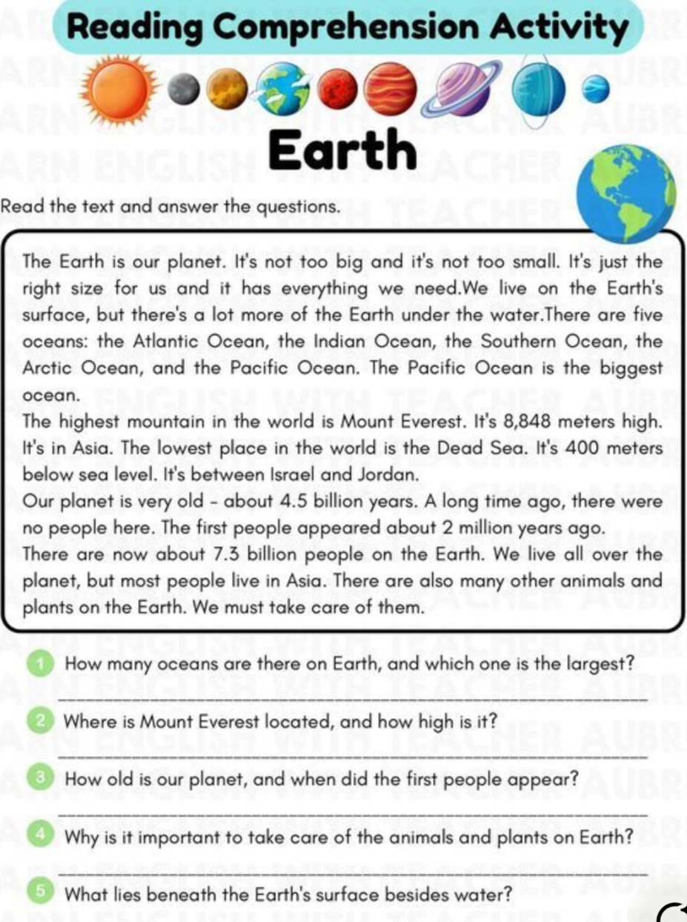
9 TO 1 SCHOLAR’S HEAVEN SCHOOL
SIKANDERPUR
Think Room : 5 Subject. Hindi

पहला सप्ताह
पाठ 1 के शब्दार्थ श्रुतलेख प्रश्न उत्तर अभ्यास पुस्तिका में लिखें । एक अपठित गद्यांश लिखें।
गतिविधि पहले सप्ताह की
शब्दमाला बनाएं :- बच्चे अपने नाम के पहले अक्षर से शब्द शुरू करें और 30 नए शब्द बनाएं।

दूसरा सप्ताह
पाठ 2 के श्रुतलेख शब्दार्थ और प्रश्न उत्तर लिखे एक अपठित गद्यांश भी लिखें।
चित्र देखकर कहानी लिखो
किसी सुंदर चित्र को देखकर 8–10 पंक्तियों की कहानी लिखिए।
पेड़ बचाओ व स्वच्छ पर्यावरण पर एक पोस्टर बनाएं।
दूसरे सप्ताह की गतिविधि
किसी गौशाला अथवा दुग्ध उत्पादन डेरी फार्म का भ्रमण कर पता कीजिए कि पशुओं का लालन पालन कैसे किया जाता है आप इस गतिविधि का वीडियो बनाकर भेजें।

तीसरा सप्ताह। पाठ 3 के श्रुतलेख शब्दार्थ प्रश्न उत्तर लिखे एक अपठित गद्यांश भी लिखें।
तीसरे हफ्ते की गतिविधि
बच्चे अपने घर के सदस्यों को न्याय की कुर्सी का पाठ रोलप्ले सहित पढ़ाते हुए वीडियो भेजें ।

चौथा सप्ताह
हिंदी व्याकरण
निबंध लेखन स्वयं लिखें । मेरा प्रिय दर्शनीय स्थल
या
मेले का भ्रमण
बच्चे अखबार की कटिंग में से संज्ञा, सर्वनाम चुने व अपनी पुस्तिका पर लिखें।
और
बच्चे अखबार की कटिंग पुस्तिका पर चिपकाए और सभी मात्राओं के शब्द चुनकर पुस्तिका पर लिखें।
और
बच्चे अपने परिवार के बारे में 10 वाक्य लिखकर उसमें से विशेषण शब्द लिखिए।
विशेष कार्य :- रोज एक पेज सुलेख का लिखें ।

9 TO 1 SCHOLAR’S HEAVEN SCHOOL
SIKANDERPUR
Think Room : 5 Subject. Punjabi

(Week – 1) ਪਾਠ -1 full revision. *ਆਪਣੇ ਇਲਾਕੇ ਦੀ ਕੋਈ ਵੀ ਦਸ (10) ਬੋਲੀਆਂ ਪੰਜਾਬੀ notebook ਉੱਤੇ ਲਿਖ ਕੇ ਲਿਆਓ with any sketch colour.
(Week -2) ਪਾਠ -2 full revision.
*ਆਪਣੇ ਘਰ ਵਿੱਚ ਪੰਛੀਆਂ ਲਈ ਇੱਕ ਮਿੱਟੀ ਬਰਤਨ ਪਾਣੀ ਪਾ ਕੇ ਰੱਖੋ ਜਾਂ ਇੱਕ ਆਲਣਾ ਲਗਾਓ ਤੇ ਉਸ ਦੀ picture ਖਿੱਚ ਕੇ notebook ਤੇ ਲਾਓ।
(Week-3)*ਪਾਠ-3 full revision.
*ਆਪਣੇ parents ਨੂੰ ਪੰਜਾਬੀ ਦੀ (ਪੈਂਤੀ ਅੱਖਰੀ) ਦੇ ਸ਼ਬਦ ਸਿਖਾਓ।
(Week-4) *ਆਪਣੇ ਘਰ ਵਿੱਚ ਕੋਈ ਵੀ ਪੁਰਾਣੀਆਂ (1or 2) ਚੀਜ਼ਾਂ ਜਿਹੜੀਆਂ ਤੁਹਾਡੇ ਦਾਦੀ ਦਾਦਾ ਦੇ ਸਮੇਂ ਤੋਂ ਸੰਬੰਧਿਤ ਹੋਵੇ ਸਕੂਲ ਵਿੱਚ ਲੈ ਕੇ ਆਉਣੀਆਂ ਨੇ।

9 TO 1 SCHOLAR’S HEAVEN SCHOOL
SIKANDERPUR
Think Room : 5 Subject. Mathematics

Summer holidays homework
Week 1 : A. Make a human angle ( draw in your maths notebook)
- Arms open-
- Bent elbow –
- Legs open-
- Plant growth record:-
  - Measure plant height daily
  - Make a table or graph in maths notebook
Week 2 : Maths news reporter
Pretend to be a news reporter. Make at least 2 news
Example:- today maths news -the train travelled 250km

Week 3 : Angle:-
  - Children find objects from home
Acute , Right, obtuse
Paste or draw pictures in your notebook and write angle name .
Find angle:- Door corners. , scissors. ,Books edge , 7 o’ clock. , 12 o’ clock
Week 4 : 1) Waste material geometry:-
A ) Bottle caps.
B) Boxes
C.) Straws
To make :- cube. , cuboid. , pyramid
2) Shape Robot. Model. “The model link has been sent in the WhatsApp group.”.

9 TO 1 SCHOLAR’S HEAVEN SCHOOL
SIKANDERPUR
Think Room : 5 Subject. Computer

Week 1

Chapter 1 – Introduction & Reading
- Read Chapter 1 carefully.
- Learn and write the important definitions from the chapter.
- Write and learn 10 new computer-related words with meanings.
- Draw and color a neat diagram related to Chapter 1.
- Solve Exercise A and B from the book.

Week 2

Chapter 1 – Practice Work
- Write the question answers of Chapter 1 in neat handwriting.
- Prepare 10 fill in the blanks from the chapter.
- Make 5 true/false statements.
- Practice computer work related to the chapter on a computer/laptop.
- Revise all work completed in Week 1 and Week 2.

Week 3

Chapter 2 – Introduction & Reading
- Read Chapter 2 thoroughly.
- Write important points and keywords from the chapter.
- Learn and write 10 difficult words with meanings.
- Draw a picture/chart related to Chapter 2.
- Solve Exercise A and B from the book.

Week 4

Chapter 2 – Practice Work
- Write question answers of Chapter 2.
- Prepare 10 fill in the blanks and 5 true/false questions.
- Do practical computer activities related to the chapter.
- Revise Chapter 1 and Chapter 2 completely.
- Prepare for an oral test after vacation.

General Instructions
- Complete all work in neat handwriting.
- Use colors and creativity in diagrams/charts.
- Maintain a separate Computer Holiday Homework notebook.
- Submit the homework on the reopening day of school.

9 TO 1 SCHOLAR’S HEAVEN SCHOOL
SIKANDERPUR
Think Room : 5 Subject. English

Week 1
- Unseen Comprehension Passage
(Worksheets shared in WhatsApp Group)
Worksheet 1
Worksheet 2
- Grammar Worksheet
5th grade vocabulary ( shared in group )
- Write 10 tongue twisters on A4 size sheet. E.g.
She sells seashells at the sea shore.
Week 2
- Unseen Comprehension Passage ( shared in group)
Worksheet 3
Worksheet 4
- Grammar worksheet
Match broken words (shared in group)
Complete the puzzle. (shared in group)
- Create a colourful comic strip in 4–6 boxes on any topic
Of your choice. ( Refer pic shared in group)
Week 3
- Unseen comprehension passage (shared in group)
Worksheet 3
- Grammar worksheet
Antonym crossword puzzle
Put the words in correct order
( Both shared in the group)
- Prepare a solo role play by becoming any one object, character, or element of nature and speak about yourself creatively.
- Suggested Characters:
- The Sun
- The Moon
- A Mobile Phone
- A Book
- A Tree
- A River
Instructions:
- Prepare a role play of 1–3 minutes.
- Speak as if you are the chosen character/object.
- Use simple, creative, and expressive English language.
- Include:
Introduction of the character
Its importance
Problems it faces
A message for people
- Students may use:
Costumes
Props
Headgear or drawings
- Maintain proper pronunciation, expression, and confidence while speaking.
- Students must submit
a recorded video.

Worksheet 1

PASSAGE 1
Kavita’s brother is very lazy. His name is Vishal and he is fourteen years old. He wakes up late every morning at around nine. He gets ready very quickly within 20 minutes.
His online classes start at 10 am and end at 3 pm. During his classes, he looks very sad and inactive. He has lunch around 1 o’clock. After having lunch, he rests for 20 minutes as the classes are closed for a while.
As the online classes end, he stands up and runs to play a cricket match. It’s one of his favourite games. Some time back, he used to play football but due to an accident, he doesn’t like that game.
He completes his homework at night and always eats dinner after completing his work.
Questions –
- What is the name of Kavita’s brother?
( a ) Karan
( b ) Shiva
( c ) Vishal
( d ) Vijay
- At what time does Vishal take his lunch?
( a ) 2 o’clock
( b ) 12 o’clock
( c ) 3 o’clock
( d ) 1 o’clock
- After lunch, he rests for
( a ) 20 minutes
( b ) 15 minutes
( c ) 10 minutes
( d ) 25 minutes
- What is the name of his favourite game?
( a ) Football
( b ) Cricket
( c ) Carom
( d ) Golf
- When does he complete his homework?
( a ) In the noon
( b ) In the morning
( c ) In the evening
( d ) At night

Worksheet 2

PASSAGE 2

The Sun is a star around which many planets revolve such as Mercury, Venus, Earth, Mars, Jupiter, etc. The nearest planet to the Sun is Mercury and Neptune is the farthest one. There is a total of eight planets in the solar system.
The sun is a ball of gasses like helium, oxygen, carbon, and hydrogen but it has the largest amount of helium and hydrogen gas. The temperature of the outer surface of the Sun is about 5500°C, which is very high.
Also, there are some such stars that are bigger and brighter than the Sun in the entire galaxy.
The Sun plays an important role in eclipses. A solar eclipse occurs when the Moon comes between the Sun and the Earth whereas a lunar eclipse occurs when the Earth comes between the Sun and the Moon.
Questions –
- Write the names of any three planets.
- Which planet is the nearest to the Sun?
- What is the temperature of the outer surface of the Sun?
- When does a solar eclipse occur?
- How many planets are there in the solar system?

Worksheet 3

PASSAGE 3
Atul and Pratul are brothers and they are twins. They study in the same class, so sometimes teachers get confused to recognize them.
Atul always wears a blue watch and Pratul wears a yellow watch. The height of Atul is a little more than that of Pratul.
They eat lunch together and play in the playground together. Atul is nine years old and Pratul is eight and a half years old.
Atul’s favourite fruit is the apple and he wants to eat an apple every day whereas Pratul doesn’t like fruits but prefers fast food like pizza and momos.
Questions –
- Who is nine years old, Atul or Pratul?
- What does Pratul like?
- What is the color of Atul’s watch?
- Who gets confused to recognize Atul and Pratul?
- Which fruit does Atul like?

Worksheet 4

PASSAGE 4
Many people think of teeth as bone, but they are not made of bones. Actually, they are made of tissues.
The main function of teeth is to chew and bite food.
The roots of the teeth are surrounded by the gums. The beauty of a person’s face is also affected due to the lack of proper settlement of the teeth.
There are 20 teeth in children and 32 teeth in adults. Teeth erupt twice in humans. The first time, they are temporary but the second time, they become permanent.
Humans have four types of teeth, Incisors, Premolars, Molars, and Canines.
Questions –
- Teeth are made of ……..
( a ) Bones
( b ) Tissues
( c ) Flesh
( d ) Cells
- An adult has …….. teeth.
( a ) 20
( b ) 28
( c ) 32
( d ) 24
- The main function of teeth to ……..
( a ) Ingest
( b ) Increase the beauty of the face
( c ) Collect the food
( d ) Chew
- Children have …….. teeth.
( a ) 20
( b ) 12
( c ) 15
( d ) 32
- Name any two types of teeth.

Worksheet 5

PASSAGE 5
Last Sunday, Anaya and her family went to the beach. The sun was shining, and the sky was clear. Anaya built a huge sandcastle with towers and a moat. Her little brother splashed in the shallow water while her parents relaxed under an umbrella. They ate sandwiches, played frisbee, and collected seashells. When it was time to leave, Anaya didn’t want to go but promised to come back again.
Questions:
- Where did Anaya and her family go?
- What did Anaya build?
- What was Anaya’s brother doing?
- What did the family eat?
- Did Anaya enjoy her time at the beach?

- Grammar worksheet

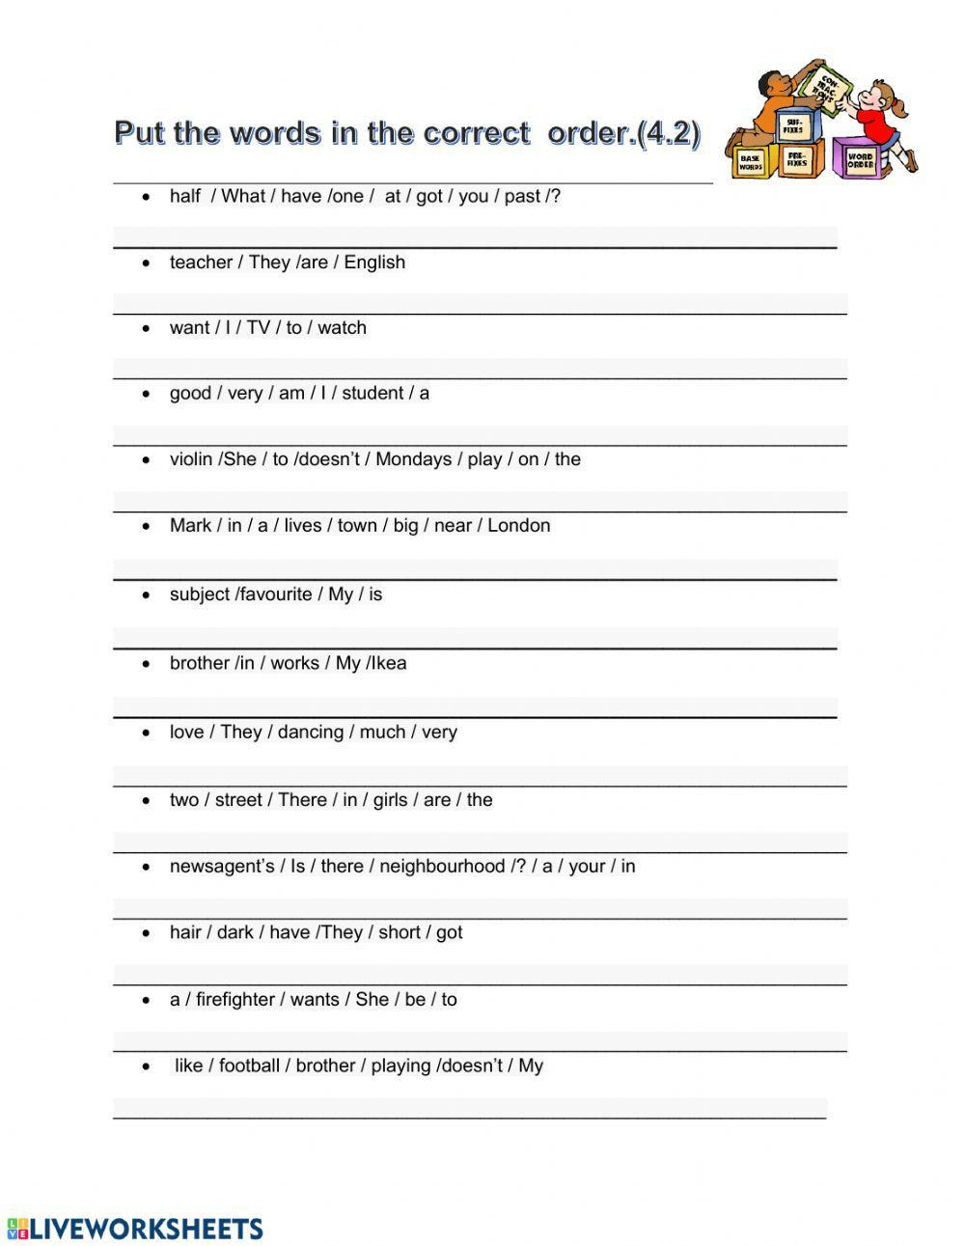

- Grammar worksheet

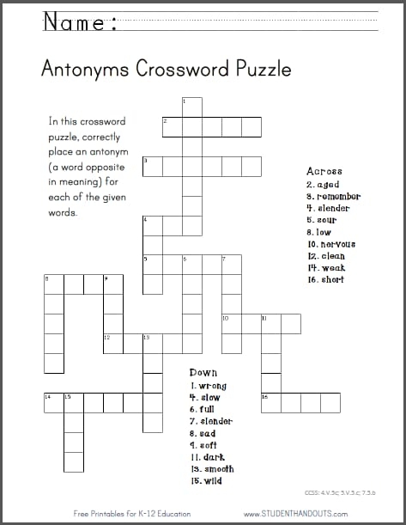
- Grammar worksheet

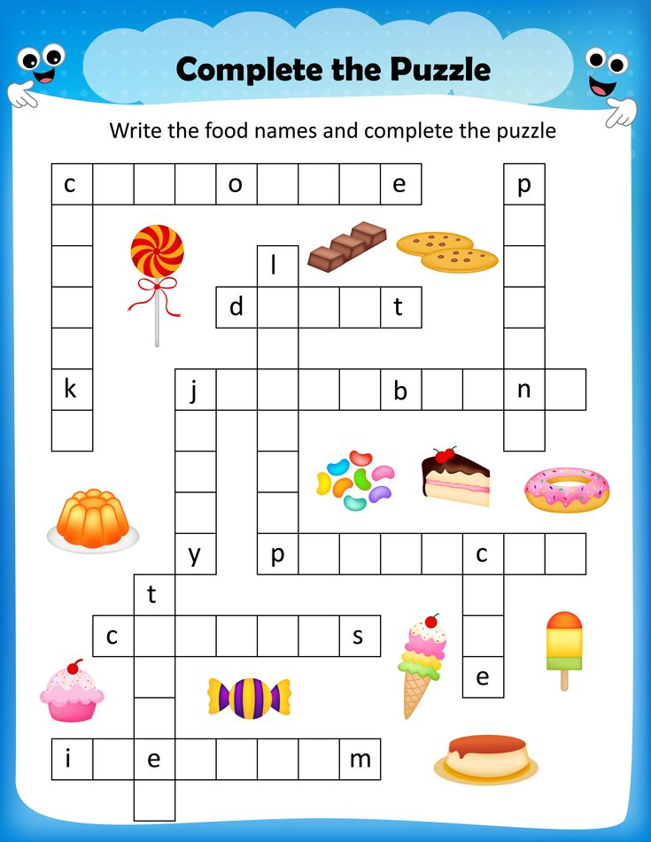
- Grammar worksheet

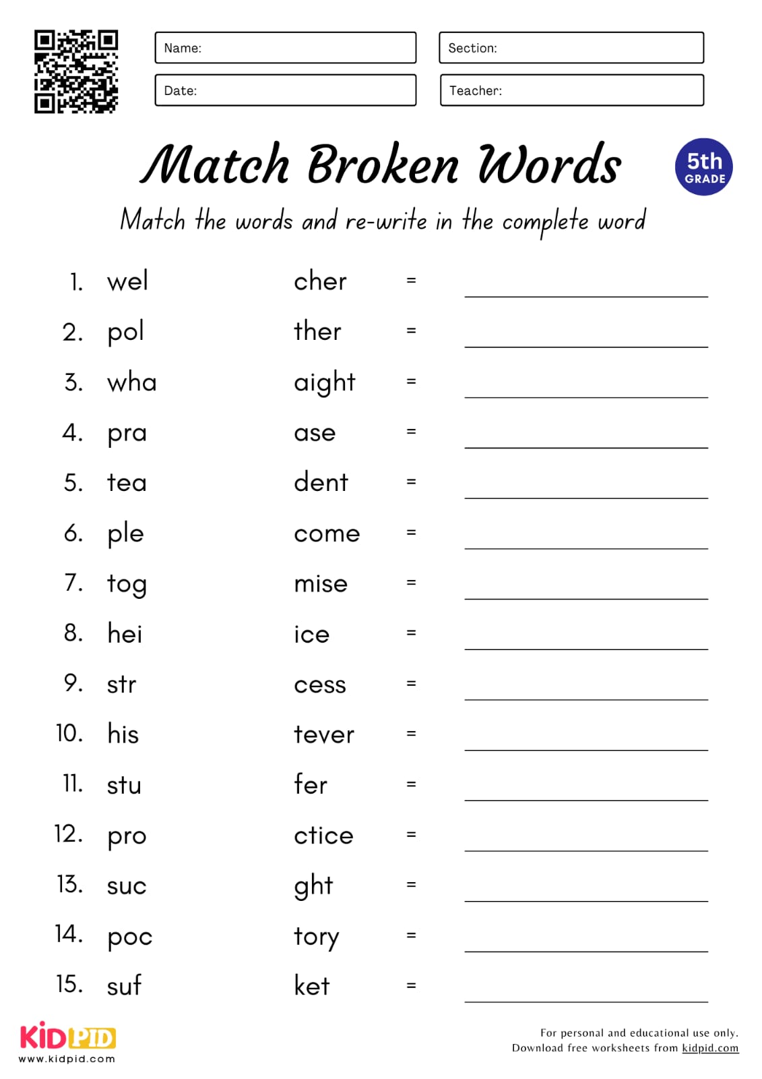
- Grammar worksheet

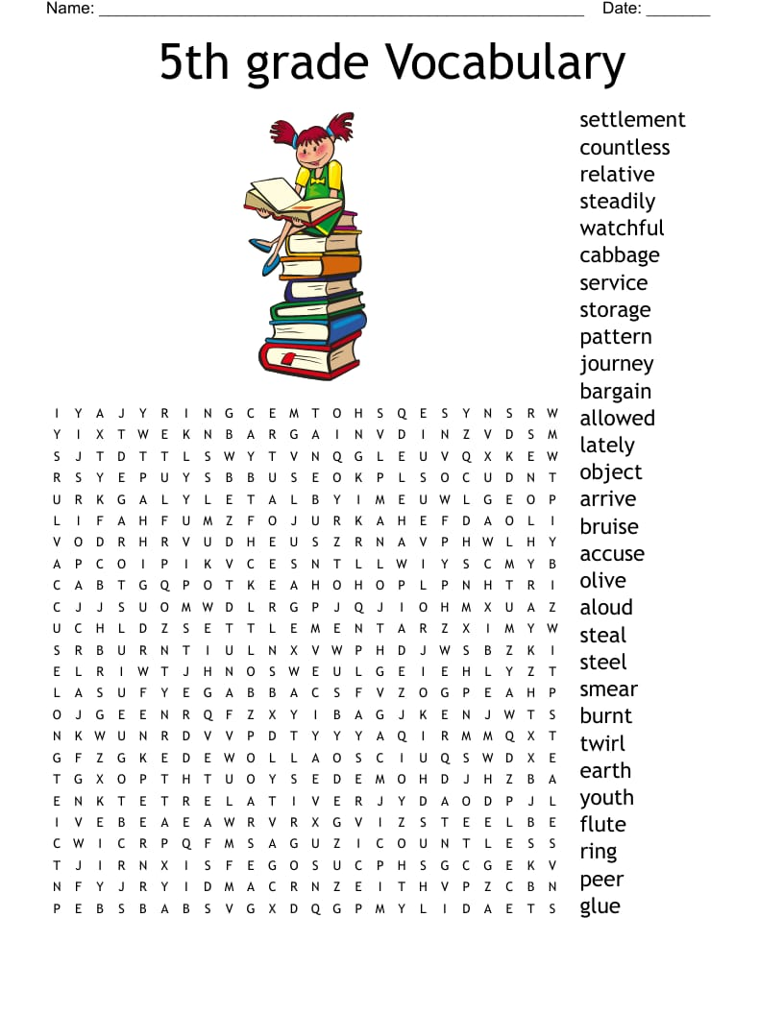
- Grammar worksheet
