
9 TO 1 SCHOLAR’S HEAVEN SCHOOL
SIKANDERPUR
Think Room : 6 Subject. S.St.

Week 1
Ch-1 (Locating Places on Earth)
- Find approximate latitudes and longitudes of :
*USA
*France
*Russia
*India
*Australia
- Read page no. 14-16 of ch-1.
- Learn full chapter with concept for a surprise test in July.
Week 2
Ch-2 (Oceans and Continents)
- Make a 3D continent model by using clay, cardboard or thermocol sheet.
- Read page no. 31-35 of ch-2.
- Write and learn question answers and keywords of ch-2.
Week 3
Ch-13 (The value of Work)
- Write paragraphs mentioning the importance of 3 community helpers.
OR
Create a small market at home and use
paper currency to buy and sell items and
make a video.
- Read page no. 185-187 of ch-13.
- Learn and write ch-13 full for test in July.

9 TO 1 SCHOLAR’S HEAVEN SCHOOL
SIKANDERPUR
Think Room : 6 Subject. Punjabi

(Week-1)
*ਆਪਣੇ ਦਾਦਾ ਦਾਦੀ ਤੋਂ ਕੋਈ ਇੱਕ ਕਹਾਣੀ ਸੁਣੋ ਅਤੇ ਪੰਜਾਬੀ notebook ਉੱਤੇ ਲਿਖ ਕੇ ਲਿਆਓ।
(Week-2)ਪਾਠ-3,4 full revision
* Colourful paper ਕੱਟ ਕਰਕੇ ਇੱਕ ਰੇਲਗਾਡੀ shape ਬਣਾਓ ਅਤੇ ਉਸ ਤੇ ਪੈਂਤੀ ਅੱਖਰੀ ਲਿਖੋ।
(Week-3) ਵਿਆਕਰਣ ਵਿੱਚ ਪਾਠ-2 Read ਕਰਕੇ ਆਓ।
(Week-4) ਕੋਈ ਵੀ (1 or 2) ਪੁਰਾਣੀਆਂ ਚੀਜ਼ਾਂ ਜਿਹੜੀਆਂ ਤੁਹਾਡੇ ਦਾਦਾ ਤੇ ਦਾਦੀ ਦੇ ਸਮੇਂ ਤੋਂ ਸੰਬੰਧਿਤ ਹੋਵੇ ਸਕੂਲ ਵਿੱਚ ਲੈ ਕੇ ਆਣਿਆਂ ਨੇ।

Class 6th हिंदी
*Summer vacation Holiday Homework
*अनुच्छेद कार्य:- (80 से 100 शब्दों में)
.मोबाइल की उपयोगिता (सुखद / दुखद पक्ष)
.बढ़ती जनसंख्या क्या भयानक रूप
.बाल श्रम
*अपने नाना नानी ,दादी -दादी या माता-पिता के लिए धन्यवाद कार्ड बने A4 sheet का प्रयोग करते हुए।
*अ से ओ( 10 मात्राएं Newspaper में से निकलते हुए शब्दों को A 4 sheet में लिखें ।
*हिंदी भाषा दिवस पर एक पोस्टर तैयार कीजिए।
*पंचतंत्र की कोई दो कहानियों का चयन करते हुए लिखे।
कहानी का नाम ,लेखक का नाम ,मुख्य पात्र, क्या शिक्षा मिली।
(Reverse word)
*उल्टा पुल्टा ऐसे शब्द का चयन करें जिन्हें उल्टा पढ़ने पर भी अर्थपूर्ण या नया शब्द बनता हो (कम से कम 15 शब्द जैसे नदी - दिन )
*निम्न विषयों पर 3-3 स्लोगन लिखे, ( A 4 sheet) का प्रयोग करके।
* स्वच्छता * पेड़ बचाओ * शिक्षा
*Cooking without 🔥 fire कोई simple dish बनाएं और उसकी रेसिपी लिखे।
फ्रूट चार्ट ,सैंडविच ,नींबू पानी, सामग्री विधि चित्र सहित A4 सीट पर
और उसकी रेसिपी लिखे।
*5 संज्ञा , 5 सर्वनाम , 5 क्रिया (पाठ -1,2 )मल्हार बुक में से चुने ।
* पाठ 1 ,2 के प्रश्न उत्तर याद करें।

9 TO 1 SCHOLAR’S HEAVEN SCHOOL
SIKANDERPUR
Think Room : 6 Subject. English

WEEK 1
- Unseen Comprehension passage ( shared in WhatsApp group )
Worksheet 1
Worksheet 2
- Grammar worksheet
Back to School ( shared in group)
Antonym crossword puzzle
- Write 10 tongue twisters on A4 size sheet. E.g.
She sells seashells at the sea shore.
WEEK 2
- Unseen Comprehension Passage ( shared in group)
Worksheet 3
Worksheet 4
- Grammar worksheet
Word order in sentence (shared in group)
Complete the puzzle. (shared in group)
- Create a colourful comic strip in 4–6 boxes on any topic
Of your choice. ( Refer pic shared in group)
WEEK 3
- Unseen Comprehension Passage ( shared in group)
Worksheet 5
- Grammar worksheet
A Day at the Beach ( shared in group)
Homophones crossword puzzle ( shared in group)
- Prepare a solo role play by becoming any one object, character, or element of nature and speak about yourself creatively.
• Suggested Characters:
- The Sun
- The Moon
- A Mobile Phone
- A Book
- A Tree
- A River
Instructions:
• Prepare a role play of 1–3 minutes.
- Speak as if you are the chosen character/object.
- Use simple, creative, and expressive English language.
- Include:
Introduction of the character
Its importance
Problems it faces
A message for people
- Students may use:
- Costumes
- Props
- Headgear or drawings
- Maintain proper pronunciation, expression, and confidence while speaking.
- Students must submit A recorded video.

WORKSHEET : 1

PASSAGE 1
Plants need sunlight and water to make their own food. You can do an experiment to test if this is true. Place a bucket over a patch of green grass. After a few days, lift the bucket. You will see that the grass is not as green anymore. If you leave the bucket in place for a week, the grass will become very dull. This happens because the grass cannot make food in the dark. Remove the bucket. In a few days, the grass will start turning green again.

Answer the following questions:-
- What is the main point of this passage?
A.Buckets are bad.
B. Plants need sunlight.
C. Grass is not pretty when it is dull.
- What is an experiment?
  - A way to grow grass
  - A way to test an idea
  - A way to use a bucket
- What happens after a few days?
  - The grass turns brown.
B. The grass gets very dull
C. The grass is not as green
- What is the opposite of dull?
A.bright
B. brown
C. sunlight
- According to the passage, how long does it take for the grass to become dull?
A.a month
B. a week
C. a few days

WORKSHEET : 2

PASSAGE 2

The Kind Little Girl

In a small town, there lived a kind little girl named Maya. She loved helping others and often shared her toys with her friends. One day, while walking home from school, she saw an old man sitting on a bench looking sad. Maya approached him and asked, “Why are you sad, sir?”
The old man replied, “I lost my way home and don’t know how to get back.” Maya felt sorry for him and decided to help. She asked him to describe his home, and after listening carefully, she remembered the way. Together, they walked to the old man’s house.
When they arrived, the old man thanked Maya and gave her a shiny coin as a reward. Maya smiled and said, “I just wanted to help!” From that day on, the old man became her friend.
Questions:
Fill in the Blanks:
- Maya lived in a __________ town.
- The old man was sitting on a __________.
- Maya received a shiny __________ as a reward.

Multiple Choice Questions (MCQs):
- What did Maya love to do?
  - Play alone
  - Help others
  - Collect coins
  - Go shopping
- How did Maya help the old man?
  - She gave him money
  - She walked him home
  - She bought him food
  - She called for help
Short Answer Questions:
- What did the old man lose?
- How did Maya feel when she helped the old man?

WORKSHEET : 3

PASSAGE 3
The Busy Honeybees
Honeybees are small insects that live in large groups called colonies. Each colony has three types of bees, the queen, the workers, and the drones. The queen bee lays eggs, while the worker bees collect nectar and pollen from flowers to make honey. Drones help the queen bee in reproduction.
Bees play an important role in nature. When they collect nectar, they also help flowers to make fruits and seeds through a process called pollination. Without bees, many plants would not be able to grow properly. Honey made by bees is also used by humans as food and medicine.
Questions
- Choose the correct answer.
  - How many types of bees are there in a colony?
    - Two
    - Three
    - Four
  - What do worker bees collect from flowers?
    - Nectar and pollen
    - Honey and wax
    - Fruits and seeds
  - What is the main work of the queen bee?
    - Making honey
    - Laying eggs
    - Collecting nectar
- Answer in one or two sentences.
4. How do bees help plants?
5. Mention one use of honey for humans.
- Vocabulary and Grammar Check
6. Find a word from the passage that means a group of bees.
7. Write the plural form of “colony.”

Grammar worksheet

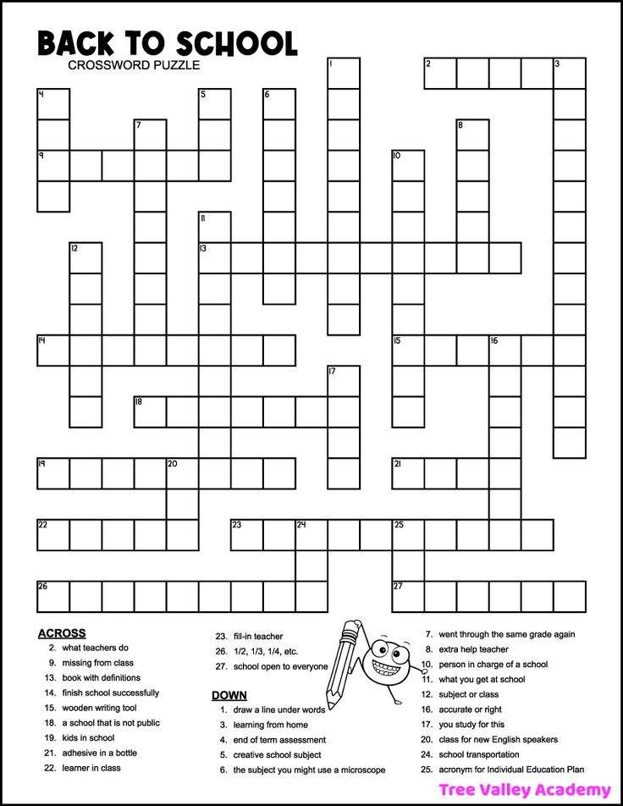

Grammar worksheet

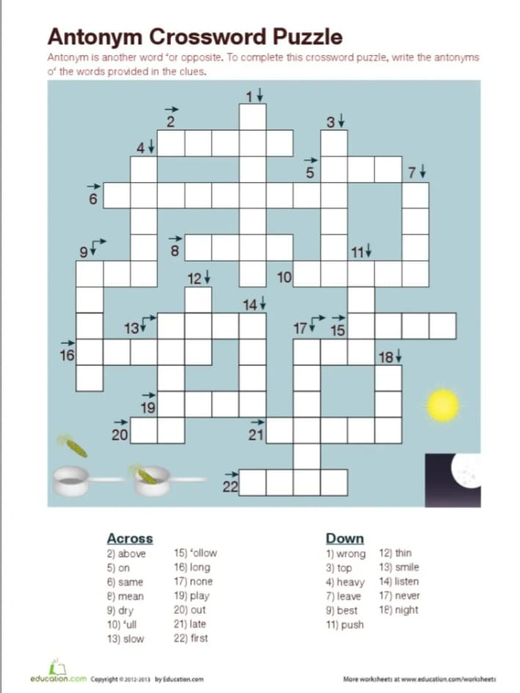
Grammar worksheet
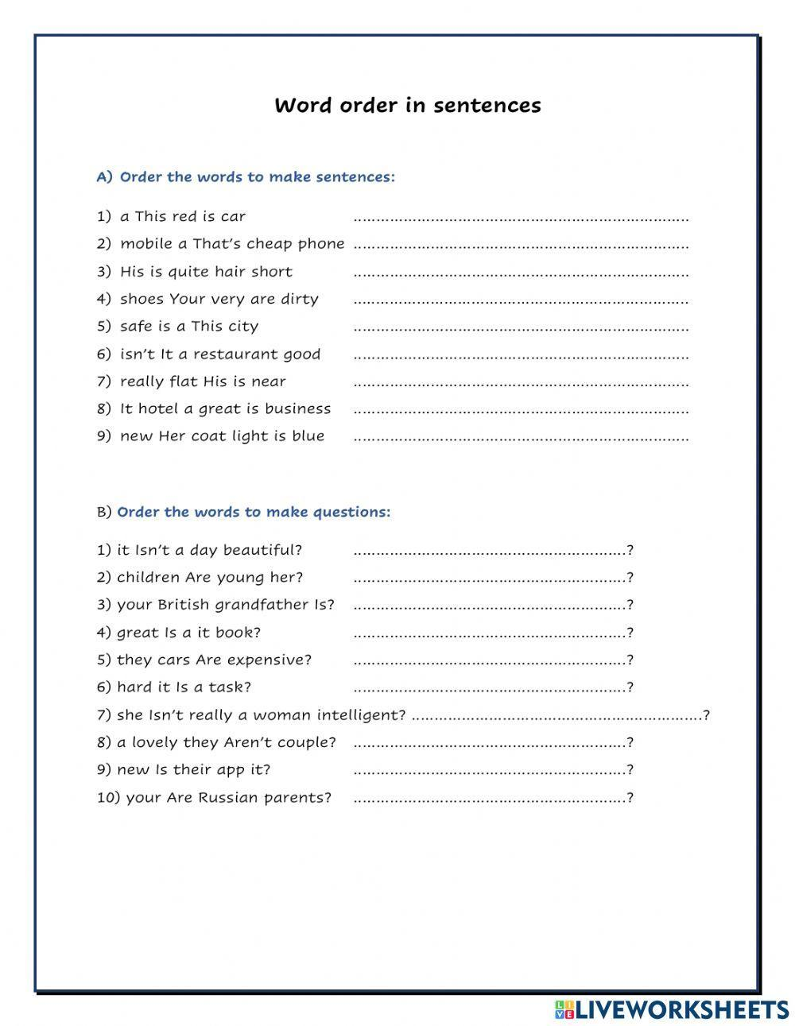
Grammar worksheet

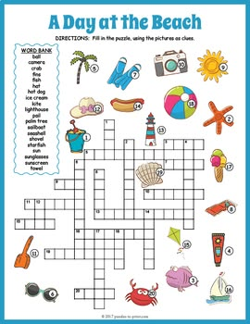

Grammar worksheet
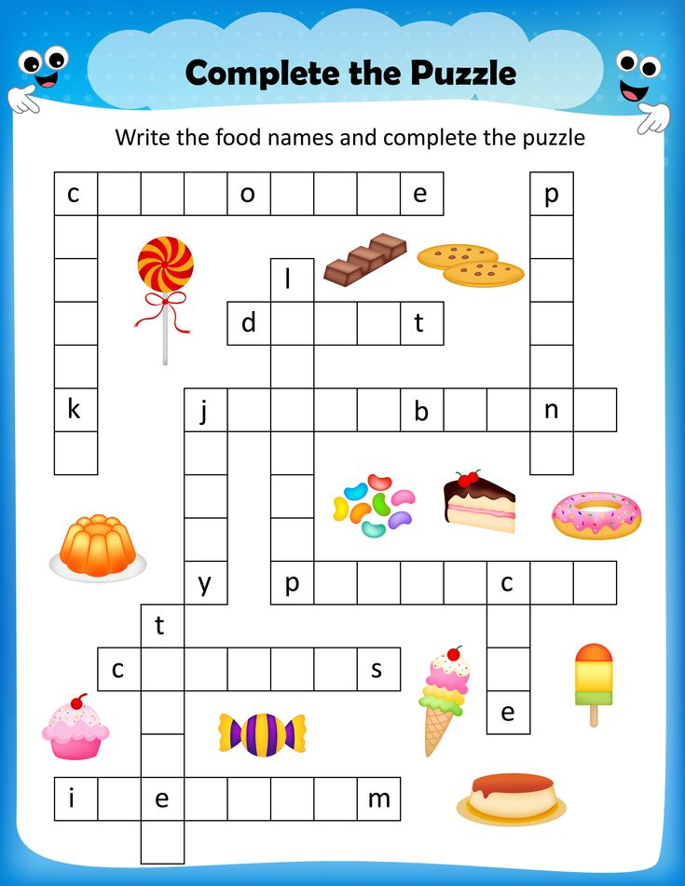

Grammar worksheet
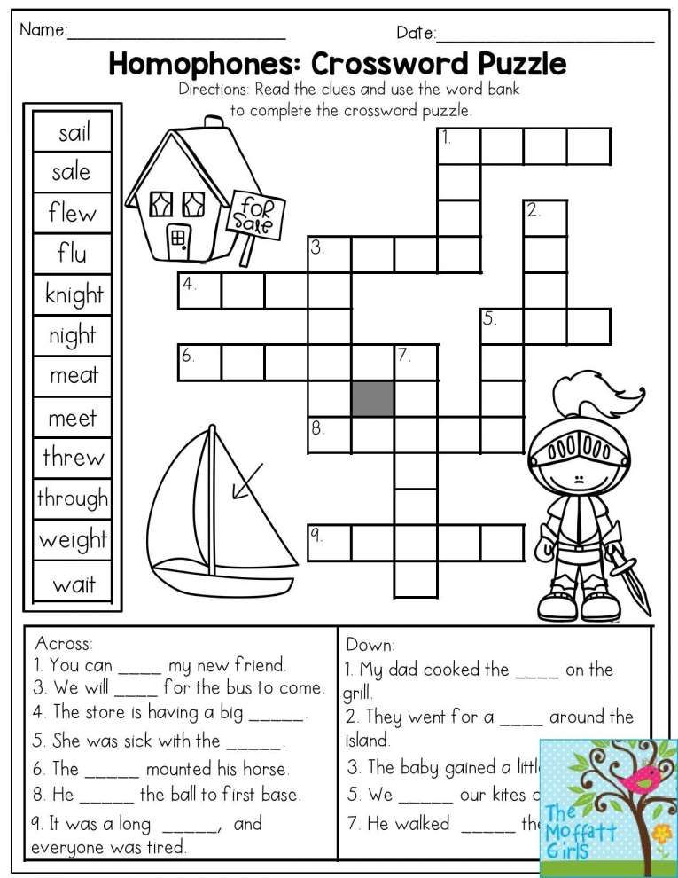

Grammar worksheet

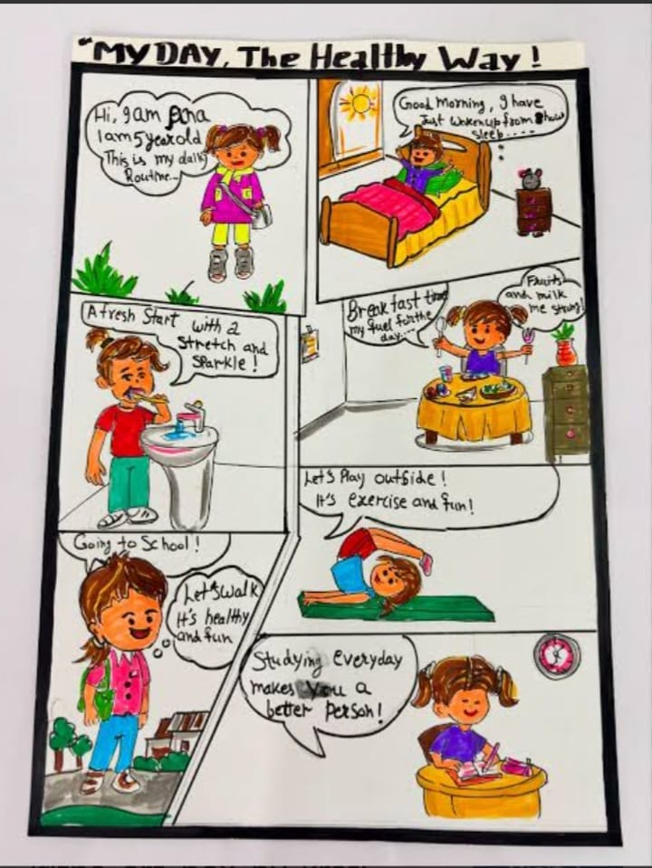
9 TO 1 SCHOLAR’S HEAVEN SCHOOL
SIKANDERPUR
Think Room : 6 Subject. Science

Week-1
- Read Ch-1(The wonderful world of science)and solve foundation course book (Exercise-3)
- Build a working solar oven model using a recycled pizza box, aluminium foil, plastic wrap paper and black construction.( With the help of video link provided in WhatsApp group)
Week 2
- Read Ch.2(Diversity in the living world)and solve foundation bookwork (Exercise- 3)
- Do a Surprising activity related to magic of science in front of your father to celebrate father’s day. Capture your father’s reaction and create a sweet memory. Don’t forget to share with us. You can do activity given according to your Roll No. Or any other which you find interesting to do.
Roll no.:- (1 to4) Ice sticks with thread using salt
Roll no:- (5 to 8) Bottle balance on ruler with the help of paper
Roll no:- (9 to 12) Aluminium foil ball sink in Water
Roll no:- (13 to 17) Balloon stick with glass containing water.

Week 3
- Read ch-4 (Exploring magnets) and solve foundation course book (Exercise. 4).
- Design a 5- page creative scrapbook focusing on a balanced Diet Chart (one week) for a 12-year-old-child
Week-4
- Read Ch-3(Mindful Eating: A path to healthy body) And underline important words and definitions. Also write summary in your fair notebook.
- Track your Water intake for 5 days (in litres). And record in fair notebook.
- Visit to a farm observe and make a report of
  - Crops grown there.
  - Irrigation method
  - farm tool
  - farming process.
Make your report creative using pictures and drawings.( On fair notebook)

9 TO 1 SCHOLAR’S HEAVEN SCHOOL
SIKANDERPUR
Think Room : 6 Subject. Computer

📅 Weekly Homework Plan

🌟 Week 1: Chapter 1 – Introduction to HTML

📘 Learn & Write
- Write the full form of HTML.
- What is HTML? (Write definition in your own words)
- Write any 5 uses of HTML.
- What is a web page?
- What is a web browser? Write 2 examples.

✍️ Practical Work
- Draw and label:
  - A simple diagram of a web page showing title, heading, and content area.
- Write HTML tags (only names):
  - <html>, <head>, <title>, <body>, <h1>, <p>

💻 Activity
- Observe any 2 websites on a mobile/computer and write:
  - Website name
  - What information it shows

🌟 Week 2: Chapter 2 – Read (HTML Basics Revision)

📘 Learn & Write
- Read Chapter 2 carefully.
- Write short notes on:
  - Web page structure
  - HTML tags
- Answer:
  - Why do we use tags in HTML?
  - What is the difference between heading and paragraph?

✍️ Activity
- Open a textbook or notes and underline important keywords.
- Make a small chart:
  - Title: “Parts of a Web Page”
  - Include: Header, Body, Footer

💡 Fun Task
- Ask your parents or teacher:
  - How websites are made?
- Write 5–6 lines about what you learned.

📌 Instructions:
- Complete all work neatly in notebook.
- Use proper headings and date.
- Draw diagrams with pencil and colors.
- Read chapter 2 at least 2 times.

9 TO 1 SCHOLAR’S HEAVEN SCHOOL
SIKANDERPUR
Think Room : 6 Subject. Mathematics

Summer holidays homework
Week 1 : Matchstick pattern
    - Triangle , b .)square c.) star ( do in maths notebook)
d. Clock angle model
Make a beautiful clock using cardboard ( Do in notebook)
Week 2 : Write real life maths examples at least 5 points.( Do in maths notebook)
Week 3: Line art drawing
Draw a creative picture using only
. Parallel lines
. Curved lines
. Intersecting lines
. Zig-zig lines
Example:- House, city scene ( do in your notebook)
Week 4 : Make a Angle model “ The model link has been sent in the WhatsApp group.”.

