
9 TO 1 SCHOLAR’S HEAVEN SCHOOL
SIKANDERPUR
Think Room : 7 Subject. Punjabi

(Week-1)*ਪਾਠ -1,2 full revision.
*ਪੰਜਾਬ ਦੇ ਰਹਿਣ ਸਹਿਣ ਖਾਣ-ਪੀਣ ਅਤੇ ਪਹਿਨਾਵੇ ਬਾਰੇ ਆਪਣੀ ਪੰਜਾਬੀ ਦੀ notebook ਤੇ ਲਿਖੋ with pictures.
(Week-2) ਪਾਠ -3 full revision.
*ਪੰਜਾਬ ਦਾ ਨਕਸ਼ਾ(Map)ਬਣਾ ਕੇ ਉਸ ਵਿੱਚ colour ਭਰੋ।
(Week-4) ਆਪਣੇ ਘਰ ਤੋਂ ਕੋਈ ਵੀ(1or2) ਚੀਜ਼ਾਂ ਜਿਹੜੀਆਂ ਤੁਹਾਡੇ ਦਾਦਾ ਤੇ ਦਾਦੀ ਦੇ ਸਮੇਂ ਤੋਂ ਸੰਬੰਧਿਤ ਹੋਣ ਸਕੂਲ ਵਿੱਚ ਲਿਆਉਣੀਆਂ ਨੇ।
9 TO 1 SCHOLAR’S HEAVEN SCHOOL
SIKANDERPUR
Think Room : 7 Subject. S.St.

Week 1. Chapter 2. Understanding weather and its elements
1.Prepare a 1-2 minutes video on weather forecasting like a news anchor and share it on school app.
2. Record daily temperature and write in your holiday homework notebook.
3. Find out difficult 15 words from the chapter and write in your notebook with meaning.
4. Learning work. Learn all the questions answers of the chapter and worksheet that have written in notebook
Week 2. Chapter 1 geographical diversity in India
- Prepare an assignment about Geographical diversity of Haryana and paste a political map of haryana.
- Maintain a scrapbook maintaining information about different states.(Any five)
Information may include
Clothes, weather, festival, Food, language and culture or tradition
- Learning work. Learn summary,notes and question answer.
Week 3. Chapter 11. From Barter to Money
  - Collect different types of coins and paste it on A4 size sheet.
  - Learning work. Learn keywords and question answer of the chapter.
Chapter 9. From the ruler to Ruled: Types of Government.
- Collect the pictures of all the prime minister and President and mention their tenure.
- Write the questions answers and keywords of the chapter and learn it.
9 TO 1 SCHOLAR’S HEAVEN SCHOOL
SIKANDERPUR
Think Room : 7 Subject. Computer

Week 1

Chapter 1 – Reading & Understanding
- Read Chapter 1 thoroughly.
- Write all important definitions and keywords from the chapter.
- Prepare a list of 15 new computer terms with meanings.
- Solve Exercise A and B from the book.
- Draw a diagram/chart related to the topic of Chapter 1.

Week 2

Chapter 1 – Written & Practical Work
- Write detailed question answers of Chapter 1.
- Prepare 10 fill in the blanks and 10 one-word questions.
- Write 5 true/false statements with corrections.
- Perform practical activities related to the chapter on a computer.
- Revise the complete Chapter 1.

Week 3

Chapter 2 – Reading & Practice
- Read Chapter 2 carefully and underline important points.
- Write important notes and definitions from the chapter.
- Learn and write 15 difficult words with meanings.
- Solve Exercise A and B from the book.
- Prepare a creative chart/model related to Chapter 2.

Week 4

Chapter 2 – Revision & Project Work
- Write detailed question answers of Chapter 2.
- Prepare 10 MCQs and 10 fill in the blanks from the chapter.
- Complete practical work related to Chapter 2.
- Revise both Chapter 1 and Chapter 2 thoroughly.
- Prepare a short project/file on any topic from the syllabus.

General Instructions
- Complete all work neatly in a separate Computer Holiday Homework notebook.
- Use proper headings, colors, and diagrams wherever required.
- Practical work should be done regularly for better understanding.
- Homework must be submitted on the reopening day after summer vacation.

9 TO 1 SCHOLAR’S HEAVEN SCHOOL
SIKANDERPUR
Think Room : 7 Subject. English
WEEK 1
- Unseen comprehension passage (shared in WhatsApp group)
Worksheet 1
Worksheet 2
- Solve English Crossword Puzzle ( shared in group)
- Collect 10 English tongue twisters and practice reading them aloud daily. Write your favourite one and decorate the page creatively.
- Write a paragraph – A Day Without Electricity
WEEK 2
- Unseen Comprehension Passage ( Shared in group)
Worksheet 3
Worksheet 4
- Solve Homophones worksheet. ( shared in group)
- Prepare a creative English Magazine.
Your magazine should include any 5–6 of the following:
- Newspaper or magazine cuttings
- Pictures and illustrations
- Short stories or comics
- Poems
- Jokes/riddles
- Tongue twisters
- Interesting facts
- Vocabulary corner
- Inspirational quotes
- Puzzles or word search
Students may use:
- Newspaper cuttings
- Old magazines
- Printed pictures
- Handmade drawings

WEEK 3
- Unseen Comprehension Passage
Worksheet 5
- Write the English alphabets from A to Z in Braille Script.
Use decorative pearls, beads, pulses, or grains of daal to create the raised Braille dots.
(Refer pg no 38 of Poorvi)
- Write a paragraph – Value of Time.

Worksheet 1

READING SECTION
Read the following passages and answer the questions below:

PASSAGE 1
The Magic of the Banyan Tree
Long ago, in a small Indian village, lived a wise old man named grandfather Gopal. In the center of his village stood an enormous banyan tree that had been there for over a hundred years. Its thick, twisting roots hung down from the branches like strong ropes, and its vast green leaves provided cool shade for everyone.
During the hot summer afternoons, the village children would gather under the great tree. They loved to swing on the hanging roots, play hide-and-seek, and listen to Gopal’s wonderful stories. Grandfather Gopal taught the children that the tree was like a great, kind grandmother. It gave shelter to birds, shade to tired travelers, and fresh air to the village.
One day, a wealthy businessman visited the village. He told the villagers that he wanted to cut down the old tree to build a big, modern hotel. The villagers were sad and confused, not knowing what to do. The children, however, remembered Gopal’s lessons. They held hands, forming a large circle around the tree to protect it. Seeing the children’s bravery and love for nature, the businessman felt deeply ashamed. He changed his mind, apologized to the villagers, and decided to build his hotel somewhere else. The banyan tree remained safe, standing tall and proud.
Multiple Choice Questions (MCQs)
- Who is the main character in the story?
- A wealthy businessman
- Grandfather Gopal
- A tired traveler
- ) A villager
- Where did the story take place?
A) In a busy city
B) In a deep forest
C) In a small Indian village
D) On a high mountain

3. How old was the banyan tree?
A) Exactly fifty years old
B) A few years old
C) Over a hundred years old
D) Exactly ten years old

4. What did the hanging roots of the tree look like?
A) Thick, twisting ropes
B) Thin, green vines
C) Long, wooden ladders
D) Sharp, iron chains

5. What did the children NOT do under the tree?
A) Swing on the roots
B) Play hide-and-seek
C) Listen to Gopal’s stories
D) Sleep in the businessman’s hotel

6. Who wanted to cut down the tree?
A) Grandfather Gopal
B) A wealthy businessman
C) The village children
D) A tired traveler

7. Why did the businessman want to cut down the tree?
A) To make space for a garden
B) To get firewood
C) To build a big, modern hotel
D) To sell the wood

8. How did the children protect the banyan tree?
A) They shouted at the businessman
B) They built a fence around it
C) They held hands in a large circle around it
D) They hid the businessman’s tools

9. How did the businessman feel at the end of the story?
A) Angry
B) Ashamed
C) Happy
D) Excited

10. What lesson does the story teach us?
A) Money is more important than trees
B) We should protect nature and trees
C) Villages are better than cities
D) Children should not play
Outside

Worksheet 2

PASSAGE 2

The Mountain Trek
Last summer, Neha and her family went on a trek in the Himalayas. The path was steep, and the air was chilly, but the views were breathtaking. They saw snow-capped peaks, clear streams, and colorful flowers growing on the slopes.
Neha learned to be careful while walking on rocky paths and to respect nature. At night, they sat around a campfire, shared stories, and admired the starry sky. The trek was challenging, but it taught Neha courage, patience, and the joy of adventure.
Questions

- Multiple Choice Questions
  - Where did Neha go on a trek?
    - Alps
    - Himalayas
    - Andes
  - What did Neha see on the trek?
    - Beaches and sand dunes
    - Snow-capped peaks, streams, and flowers
    - Cities and markets
  - What lessons did Neha learn?
    - Courage, patience, and respect for nature
    - Cooking and cleaning
    - Swimming and fishing
- Short Answer Questions
4. How did Neha and her family spend the night?
5. Why was the trek challenging?
- Vocabulary and Grammar Check
6. Find a word that means very beautiful.
7. Write the past tense of “go.”

Worksheet 3

PASSAGE 3
The Festival of Kites
Every year, the town of Jaipur celebrates a colourful Kite Festival. Early in the morning, rooftops are filled with people flying kites of all shapes and sizes. Children laugh as they try to cut each other’s kites in friendly competition. The sky looks like a rainbow with kites of red, blue, green, and yellow flying high.
Rohan and his sister Priya joined the festival for the first time. They had prepared their kites at home and were excited to fly them. Rohan’s kite got stuck in a tree, but Priya helped him get it down. By the end of the day, both were tired but happy, having enjoyed the lively festival and the beautiful view of thousands of kites in the sky.
Questions

- Multiple Choice Questions
  - Where is the Kite Festival celebrated?
    - Delhi
    - Jaipur
    - Mumbai
  - What do children try to do during the festival?
    - Sell kites
    - Cut each other’s kites
    - Make new kites
  - How did Rohan get help with his kite?
    - His father helped
    - Priya helped
    - A stranger helped
- Short Answer Questions
4. How did the sky look during the festival?
5. How did Rohan and Priya feel at the end of the day?
Vocabulary and Grammar Check
6. Find a word that means very colourful or bright.
7. Write the plural of “roof.”

Worksheet 4

PASSAGE 4
A Day at the Village Fair
Last Sunday, Aryan visited the village fair with his family. The fair was lively, with colorful stalls selling toys, sweets, and clothes. Children ran around excitedly, holding balloons and playing games. There was a stage where local artists performed dances and sang songs. Aryan and his sister tried their luck at a ring toss game and won a small stuffed toy. They also tasted delicious cotton candy and fresh fruit juice. Outside the fair, there was a small pond where ducks swam peacefully, and a few children were feeding them. Aryan’s parents explained how fairs bring the community together and provide entertainment for everyone. As the evening approached, the fair lit up with strings of lights, and music filled the air. Aryan felt happy and tired but enjoyed every moment of the day.
Questions:
- Where did Aryan go last Sunday?
- Name two things Aryan bought or won at the fair.
- What were the local artists doing?
- How did Aryan feel at the end of the day?
- Why do fairs bring people together?

Worksheet 5

PASSAGE 5
The Mountain Trek
Ria and her friends went on a mountain trek during the summer holidays. They packed their bags with food, water, and first aid kits. The trail was steep, and they had to be careful while walking on rocky paths. Along the way, they saw wildflowers growing on the slopes and a few mountain goats grazing near cliffs. They also crossed a small stream, where they rested for a while and drank fresh water. The trek was tiring, but reaching the top was worth it. From the peak, they could see a vast forest, rivers winding through valleys, and distant villages. Ria felt proud of her effort and promised herself to go on more such adventures to explore nature.
Questions:
- Who went on the trek?
- Name two things they packed for the trek.
- What animals did they see along the way?
- What could they see from the mountain top?
- How did Ria feel after completing the trek?

Grammar Worksheet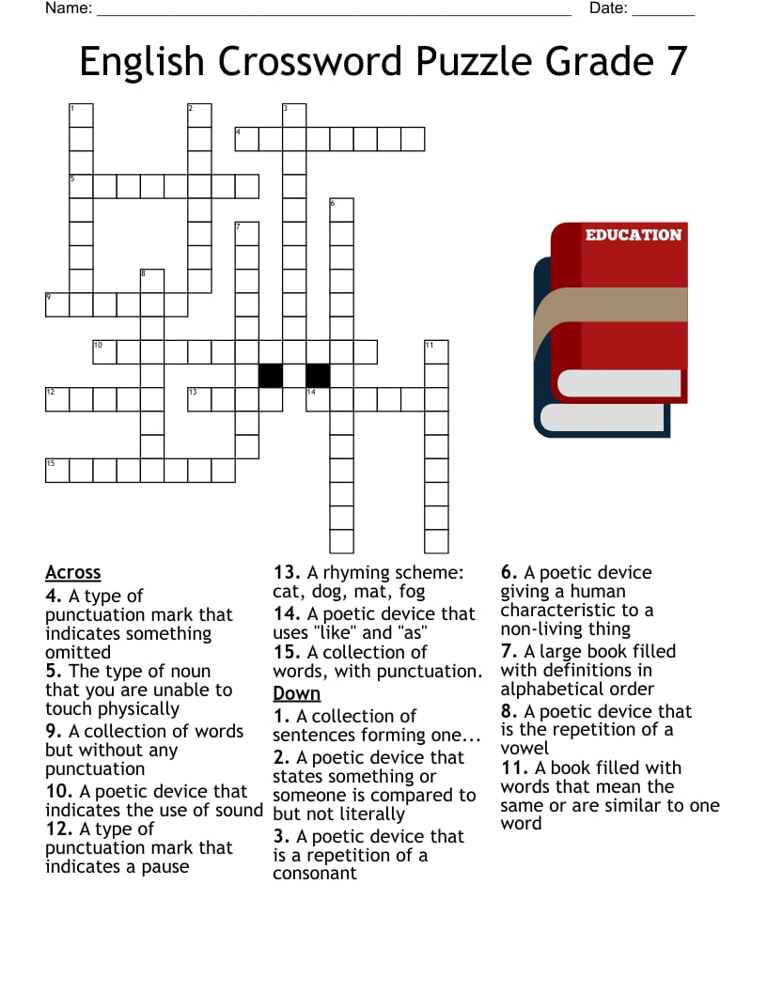
Grammar Worksheet
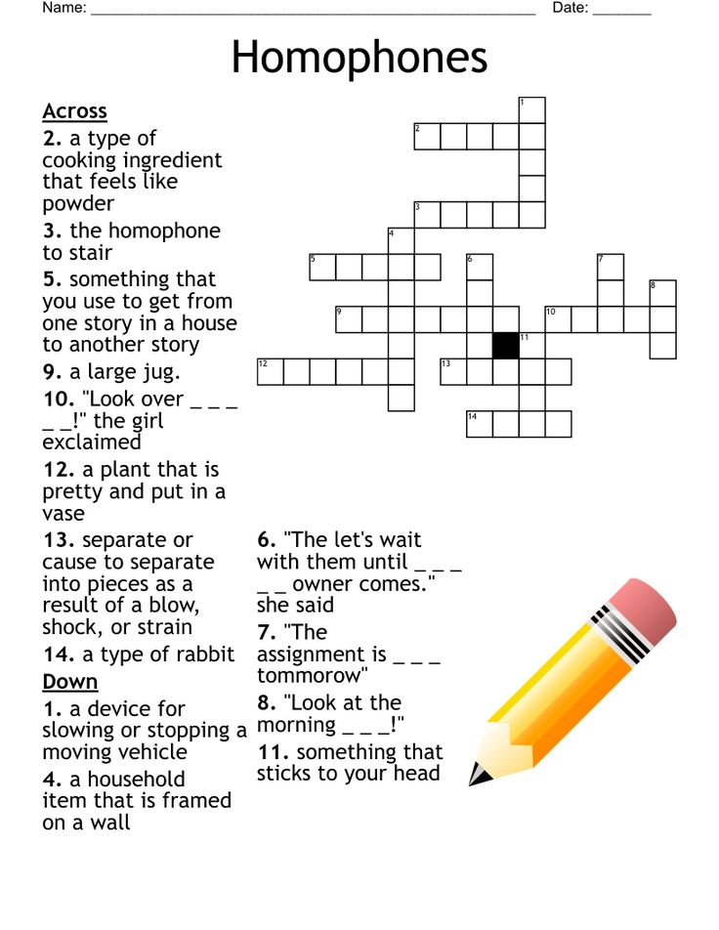
9 TO 1 SCHOLAR’S HEAVEN SCHOOL
SIKANDERPUR
Think Room : 7 Subject. Science
Week-1
- Read ch-1( The ever evolving world of science) and solve foundation course Book work (Exercise -3)
- Compose a story (150-200 words) with pictures and drawings with message wherein a girl or boy explains his younger sibling the importance of cleanliness to save environment. (On fair notebook)
Week 2
- Read ch-2 ( exploring substances: acidic, basic and neutral) and solve foundation course book work(exercise -3)
- Make a beautiful card using basic or acidic solution to surprise your father on father’s day. And make the card’s content visible with magical ink (acid -base indicator ) Click picture of card and share with us. Or make a small video while making of card and giving to your father.
Week:-3
- Read Ch-3 (Electricity: circuits and their components) and solve foundation course bork work (Exercise -3)
- Make a simple and creative working model of electricity generation from Wind, water or sunlight ( with the help of link provided in WhatsApp group)
- Visit and electrical Shop and with the help of shopkeeper take information of different types of fuses, cells and switches and their uses. Make a report of it ( on fair notebook using pictures and drawings). Bring any one item from above mentioned in school.
Week:-4
- Read Ch-4 (The world of metals and non metals) and underline the important words and definitions. Make a picture related to it and write summary in fair notebook
- Observe your daily meal for 3 days and complete the following table for each day on fair notebook.

Meal | Food you eat | Nutrients it contains
Breakfast
Lunch
Dinner

- Explain any topic to your siblings using activity or model and make video and share with us.
1 to 5 Physical change and chemical change.
6 to 10 properties of metals
11to 15 Real life example of neutralisation

9 TO 1 SCHOLAR’S HEAVEN SCHOOL
SIKANDERPUR
Think Room : 7 Subject. Mathematics

Summer holidays homework
Week 1 : Newspaper Number hunt
  - Cut 5 large number from newspaper magazine, or the internet. Paste them in your notebook and write.
b. 1. Greatest digit
2. Smallest digit
3. Write place value chart national and international
Week 2 : Write 3 real life situation and convert them into Arithmetic expression
Week 3 : Draw a tree , robot ,train
. Number
. Mathematics. Symbols
. Arithmetic expression
Week 4 : Make a model -Maths park “The model link has been sent in the WhatsApp group.”.

9 TO 1 SCHOLAR’S HEAVEN SCHOOL
SIKANDERPUR
Think Room : 7 Subject. Hindi

Summer vacation holiday homework
*अपने नाना नानी ,दादी -दादी या माता-पिता के लिए धन्यवाद कार्ड बने A4 sheet का प्रयोग करते हुए।
*अ से ओ( 10 मात्राएं Newspaper में से निकलते हुए शब्दों को A 4 sheet में लिखें ।
*हिंदी भाषा दिवस पर एक पोस्टर तैयार कीजिए।
*पंचतंत्र की कोई दो कहानियों का चयन करते हुए लिखे।
कहानी का नाम ,लेखक का नाम ,मुख्य पात्र, क्या शिक्षा मिली।
*निम्न विषयों पर 3-3 स्लोगन लिखे, ( A 4 sheet) का प्रयोग करके।
* स्वच्छता *पेड़ बचाओ *शिक्षा
(Cooking without fire )कोई simple dish बनाएं और उसकी रेसिपी लिखे।
फ्रूट चार्ट ,सैंडविच ,नींबू पानी, सामग्री विधि चित्र सहित A4 सीट पर
और उसकी रेसिपी लिखे। फ्रूट चार्ट ,सैंडविच ,नींबू पानी, सामग्री विधि चित्र सहित A4 सीट पर।
*पर्यायवाची tree activity:- एक पेड़ बनाएं और हर शाखा पर एक शब्द और उसका पर्यायवाची अर्थ चिपकाए ।
* पाठ 1 ,2 के प्रश्न उत्तर याद करें।
*अनुच्छेद कार्य:-महिला सशक्तिकरण .प्रकृति बनाम विज्ञान .अच्छे संगति
.युवकों का देश के प्रति कर्तव्य 120 शब्दों में लिखो।

